Lab 3

Android User Interface. Part 2

For the exercises below, follow the steps in the Bruschetta example from Lab 2.

1. **Youth Hostel App**

|  |  |
| --- | --- |
| Application Title: | Youth Hostel App |
| Purpose: | In a youth hostel reservation app, a hostel is selected and an address and other information is displayed |
| Algorithm: | 1. The opening screen displays the name of a hostel, an image (provided in the Pictures folder on the course page in moodle), and a Button control. Research a real name of a hostel and address and cost range to display in your own customized app (do not use the one in the figure below!) 2. When the user selects a hostel, an address and a cost range are displayed in a second screen. |
|  |  |

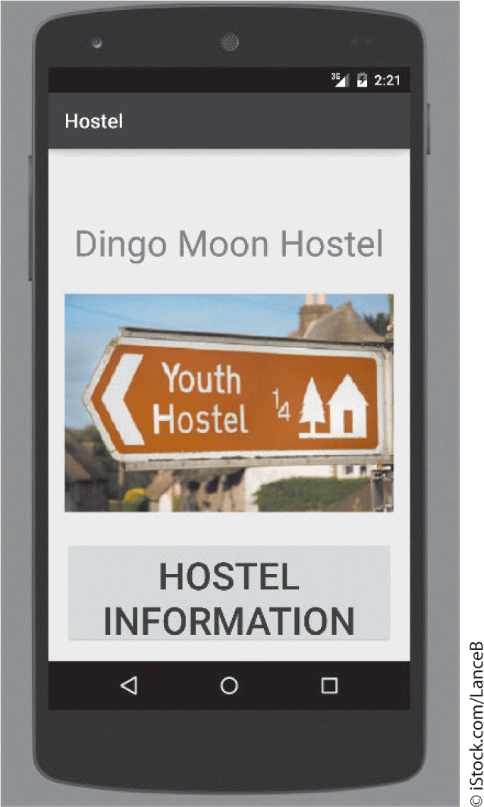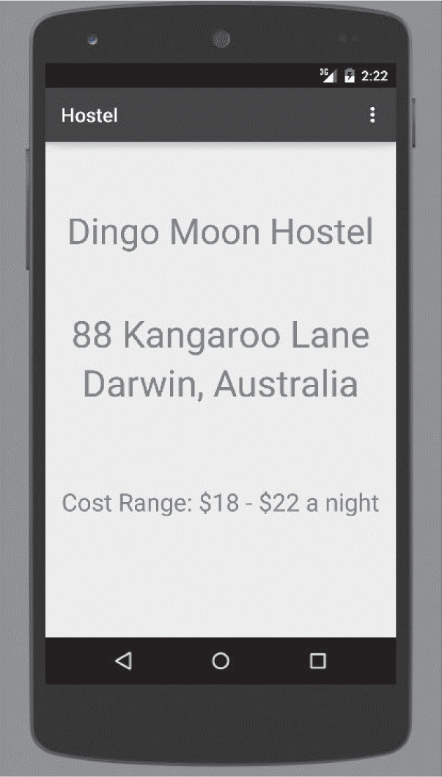

1. **Segway Rental App**

|  |  |
| --- | --- |
| Application Title: | Segway Rental App |
| Purpose: | In this app, a Segway tour is selected and a Segway image is displayed with rental information |
| Algorithm: | 1. The opening screen displays the title of the app, a description and a Button control. 2. When the user chooses to rent a Segway, an image (available in the Pictures folder on the course page in moodle) displaying the Segway and tour price is shown |
|  |  |

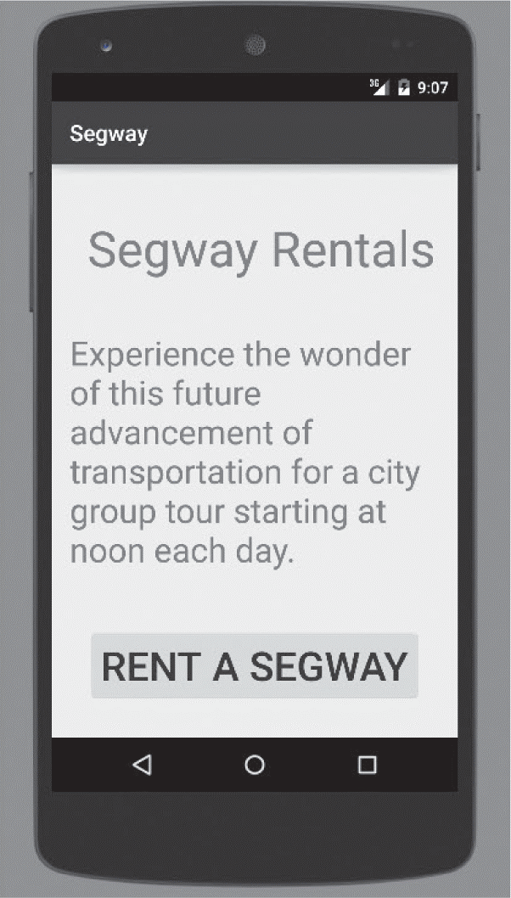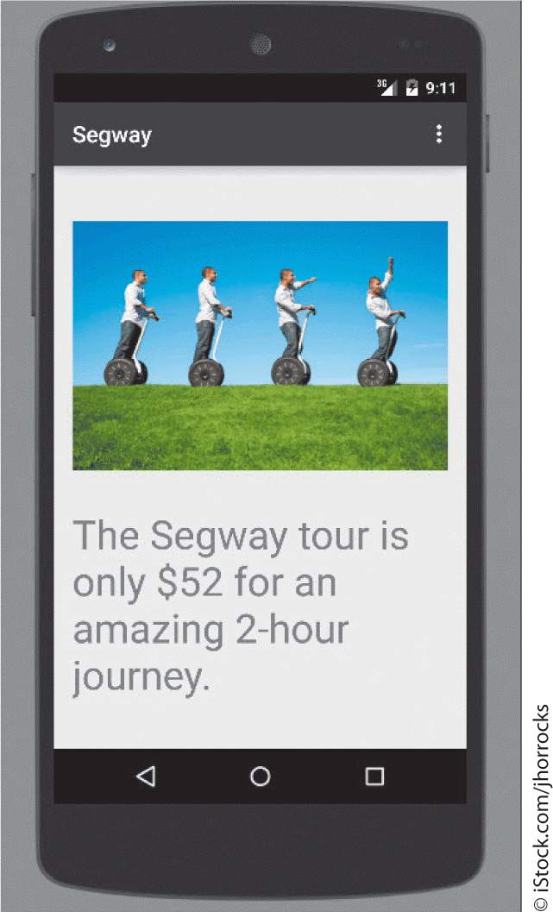

1. **Business Card App**

|  |  |
| --- | --- |
| Application Title: | Business Card App |
| Purpose: | This app provides your business card information with your own picture. Create two screens for the business card app. You use the app to select the name of a business contact, and then display detailed business card information |
| Algorithm: | 1. The opening screen displays the name of the contact, your picture converted to a .png file, and a Button control. Create your own layout. To convert a picture to a .png format, you could use the Paint application available from the Start menu on the University computers. From the main menu you Open the picture you want to convert, click on Save as and choose a PNG picture format from the drop down menu. 2. The second screen displays your business card information. Create your own layout. |
|  |  |

**Reference:**

Hoisington, C. (2016) Android Boot Camp for Developers Using Java: A Guide to Creating Your First Android Apps, Cengage Learning, Chapter 2