HAMLET: a grounded agentic framework for proteomics metadata mining
Harikrishnan Ramadasan*^{1,2}, Arnaud Jung*^{3,4}, Katerina Nastou, Sander Heyndrickx^{1,2}, Ian Sitarik, Wout Bittremieux, Samuel de la Cámara Fuentes, Eric W. Deutsch, Iddo Friedberg, Karolina Krystofova, Lev Levitsky, Marta Lozano Prieto, Ana Mendes, Fatemeh Mirzadeh Sarcheshmeh, Magnus Palmblad, Tobias Schmidt, Veit Schwämmle, Armin Soleymaniniya, Natalia Tichshenko, Julian Uszkoreit, Tim Van Den Bossche^{1,2}, Maike Weber, Shomir Wilson, Lennart Martens^{%1,2,3,4}, Tine Claeys^{1,2}
Author | Affiliation | ORCID
Harikrishnan Ramadasan | CompOmics, VIB-UGent Center for Medical Biotechnology, VIB, 9000 Ghent, Belgium  Department of Biomolecular Medicine, Faculty of Medicine and Health Sciences, Ghent University, 9000 Ghent, Belgium
Arnaud Jung
Katerina Nastou | Statens Serum Institut  Artillerivej 5, 2300 Copenhagen, Denmark
Sander Heyndrickx | CompOmics, VIB-UGent Center for Medical Biotechnology, VIB, 9000 Ghent, Belgium  Department of Biomolecular Medicine, Faculty of Medicine and Health Sciences, Ghent University, 9000 Ghent, Belgium
Ian Sitarik
Wout Bittremieux
Samuel de la Cámara Fuentes | Proteomics Unit, Faculty of Pharmacy, Complutense University of Madrid  Plaza Ramón y Cajal, 28040 Madrid, Spain
Eric W. Deutsch
Iddo Friedberg
Karolina Krystofova
Lev Levitsky | Protein Research Group, Department of Biochemistry and Molecular Biology, University of Southern Denmark  Campusvej, 5230 Odense, Denmark
Marta Lozano Prieto
Ana Mendes
Fatemeh Mirzadeh Sarcheshmeh
Magnus Palmblad | Center for Proteomics and Metabolomics  Postbus 9600, 2300 RC Leiden, Netherlands
Tobias Schmidt
Veit Schwämmle | University of Southern Denmark  Campusvej 55, 5230 Odense, Denmark
Armin Soleymaniniya
Natalia Tichshenko | CompOmics, VIB-UGent Center for Medical Biotechnology, VIB, 9000 Ghent, Belgium  Department of Biomolecular Medicine, Faculty of Medicine and Health Sciences, Ghent University, 9000 Ghent, Belgium
Julian Uszkoreit | Ruhr University Bochum, Medical Faculty, Medical Bioinformatics  Universitätsstr. 150, D-44801 Bochum, Germany
Tim Van Den Bossche | CompOmics, VIB-UGent Center for Medical Biotechnology, VIB, 9000 Ghent, Belgium  Department of Biomolecular Medicine, Faculty of Medicine and Health Sciences, Ghent University, 9000 Ghent, Belgium
Maike Weber
Shomir Wilson
Lennart Martens | CompOmics, VIB-UGent Center for Medical Biotechnology, VIB, 9000 Ghent, Belgium  Department of Biomolecular Medicine, Faculty of Medicine and Health Sciences, Ghent University, 9000 Ghent, Belgium  BioOrganic Mass Spectrometry Laboratory (LSMBO), IPHC UMR 7178, University of Strasbourg, CNRS, 67000 Strasbourg, France  Infrastructure Nationale de Protéomique ProFI − UAR 2048, 67087 Strasbourg, France
Tine Claeys | CompOmics, VIB-UGent Center for Medical Biotechnology, VIB, 9000 Ghent, Belgium  Department of Biomolecular Medicine, Faculty of Medicine and Health Sciences, Ghent University, 9000 Ghent, Belgium
* Contributed equally
% corresponding author
¹ CompOmics, VIB-UGent Center for Medical Biotechnology, VIB, 9000 Ghent, Belgium
² Department of Biomolecular Medicine, Faculty of Medicine and Health Sciences, Ghent University, 9000 Ghent, Belgium
³ BioOrganic Mass Spectrometry Laboratory (LSMBO), IPHC UMR 7178, University of Strasbourg, CNRS, 67000 Strasbourg, France
⁴ Infrastructure Nationale de Protéomique ProFI − UAR 2048, 67087 Strasbourg, France

Abstract
Public proteomics repositories hold tens of thousands of datasets whose reuse depends on metadata absent from structured fields and described only in the associated papers. Manual curation does not scale, while ungrounded, automated reading mixes reliable and unreliable extractions. We present HAMLET, an agentic framework that reconstructs the biological, technical and experimental context of deposited datasets from text. Three specialized agents complete a fixed schema of 38 fields, each value carries its supporting evidence span, and terms are normalized against community ontologies. We benchmarked against human performance, yielding an upper bound for what an automated method can achieve. Ablation shows that specialized agents, rules and normalization matter more for accuracy than the language model used. Across six models, open-weights and commercial systems performed comparably. Applying HAMLET to 1,736 PRIDE datasets and their associated papers, we quantify what deposited records contribute beyond their papers, and find that repository descriptors recover most of what closed access would withhold. When combined with MLMarker, our existing tissue classifier, HAMLET resolves multi-tissue projects down to individual, tissue-specific raw files. HAMLET is released as a dockerized tool for retroactive curation and annotation at deposition.

Introduction
The systematic sharing of biological data has become a central mechanism by which the life sciences accumulate and extend knowledge, guided by the FAIR principles ¹. This has led to an accumulation of large volumes of genomics, transcriptomics, proteomics, metabolomics, structural, and imaging data in various public repositories^{2–5}. However, the potential scientific value of these deposited datasets hinges on the presence of sufficient context for interpretation and reuse^{6–8}. That context is captured in metadata: the organism, tissue, cell type, disease state, perturbation, replicate structure, instrument, and processing choices behind a measurement. Therefore, while deposited datasets without metadata in structured and computable form remain technically accessible, these are essentially uninterpretable in practice. Importantly, the cost of lacking metadata is rising, as datasets are increasingly reused for purposes their original investigators did not anticipate, including cross-study meta-analysis, benchmarking of computational methods, and the training of machine learning models ^{9–12}. In each of these settings, incomplete metadata translates directly into issues such as inappropriate dataset selection, confounded comparison, and an inability to reach meaningful biological conclusions.
Mass spectrometry-based proteomics shows both the promise and the difficulty of such structured reuse of public data. Proteomics repositories coordinated through ProteomeXchange⁴ hold large numbers of datasets combining raw instrument files, processed identifications, and links to associated publications, and have already successfully supported repository-scale reanalysis, comparison of protein abundances across conditions, the evaluation of identification and quantification workflows, and the development of spectral prediction and de novo sequencing models ^{13–18}. However, more advanced reuse, particularly with a biological goal, requires much more detailed annotations, including organism, tissue, cell type, disease state, sample preparation, digestion enzyme, labelling strategy, enrichment protocol, acquisition mode, instrument, fractionation scheme, and replicate structure. The majority of these annotations are absent from structured repository fields, inconsistently represented across submissions, or stated only in free text or the associated paper⁷. Biology-oriented reuse is therefore in practice bounded by the ability to read and correctly interpret scientific text at scale.
Community standards address part of this problem. SDRF-Proteomics¹⁹ represents the relationships among samples, assays, raw files, and experimental variables in a structured tabular format, and annotation tools now support standard-compliant submission of this information^{7,20}. However, adoption of SDRF remains limited as only a fraction of public proteomics datasets is associated with SDRF metadata upon submission. More fundamentally, SDRF-sourcing of metadata only applies to new depositions and does not help recover existing records. Indeed, many valuable datasets predate SDRF, and recent submissions are often incompletely annotated, leaving biological and experimental detail that determines whether a dataset is fit for a given purpose frequently described only in the associated paper. This in turn forces researchers who wish to reuse public proteomics data to read individual papers by hand before deciding whether a dataset suits their analysis; a very slow and error-prone process. An obvious solution lies in the automated reading of biomedical literature, which has moreover already been actively pursued for many years. Dictionary-driven entity recognition is the established approach, and is utilized at scale in systems such as SciBite ²¹ and EuropePMC ²². However, while these systems recognize entities, they lack context awareness, greatly reducing their utility. Large language models (LLMs) can remove this constraint, and the closest prior work here is SPIRES ²³, which takes a user-defined schema, queries a model recursively over nested structure, and grounds each extracted value to an ontology identifier. However, SPIRES extracts general nested relations from a single input text rather than treating a specific deposited dataset as the object of extraction, with no mechanism for reconciling what a manuscript states against what an associated repository record states. Nor does SPIRES distinguish a reliable extraction from an unreliable one: once a value resolves to an ontology identifier, the tool has no further way to flag it for downstream review. Moreover, it is not known whether SPIRES's accuracy depends on the specific model behind it, as the published evaluation used a single commercial model. This begs the question whether a community resource of dataset metadata should depend on a commercial model, and whether it will still be reproducible years later ²⁴.
Here we present HAMLET, the Harmonized Agentic Metadata Literature Extraction Tool that reconstructs the biological, technical and experimental context of public proteomics datasets from their associated manuscripts. Extraction is decomposed across specialized agents operating on a fixed schema, every value is tied to its supporting sentence, and extracted terms are normalized to community ontologies, so that each component's contribution can be measured rather than assumed. We first establish an agreement ceiling for the task from a corpus of 27 manuscripts annotated by nine human experts. A cumulative ablation then shows that model identity stops mattering once this structure is in place, and a six-model benchmark confirms the consequence directly: an open-weights model matches the strongest commercial system tested, so the extraction need not depend on a proprietary one. Applied at scale to 1,736 PRIDE²⁵ datasets, the same framework quantifies what the deposited record adds over the manuscript itself, and resolves project-level annotation down to individual raw files using MLMarker⁹, an existing tissue classifier, thus moving experimental metadata from merely extracted elements towards genuinely usable information.

Results

Language models annotate more consistently than human experts
Before agentic metadata extraction can be evaluated, the task itself must be characterized. We therefore first established how consistently human experts agree with one another when annotating the same manuscripts, which defines the distribution against which any automated annotation should be judged. We then examined what drives deviation from that distribution, separating limitations of the annotation task itself from those of the models applied to it. Importantly, this reference standard was established prior to any agentic development.
A human annotation effort was thus conducted to establish baseline performance for the LLM. A core group of annotators first established annotation rules across three annotation cycles followed by selection of 27 open-access proteomics manuscripts based on two criteria: (i) an available annotated SDRF-Proteomics file to prove technical feasibility of annotation, and (ii) a mix of journals and publication years to mitigate potential bias. Nine experts annotated these manuscripts at the 2025 EuBIC-MS developers meeting²⁶, eight working through overlapping batches and one covering the full corpus alone. A harmonized consensus was reconciled from their output. Forty-two entity types were annotated often enough to support pairwise comparison. Three open-source language models, Qwen3.8-27B, Gemma 4 31B, and GLM-4.7, annotated the same 27 manuscripts under the same schema using a single annotation prompt.
Comparing these annotations establishes both accuracy and consistency, quantified using Cohen’s kappa. This metric measures agreement between annotators after correcting for random chance agreement. On this scale, agreement among experts is moderate and highly variable. Scored on the extracted values, pairwise Cohen’s kappa under exact string identity ranges from 0.14 to 0.56 between individual annotators. The harmonized consensus and single expert fall both within this agreement range (mean of 0.41 and 0.36 respectively, Fig. 1a, lower triangle). Interestingly, the three LLMs show a more consistent agreement within annotation. Against human annotators they reach a mean kappa of 0.28, inside the range at which the humans agree with one another. Against each other they reach a consistent 0.45.
We explored whether the observed disagreement could be contributed to conceptual differences, rarity or absence, which did not seem to be the case. First, part of the disagreement amongst annotators is wording rather than substance. When using SapBERT embeddings of the annotations instead of exact string matching, kappa is raised in every one of the pairs (Fig. 1a, upper triangle). Over all instances in which two annotators both marked a field, 73.4% carry identical value strings; a further 15.0% differ in wording but lie within SapBERT cosine 0.70 of each other, leaving 11.6% as genuine mismatches (Fig. 1c). The gain of using SapBERT embeddings is concentrated in technical fields (+0.11), ahead of biological (+0.08) and experimental-design fields (+0.05; Fig. 1e). Second, the disagreement is not explained by entity rarity: per-field presence kappa shows no relationship with how often a field is stated (Spearman rho = 0.07, p = 0.65 over 42 fields; Fig. 1b). The difficult fields are therefore not simply the uncommon ones.
Third and last, the models agree with each other more than the experts do. Scored on presence alone, Cohen's kappa is 0.69 between models, against 0.43 between humans (Fig. 1e). The obvious objection is that this reflects shared silence rather than shared judgement: presence is scored over every paper by field slot, most slots are empty, and two raters who both leave a field empty agree without having read or extracted anything. Figure 1e decomposes the agreement to test that objection, top to bottom. Raw agreement, the plain share of slots on which a pair gives the same answer, is 0.85 for model pairs against 0.75 for human pairs (p = 0.018). Chance agreement, the share expected from each rater's marking rate alone, is what shared sparsity would inflate. However, it is lowest for the model pairs (0.51 vs 0.56, p = 0.26). The both-absent share, i.e., those slots neither rater marked, is comparable across groups (0.50 vs 0.54, p = 0.55). Positive specific agreement discards the both-absent cell entirely, so it cannot be inflated by shared silence, and it actually widens the gap rather than closing it: 0.82 between models, against 0.60 between humans (p = 0.023). Cohen's kappa is the raw agreement corrected by the chance agreement, and its difference is significant (p = 0.018), while the two quantities that shared sparsity would move are not (Fig. 1e). The models are therefore internally consistent to a degree the human annotators do not achieve, which is exactly why a single human reference is an unsafe measure: a model that shares a systematic bias with the other models would look accurate against one annotator and no pairwise comparison would reveal it. The mechanism is visible in how much each rater marks (Fig. 1f). The human annotators judge between 17% and 44% of field slots to be present, whereas the three models span 41% to 43%. Much of the disagreement between people is thus a difference in threshold e.g. how readily a reader decides that a field is stated at all, whereas the models share almost exactly the same threshold.
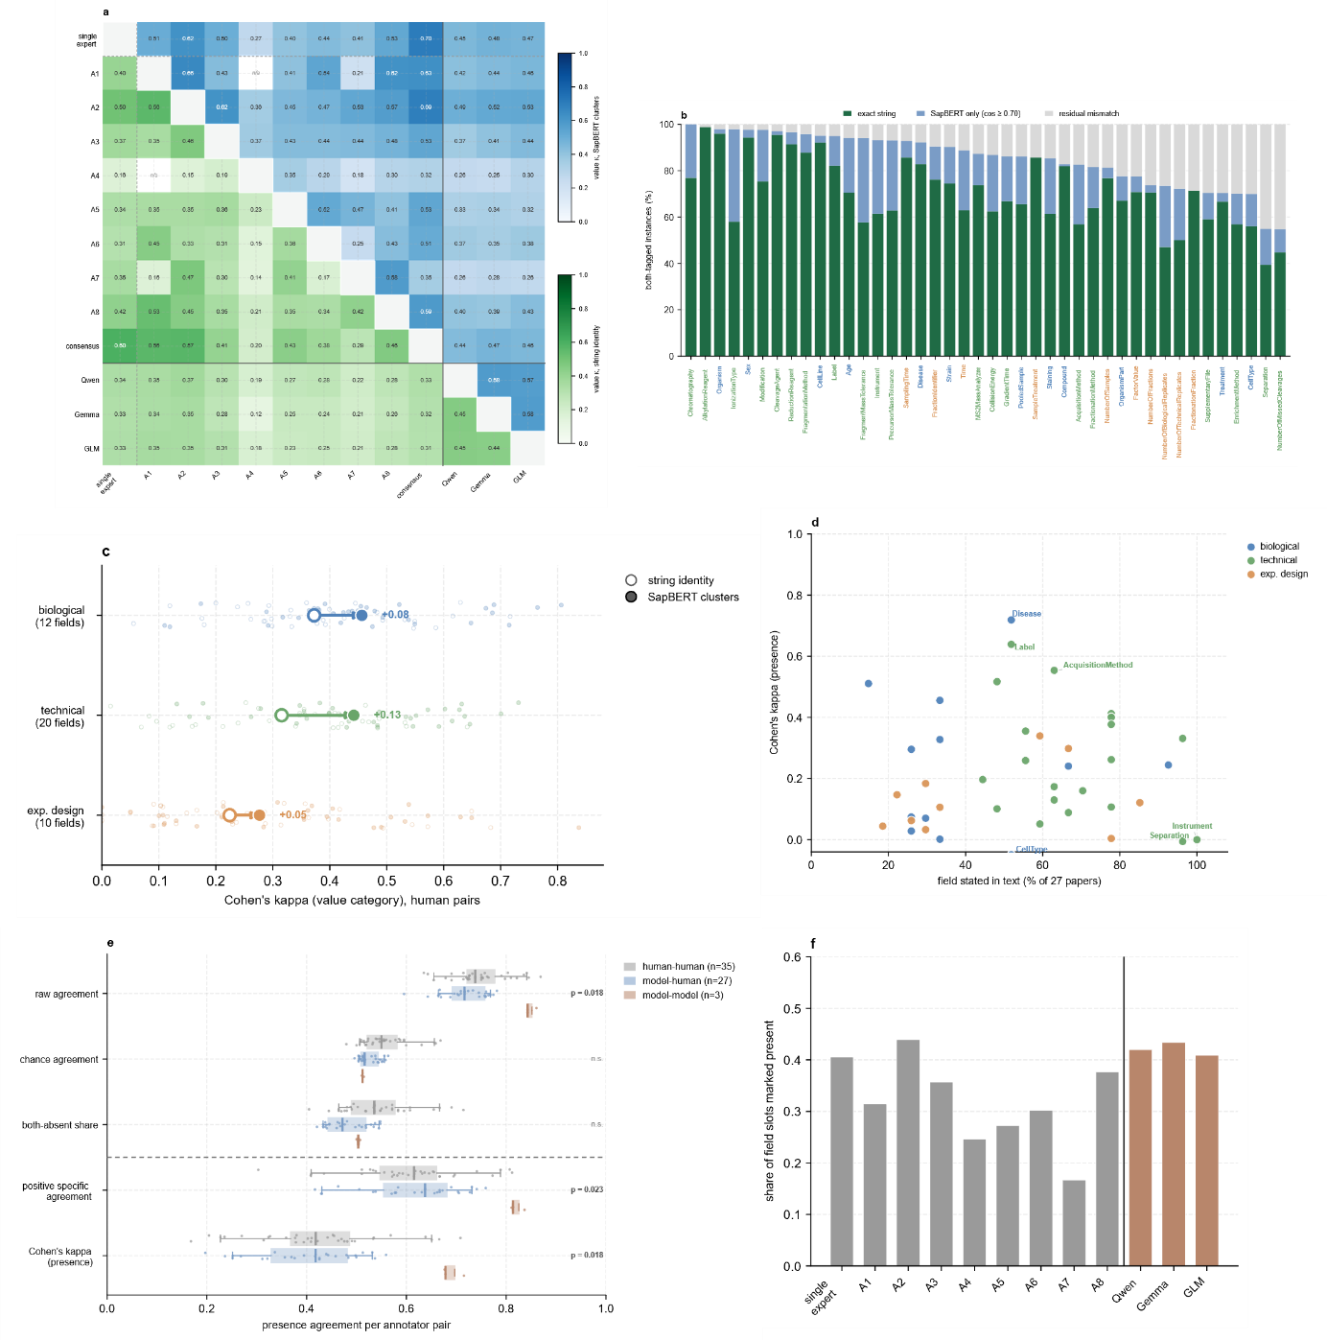Figure 1. Expert annotators agree only partially on proteomics metadata, and three models agree with each other more than with the experts. 27 manuscripts, 42 fields; nine human annotators (one expert covering all papers, A1–A8 covering overlapping batches), the harmonised consensus, and three models (Qwen3.8-27B, Gemma 4 31B, GLM-4.7). (a) Pairwise value-level Cohen's kappa for every identity. Lower triangle: values count as the same only if their strings are identical; upper triangle: values within SapBERT cosine 0.70 count as the same. Lines separate humans, consensus and models; n/a, no shared papers. (b) For instances tagged by both annotators of a pair (n = 8,286), share of values that are identical strings, matched only by SapBERT (cosine ≥ 0.70), or unmatched, per field; field names coloured by category. (c) Value-level kappa between human pairs per category under string identity (open) and SapBERT clusters (filled); large markers, category means with the shift; small points, individual pairs. (d) Presence kappa between human pairs per field against how often the field is stated coloured by category. (e) Decomposition of presence agreement per annotator pair, grouped as human–human, model–human and model–model: raw agreement, chance agreement and the share of slots both left empty (shares of every document × field slot; above the dashed line), positive specific agreement (share of slots at least one rater filled) and Cohen's kappa. p values, rater-level permutation test of model–model against human–human; n.s., not significant. (f) Share of document × field slots each rater marked as present; grey, humans; orange, models.

A grounded agentic framework for metadata extraction
The human annotation set out two main requirements for a reliable automated annotation approach: (i) it must be benchmarked against a human annotated ground-truth; and (ii) as disagreement often arises from wording rather than substance, it must be normalized to a controlled vocabulary. We designed HAMLET to address both requirements. HAMLET is an agentic pipeline that extracts experimental metadata directly from text. It reads a manuscript’s abstract, its materials and methods section, and the associated PRIDE project descriptor to output an SDRF-Proteomics file linked directly to the deposited raw files. Other manuscript sections are deliberately excluded, as these introduce confusion whenever the text compares or situates itself against other studies or experiments.
Three specialized agents, biological, technical and experimental design, handle this input under fixed prompts that supply definitions, extraction rules and explicit instructions. Three constraints limit hallucinations: (i) HAMLET does not allow reasoning; (ii) it also limits inference beyond what the text states; and (iii) it pairs every extracted entity with its supporting evidence for mechanical verification. Extracted entities are then normalized against nineteen SDRF-Proteomics-supported ontologies (including CL, UBERON, NCBITaxon, DOID, PSI-MS and ChEBI) using SapBERT²⁷ embeddings and FAISS nearest-neighbor search²⁸ through a hierarchy that ranges from exact string identity down to ontology-based semantic matches. This hierarchy later determines whether an extracted value is accepted, and at which tier, independently of whether the value itself turns out to be correct.
HAMLET returns structured JSON across 38 metadata fields through DocETL (four of the 42 entity types evaluated in the human-annotation benchmark were excluded here for insufficient coverage in the training coverage). Fields may hold several scientifically distinct values, each with its own evidence, and values are restricted to the deposited experiment itself rather than background or comparative context; missing information is recorded explicitly as unknown, and sample, replicate and fraction counts are never defaulted to one. A separate grounding check then verifies each value's evidence against the source text, reconciling minor typographical differences and flagging evidence that cannot be located, while a three-component quality-control layer checks ontology-supported consistency between biological fields, detects negated evidence with NegEx through negspacy, and verifies numerical agreement between values and their cited evidence. None of these checks establish that an extraction is wrong; they only flag it for review, and flagged values are retained alongside machine-readable diagnostics.

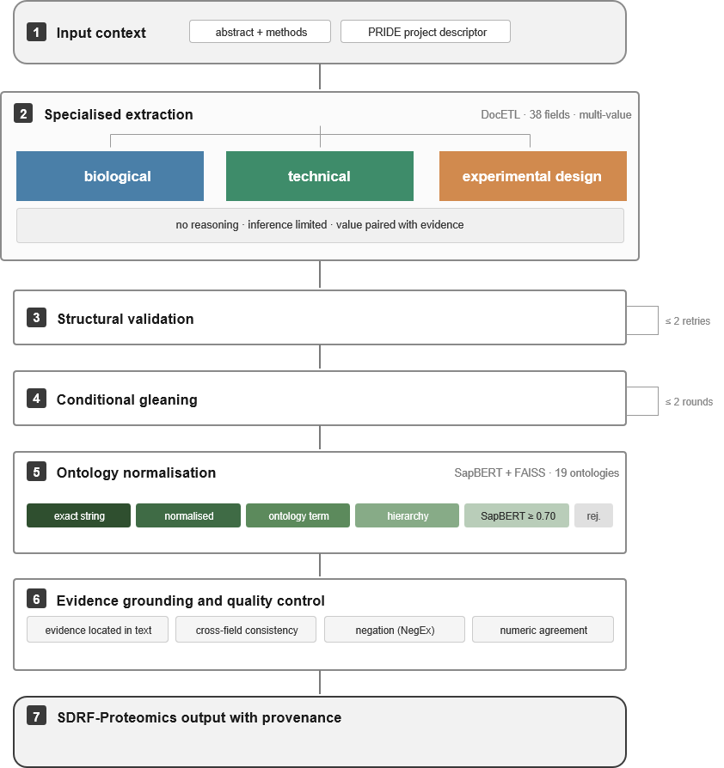
Figure 2. The HAMLET framework. Three specialist agents extract biological, technical and experimental design metadata across 38 fields from the manuscript abstract and methods section together with the PRIDE project descriptor, pairing every value with its supporting evidence span and recording absent information explicitly as unknown. Structural validation and conditional gleaning repair fields that are malformed or lack evidence, after which values are normalized against nineteen SDRF-Proteomics-supported ontologies through a five-tier matcher. Evidence grounding and quality control flag values for review rather than remove them. The output is an SDRF-Proteomics file linked to the deposited raw files, carrying for each value its evidence, ontology identifier, matching tier and quality-control flags.

The framework determines performance, not the model
Using 137 PRIDE datasets with SDRF-Proteomics annotations, prompts were optimized using an 80/20 train test split. Extractions were scored against the SDRF-Proteomics ground truth annotations along three complementary axes: (i) weighted F1, which rewards a value for matching the annotation itself; (ii) Lin information content (Lin IC), an ontology-anchored metric which scores the semantic distance between the extracted and annotated ontology terms and so gives partial credit for a near-miss within the same branch; and (iii) a decomposed matching hierarchy into five categories.
To locate where the pipeline earns its accuracy, we ran a cumulative ablation with three open-weight, locally deployable models (Qwen3.8-27B, Gemma 4 31B and GLM-4.7 32B), each repeated three times across six nested configurations: (i) a single master prompt producing bare extractions (S0); (ii) the same task split across three specialized agents (S1); (iii) the addition of field definitions, extraction rules, examples and an explicit unknown instruction (S2); (iv) structural validation with retries for unknowns (S3); (v) gleaning (S4); and (vi) ontology normalization (S5) (Fig. 3a). Once this structure was fixed, we separately benchmarked the complete framework across a wider set of open-weight and commercial models, to test whether the conclusion generalized.
At S0 the models diverge sharply on both F1 and Lin IC. This divergence closes by S2, where all three converge onto a common plateau that holds flat throughout validation, gleaning and normalization (Fig. 3a). The increased performance from S0 to S1 is mainly influenced by an increased recall due to a drop in the amount of unknown values being returned. Indeed, the single master prompt leaves between 30 to 80% of values unannotated, depending on the model (Fig. S1). The two consecutive ablation steps converts those silences into, mostly correct, values. Later stages add structure, validation and ontology-grounding, all essential for downstream usability but these do not change extraction nor further accuracy. This convergence appears across all metadata categories (Fig. 3b) but experimental design settles markedly lower. The acceptance tiers at S5 explain why this category-level gap persists (Fig. 3c), by decomposing F1 into how each ground truth value was accepted: exact string, ontology structure, semantic similarity or not at all. Biological and technical fields clear one of the accepted tiers for most ground truth values, leaving only a small residual of outright rejections. Experimental design fields match exactly as often as the other two classes but lose most of the remainder to rejection. This indicates that the values are impossible to accept and are not caused by different wording. The same acceptance pattern holds at the level of individual fields across the ablation arms (Fig. S2a). At S5, per-field accuracy can be compared directly against the human-agreement ceiling established in Fig. 1, field by field, and, for ontology-backed fields, against how far a value that was not an exact match actually sits from the correct term (Fig. S2b-c).
The framework impacts model behavior as much as accuracy. Under a single master prompt, the number of non-unknown values per dataset varies considerably, both between models and between repeated runs of the same model. Once agents are specialized, output volume roughly doubles at S1 and converges across models at S2 (Fig. 3d). Three-run reproducibility follows a similar path but converges less completely, rising steeply at the same step and in contrast to accuracy, this metric does not converge across models (Fig. 3e).
Benchmarked across six models on the same 30-PXD test set, the open-weights Gemma 4 31B reached an overall F1 close to the strongest model in the comparison, Claude Opus 4.5, and level with Gemini 3.5 Flash and Qwen 3.7 Max. Llama-4 Scout, by contrast, matched the top scorers on technical fields, trailed clearly on biological fields, and fell furthest behind on experimental design, the gap that pulled down its overall score. A locally deployable open-weights model therefore performs comparably to the commercial systems tested once placed inside the same grounded, validated framework, which supports the ablation result that the framework carries the performance. Qwen reached the same plateau as Gemma and GLM-4.7 from S2 onward (Fig. 3a) and was selected for large-scale processing, pairing competitive extraction performance with the cost advantage of local, open-weights deployment (Fig. 3a, f).
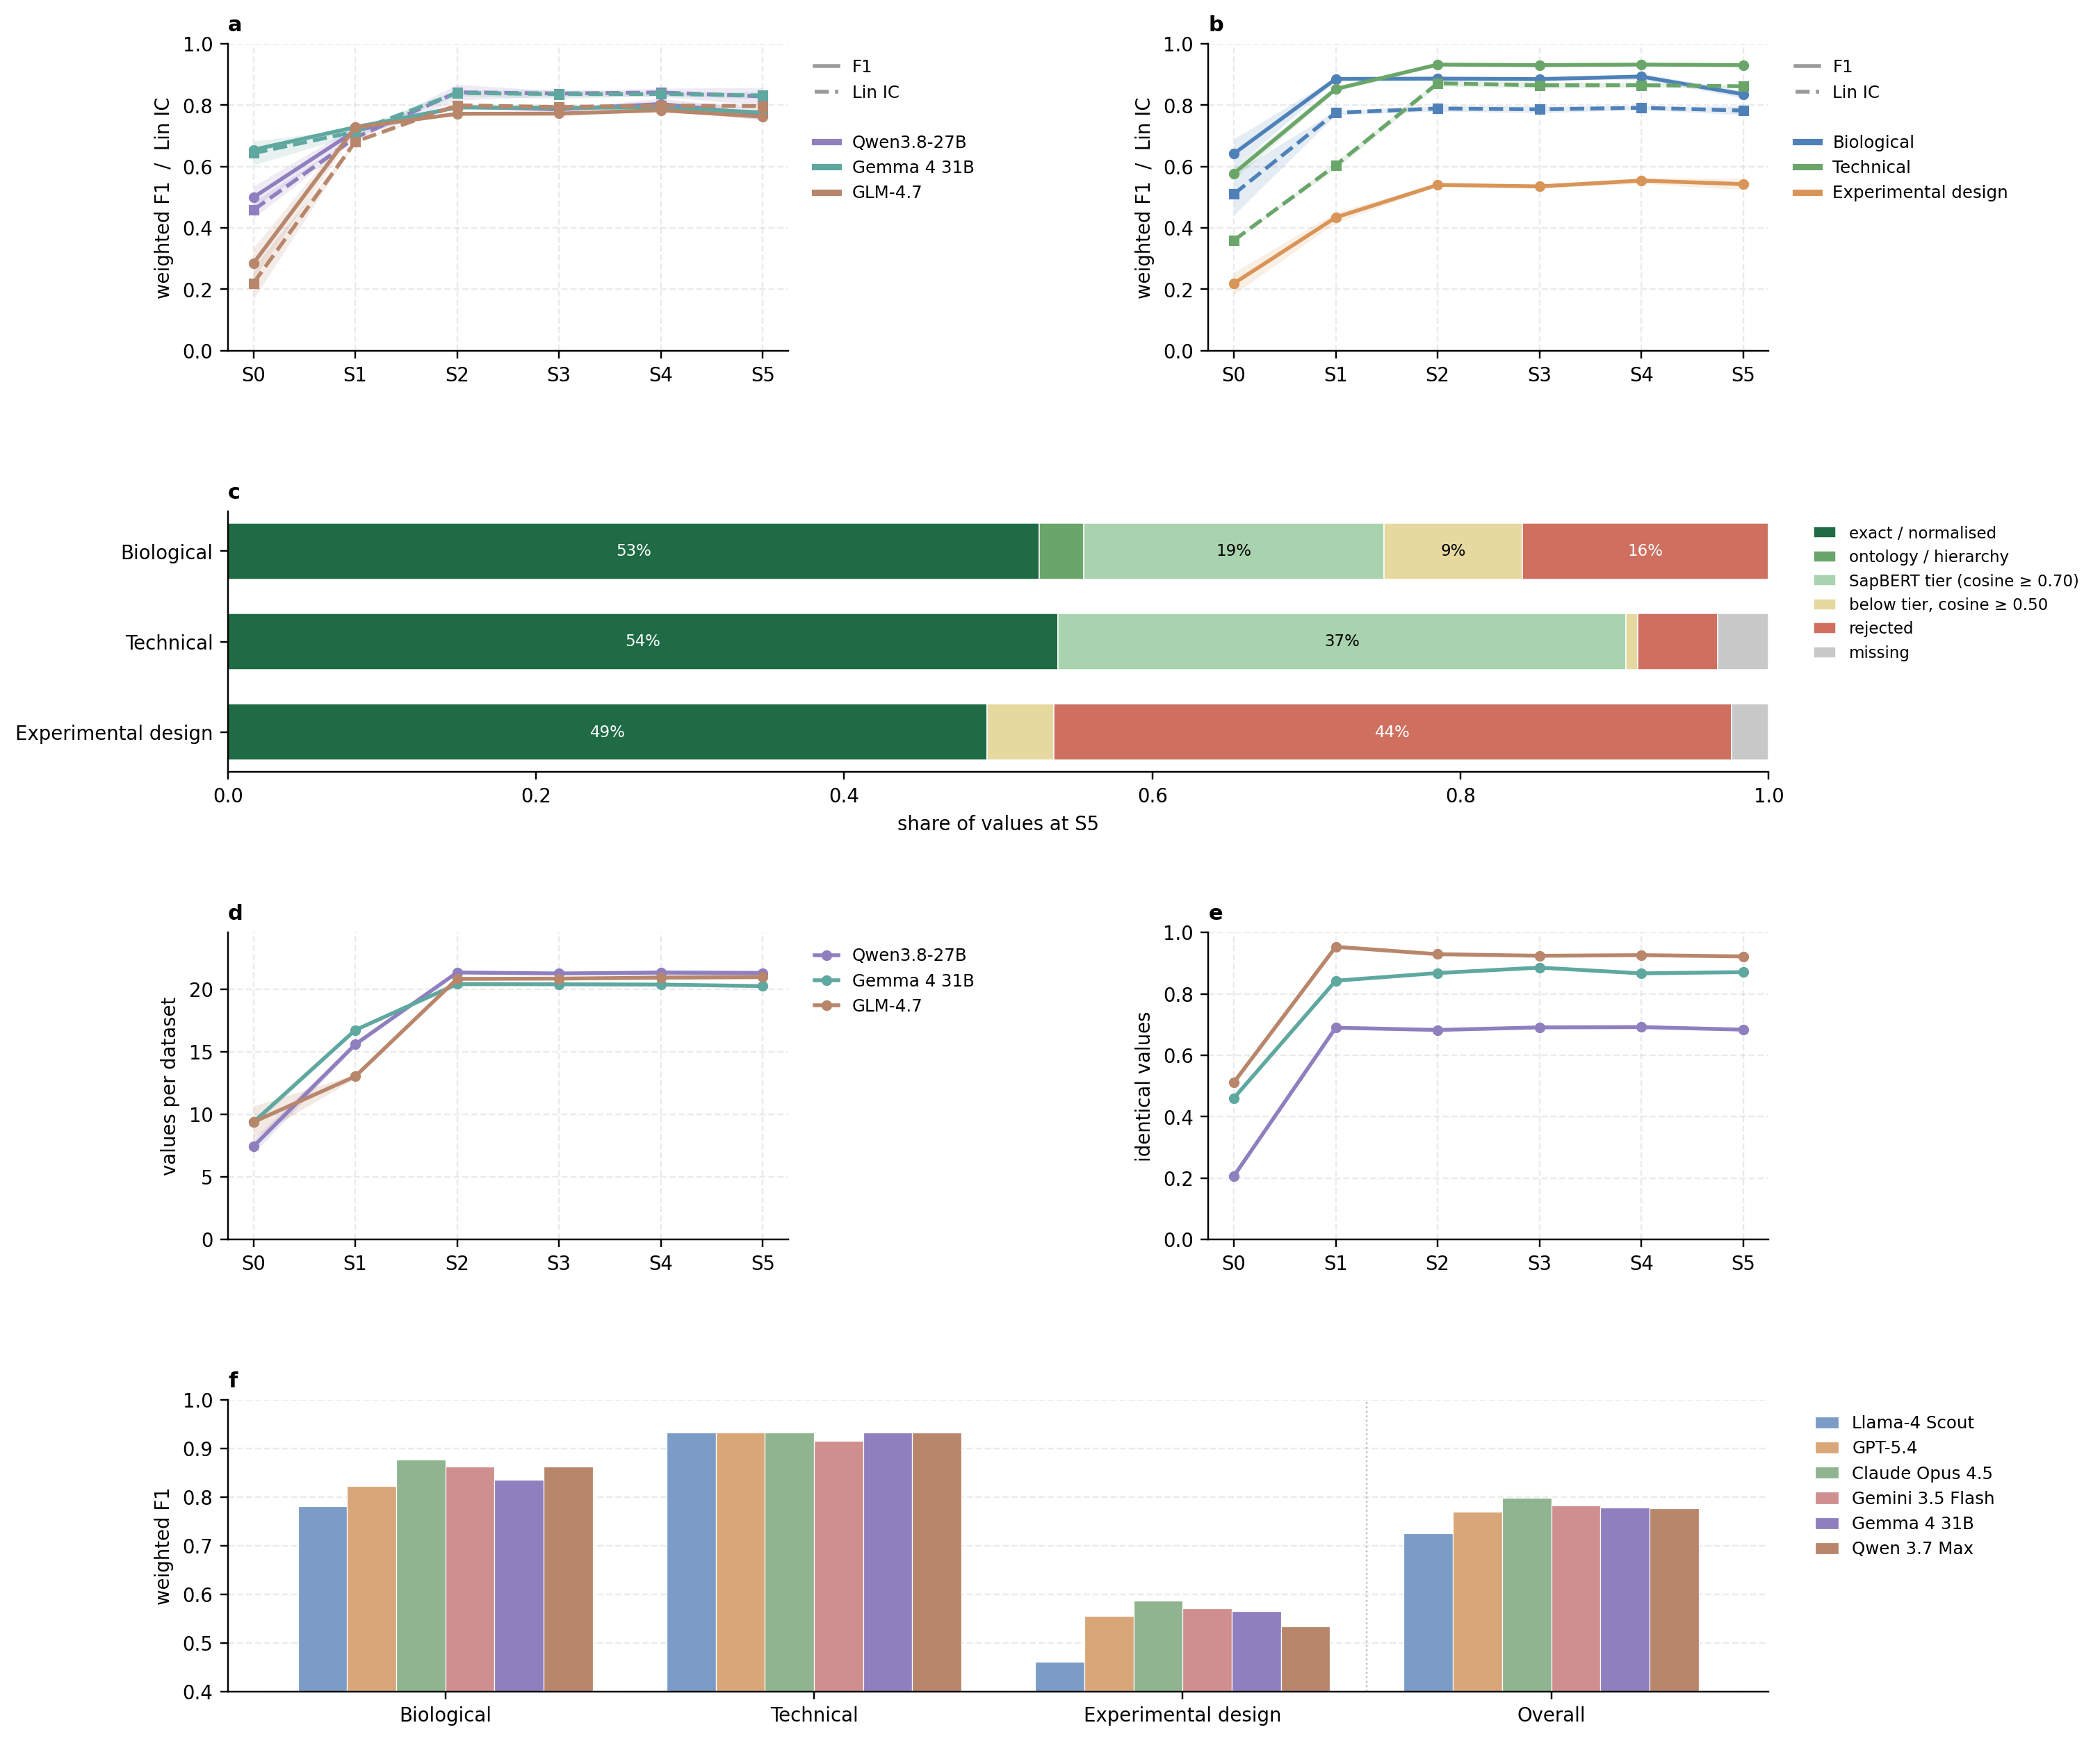
Figure 3. Cumulative ablation of the HAMLET framework on the 30-dataset test set.
Arms: S0 single master prompt; S1 three specialized agents; S2 + field definitions, rules and examples; S3 + structural validation with retries; S4 + gleaning; S5 + ontology normalization. Three inference runs per arm at temperature 0 for Qwen3.8-27B, Gemma 4 31B and GLM-4.7, scored against SDRF-derived ground truth with the five-tier matcher (numeric fields require equality). (a) Weighted F1 averaged over the three agents (solid) and mean Lin similarity on the ontology-backed fields (dashed), per model; bands, ± SD over runs. (b) The same per agent, averaged over models; bands, ± SD over runs. Experimental design has no ontology-backed field and no Lin curve. (c) How the ground truth values are matched at S5, pooled over models and runs: exact or normalized string, ontology or hierarchy match, SapBERT cosine ≥ 0.70, accepted below that tier at cosine ≥ 0.50, rejected, or missing from the output. (d) Non-unknown values per dataset (mean ± SD over runs). (e) Share of dataset–field slots with identical values in all three runs. (f) weighted F1 score of six open and closed source models against ground truth on the same test set using the full HAMLET framework (S5).

Dataset descriptors are essential to navigate the closed-access gap
We selected 1,736 human PRIDE datasets and processed these with HAMLET, using Qwen3.8 for production. Although Gemma reached similar performance (Fig 3a), it proved unreliable in development, so Qwen was used for the full corpus. Each dataset was annotated from three different sources: (i) manuscript text alone; (ii) PRIDE project descriptor alone, and (iii) both combined. The manuscript input consisted of abstract and methods section where accessible, or the abstract alone otherwise. This split the corpus into a closed-access group (abstract only, n = 1,135) and an open-access group (abstract plus methods, n = 601). This design isolates a direct question: what does the published article add over the deposited record, field by field, and does the answer depend on whether the article itself can be read.
Coverage followed a consistent, asymmetric pattern (Fig. 4a-c). For closed-access datasets, the descriptor alone populated two to three times as many fields and values as the abstract alone. For open-access manuscripts the balance shifted: manuscript text, now including the methods section, populated more than the descriptor alone, though the descriptor still recovers a handful of unique fields not present within the manuscript. On average the combined input populated more fields than either source alone in both groups, so manuscript and descriptor content are complementary, although individual datasets can lose fields because each condition is an independent extraction. What each information source contributes is genuinely different (Fig 4d.). In the closed-access group the descriptor supplies the bulk of populated technical and experimental design fields on its own, against a minority of biological fields. Indeed, the deposited record carries the technical layer almost single-handedly, as well as most of the experimental design layer, while biology instead is largely shared. In the open-access group, the descriptor’s contribution shrinks and most entities are covered by both inputs. Coverage alone, however, says nothing about whether the two sources agree on the values they both supply. Tiering those shared fields with the HAMLET matcher shows that agreement is weakest for technical and experimental design entities, a trend exaggerated by the absence of an open access publication. So even where both sources describe the same field, written by the same authors, they still often diverge on a substantial share of what they report. Decomposed by field, this disagreement is concentrated in specific entities, with integer counts agreeing in the majority of cases and genuine contradiction sitting almost entirely in free text and dataset specific fields such as factor value, enrichment and ionization type (Fig. S3). PRIDE descriptors therefore provide a fallback for closed-access papers, but only partially: (i) they mostly provide technical annotation; (ii) they lack experimental design annotation, and (iii) the two sources contradict each other most for technical and experimental design fields, especially when the article is closed access.
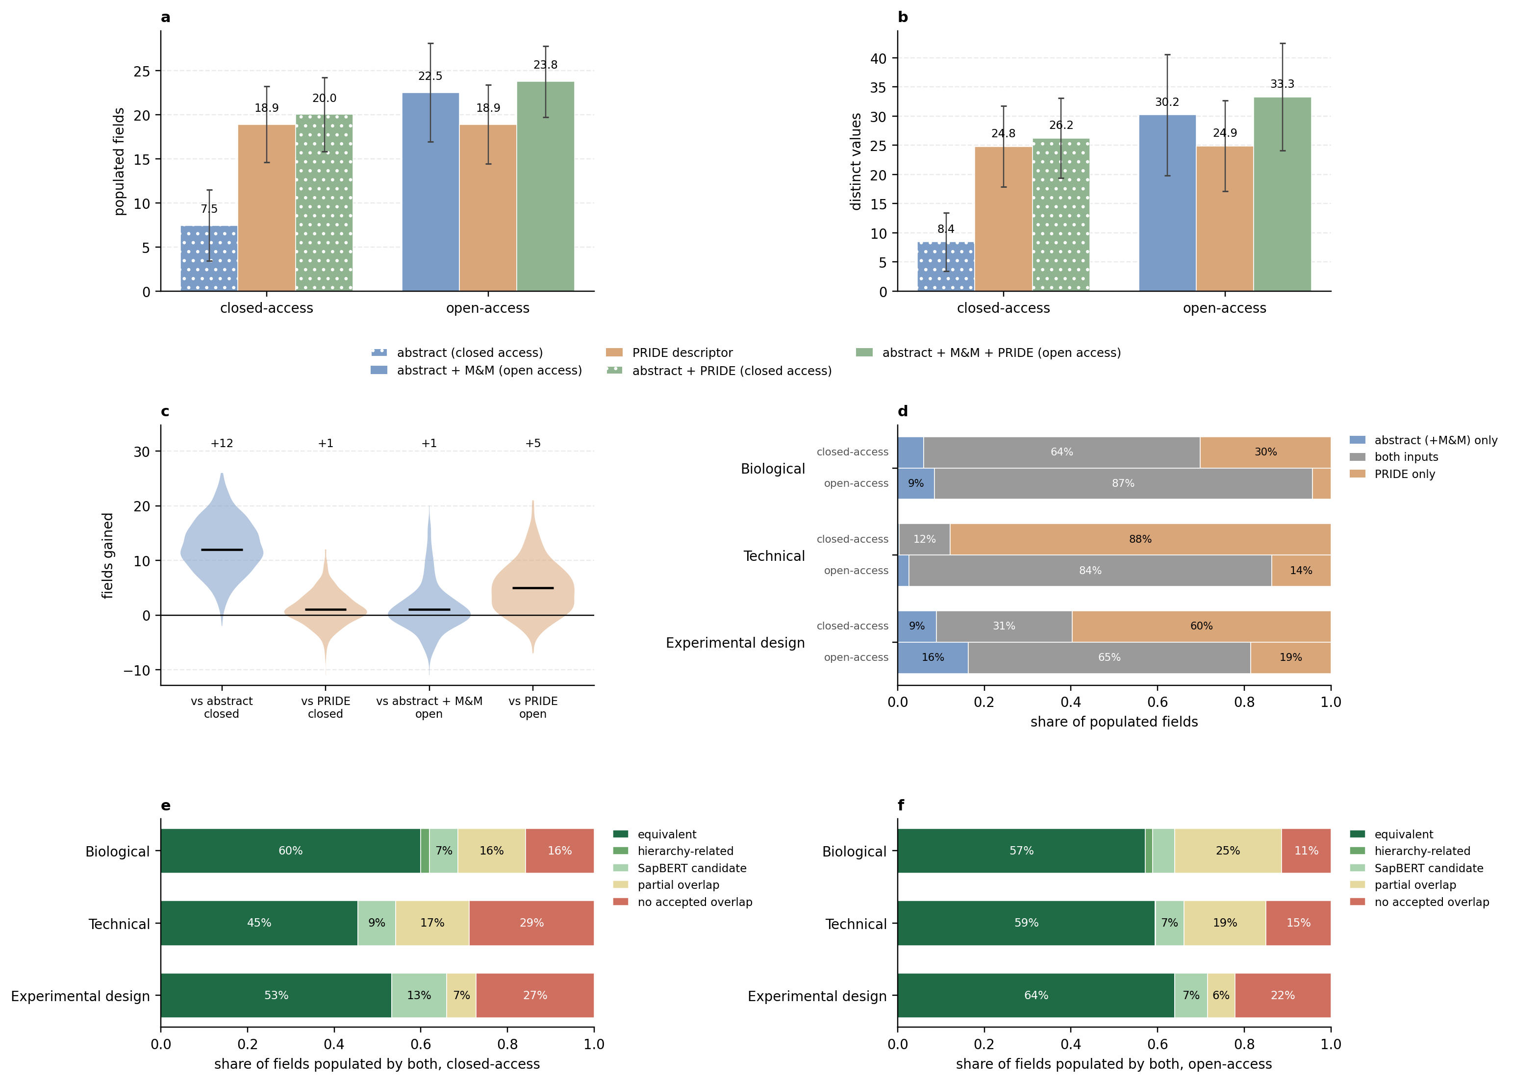
Figure 4. What the deposited PRIDE record adds to the article, across 1,736 datasets.
Three HAMLET extractions per dataset: manuscript text only (abstract, plus methods where available), PRIDE project descriptors only, and both combined; datasets split by whether a methods section could be extracted (closed-access: abstract only, n = 1,135; open-access: n = 601). (a, b) Populated fields and distinct values per dataset for each input (mean ± SD). (c) Per-dataset difference in populated fields between the combined input and each single input; numbers are medians. Negative values arise because each condition is an independent extraction. (d) Share of populated (field, dataset) slots per agent supplied by the manuscript run only, by both runs, or by the descriptor-augmented run only, for closed- and open-access datasets. (e, f) Fields populated by both runs, tiered by the HAMLET matcher for closed-access (e) and open-access (f) datasets.

File-level tissue annotation with MLMarker
HAMLET annotates uniformly at the level of the project, but the raw files deposited under it are rarely homogenous. Indeed, a single dataset routinely bundles several tissues and experimental conditions, and the text rarely states which file is which. Project-level metadata therefore carries an ambiguity that no improvement in extraction can remove. Within the corpus, most of this ambiguity concentrates in three technical entities namely: instrument, acquisition method and cleavage agent, with the remainder spread across a handful of biological entities predominantly: cell type, disease state, cell line and tissue (Supplementary Table 1). Technical entities can often be recovered post-hoc from the raw data using extraction tools^{29–31}, but biological entities carry no such fallback: nothing in a run itself states what tissue or disease state produced it, so using the raw data itself or a classifier predicting biological identity from expression alone is a valuable route to file-level disambiguation. Tissue is the one biological entity for which such a classifier already exists and is validated. MLMarker⁹, trained on healthy human tissue, predicts tissue of origin from a run's protein abundance alone, independent of HAMLET's manuscript-derived call and without retraining. The ambiguity it addresses is substantial: of the 1,736 annotated datasets, 1,409 include human runs: 857 name exactly one tissue, 371 name none at all, and 181 list several candidates (Supplementary Table 2).
We applied MLMarker across all reprocessed runs, retaining for comparison those carrying both a HAMLET tissue annotation and an MLMarker prediction. Because the two labels come from independent evidence, one from what the authors wrote, the other from what the instrument measured, agreement between them is a meaningful check. Agreement is strong overall and depends heavily on how much of MLMarker’s feature space is covered in a run. Indeed, because the classifier predicts from a fixed protein set, low coverage leaves it little to work with. Restricting to healthy, native human runs where HAMLET names a single tissue, and excluding projects in MLMarker's own training set, we compared the two labels by Lin IC (Fig. 5a). High coverage samples usually have exact or closely related agreement. Nearly all disagreements involve a HAMLET tissue, often a biofluid, with no counterpart in MLMarker’s trained classes which makes agreement impossible by construction rather than mistaken prediction. Low coverage samples show a drop in agreement, a trend mirrored in the drop of MLMarker’s own reported confidence (Fig 5b). Both similarity and exact-match rate rise steeply with its top-class probability. Coverage and confidence are therefore both informative, externally validated signals of when MLMarker's call can be trusted.
This pays off directly for the multi-tissue projects, a subset of which carries enough usable, non-biofluid files to be resolved (Fig. 5c). MLMarker's top prediction matches one of HAMLET's candidates for most of these files, and a candidate appears among its next few ranked predictions for nearly all the remainder, leaving only a small share unresolved. Six representative projects illustrate this resolution directly, spanning cases with and without run-level ground truth and cases inside MLMarker's training set (Fig. S4). Raw-file classification can therefore mitigate project-level tissue ambiguity in most cases, even where the manuscript itself leaves the question open. Remarkably, agreement also separates cleanly by disease status (Fig. 5d). Among well-covered runs, similarity between the two labels is high and tightly clustered for healthy native tissue, but markedly lower and more scattered for cancer or diseased tissue. This does not point to wrongful HAMLET annotation but rather to MLMarker's reference atlas being built from healthy tissue, and the tendency of a malignant or otherwise altered proteome to diverge enough from its healthy tissue of origin to reduce agreement even where the manuscript-derived label is correct.

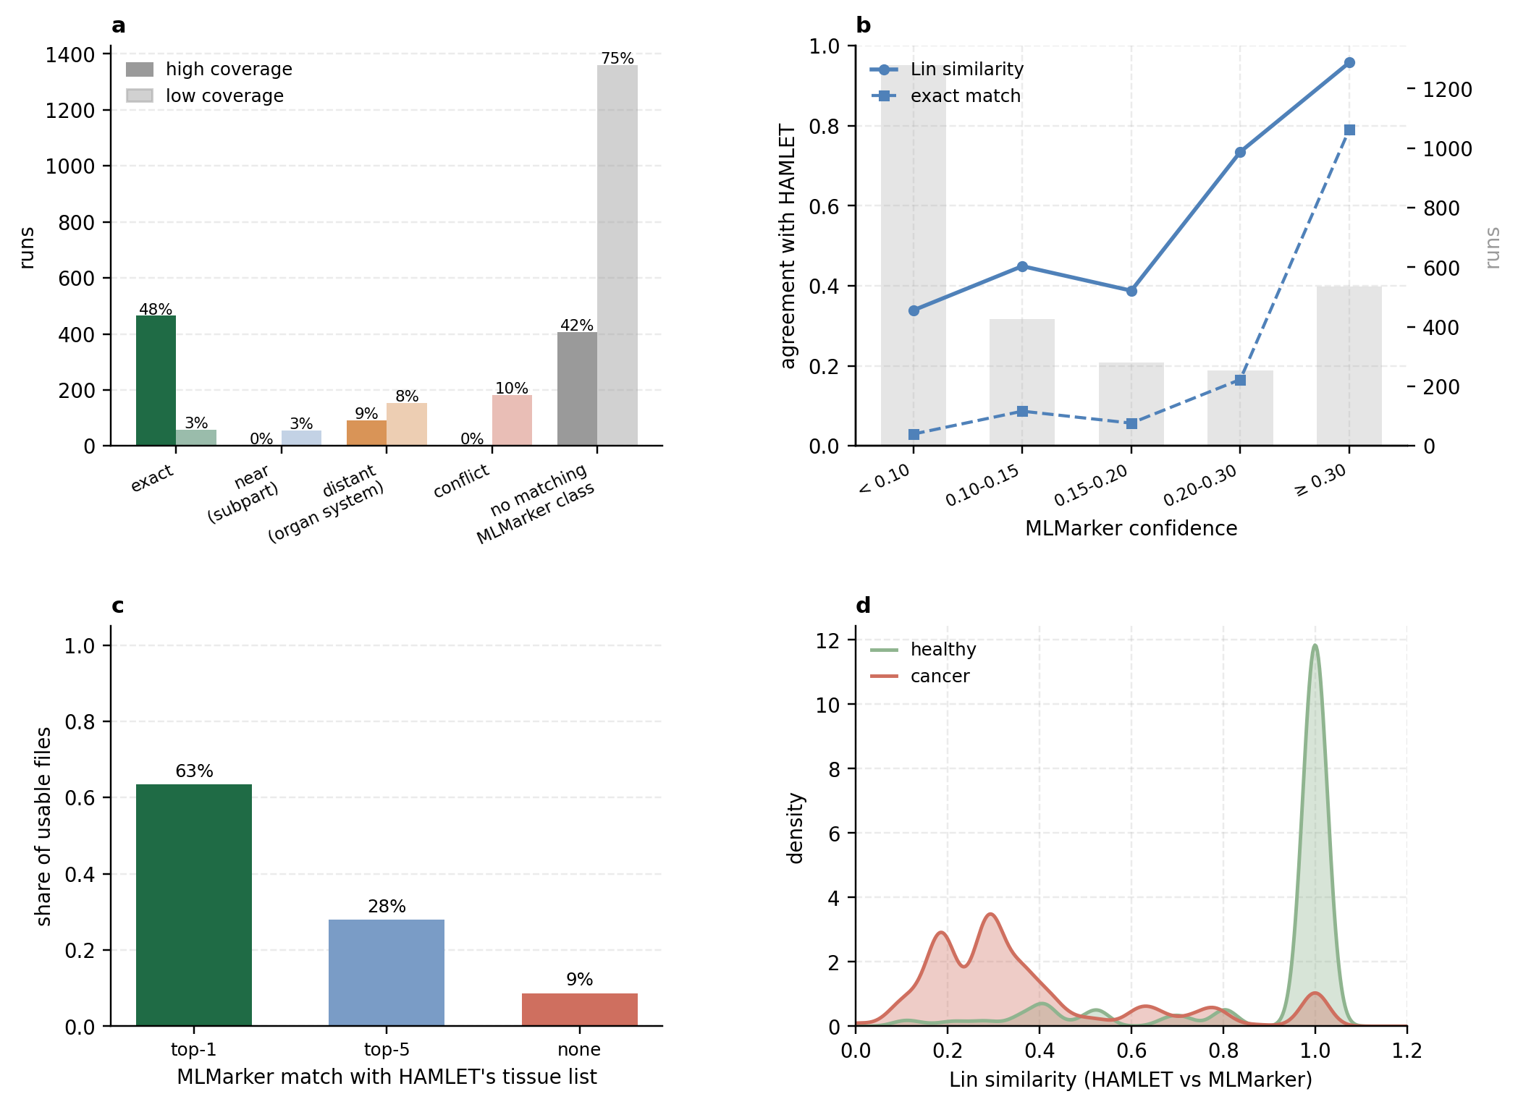
Figure 5. MLMarker confirms and refines HAMLET's project-level tissue annotation at the level of individual raw files. (a) Agreement between HAMLET's tissue annotation and MLMarker's per-file prediction for healthy, native human runs where HAMLET names a single tissue (n = 2,775). Runs are tiered by ontology distance between the two labels based on their Lin similarity score: exact (same UBERON/CL term), near (Lin ≥ 0.7), subpart (0.35 ≤ Lin < 0.7), distant (0.01 ≤ Lin < 0.35), conflict (Lin < 0.01), or no matching MLMarker class. The last tier contains runs whose HAMLET tissue lies outside MLMarker's 34 classes and cannot be matched by construction; it includes the biofluid runs (plasma, serum, cerebrospinal fluid, urine and similar; 1,343 runs), for which MLMarker has no class at all. Dark bars, runs in which at least 10% of MLMarker's feature proteins were detected (high coverage, n = 967); light bars, runs below that threshold (n = 1,808). Percentages are within each coverage group. (b) Calibration of MLMarker's confidence (probability of the top class) on the same runs with a matchable tissue: mean Lin similarity (solid) and exact-match rate (dashed) between the two labels per confidence bin; grey bars, number of runs per bin (right axis). (c) Projects for which HAMLET lists several candidate tissues (9 projects, 473 usable files): share of files whose MLMarker top-1 prediction is one of HAMLET's candidates (top-1), whose top-1 lies outside the list but a candidate appears at rank 2–5 (top-5), or for which no candidate appears in the top five (none). Restricting projects outside MLMarker's training set gives 59%, 33% and 8% over 133 files. (d) Distribution of Lin similarity between HAMLET's tissue and MLMarker's prediction for high-coverage runs from healthy native tissue (green, n = 823; mean 0.90) and from cancer or diseased tissue (red, n = 8,116; mean 0.38), kernel density estimates.

Discussion & conclusion
In this work, we introduce HAMLET, a Harmonized Agentic Metadata Literature Extraction Tool. Our central finding is that extraction accuracy is determined by the framework and not the model capability. Once specialized agents work under fixed definitions, performance converges to a common plateau regardless of the underlying model, both in the controlled ablation and the wider six-model benchmark, where open-weights models match the strongest commercial systems. This solidifies that a community resource for metadata extraction can rely on open, local deployment, removing the per-call cost that archive-scale processing would otherwise require.
That conclusion should be read against the ceiling human annotation establishes. Expert annotators agreed with one another at a mean kappa of only 0.41-0.45, so the single SDRF-Proteomics reference HAMLET is scored against, is itself one reasonable annotation among several equally qualified experts would produce. Any accuracy we report is therefore bound by that reference and a higher score means closer agreement with one particular annotation rather than a more accurate reading of the text. The models, meanwhile, agree with each other more closely than the experts do. This is an advantage and a limitation at once: automated annotation is more reproducible than expert annotation, which matters for any resource built at scale, but reproducibility is not accuracy, and models converging on a single reading is no evidence that that reading is correct. Within that same evaluation, one weakness recurs across three independent analyses: experimental design fields show the lowest human agreement, the lowest acceptance-tier recovery in the ablation, and the largest unmatched share between manuscript and PRIDE extractions. That convergence is strong evidence of a structural limitation. Experimental design details are often written ambiguously, left to be inferred rather than stated as a clean, extractable value. Embeddings offer little further help here as these fields are predominantly numeric rather than ontology-anchored. One plausible route forward to address both limitations is the usage of references independent of human reading such as instrument recorded information in the acquisition files or tissue predicted from an expression profile, as used here, combined with more agentic reasoning than the current framework permits.
Using tissue prediction with MLMarker allowed us to move from project level to raw file level annotation. However, this approach has two limits: vocabulary and distribution. Application of the model on unseen tissue classes or disease states results in low prediction performance. Both are limits of the classifier rather than of the approach itself. The growing volume of annotated public data makes it increasingly feasible to train predictors that are both broader in scope, covering entities beyond tissue, and deeper within it, distinguishing diseased from healthy states.
Taken together, these results show that annotating public proteomics data at scale, in a way that can actually be trusted, is feasible. That trust cannot come from prompting a general-purpose assistant against a manuscript with no fixed schema, no evidence grounding, and no characterized failure rate. An approach our ablation shows produces answers that look plausible, are frequently wrong, and vary between runs. The underlying principle is that wrong metadata is worse than missing metadata: missing metadata visibly demands caution, while a wrong entry is silently indistinguishable from a correct one. HAMLET is designed around that principle, which is why nothing is defaulted, disagreement is flagged rather than resolved by guessing, and every value carries the evidence it was drawn from. As a community, we should treat metadata with the same care as the data it accompanies, and as repositories absorb a growing share of automated annotation, agentic and author-submitted values need to remain clearly distinguishable rather than folded silently into the same fields.
The more fundamental limit, however, sits earlier than any agent or classifier can reach. While extraction can recover what has been written down, it cannot recover what never was. For the archive as it exists today, that recovery is genuinely valuable and HAMLET makes it available at a scale manual curation cannot reach. Going forward, the more durable fix remains that authors clearly state their metadata in structured, standardized form at the point of submission, because a detail as basic as replicate structure, if it appears nowhere at all, is unrecoverable by any method on offer. Metadata that is written down once, properly, will easily outlast any tool built to recover it.

Materials and Methods

Dataset identification and input preparation
HAMLET processes proteomics datasets identified by their ProteomeXchange accession numbers (PXD identifiers). These identifiers were retained throughout input preparation, extraction and postprocessing to associate the generated metadata with the corresponding PRIDE projects.
The production corpus comprised 1,736 datasets. Input text was assembled from abstract text, available materials and methods, PRIDE project properties, and available PRIDE sample- and data-processing protocols. The input-preparation script preferentially selected a PubMed abstract when available and otherwise used the abstract section supplied through PRIDE. The preparation manifest recorded 296 PubMed-sourced and 1,441 PRIDE-sourced abstracts. Extracted methods were available for 601 datasets; the remaining 1,136 datasets lacked methods in the prepared input. This classification describes input availability rather than the absence of methods from the published article.
Text was parsed using explicit section boundaries and assembled into separately labelled blocks. Introduction, results, supplementary text and pre-existing SDRF summaries were excluded from the prepared extraction input. PRIDE project properties included organism, organism part, disease, instrument, modification, experiment type, quantification and keyword descriptors where available. Sample- and data-processing protocols were each available for 1,727 datasets. Explicit missing-value markers were treated as unavailable text rather than included as substantive evidence.
A preparation manifest recorded the accession, input paths, abstract provenance, section availability and section lengths. For the source-comparison experiments, input hashes were additionally retained to verify that the intended source blocks were preserved.

Agent-based metadata extraction
Extraction was implemented using DocETL and three specialized agents addressing biological characteristics, mass-spectrometry procedures and experimental design. Together, the agents targeted 38 predefined metadata fields. Biological fields described characteristics such as species, tissue, cell type, cell line and disease state. Technical fields described instrumentation, acquisition, sample preparation, labelling and modifications. Experimental-design fields described study comparisons, experimental factors and sample, replicate and fraction counts.
Each agent used a fixed prompt specifying field definitions, extraction scope, evidence requirements and the expected output structure. Prompts instructed the model to extract information relevant to the deposited proteomics experiment and to exclude entities mentioned solely as background, biological motivation or descriptions of unrelated experiments. Inference was restricted to circumstances explicitly permitted by the field instructions; it was not treated as unrestricted completion of missing metadata.
The production multi-value format represented each field as a list of objects containing a value and its supporting evidence. Scientifically distinct values were represented separately, allowing heterogeneous datasets to retain multiple organisms, tissues, instruments or experimental conditions. Unsupported or unavailable information was represented as {"value": "unknown", "evidence": ""}.
PRIDE properties were treated by the prompts as dataset-level descriptors. The prompts specified how these descriptors should populate the extraction schema and distinguished anatomical regions, biological cell populations, named cell lines and sample materials. Every extracted value was required to have its own evidence. For PRIDE property-derived values, the production prompt requested the complete corresponding property line.

Model inference and execution
For the production runs and source-comparison experiments described here, Qwen was served locally through vLLM using the recorded model identifier Qwen/Qwen3.8-27B. Inference used the vLLM 0.27.1 container with model weights loaded in BF16 precision without quantization. Each model server used one NVIDIA B300 GPU, a tensor-parallel size of one, a maximum sequence length of 65,536 tokens and a GPU-memory-utilization setting of 0.70. Model loading occupied approximately 51.1 GiB of GPU memory, excluding additional memory required for the key-value cache and runtime overhead.
The corpus of 1,736 projects was partitioned into eight shards of 217-218 projects. Independent model servers processed the shards, with biological, technical and experimental-design extraction executed within each shard. Production tasks were scheduled at staggered times, whereas the source-comparison experiments allocated eight GPUs concurrently. Production tasks reserved 32 CPU units and 256 GiB of host memory per server; the eight-worker source-comparison jobs reserved 96 CPU units and 2 TiB of host memory in total. These allocations describe the tested configurations rather than minimum hardware requirements. Model snapshots, extraction prompts and configuration files were retained for reproducibility. The manuscript-input and PRIDE-only conditions used copies of the same frozen production pipeline.
The standard DocETL request timeout was 600 seconds, with automatic timeout retries disabled at that level. Targeted repair runs used an existing configuration with a 1,800-second timeout. These settings governed execution and recovery; they were not used as criteria for accepting an extracted value.
The manuscript-plus-PRIDE production run consumed 4.20 allocated B300 GPU-hours, including targeted recovery jobs. The interval from the first task starting to the final recovery task completing was 5 h 14 min, including gaps between scheduled tasks. The completed run produced 5,211 raw and 5,211 normalized agent outputs across all 1,736 projects. In the five initially complete shards with retained phase timings, server startup required 232–273 seconds and subsequent extraction, normalization and output auditing required 741–1,638 seconds per shard.
For the manuscript-only control, the eight-GPU main job lasted 32 min 01 s. Nine missing agent records were subsequently recovered from cached model responses without additional inference in a CPU job lasting 2 min 15 s. Including the intervening scheduling gap, completion took 56 min 08 s. Reported runtimes exclude initial model downloads, ontology retrieval and index construction, input preparation and downstream benchmark scoring

Ontology normalization
Extracted values were normalized using field-specific ontology mappings. The configured resources comprised 19 ontologies or controlled vocabularies, including CL, CLO, UBERON, a curated NCBITaxon-derived species subset, DOID, Mondo, PSI-MS, UNIMOD, ChEBI, EFO and additional domain-specific resources.
Normalization first evaluated deterministic lexical matches within the requested ontology namespace. Unambiguous primary-label matches took precedence over synonym matches. Exact or explicitly curated synonyms could also support deterministic normalization. Ambiguous labels and related synonyms were distinguished from unambiguous equivalence rather than automatically assigned to a single concept.
Values requiring embedding-based resolution were represented using cambridgeltl/SapBERT-from-PubMedBERT-fulltext. Text was tokenized with a maximum length of 128 tokens, and the final-layer [CLS] representation was L2-normalized. FAISS indices supported nearest-neighbour retrieval against ontology labels and indexed synonyms. The configured retrieval size was five candidates, with a similarity threshold of 0.70.
Normalization retained the original extracted value alongside the ontology identifier, preferred label, similarity information and diagnostic metadata. Raw and normalized outputs were stored separately to preserve traceability and permit inspection of normalization decisions.

Evidence grounding and quality control
Evidence quotations were checked against the prepared input text. Where possible, minor typographical differences were reconciled to the corresponding source span. Known values with missing evidence, or quotations that could not be grounded to the input, received explicit diagnostic flags. Inferred values were distinguished by an inferred: prefix followed by supporting source text.
Three complementary checks assessed potential inconsistencies. First, ontology-supported cross-field checks evaluated biological relationships, including consistency between cell lines and species and between cellular, disease and anatomical annotations. Second, a NegEx-based detector implemented through negspacy identified potentially negated evidence. Third, numerical checks compared extracted quantities with the values appearing in their evidence.
Diagnostic flags were retained with the annotations rather than used to delete flagged values automatically. They therefore identified records requiring review without treating every flagged extraction as demonstrably incorrect.

Output auditing and recovery
Mandatory QC resources were checked before extraction. Production outputs were subsequently audited for expected dataset coverage, required schemas, evidence-grounding issues and preservation of multi-value entries during normalization. Runs with missing required outputs were not marked as complete.
When requests timed out, cached responses were inspected before new inference was attempted. Recoverable responses were associated with their original inputs and prompts using exact request-cache keys. Recovered responses underwent the same evidence processing, confidence assessment, normalization and QC as normally exported responses. Only missing output files were added; completed annotations were preserved.

Comparison of input sources
The contribution of different input components was evaluated using three conditions: abstract plus available methods; PRIDE project properties and available processing protocols alone; and both components combined. Source-specific inputs were generated by retaining or removing complete labelled blocks from the same prepared documents. The abstract-plus-methods condition contained no PRIDE property or protocol blocks, although its abstract text could originate from PRIDE as described above.
Coverage was measured as the number of populated metadata fields and the number of distinct values within fields per dataset. Unknown values were excluded. Multiple values within a field increased the distinct-value count but contributed only one populated field. Means were calculated separately for datasets with and without methods. Combined-input outputs were treated as independent extractions, not as the calculated union of the source-specific outputs.
For the abstract-plus-methods versus combined-input comparison, field overlap distinguished shared populated fields from fields populated in only one condition. Within shared fields, values were compared using one-to-one matching. Lexical, numeric and unambiguous ontology equivalence were distinguished from broader–narrower ontology relationships and SapBERT semantic candidates. Hierarchical comparisons traversed up to four is_a edges; semantic candidates required cosine similarity of at least 0.70. Partial overlap and absence of accepted overlap were reported separately. Neither extraction was treated as ground truth, and coverage or agreement was not interpreted as an accuracy estimate.

Expert annotation
Twenty-seven open-access manuscripts were annotated in brat by nine EuBIC-MS annotators: one expert covering all 27 papers and eight annotators covering overlapping batches, plus a curated consensus per paper. The three models annotated the same abstract-plus-methods text in the S0 single-prompt configuration (Section 9). Of 68 raw entity labels, 42 were retained: tagged by the consensus in at least three papers and by at least two distinct annotators. Presence agreement was Cohen's kappa on binary per-paper, per-label indicators over the papers a pair shared. Because most slots are empty, kappa was decomposed into raw agreement, chance agreement, the both-absent share and positive specific agreement (2·n11/(2·n11+n10+n01)); model–model against human–human differences were tested by an exact permutation over which raters are models (C(12,3) = 220 assignments). Value-level agreement used two schemes: exact string identity, and clusters of values within SapBERT cosine 0.70. The threshold was taken from the normaliser rather than tuned; on a negative control of 88,226 value pairs from unrelated fields SapBERT never exceeded 0.49, whereas mean-pooled SciBERT reached 0.70 on 18.2% of them, which is why SciBERT was replaced throughout. Rarity was the share of papers in which the consensus stated the field; its relation to difficulty was tested by Spearman correlation over human pairs.

Benchmark ground truth and matching
Prompts were developed on 107 datasets with community SDRF-Proteomics files and evaluated on 30 held-out datasets. Ground truth values were derived per agent and field from the SDRF (12 datasets) or from curated annotation files in the same schema (18 datasets); taxon-identifier prefixes in organism values were stripped during conversion. Six fields not reported in the manuscript (material type, PTM, technology type, developmental stage, ethnicity, mass analyser) were excluded, leaving 16 fields and 179 ground truth values per run.
Each extracted value was compared with its ground truth ground truth value by a five-level matcher: exact string; normalised string (case and trademark symbols); identical ontology term; ancestor–descendant relation within four is_a edges in CL or UBERON; SapBERT cosine ≥ 0.70. Numeric fields (replicate, sample and fraction counts, collision energy) were compared as numbers and accepted only when equal, because SapBERT places unrelated small integers above the semantic threshold. Multi-valued fields were scored per ground truth ground truth value against the best extracted value, averaged. A ground truth value counted as a true positive when an extracted value was present and its match score reached 0.50, as a false negative when no value was extracted, and as both a false positive and a false negative when a value was present but did not match. Precision, recall and F1 were computed per agent and the overall F1 is the mean over the three agents. For the ontology-backed fields (species, tissue, cell type, cell line, disease, instrument, cleavage agent, label) agreement was additionally graded by Lin similarity, 2·IC(MICA)/(IC(a)+IC(b)) with IC(c) = −log2((|descendants(c)|+1)/(N+1)), on the is_a (plus part_of for anatomy) graph of the relevant ontology, after resolving both values with the normaliser; cell types and cell lines were resolved against both CL and CLO. A missing or unresolvable extracted value scored 0; ground truth values that did not resolve were left out of the denominator.

Cumulative ablation
Six arms were run on the 30 test datasets with frozen prompts: S0, one master prompt returning bare extractions; S1, three specialised agents; S2, S1 plus field definitions, rules, examples and explicit unknown handling; S3, S2 plus structural validation with retries; S4, S3 plus gleaning; S5, S4 plus ontology normalisation. Inputs were restricted to title, abstract and methods. Each arm was run three times per model at temperature 0; figures report the mean and standard deviation over runs. Output volume is the number of non-unknown values per dataset; unanimity is the share of (dataset, field) slots whose normalised value was identical in all three runs. The composition of accepted values at S5 records which matcher level accepted each ground truth value. A value of 'unknown' returned after normalisation is counted as an attempted value rather than a missing one, which slightly lowers precision at S5.

Comparison of input sources
Three extractions of the 1,736 datasets were made with the frozen production pipeline: manuscript text only (abstract, plus methods where available), PRIDE project properties and protocols only, and both combined. Coverage was the number of populated fields and of distinct values per dataset, excluding unknowns, reported separately for the closed-access (1,135; PXD001017 excluded because its PRIDE-only extraction did not complete) and open-access (601) datasets. For the manuscript versus combined comparison, fields populated in both runs were compared value set against value set: lexical, numeric or unambiguous ontology equivalence; broader–narrower relation within four is_a edges; SapBERT candidate at cosine ≥ 0.70; partial overlap; no accepted overlap. The same pairs were graded with Lin similarity on the ontology-backed fields (Section 8), and the experimental-design fields with a field-appropriate rule: Lin on EFO for technology type and on EFO, Mondo, UBERON, CL and ChEBI for factor values; identity for the nine-value experimental-design vocabulary; and, for counts, equal (agree), within one (partial) or otherwise (disagree). Neither run was treated as ground truth and the two conditions are independent stochastic generations, so a dataset can lose fields when PRIDE text is added. Field counts include schema aliases.

Expression-based tissue prediction and file-level resolution
The 62,329 fraction-collapsed human samples of the reprocessing database (intensity-based NSAF) were scored with MLMarker (34 tissue classes, model TP_full_quant_update_20250113). Coverage is the share of MLMarker's 5,979 feature proteins quantified in a sample. Samples with coverage ≥ 0.10 were scored by the Random Forest's class probabilities; samples below it by the package's SHAP path with penalty factor 1, which removes the bone-marrow default that near-empty profiles otherwise receive. Only samples with coverage ≥ 0.10 were used for conclusions; the 183 MLMarker training projects were excluded from every comparison unless stated.
Concordance between HAMLET's tissue and MLMarker's top prediction was tiered by Lin similarity and UBERON graph distance: exact match; near agreement (Lin ≥ 0.70 or ≤ 2 edges); distant concordance (Lin ≥ 0.35 or ≤ 4 edges); conflict; and, separately, HAMLET tissues outside MLMarker's 34 classes. Calibration was assessed by binning the top-class probability. Healthy native and cancer/diseased cohorts were defined from HAMLET's disease state, species and material fields.
Where HAMLET listed several tissues for a project, each file was assigned the listed tissue ranking highest in MLMarker's top five; a file whose own top prediction was one of the listed tissues counted as top-1 agreement, one rescued from rank 2–5 as top-5 agreement. Assignments were validated against file-level labels that never derive from HAMLET: community SDRFs (PXD000561, PXD020192, PXD010154, PXD006401 human files) and a sample-to-tumour-type map (PXD048734); PXD010296 was dropped because its files are rat. Projects inside MLMarker's training set are shown but marked.

Supplementary figures
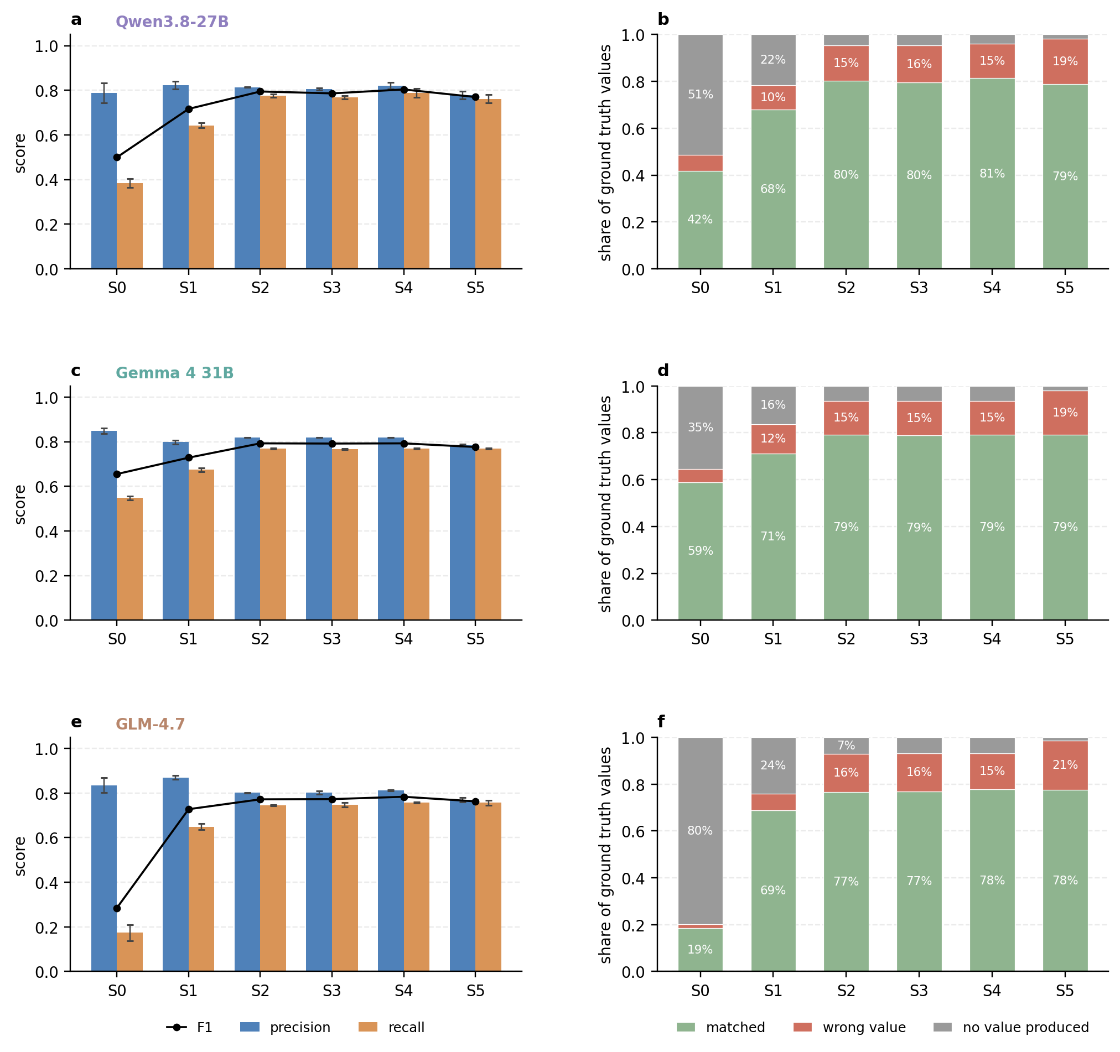
Supplementary figure 1. The cumulative ablation removes unanswered fields rather than correcting wrong ones. Per model (rows: Qwen3.8-27B, Gemma 4 31B, GLM-4.7), on the 30 held-out datasets with 179 ground truth values, three runs per arm. Left (a, c, e): precision and recall per arm, mean ± SD over runs, with the mean F1 (line). Right (b, d, f): outcome of every ground truth value per arm, matched by the five-level matcher (score ≥ 0.50), a value produced that did not match, or no value produced. Precision stays within 0.77–0.87 across the whole staircase while recall rises from 0.17-0.55 at S0 to ~0.76 at S5, and the share of values left unanswered falls from 35-80 % to 2 %.
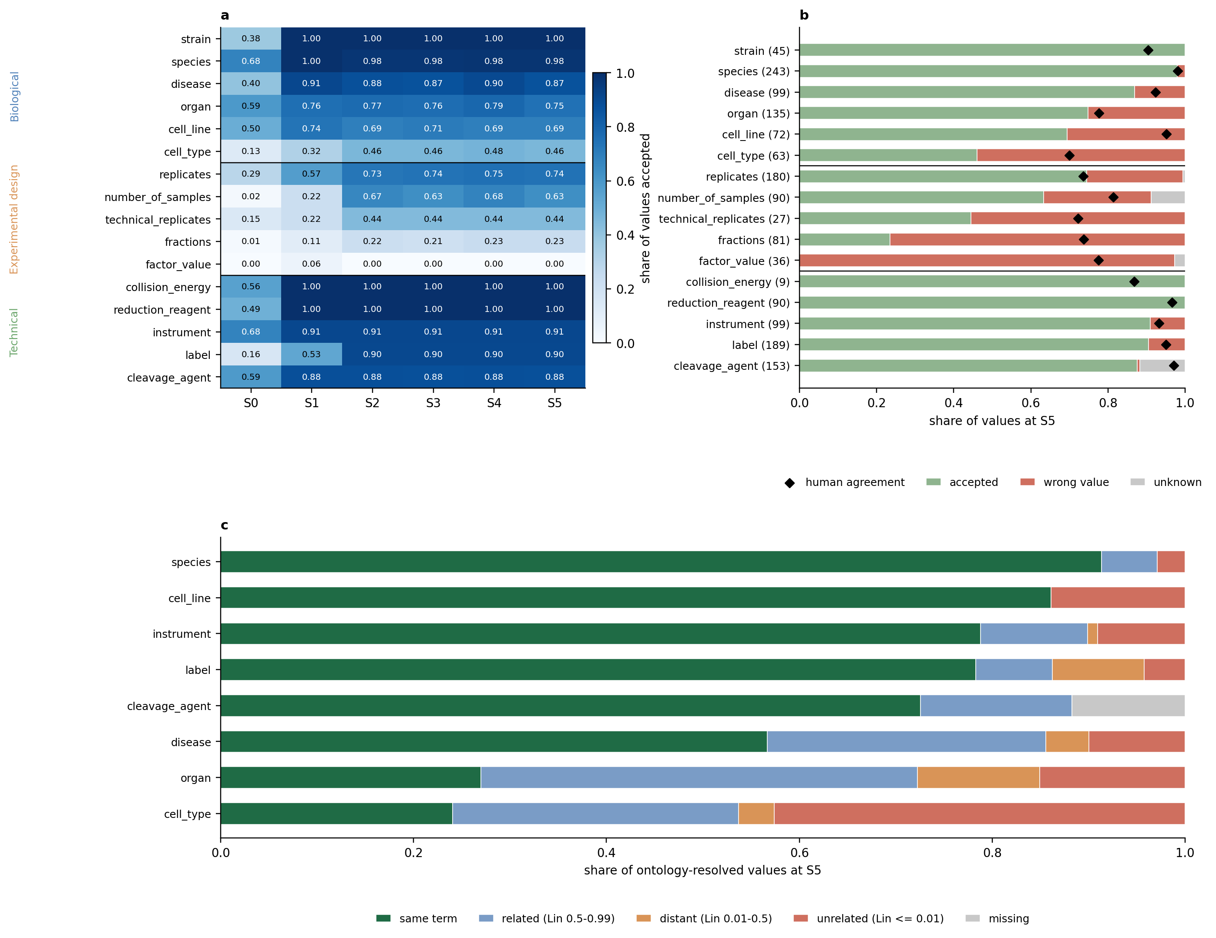
Supplementary Figure 2. Per-entity acceptance, outcome and error distance along the cumulative ablation (Qwen3.8-27B, 30 test datasets). (a) Share of ground truth values accepted by the five-level matcher per field and arm S0–S5, grouped by agent (biological, experimental design, technical). (b) Outcome per field at S5: accepted, wrong value, or unknown; numbers in parentheses are ground truth values; diamonds mark the share of values on which human annotators agreed for the corresponding field (Fig. 1). (c) For ontology-backed fields, how far accepted or rejected values are from the ground truth ground truth term at S5: identical term, related (Lin 0.5–0.99), distant (Lin 0.01–0.5), unrelated (Lin ≤ 0.01), or missing.
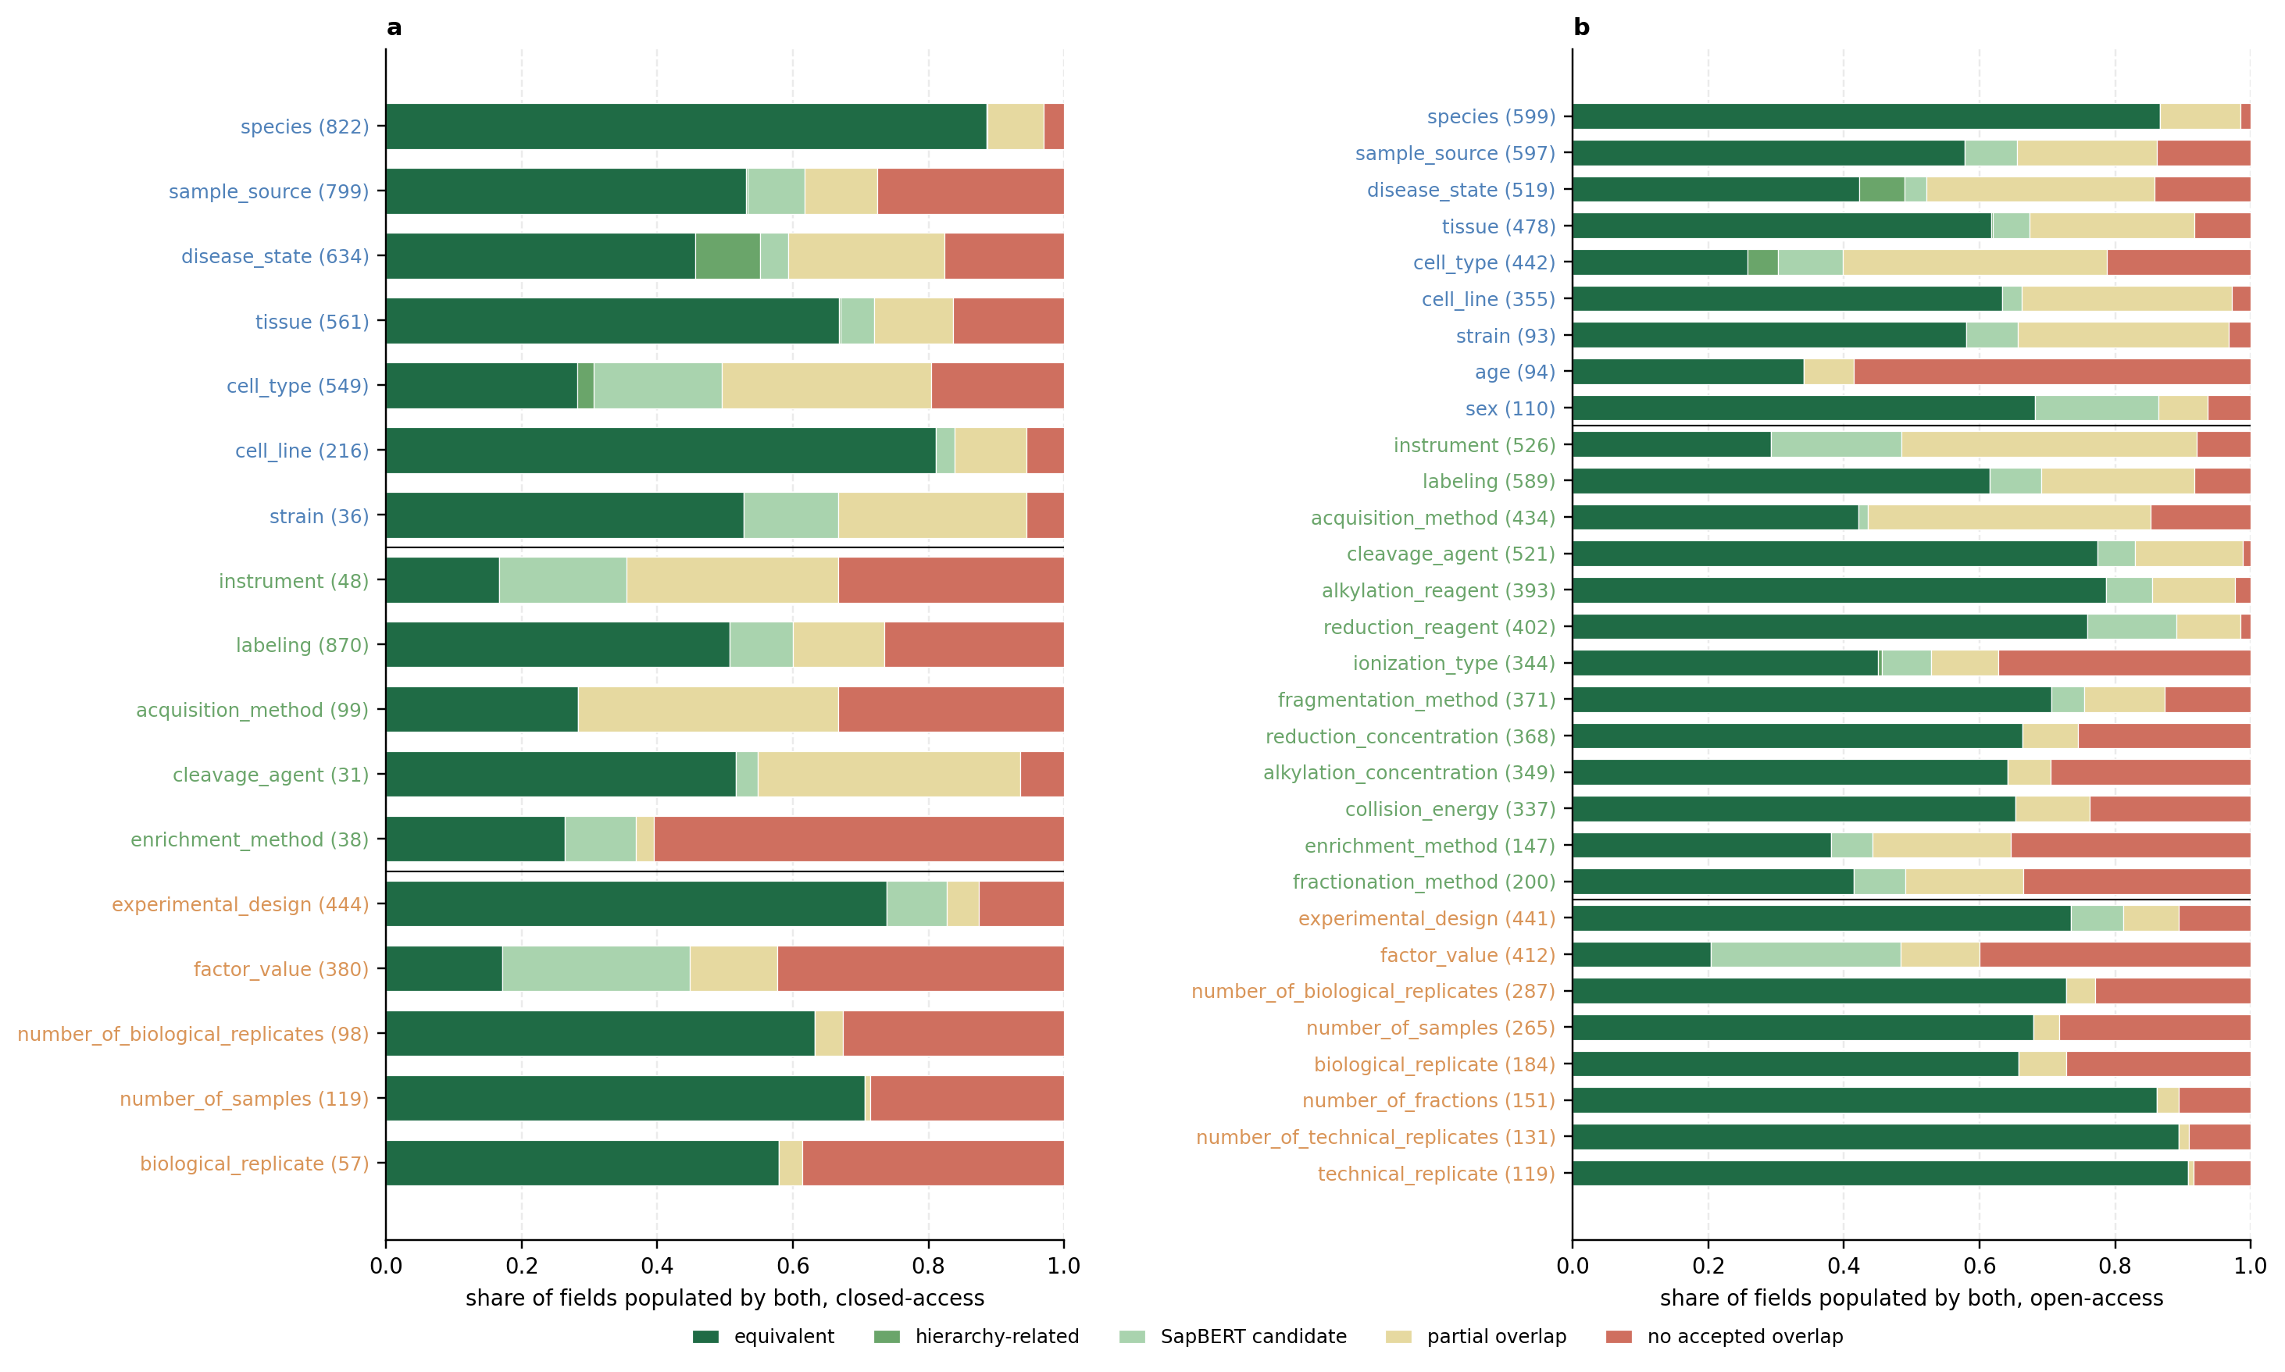
Supplementary Figure 3. Agreement between the manuscript and the PRIDE descriptor per field. For each field populated by both the manuscript-only run and the descriptor-augmented run, the share of field–dataset pairs in each HAMLET matcher tier, equivalent value sets, hierarchically related, SapBERT candidate (cosine ≥ 0.70), partial overlap, or no accepted overlap, for closed-access (a; abstract only, 1,135 datasets) and open-access (b; abstract + M&M, 601 datasets) datasets.
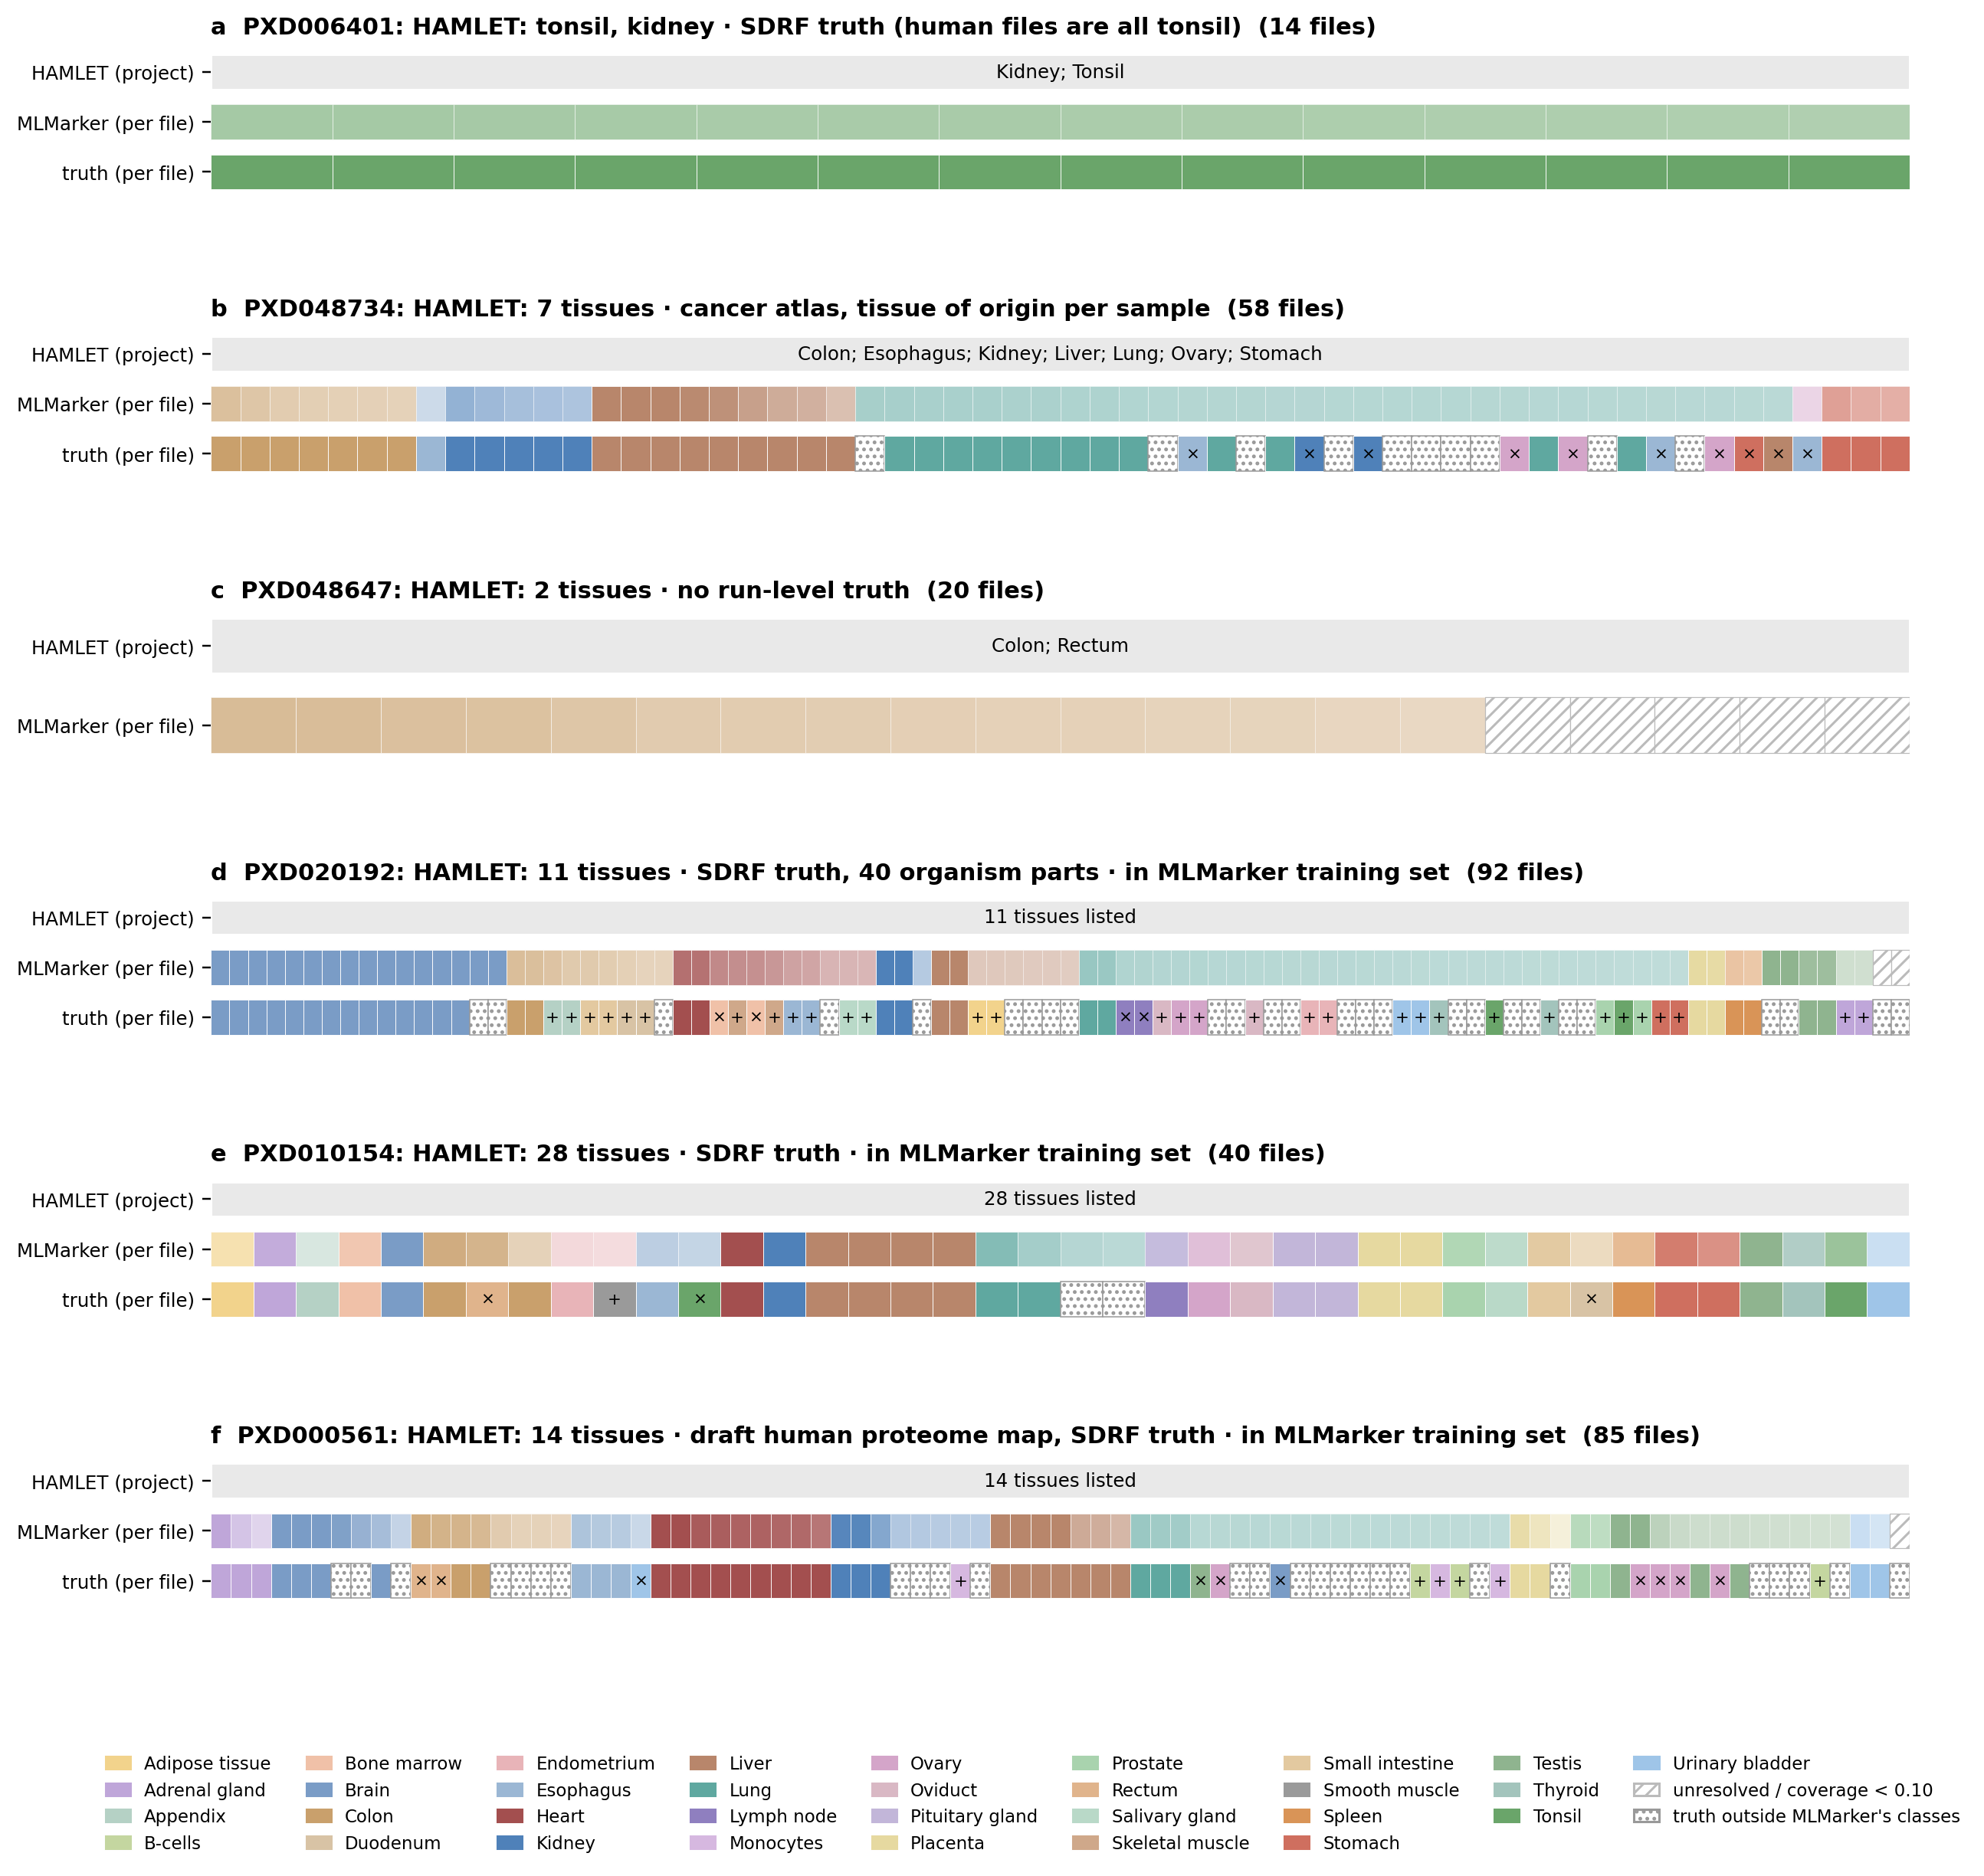
Supplementary figure 4: Worked examples of raw-file tissue disambiguation. For each project, HAMLET's project-level tissue call (top row), MLMarker's per-file prediction (middle row) and, where available, file-level ground truth (bottom row); each file is one coloured segment, coloured by tissue (legend). (a) PXD006401: HAMLET lists two tissues (tonsil, kidney); SDRF ground truth shows all human files are tonsil (14 files). (b) PXD048734: a cancer atlas with tissue of origin annotated per sample, 7 tissues listed by HAMLET (58 files). (c) PXD048647: 2 tissues listed by HAMLET (colon, rectum), no run-level ground truth available (20 files). (d-f) Projects inside MLMarker's training set, with SDRF ground truth available: (d) PXD020192, 11 tissues listed against 40 annotated organism parts (92 files); (e) PXD010154, 28 tissues listed (40 files); (f) PXD000561, a draft human proteome map, 14 tissues listed (85 files). Crosses indicate misannotations by MLMarker.

Supplementary table S1
Agent | Field | Datasets annotated | Several values | Share multi-valued
Technical | instrument | 1718 | 621 | 0.36
Technical | acquisition_method | 1627 | 617 | 0.38
Technical | cleavage_agent | 1579 | 470 | 0.3
Biological | cell_type | 1317 | 426 | 0.32
Technical | labeling | 1704 | 352 | 0.21
Biological | disease_state | 1457 | 321 | 0.22
Biological | cell_line | 816 | 278 | 0.34
Biological | sample_source | 1686 | 234 | 0.14
Biological | tissue | 1306 | 199 | 0.15
Technical | collision_energy | 890 | 189 | 0.21
Technical | _hallucination_flags | 315 | 185 | 0.59
Technical | _evidence_grounding_flags | 964 | 177 | 0.18
ExperimentalDesign | factor_value | 1232 | 173 | 0.14
Technical | fragmentation_method | 1020 | 130 | 0.13
Technical | alkylation_reagent | 1376 | 121 | 0.09
Technical | enrichment_method | 513 | 110 | 0.21
Biological | species | 1732 | 94 | 0.05
Technical | reduction_concentration | 1022 | 83 | 0.08
Technical | fractionation_method | 535 | 78 | 0.15
Technical | alkylation_concentration | 941 | 76 | 0.08
Technical | reduction_reagent | 1155 | 67 | 0.06
Technical | ionization_type | 1059 | 66 | 0.06
Biological | strain | 177 | 58 | 0.33
ExperimentalDesign | experimental_design | 1300 | 51 | 0.04
Biological | age | 166 | 38 | 0.23
ExperimentalDesign | biological_replicate | 624 | 33 | 0.05
ExperimentalDesign | number_of_biological_replicates | 743 | 21 | 0.03
Biological | sex | 172 | 20 | 0.12
ExperimentalDesign | number_of_fractions | 421 | 13 | 0.03
ExperimentalDesign | number_of_samples | 690 | 8 | 0.01
ExperimentalDesign | technical_replicate | 357 | 4 | 0.01
ExperimentalDesign | number_of_technical_replicates | 369 | 3 | 0.01
Biological | anatomic_site_tumor | 31 | 2 | 0.06
Biological | BMI | 9 | 1 | 0.11

Acknowledgments
T.C. acknowledge funding from the Research Foundation Flanders (FWO) [12A8W25N]. L.M. acknowledges funding from the Horizon Europe Project COMBINE [101191739] and the CHIST-ERA project ODEEP-EU [G0GDV23N]. We thank all laboratories that deposited their data in ProteomeXchange; this work would not have been possible without public data sharing.

Author contributions
T.C. conceived and supervised the study and wrote the manuscript. H.R. led software implementation, with additional contributions from A.J. and S.H. L.M. contributed to manuscript revision. A.M., A.S., H.R., J.U., K.K., L.L., M.P., M.W., M.L.P., N.T., S.d.l.C.F., T.V.D.B., T.S. and V.S. performed manual expert annotation for the human-annotation benchmark. K.N. additionally contributed to the design of the annotation protocol and to the framing of the human-model comparison. I.S. contributed to annotation and to metadata schema structuring. F.M.S., E.W.D., S.W., I.F. and W.B. contributed to discussion within the NCEMS working group. All authors reviewed and approved the final manuscript.

Data availability
Corpus of metadata will be available upon publication on Zenodo. All code is available on github .

REFERENCES
(1) Wilkinson, M. D.; Dumontier, M.; Aalbersberg, Ij. J.; Appleton, G.; Axton, M.; Baak, A.; Blomberg, N.; Boiten, J.-W.; da Silva Santos, L. B.; Bourne, P. E.; Bouwman, J.; Brookes, A. J.; Clark, T.; Crosas, M.; Dillo, I.; Dumon, O.; Edmunds, S.; Evelo, C. T.; Finkers, R.; Gonzalez-Beltran, A.; Gray, A. J. G.; Groth, P.; Goble, C.; Grethe, J. S.; Heringa, J.; ’t Hoen, P. A. C.; Hooft, R.; Kuhn, T.; Kok, R.; Kok, J.; Lusher, S. J.; Martone, M. E.; Mons, A.; Packer, A. L.; Persson, B.; Rocca-Serra, P.; Roos, M.; van Schaik, R.; Sansone, S.-A.; Schultes, E.; Sengstag, T.; Slater, T.; Strawn, G.; Swertz, M. A.; Thompson, M.; van der Lei, J.; van Mulligen, E.; Velterop, J.; Waagmeester, A.; Wittenburg, P.; Wolstencroft, K.; Zhao, J.; Mons, B. The FAIR Guiding Principles for Scientific Data Management and Stewardship. Sci Data 2016, 3 (1), 160018. https://doi.org/10.1038/sdata.2016.18
(2) Sayers, E. W.; Beck, J.; Bolton, E. E.; Brister, J. R.; Chan, J.; Connor, R.; Feldgarden, M.; Fine, A. M.; Funk, K.; Hoffman, J.; Kannan, S.; Kelly, C.; Klimke, W.; Kim, S.; Lathrop, S.; Marchler-Bauer, A.; Murphy, T. D.; O’Sullivan, C.; Schmieder, E.; Skripchenko, Y.; Stine, A.; Thibaud-Nissen, F.; Wang, J.; Ye, J.; Zellers, E.; Schneider, V. A.; Pruitt, K. D. Database Resources of the National Center for Biotechnology Information in 2025. Nucleic Acids Res 2024, 53 (D1), D20–D29. https://doi.org/10.1093/nar/gkae979
(3) Clough, E.; Barrett, T.; Wilhite, S. E.; Ledoux, P.; Evangelista, C.; Kim, I. F.; Tomashevsky, M.; Marshall, K. A.; Phillippy, K. H.; Sherman, P. M.; Lee, H.; Zhang, N.; Serova, N.; Wagner, L.; Zalunin, V.; Kochergin, A.; Soboleva, A. NCBI GEO: Archive for Gene Expression and Epigenomics Data Sets: 23-Year Update. Nucleic Acids Res 2023, 52 (D1), D138–D144. https://doi.org/10.1093/nar/gkad965
(4) Deutsch, E. W.; Bandeira, N.; Perez-Riverol, Y.; Sharma, V.; Carver, J. J.; Mendoza, L.; Kundu, D. J.; Bandla, C.; Kamatchinathan, S.; Hewapathirana, S.; Sun, Z.; Kawano, S.; Okuda, S.; Connolly, B.; MacLean, B.; MacCoss, M. J.; Chen, T.; Zhu, Y.; Ishihama, Y.; Vizcaíno, J. A. The ProteomeXchange Consortium in 2026: Making Proteomics Data FAIR. Nucleic Acids Res 2026, 54 (D1), D459–D469. https://doi.org/10.1093/nar/gkaf1146
(5) Yurekten, O.; Payne, T.; Tejera, N.; Amaladoss, F. X.; Martin, C.; Williams, M.; O’Donovan, C. MetaboLights: Open Data Repository for Metabolomics. Nucleic Acids Res 2024, 52 (D1), D640–D646. https://doi.org/10.1093/nar/gkad1045
(6) Van Den Bossche, T.; Prakash, A.; Claeys, T.; Vizcaíno, J. A.; Martens, L. Unlocking the Next Decade of Proteomics with Standardized, Structured Metadata. J Proteome Res 25 (2), 556–561. https://doi.org/10.1021/acs.jproteome.5c00958
(7) Claeys, T.; Van Den Bossche, T.; Perez-Riverol, Y.; Gevaert, K.; Vizcaíno, J. A.; Martens, L. lesSDRF Is More: Maximizing The Value Of Proteomics Data Through Streamlined Metadata Annotation. Nature communications 2023, 14 (6473). https://doi.org/https://dx.doi.org/10.21203/rs.3.rs-2937726/v1
(8) Martens, L.; Vizcaíno, J. A. A Golden Age for Working with Public Proteomics Data. Trends in Biochemical Sciences 2017, 42 (5), 333–341. https://doi.org/10.1016/j.tibs.2017.01.001
(9) Claeys, T.; van Puyenbroeck, S.; Gevaert, K.; Martens, L. MLMarker: A Machine Learning Framework for Tissue Inference and Biomarker Discovery. Genome Biol 2026, 27 (1), 207. https://doi.org/10.1186/s13059-026-04125-8
(10) Hu, Y.; Shah, P.; Clark, D. J.; Ao, M.; Zhang, H. Reanalysis of Global Proteomic and Phosphoproteomic Data Identified a Large Number of Glycopeptides. Analytical Chemistry 2018, 90 (13), 8065–8071. https://doi.org/10.1021/acs.analchem.8b01137
(11) Jarnuczak, A. F.; Najgebauer, H.; Barzine, M.; Kundu, D. J.; Ghavidel, F.; Perez-Riverol, Y.; Papatheodorou, I.; Brazma, A.; Vizcaíno, J. A. An Integrated Landscape of Protein Expression in Human Cancer. Scientific data 2021, 8 (1), 115. https://doi.org/10.1038/s41597-021-00890-2
(12) Rung, J.; Brazma, A. Reuse of Public Genome-Wide Gene Expression Data. Nature Reviews Genetics 2013, 14 (2), 89–99. https://doi.org/10.1038/nrg3394
(13) Degroeve, S.; Martens, L. MS2PIP: A Tool for MS/MS Peak Intensity Prediction. Bioinformatics 2013, 29 (24), 3199–3203. https://doi.org/10.1093/bioinformatics/btt544
(14) Desiere, F.; Deutsch, E. W.; King, N. L.; Nesvizhskii, A. I.; Mallick, P.; Eng, J.; Chen, S.; Eddes, J.; Loevenich, S. N.; Aebersold, R. The PeptideAtlas Project. Nucleic Acids Research 2006, 34 (suppl_1), D655–D658. https://doi.org/10.1093/nar/gkj040
(15) Madrigal, P.; Thanki, A. S.; Fexova, S.; Yu, I. D.; Chatzigeorgiou, A.; Zucchi, I.; Marugan Calles, J. C.; Vilmovsky, L.; Khen, A.; Zhao, L.; Erdos, K.; Kurri, S. R.; Selvakumar, S.; Kumbham, U.; Prakash, A.; Wang, S.; Green, A.; Ribas, C. E.; Sweeney, B.; Alegbe, T.; Suveges, D.; Hemrom, A.; Gomez Gutierrez, D. E.; Insua, S.; Jeffryes, M.; Pearce, M.; Basutkar, P.; Kaforou, M.; Cunnington, A.; Levin, M.; Kumari, S.; Ware, D.; Goutte-Gattat, D.; Röper, K.; Brown, N. H.; Hu, Y.; Perrimon, N.; Papatheodorou, I.; Brazma, A.; Hermjakob, H.; Harrison, M.; Ocaña, D.; Ochoa, D.; McDonagh, E. M.; Bateman, A.; Keane, T.; Vizcaíno, J. A.; Ernst, C. Expression Atlas in 2026: Enabling FAIR and Open Expression Data through Community Collaboration and Integration. Nucleic Acids Research 2026, 54 (D1), D147–D157. https://doi.org/10.1093/nar/gkaf1238
(16) Schmidt, T.; Samaras, P.; Frejno, M.; Gessulat, S.; Barnert, M.; Kienegger, H.; Krcmar, H.; Schlegl, J.; Ehrlich, H.-C.; Aiche, S.; Kuster, B.; Wilhelm, M. ProteomicsDB. Nucleic Acids Research 2018, 46 (D1), D1271–D1281. https://doi.org/10.1093/nar/gkx1029
(17) Lauridsen, J.; Canbay, V.; Catzel, R.; Ramasamy, P.; Mabona, A.; Eloff, K.; Fullwood, P.; Ferguson, J.; Kirketerp-Møller, A.; Goldschmidt, I. S.; Claeys, T.; van Puyenbroeck, S.; Carranza, N. L.; Schoof, E. M.; Martens, L.; Van Goey, J.; Francavilla, C.; Jenkins, T. P.; Kalogeropoulos, K. InstaNovo-P: A de Novo Peptide Sequencing Model for Phosphoproteomics. Nat Commun 2026, 17 (1), 9277. https://doi.org/10.1038/s41467-026-75138-x
(18) Bouwmeester, R.; Gabriels, R.; Hulstaert, N.; Martens, L.; Degroeve, S. DeepLC Can Predict Retention Times for Peptides That Carry As-yet Unseen Modifications. Nature Methods 2021, 18 (11), 1363–1369. https://doi.org/10.1038/s41592-021-01301-5
(19) Dai, C.; Füllgrabe, A.; Pfeuffer, J.; Solovyeva, E.; Deng, J.; Moreno, P.; Kamatchinathan, S.; Kundu, D. J.; George, N.; Fexova, S.; Grüning, B.; Föll, M. C.; Griss, J.; Vaudel, M.; Audain, E.; Locard-Paulet, M.; Turewicz, M.; Eisenacher, M.; Uszkoreit, J.; Van Den Bossche, T.; Schwämmle, V.; Webel, H.; Schulze, S.; Bouyssié, D.; Jayaram, S.; Duggineni, V. K.; Samaras, P.; Wilhelm, M.; Choi, M.; Wang, M.; Kohlbacher, O.; Brazma, A.; Papatheodorou, I.; Bandeira, N.; Deutsch, E. W.; Vizcaíno, J. A.; Bai, M.; Sachsenberg, T.; Levitsky, L.; Perez-Riverol, Y. A Proteomics Sample Metadata Representation for Multiomics Integration, and Big Data Analysis. Nature Communications 2021, 12, 5854. https://doi.org/doi.org/10.1038/s41467-021-26111-3
(20) CUPCAKE Vanilla. https://cupcake.proteo.info/#/login?returnUrl=%2Fhome (accessed 2026-09-15)
(21) SciBite | Technology that unlocks scientific data | Elsevier. www.elsevier.com. https://www.elsevier.com/products/scibite (accessed 2026-09-15)
(22) Yang, X.; Saha, S.; Venkatesan, A.; Tirunagari, S.; Vartak, V.; McEntyre, J. Europe PMC Annotated Full-Text Corpus for Gene/Proteins, Diseases and Organisms. Sci Data 2023, 10 (1), 722. https://doi.org/10.1038/s41597-023-02617-x
(23) Caufield, J. H.; Hegde, H.; Emonet, V.; Harris, N. L.; Joachimiak, M. P.; Matentzoglu, N.; Kim, H.; Moxon, S.; Reese, J. T.; Haendel, M. A.; Robinson, P. N.; Mungall, C. J. Structured Prompt Interrogation and Recursive Extraction of Semantics (SPIRES): A Method for Populating Knowledge Bases Using Zero-Shot Learning. Bioinformatics 2024, 40 (3), btae104. https://doi.org/10.1093/bioinformatics/btae104
(24) Martens, L.; Nesvizhskii, A. I.; Hermjakob, H.; Adamski, M.; Omenn, G. S.; Vandekerckhove, J.; Gevaert, K. Do We Want Our Data Raw? Including Binary Mass Spectrometry Data in Public Proteomics Data Repositories. PROTEOMICS 2005, 5 (13), 3501–3505. https://doi.org/10.1002/pmic.200401302
(25) Perez-Riverol, Y.; Bandla, C.; Kundu, D. J.; Kamatchinathan, S.; Bai, J.; Hewapathirana, S.; John, N. S.; Prakash, A.; Walzer, M.; Wang, S.; Vizcaíno, J. A. The PRIDE Database at 20 Years: 2025 Update. Nucleic Acids Res 2025, 53 (D1), D543–D553. https://doi.org/10.1093/nar/gkae1011
(26) Winkelhardt, D.; Schessner, J. P.; Berres, S.; Nameni, A.; Soleymaniniya, A.; Schröder, A.; Jachmann, C.; Schulte, D.; Wallmann, G.; Webel, H.; Rainer, J.; Nastou, K.; Gatto, L.; Palmblad, M.; Weber, M.; Shouman, O.; Sinitcyn, P.; Gabriels, R.; Devreese, R.; Van Den Bossche, T.; Claeys, T.; Bittremieux, W.; Uszkoreit, J. Community-Driven Advances in Computational Mass Spectrometry: The Perspective of EuBIC-MS Members. Journal of Proteomics 2026, 331, 105708. https://doi.org/10.1016/j.jprot.2026.105708
(27) Liu, F.; Shareghi, E.; Meng, Z.; Basaldella, M.; Collier, N. Self-Alignment Pretraining for Biomedical Entity Representations. arXiv April 7, 2021. https://doi.org/10.48550/arXiv.2010.11784
(28) Douze, M.; Guzhva, A.; Deng, C.; Johnson, J.; Szilvasy, G.; Mazaré, P.-E.; Lomeli, M.; Hosseini, L.; Jégou, H. The Faiss Library. arXiv October 23, 2025. https://doi.org/10.48550/arXiv.2401.08281
(29) Andken, M.; Zheng, C.; Sun, Z.; Deutsch, E. W. Automated Metadata Extraction from mzML Files with RunAssessor. J. Proteome Res. 2026, 25 (5), 2581–2590. https://doi.org/10.1021/acs.jproteome.5c01045
(30) Lutfi, A.; Chen, Z. A.; Fischer, L.; Rappsilber, J. MetaXtract: Extracting Metadata from Raw Files for FAIR Data Practices and Workflow Optimisation. bioRxiv March 16, 2026, p 2025.11.12.687968. https://doi.org/10.1101/2025.11.12.687968
(31) Hulstaert, N.; Reisinger, F.; Rameseder, J.; Barsnes, H.; Vizcaíno, J. A.; Martens, L. Pride-Asap: Automatic Fragment Ion Annotation of Identified PRIDE Spectra. Journal of Proteomics 2013, 95, 89–92. https://doi.org/10.1016/j.jprot.2013.04.011

