Introduction
The systematic sharing of biological data has become a central mechanism by which the life sciences accumulate and extend knowledge, and the FAIR principles provide the framework for doing so [FAIR]. Public repositories now preserve large volumes of sequencing, transcriptomics, proteomics and imaging data [refs]. Their scientific value, however, depends not only on whether files are deposited but also on whether those files carry enough context to be interpreted and reused. That context is metadata: the organism, tissue, cell type, disease state, perturbation, replicate structure, instrument and processing choices behind a measurement. Without it in structured and computable form, deposited datasets remain technically accessible but scientifically opaque. The cost of that opacity is rising, because datasets are increasingly reused for purposes their original investigators did not anticipate, including cross-study meta-analysis, benchmarking of computational methods, and the training of machine learning models [MLMarker, others]. In each of these settings, incomplete metadata translates directly into inappropriate dataset selection and confounded comparison.
Mass spectrometry-based proteomics shows both the promise and the difficulty of this reuse. Repositories coordinated through ProteomeXchange hold large numbers of datasets combining raw instrument files, processed identifications and links to associated publications [PX], supporting repository-scale reanalysis, comparison of protein abundance across conditions, evaluation of search and quantification workflows, and the development of spectral prediction and de novo sequencing models [refs]. Reuse with a biological goal, however, requires knowing the organism, tissue, cell type, disease state, sample preparation, digestion enzyme, labelling strategy, enrichment protocol, acquisition mode, instrument, fractionation scheme and replicate structure. Much of this is absent from structured repository fields, inconsistently represented across submissions, or stated only in free text; most of what remains sits in the associated manuscript, so reuse is bounded in practice by whether manuscripts can be read at scale.
Community standards address part of this problem. SDRF-Proteomics represents the relationships among samples, assays, raw files and experimental variables in a structured tabular format [SDRF], and annotation tools now support standard-compliant submission [lesSDRF]. However, adoption remains limited: of 9,671 datasets deposited since mid-2022, 156 carried submitter-supplied SDRF annotation, rising to 3.9% of projects once post-hoc annotation efforts are included [lesSDRF]. More fundamentally, the standard governs new deposition and does not recover what is missing from existing records. Many valuable datasets predate it, recent submissions are often coarse or incomplete, and the biological and experimental detail that determines whether a dataset is fit for a given purpose is frequently described only in the manuscript. Researchers who wish to reuse public proteomics data therefore still read papers by hand before deciding whether a dataset suits their analysis, which is slow and error prone.
Automated reading of the biomedical literature is not new. Dictionary-driven entity recognition is the established approach and remains in industrial use, with systems such as SciBite's TERMite tagging text against manually curated vocabularies of millions of synonyms mapped onto public ontologies [SciBite]. Such systems recognise entities rather than populate a schema. Tagging trypsin as an enzyme does not establish that trypsin was the digestion enzyme for a particular dataset, as the method is context unaware. Large language models (LLMs) remove that constraint, and the closest prior work is SPIRES, implemented in OntoGPT, which takes a user-defined schema, queries a model recursively over nested structure, and grounds each extracted value to an ontology identifier, essential for the methodology [SPIRES]. However, the current tool only allows a broad extraction of general text: it does not address per-dataset experimental metadata, does not reconcile conflicting evidence between a manuscript and a repository record, and does not measure what its individual components contribute. That last question is the one this work addresses, and it is practical rather than academic: the answer determines whether a community resource must depend on a commercial model, and whether it can be reproduced years later.
Here we present HAMLET, an agentic framework that reconstructs the biological, technical and experimental context of public proteomics datasets from their associated manuscripts. Extraction is decomposed across specialised agents operating on a fixed schema, every value is tied to the sentence that supports it, and extracted terms are normalised to community ontologies. Because the components are separable, their contributions can be measured rather than assumed. We first quantify how hard the task is for human annotation, using a corpus of 27 manuscripts annotated by nine experts, which establishes the agreement ceiling any automated method should be judged against. We then show through a cumulative ablation that three models spanning a wide capability range converge to almost identical performance once the framework is applied, so that the weakest model inside it outperforms a stronger model without it. Finally, applying the framework to 1,737 datasets, we quantify what open-access full text adds over the deposited repository record, where the two sources disagree, and how far the resulting annotations go towards identifying usable machine learning training data.

Results

Expert annotators agree only partially, and the models agree with each other more than with the experts
Any automated method has to be judged against what people achieve on the same task. A core group of annotators first established annotation rules across three annotation cycles. Twenty-seven open-access proteomics manuscripts were then selected on two criteria: (i) an annotated SDRF-Proteomics file was available on GitHub, establishing that annotation was technically possible, and (ii) the set covered a range of journals and publication years. Nine experts annotated these manuscripts at the EuBIC-MS developers meeting, eight working through overlapping batches and one covering the full corpus alone. A harmonised consensus was reconciled from their output. Forty-two entity types were annotated often enough to support pairwise comparison.
Agreement among the experts is moderate and highly variable. Pairwise Cohen's kappa for whether a field is stated at all ranges from 0.17 to 0.71 between individual annotators, with a mean of 0.43 (Figure 1b). Neither the harmonised consensus nor the single expert falls outside that range: the consensus agrees with individual annotators at 0.53 on average (0.30 to 0.74), the single expert at 0.45 (0.27 to 0.67). This disagreement is not explained by entity rarity, since per-field kappa shows no relationship with how often a field is stated (Spearman rho = +0.07, p = 0.65 over 42 fields; Figure 1c). The difficult fields are not simply the uncommon ones. Part of the remaining disagreement is wording rather than substance. Where two annotators both marked a field, SciBERT pass recovers 15.0% of potential mismatches (Figure 1d). Scoring agreement on the extracted values rather than on presence alone shows the same effect across all 77 pairs among the 13 identities (9 annotators, the consensus, and 3 models): kappa rises under cosine-0.70 clustering in every pair (Figure 1a). For human-human pairs specifically, mean kappa rises from 0.34 under exact string identity to 0.44 under clustering; for model-model pairs, from 0.45 to 0.58. The gain is concentrated in technical fields (+0.13), ahead of biological (+0.09) and experimental-design fields (+0.05; Figure 1e). Roughly one instance in seven is therefore a vocabulary difference rather than a substantive one, and the vocabulary problem is unevenly distributed across the schema.
Three open-source language models, Qwen3.8-27B, Gemma 4 31B and GLM-4, annotated the same 27 manuscripts under the same schema using a single annotation prompt. Against human annotators they reach a mean kappa of 0.40, inside the range at which the humans agree with one another. Against each other they reach 0.69, with all three model pairs falling between 0.68 and 0.72, a band only one of the thirty-five human pairs reaches. An exact permutation test over rater group membership puts that difference at p = 0.018 (Figure 1b), though with only three model-model pairs the test's resolution is limited and the p-value should be read as approximate. The models are therefore internally consistent to a degree the human annotators do not achieve, while remaining no closer to any individual human than the humans are to each other. They converge on a more reproducible reading of the same text, which bounds what a claim of human-level performance can mean for this task. A model scored against a single human reference could look accurate while sharing a systematic bias with every other model, and no comparison against one annotator would reveal it. That convergence is not an artefact of the models declining to annotate. Presence agreement is scored over every document-field slot, most of which are empty, so two sparse annotators would agree trivially often. Three quantities rule that explanation out. Chance agreement is lowest for the model pairs, at 0.51 against 0.56 for human pairs, which is the opposite of what shared sparsity predicts. The share of slots where neither rater marked anything is comparable across all three groups. Neither of those two differences is significant under the same permutation test (p = 0.26 and p = 0.55), whereas the difference in kappa is. Scoring instead by positive specific agreement, which discards the both-absent cell entirely and therefore cannot be inflated by shared silence, widens rather than closes the gap: 0.82 between models against 0.61 between humans (p = 0.023).
The mechanism is visible in how much each annotator marks. Human annotators judge between 17% and 44% of field slots to be present, a 2.6-fold range, whereas the three models span 41% to 43%. Much of the disagreement between people is therefore a difference in threshold, in how readily a reader decides that a field is stated at all, and the models share that threshold almost exactly.
This is an advantage and a limitation at once. Automated annotation is more reproducible than expert annotation, which matters for any resource built at scale. Reproducibility is not accuracy, however, and three models converging on one reading is not evidence that the reading is correct. The pipeline therefore has to be benchmarked against a human reference before anything can be said about accuracy.
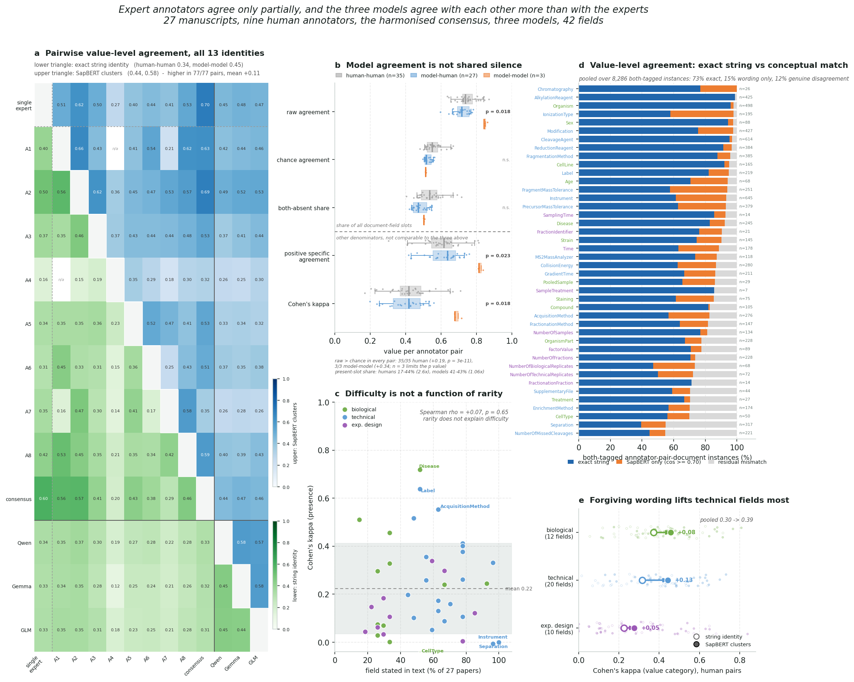

A grounded agentic framework for metadata extraction
Here we introduce HAMLET, an agentic pipeline that reads scientific text to extract experimental metadata and outputs an SDRF-Proteomics file that can be directly linked to the original raw files deposited in PRIDE. Indeed, HAMLET was designed to use abstract, material & methods or PRIDE project descriptors. To maintain the connection with the raw files, usage of other manuscripts sections was limited as this introduced a source of confusion for the LLM when comparisons or contextualization was described.
HAMLET hands the input over to three specialized extraction agents: biological, technical and experimental design with fixed prompts and entities to extract. The prompt contains definitions, extraction rules and explicit instructions. To minimize potential hallucinations, HAMLET (i) does not allow reasoning; (ii) limits interference and (iii) pairs every extracted entity with its evidence directly from the text, allowing mechanical checking. The extracted entities are then normalized against SDRF-Proteomics supported ontologies using SapBERT embeddings plus FAISS nearest-neighbour search over 19 ontologies (CL, CLO, UBERON, NCBITaxon, DOID, Mondo, PSI-MS, UNIMOD, ChEBI, EFO and others), with a five-level matching hierarchy from exact string to full semantic match.
Each extraction agent operates through DocETL and returns structured JSON, covering 38 predefined metadata fields across the three agents. Fields may contain multiple scientifically distinct values, each paired with its own supporting evidence. Values are restricted to the deposited proteomics experiment rather than background statements or unrelated experimental contexts. Missing information is represented explicitly as “unknown”; unspecified sample, replicate or fraction counts are not automatically assigned a value of one.
Evidence grounding is checked against the supplied input text. Minor typographical differences are reconciled where possible, while missing evidence or quotations that cannot be located in the source are flagged. A three-component quality-control procedure additionally evaluates ontology-supported consistency between biological fields, detects negated evidence using NegEx through negspacy, and checks numerical agreement between extracted values and their cited evidence. These checks identify potentially unreliable annotations rather than establishing that an extraction is incorrect. Flagged values are retained alongside machine-readable diagnostic information for subsequent review.

@Arnaud
five-level matching hierarchy (framework/benchmark/semantic_matcher.py) looses agreement score by construction.
your benchmark can add:
1. Permutation null, are the tier boundaries placed by the data or assumed? (The scored pairs from any tiered comparison, with labels shuffled between documents to generate the null)
2. Compare the hamlet score to the LIN score, compare max three metrics and see if the trends are the same.
input for that would be at: agentic-benchmark/benchmark_data/test_set/***/***_annotation.json compared to agentic-benchmark/benchmark_data/SDRFs_github

Framework structure, not model identity, carries performance
Prompt optimization and pipeline development of HAMLET were performed using a dataset of 137 PXD datasets with available SDRF-Proteomics annotations, split into an 80/20 train-test set. All results reported below were obtained exclusively on the 30 held-out test datasets and performance was calculated against the gold-standard SDRF-Proteomics annotations.
Using a cumulative ablation study, we assessed the improvement of accuracy of the extracted metadata against the ground truth. For this, we used three open-weight models that could be run locally and free of charge: Qwen3.8-27B, Gemma 4 31B and GLM-4.7. After optimization of the structure of the pipeline, we ran the entire pipeline with multiple open-weights and commercial models to assess any potential difference between these. The cumulative ablation runs every LLM three times and studied the following steps: (i) S0 - single master prompt outputting bare extractions; (ii) S1 - three specialized agents outputting bare extractions; (iii) S2 – S1 + field definitions, extraction rules, examples and explicit unknown instruction; (iv) S3 - S2 + structural validation and allowing retries for unknowns; (v) S4 – S3 + gleaning; (vi) S5 – S4 + ontology normalization (Fig 2a).
At S0 the three models show broad weighted F1 score distribution ranging from 0.29 to 0.70. however, by S2 all three model achieve a similar performance of approximately 0.96 which stays flat through S5. Indeed, model identity stops mattering once the scaffolding is present! Furthermore, almost the entire gain is realised by S2, i.e. by decomposition and structural. Validation, gleaning and normalisation add little further F1 on this metric. These steps, however, result in machine-readable output files so they add value for downstream usability.
When focusing on the performance on metadata class (biological, technical, experimental design), experimental design has the widest S0 spread (0.19 to 0.52) and technical fields the narrowest, which is consistent with the human annotations that previously reported the most disagreement in experimental design. The biggest change between S0 and S1 is consistency (Fig 2d). With one master prompt, non-unknown fields show a wider dispersity compared to the specialized agents, from 4-10 at S0 to a stable 23-25 from S2 onward, and three-run exact agreement at temperature 0 rises from 0.05-0.32 to 0.55-0.90. The framework makes output volume predictable, which the raw F1 curve does not show. Furthermore, not only are entities more consistently annotated, they are just more annotated in general. Indeed, unknown rate (Fig. 2e) falls from 0.73-0.91 at S0 to a stable 0.34-0.39 from S2 onward.
In summary, from step2 onwards any difference between LLMs is largely gone.
Crossover comparison (Fig. 2f): the central number for this section. Qwen3.8-27B with the complete framework reaches F1 0.961, above Gemma 4 31B at S1 (0.898) and far above Gemma at S0 (0.700) or GLM-4.7 at S0 (0.288). A weaker model inside the framework beats a stronger model without it.
Figure 2 as currently built, now plotted from the staircase tables:
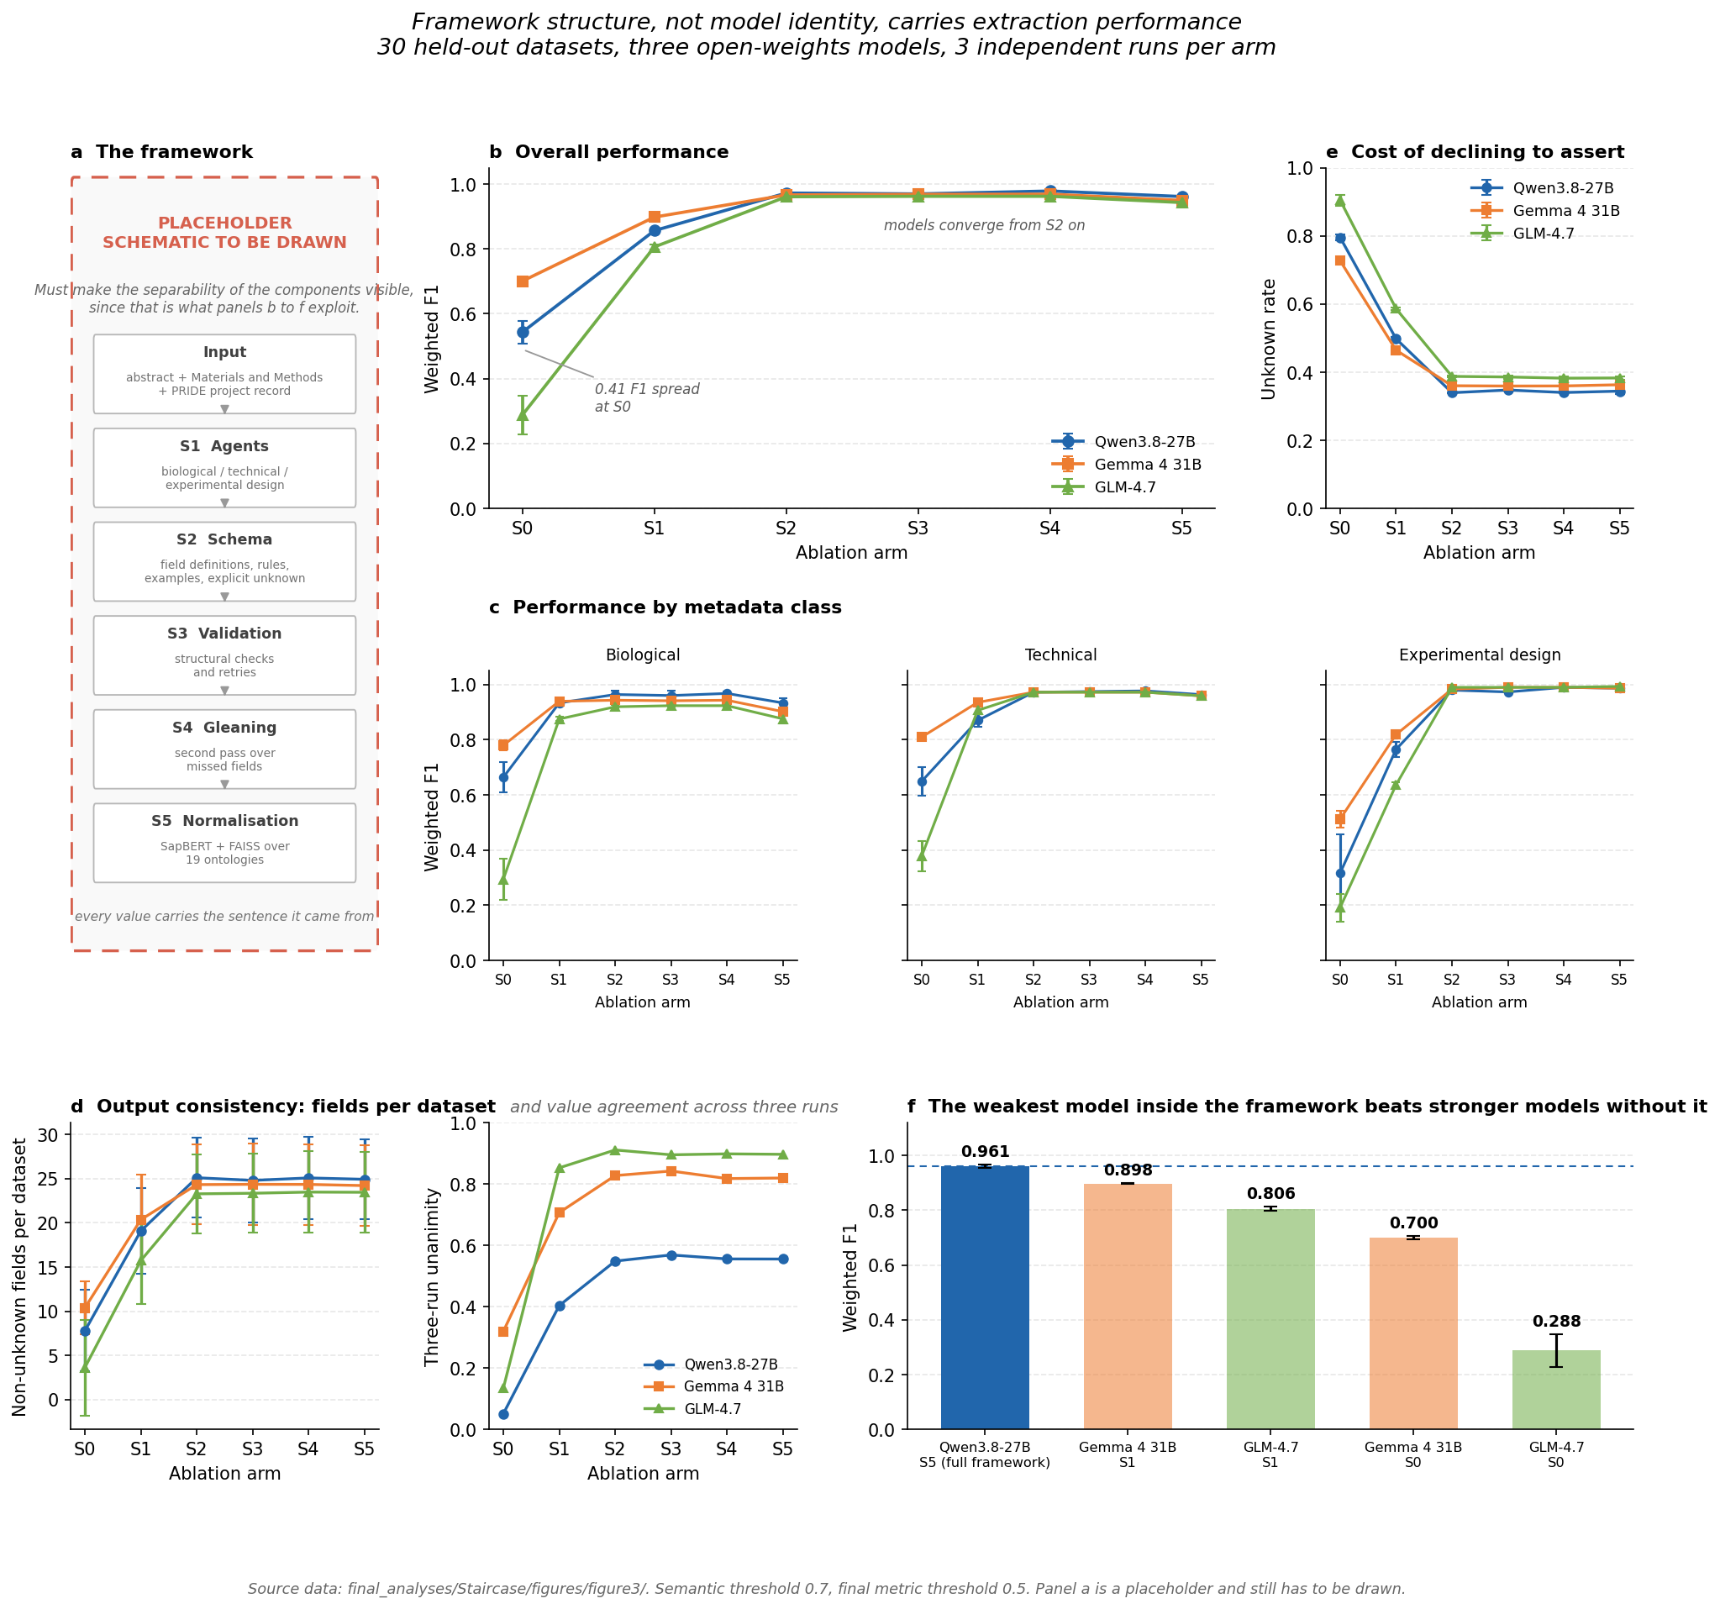
Source: final_analyses/Staircase/figures/manuscript_figure2/figure2.png

Open-weights models match commercial models inside the framework
Benchmarked across six models on the same 30-PXD test set, the open-weights Gemma 4 31B reached an overall F1 on par with the best-performing commercial model tested (GPT-5.4), ahead of Claude Opus 4.5, Gemini 3.5 Flash, and Qwen 3.7 Max, while Llama-4 Scout consistently trailed the other five models across every metadata class, most markedly on experimental design. That an open-weights model matched or exceeded several commercial systems once placed inside the same grounded, validated framework is the clearest evidence that the framework, not the model, carries the performance. Gemma 4 31B was therefore selected for large-scale processing, pairing competitive extraction performance with the cost advantage of local, open-weights deployment.
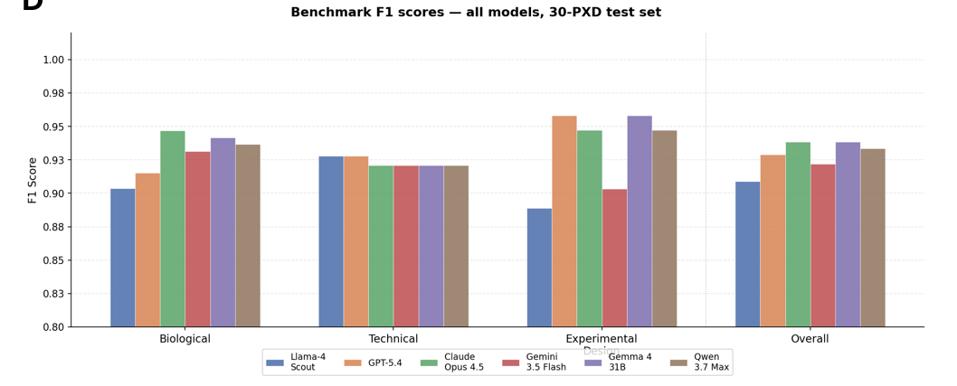

Retroactive annotation of 1.737 human PRIDE datasets
We tested the potential of HAMLET in the context of improving training data for the MLMarker model [REF]. We selected 1,737 potentially interesting human PRIDE datasets from the PRIDE API. However, due to the lack of open-access papers or text mining permissive license, we reverted back to PRIDE descriptors for XXXX papers. This allows a direct question: what does the published article contribute over the deposited record, field by field, across all 1,737 datasets?
Coverage of entities: do we find the same entities (independent of their value) in the manuscript and PRIDE summary? If we find the same entities in how many cases do they agree (using the HAMLET matching tiers)

A corpus of healthy human tissue
Out of the 1,737 annotated datasets XXX contained healthy human tissue. Indeed, the majority of public protoemics data does not contain healthy human primary tissue but often contains cell lines or cultured material. However, due to project-level ambiguity XXX of those studies mix healthy wit diseased samples, or trated with control, or combine multiple tissues. Such projects do contain usable runs but lack a label that tells them apart. This lack of annotation granularity can be partially addressed by applying classifier tools such as MLMarker [REF] which predicts tissue of origin from protein abundances at individual run level. We applied MLMarker to XXX runs across XXX projects for which HAMLET also produced tissue annotation.
- how many contained multiple tissues and would benefit from MLMArker resolution?
- how many contained eg healthy vs diseased, a phenotypic difference not solvable by mlmarker?
Where both HAMLET and MLMarker assign a tissue, the two annotations derive from independent evidence: one from what the authors wrote, one from what the instrument measured. Agreement between them but be ware of:
- circularity: XXX of MLMarkers training datasets fall inside the annotated corpus
- vocabulary: MLMarkers training atlas excludes biofluids and only has tissue classes. A HAMLET annotation naming a tissue outside that set cannot agree with an MLMarker prediction by construction, and counting it as discordant conflates two different things. We therefore decompose disagreement into cases where the HAMLET tissue lies outside MLMarker's label set (XXX per cent of discordant pairs) and cases where both terms are in vocabulary and the two sources genuinely differ (XXX per cent).
- material context: A HAMLET annotation of skin is correct for a study of patient-derived fibroblasts but they are cultured and differentiated before measurement so their proteome does no longer resemble skin, where we can expect disagreement.
- concordance metrics under exact matching, more advanced mathing (HAMLET five level matcher and ontology-graded matcher)
- link between concordance and MLMarker confidence score?
Expanding MLMarker training set:
- are there datasets not in the training data that can be added (existing and new labels) should e solid tissues, healthy baseline etc.
- how many of these required manual annotation and distinction?
- metrics of retrained MLMarker

Materials and Methods

Dataset identification and input preparation
HAMLET processes proteomics datasets identified by their ProteomeXchange accession numbers (PXD identifiers). These identifiers were retained throughout input preparation, extraction and postprocessing to associate the generated metadata with the corresponding PRIDE projects.
The production corpus comprised 1,737 datasets. Input text was assembled from abstract text, available materials and methods, PRIDE project properties, and available PRIDE sample- and data-processing protocols. The input-preparation script preferentially selected a PubMed abstract when available and otherwise used the abstract section supplied through PRIDE. The preparation manifest recorded 296 PubMed-sourced and 1,441 PRIDE-sourced abstracts. Extracted methods were available for 601 datasets; the remaining 1,136 datasets lacked methods in the prepared input. This classification describes input availability rather than the absence of methods from the published article.
Text was parsed using explicit section boundaries and assembled into separately labelled blocks. Introduction, results, supplementary text and pre-existing SDRF summaries were excluded from the prepared extraction input. PRIDE project properties included organism, organism part, disease, instrument, modification, experiment type, quantification and keyword descriptors where available. Sample- and data-processing protocols were each available for 1,727 datasets. Explicit missing-value markers were treated as unavailable text rather than included as substantive evidence.
A preparation manifest recorded the accession, input paths, abstract provenance, section availability and section lengths. For the source-comparison experiments, input hashes were additionally retained to verify that the intended source blocks were preserved.

Agent-based metadata extraction
Extraction was implemented using DocETL and three specialized agents addressing biological characteristics, mass-spectrometry procedures and experimental design. Together, the agents targeted 38 predefined metadata fields. Biological fields described characteristics such as species, tissue, cell type, cell line and disease state. Technical fields described instrumentation, acquisition, sample preparation, labelling and modifications. Experimental-design fields described study comparisons, experimental factors and sample, replicate and fraction counts.
Each agent used a fixed prompt specifying field definitions, extraction scope, evidence requirements and the expected output structure. Prompts instructed the model to extract information relevant to the deposited proteomics experiment and to exclude entities mentioned solely as background, biological motivation or descriptions of unrelated experiments. Inference was restricted to circumstances explicitly permitted by the field instructions; it was not treated as unrestricted completion of missing metadata.
The production multi-value format represented each field as a list of objects containing a value and its supporting evidence. Scientifically distinct values were represented separately, allowing heterogeneous datasets to retain multiple organisms, tissues, instruments or experimental conditions. Unsupported or unavailable information was represented as {"value": "unknown", "evidence": ""}.
PRIDE properties were treated by the prompts as dataset-level descriptors. The prompts specified how these descriptors should populate the extraction schema and distinguished anatomical regions, biological cell populations, named cell lines and sample materials. Every extracted value was required to have its own evidence. For PRIDE property-derived values, the production prompt requested the complete corresponding property line.

Model inference and execution
For the production runs and source-comparison experiments described here, Qwen was served locally through vLLM using the recorded model identifier Qwen/Qwen3.8-27B. Inference used the vLLM 0.27.1 container with model weights loaded in BF16 precision. Each model server used one NVIDIA B300 GPU, a tensor-parallel size of one, a maximum sequence length of 65,536 tokens and a GPU-memory-utilization setting of 0.70.
The corpus was partitioned into eight shards. Independent model servers processed the shards concurrently, with biological, technical and experimental-design extraction executed within each shard. Model snapshots, extraction prompts and configuration files were retained for reproducibility. The manuscript-input and PRIDE-only conditions used copies of the same frozen production pipeline.
The standard DocETL request timeout was 600 seconds, with automatic timeout retries disabled at that level. Targeted repair runs used an existing configuration with a 1,800-second timeout. Startup and processing times were logged separately. These timeout settings governed execution and recovery; they were not used as criteria for accepting an extracted value.

Ontology normalization
Extracted values were normalized using field-specific ontology mappings. The configured resources comprised 19 ontologies or controlled vocabularies, including CL, CLO, UBERON, a curated NCBITaxon-derived species subset, DOID, Mondo, PSI-MS, UNIMOD, ChEBI, EFO and additional domain-specific resources.
Normalization first evaluated deterministic lexical matches within the requested ontology namespace. Unambiguous primary-label matches took precedence over synonym matches. Exact or explicitly curated synonyms could also support deterministic normalization. Ambiguous labels and related synonyms were distinguished from unambiguous equivalence rather than automatically assigned to a single concept.
Values requiring embedding-based resolution were represented using cambridgeltl/SapBERT-from-PubMedBERT-fulltext. Text was tokenized with a maximum length of 128 tokens, and the final-layer [CLS] representation was L2-normalized. FAISS indices supported nearest-neighbour retrieval against ontology labels and indexed synonyms. The configured retrieval size was five candidates, with a similarity threshold of 0.70.
Normalization retained the original extracted value alongside the ontology identifier, preferred label, similarity information and diagnostic metadata. Raw and normalized outputs were stored separately to preserve traceability and permit inspection of normalization decisions.

Evidence grounding and quality control
Evidence quotations were checked against the prepared input text. Where possible, minor typographical differences were reconciled to the corresponding source span. Known values with missing evidence, or quotations that could not be grounded to the input, received explicit diagnostic flags. Inferred values were distinguished by an inferred: prefix followed by supporting source text.
Three complementary checks assessed potential inconsistencies. First, ontology-supported cross-field checks evaluated biological relationships, including consistency between cell lines and species and between cellular, disease and anatomical annotations. Second, a NegEx-based detector implemented through negspacy identified potentially negated evidence. Third, numerical checks compared extracted quantities with the values appearing in their evidence.
Diagnostic flags were retained with the annotations rather than used to delete flagged values automatically. They therefore identified records requiring review without treating every flagged extraction as demonstrably incorrect.

Output auditing and recovery
Mandatory QC resources were checked before extraction. Production outputs were subsequently audited for expected dataset coverage, required schemas, evidence-grounding issues and preservation of multi-value entries during normalization. Runs with missing required outputs were not marked as complete.
When requests timed out, cached responses were inspected before new inference was attempted. Recoverable responses were associated with their original inputs and prompts using exact request-cache keys. Recovered responses underwent the same evidence processing, confidence assessment, normalization and QC as normally exported responses. Only missing output files were added; completed annotations were preserved.

Comparison of input sources
The contribution of different input components was evaluated using three conditions: abstract plus available methods; PRIDE project properties and available processing protocols alone; and both components combined. Source-specific inputs were generated by retaining or removing complete labelled blocks from the same prepared documents. The abstract-plus-methods condition contained no PRIDE property or protocol blocks, although its abstract text could originate from PRIDE as described above.
Coverage was measured as the number of populated metadata fields and the number of distinct values within fields per dataset. Unknown values were excluded. Multiple values within a field increased the distinct-value count but contributed only one populated field. Means were calculated separately for datasets with and without methods. Combined-input outputs were treated as independent extractions, not as the calculated union of the source-specific outputs.
For the abstract-plus-methods versus combined-input comparison, field overlap distinguished shared populated fields from fields populated in only one condition. Within shared fields, values were compared using one-to-one matching. Lexical, numeric and unambiguous ontology equivalence were distinguished from broader–narrower ontology relationships and SapBERT semantic candidates. Hierarchical comparisons traversed up to four is_a edges; semantic candidates required cosine similarity of at least 0.70. Partial overlap and absence of accepted overlap were reported separately. Neither extraction was treated as ground truth, and coverage or agreement was not interpreted as an accuracy estimate.

