Computational Physics Homework Assignment #2

March 25, 2019; Due April 15, 2019
Reading Assignment

- Read lecture notes and references; Study sample programs and prepare your own programs with any languages you prefer.
- Complete one Lab Assignments before you lave the laboratory.

Laboratory Assignments (Total Points: 120), on April 01, 2019

- (10 points) Consider the function 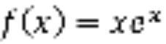 at 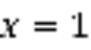. Calculate its first and second derivatives for 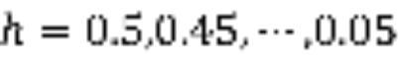, using the forward and central difference formulae. Plot the log error versus . Compare your results with that of Richardson extrapolation.

- (15 points) Use the two-point, three-point, and five-point formulae to estimate the first five derivatives of 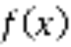 at 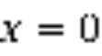.
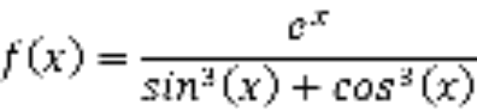
As a check, 
You are recommended to change the value of in the fashion of 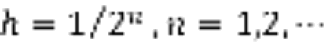.
3. (10 points) Use library functions and subroutines, to prove the following equalities numerically:
 （1）
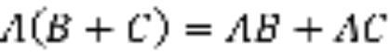 （2）
 （3）
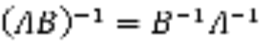 （4）
 （5）
with
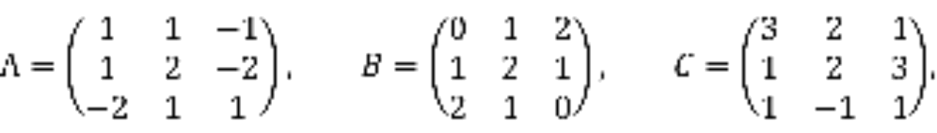
4. (20 points) Study the Hilbert matrix again.
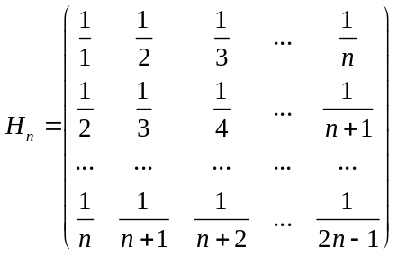
Diagonalizing H_{n} and calculate the ratio of the largest eigenvalue to the smallest eigenvalue, log(max|λ|/min|λ|), and plot it as a function of n. Discuss your results.
Do the problem for both single and double precisions. Indicate which diagonalization routine you are using.

5. Coupled Oscillators (35 Points: 10, 10, 15)
Use program similar to Oscillators to solve the dynamics equation of motion for 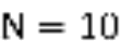 oscillators with the initial conditions 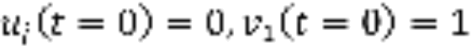. Compare numerical results of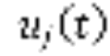 with the analytic one.
(a) What is the maximum deviation of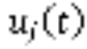?
(b) How well is the total energy conserved as function of ?
(c) How well is the total energy conserved as function of if one uses Runge-Kutta 4th order algorithm?

6. (20 points) Table 3.1 lists a few values of Bessel functions. Estimate J₁(4.5) by Lagrange polynomial interpolation for n = 1, 2, 3, and 5. Compare with exact value of J₁(4.5) from math library. Recalculate J₁(4.5) by Hermite interpolation for n 1, 3, and 5. The derivative of J₁(x) is ( J₀(x) – J₂(x) )/2.

