Computational Physics Homework Assignment #3

April 08, 2019; Due April 29, 2019
Reading Assignment

- Read lecture notes and references; Study sample programs and prepare your own programs with any languages you prefer.
- Find the 2-3 most recent review articles on nonlinear phenomena and random walks.

Laboratory Assignments (Total Points: 100; Select (1) or (2)), on April 15, 2019

- (60 points) Write a program to generate the Bifurcation Diagram. 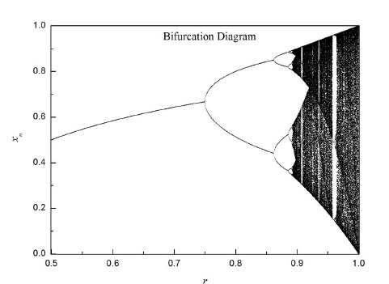
- (60 points) Write a program to enumerate all possible self-avoiding random walks on square lattice at least to N=15.

- (40 points) Find root(s) of a simple function, 0 = f(x) = cos(x) – ax , a = 1.0, 1/6.
  - Use graphic method to estimate (i) number of roots; (ii) numerical value of roots to 2 significant figures.
  - Use the bisection method to determine all roots to (i) 5 significant figures; (ii) 8 significant figures. List number of iterations in your calculations.
  - Repeat part (b) by the method of Newton-Raphson.
  - Repeat part (b) by the method of Secant.
  - Repeat part (b) by the method of false position.
  - Repeat part (b) by the method of a simple iteration scheme.

