# Software Project Management Plan

1. Introduction

This project will cover all of the requirements/restraints for the development of an inventory and database management system by Ebersoft code group and the Awaken clothing company. The system developed will track clothing and accessories currently held by the company as well as providing manipulative sales stats for multi-context analysis. This project is being commissioned by the University of Central Arkansas Computer Science department

* 1. Project overview

This project is to create a fully functioning inventory and sales management system for the company Awaken, a small fashion startup. Upon completion of this project we will have a GUI for both inventory and sales, a database for holding all inventory data, a numbering schema that allows quick data entry, an online retail host that provides sales data in CSV, and a sales management GUI that allows for the CSV data to be passed into and manipulated for analysis.

* 1. Evolution of this document

This document will be updated as the project progresses. Updates should be expected in the following sections:

1. ***References*** - updated as necessary
2. ***Definitions, acronyms, and abbreviations*** - updated as necessary
3. ***Organizational Structure*** will be updated by team leader at each phase
4. ***Technical Process -*** this section will be revised appropriately as the requirements and design decisions become clearer
5. ***Schedule –*** as the project progresses, the schedule will be updated accordingly

**Revision History**

|  |  |  |  |
| --- | --- | --- | --- |
| **Revision** | **Date** | **Updated By** | **Update Comments** |
| 0.1 | 2/25/2017 | Chase Pavlu | Document Preparation |
| 0.2 | 3/20/2017 | Justin Hill | WBS/ SCHEDULE |
| 0.3 | 4/10/2017 | Justin Hill | Update/WBS/Schedule |
|  |  |  |  |
|  |  |  |  |
|  |  |  |  |
|  |  |  |  |
|  |  |  |  |
|  |  |  |  |

* 1. References
  2. Definitions, acronyms, and abbreviations
     1. Style Number(SN)
        1. Number used to denote season-gender-style-material-iteration
     2. Stock Keeping Unit(SKU)
        1. Number used to denote SN-color-size
     3. Out of stock(OOS)
     4. Overstock(OS)

1. Project organization
   1. Process model

The process model for our project will be (process here). We will start with the basic functionalities and update what is needed for each individual piece to work with the starting pieces and slowly build on until we have the entire project. This will allow us to fix things needed and build a strong foundation for the software.

* 1. Organizational structure

Team Members –

* + 1. Chase Pavlu
    2. Justin Hill
    3. Hasani Mason
    4. Josh Kuhen
    5. Winston Biggs
    6. Calvin Flippo

|  |  |  |
| --- | --- | --- |
| Week/Deliverable | Team Leader | Deliverable Description |
| 1 | Chase Pavlu | Project Plan |
| 2 | Chase Pavlu | Requirements Specification |
| 3 | Chase Pavlu | Analysis |
| 4 | Chase Pavlu | Architecture Spec |
| 5 | Chase Pavlu | Component/Object Specification |
| 6 | Entire Team | Source Code |
| 7 | Entire Team | Test Plan |
| 8 | Entire Team | Final Deliverable |

## Organizational boundaries and interfaces

Team leader will be responsible for coordinating team meetings, updates, communications, and team deliverables

* 1. Project responsibilities

For primary responsibilities per phase, please refer to section 2.2. Ultimately the entire project team is responsible for the successful delivery of the product.

Team member assignments per deliverable according to expertise

1. Project Plan – Entire Team
2. Requirements Specification – Entire Team
3. Analysis – Entire Team
4. Architecture Spec – TBD
5. Component/Object Specification – TBD
6. Source Code – TBD
7. Test Plan – TBD
8. Final Deliverable – Entire Team
9. Managerial process
   1. Management objectives and priorities

The objective of the project is to develop an inventory and sales management system within allocated budget, time, and specified quality. The project is highly prioritized due to high benefits to the organization and to the code group.

* 1. Assumptions, dependencies, and constraint  
     The project assumptions are as follows
     1. Team of 6 resources
     2. Equipment and software availability
     3. Approval on funding
     4. Available hosting resources

The project dependencies are as follows

* + 1. Inventory size and scaling processes
    2. Availability of mock sales and inventory data

The project constraints are as follows

* + 1. Time
    2. Budget
    3. Man hours
    4. Availability of existing software
  1. Risk management
     1. Market risk
     2. Financial risk
     3. Technology risk
     4. People risk
     5. Structure/process risk
  2. Monitoring and controlling mechanisms
     1. Weekly project status meetings
     2. Shared document repository
     3. Project tracking by Excel Gantt Chart
     4. Tracking utilizing baselines in Excel

1. Technical process
   1. Methods, tools, and techniques  
      The object oriented analysis technique will be used to successfully complete the project.
   2. Software documentation
      1. Documentation such as Functional Specification document, Technical Specification document, detail design document, and Implementation Plan.
   3. Project support functions
      1. All project support documents will be completed in applicable phases
2. Gantt Chart

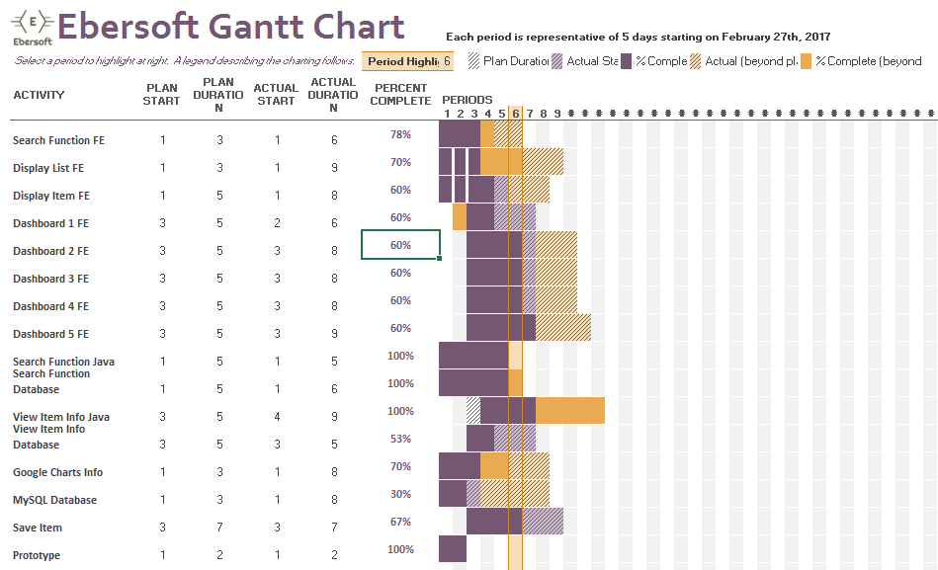

1. Work elements, schedule, and budget
   1. The project is budgeted for 6 resources, and equipment needed to complete analysis, implementation, and test the application
   2. Each period on the Gantt Chart above is representative of five days
   3. Search Function Front End
      1. Calvin Flippo
   4. View List Front End
      1. Calvin Flippo
   5. View Item Front End
      1. Calvin Flippo
   6. Dashboard 1 Front End
      1. Calvin Flippo
      2. Chase Pavlu
      3. Justin Hill
   7. Dashboard 2 Front End
      1. Calvin Flippo
      2. Chase Pavlu
      3. Justin Hill
   8. Dashboard 3 Front End
      1. Calvin Flippo
      2. Chase Pavlu
      3. Justin Hill
   9. Dashboard 4 Front End
      1. Calvin Flippo
      2. Chase Pavlu
      3. Justin Hill
   10. Dashboard 5 Front End
       1. Calvin Flippo
       2. Chase Pavlu
       3. Justin Hill
   11. Search Function Java
       1. Josh Kuhen
       2. Chase Pavlu
       3. Justin Hill
   12. Search Function Database
       1. Winston Biggs
       2. Hasani Mason
   13. View Item Information Java
       1. Josh Kuhen
       2. Chase Pavlu
       3. Justin Hill
   14. View Item Information Database
       1. Winston Biggs
       2. Hasani Mason
   15. Google Charts Info
       1. Chase Pavlu
       2. Justin Hill
   16. MySQL Database
       1. Winston Biggs
       2. Hasani Mason
   17. Save Item
       1. Chase Pavlu
       2. Justin Hill
2. Work elements, schedule, and budget

* Search Function Front End
  + Calvin Flippo
    - STATUS: 78% Completed
    - EXPECTED COMPLETION DATE: 3/29/17
* View List Front End
  + Calvin Flippo
    - STATUS: 70% Complete
    - EXPECTED COMPLETION DATE: 4/3/17
* View Item Front End
  + Calvin Flippo
    - STATUS: 60% Completed
    - EXPECTED COMPLETION DATE: 4/3/17
* Dashboard 1 Front End
  + Calvin Flippo, Justin Hill, Chase Pavlu
    - STATUS: 60% Completed
    - EXPECTED COMPLETION DATE: 4/9/17
* Dashboard 2 Front End
  + Calvin Flippo, Justin Hill, Chase Pavlu
    - STATUS: 60% Completed
    - EXPECTED COMPLETION DATE: 4/9/17
* Dashboard 3 Front End
  + Calvin Flippo, Justin Hill, Chase Pavlu
    - STATUS: 60% Completed
    - EXPECTED COMPLETION DATE: 4/10/17
* Dashboard 4 Front End
  + Calvin Flippo, Justin Hill, Chase Pavlu
    - STATUS: 60% Completed
    - EXPECTED COMPLETION DATE: 4/10/17
* Dashboard 5 Front End
  + Calvin Flippo, Justin Hill, Chase Pavlu
    - STATUS: 60% Complete
    - EXPECTED COMPLETION DATE: 4/11/17
* Search Function Java
  + Josh Kuhen, Justin Hill, Chase Pavlu
    - STATUS: 100% Completed
    - EXPECTED COMPLETION DATE: 4/2/17
* Search Function Database
  + Winston Biggs, Hasani Mason
    - STATUS: 89% Completed
    - EXPECTED COMPLETION DATE: 4/5/17
* View Item Information Java
  + Chase Pavlu, Josh Kuhen, Justin Hill
    - STATUS: 100% Completed
    - EXPECTED COMPLETION DATE: 4/10/17
* View Item Information Database
  + Winston Biggs, Hasani Mason
    - STATUS: 70% Completed
    - EXPECTED COMPLETION DATE: 4/12/17
* Google Charts Info
  + Calvin Flippo
    - STATUS: 70% Completed
    - EXPECTED COMPLETION DATE: 4/15/17
* MySQL Database
  + Winston Biggs, Hasani
    - STATUS: 30% Completed
    - EXPECTED COMPLETION DATE: 4/4/17
* Save Item
  + Chase Pavlu, Justin Hill, Josh Kuhen
    - STATUS: 67% Completed
    - EXPECTED COMPLETION DATE: 4/10/17