1. Introduction:
   1. We are creating a software solution to the problem of inventory management and sales information management using a web-based GUI, local backend Java, a web-based database and an online retail hosting site.
2. Assumptions
   1. I know what im doing … lol
3. Glossary:
   1. Style Number (Season (F or S)-Gender(1xxxxx)-Style(x1xxxx)-Material(xx1xxx)-Iteration(xxx001))
   2. Stock Keeping Unit (Style Number-Color (hex)-Size)
   3. OSS (Out of Stock)
   4. OS (Overstock)
4. Operating Environment:
   1. Desktop access only, local Java and HTML5/CSS3/JQuery code, will run in the hosts browser but will run locally and only connect to the internet for database storage and charting in google charts
5. Interfaces:
   1. Home

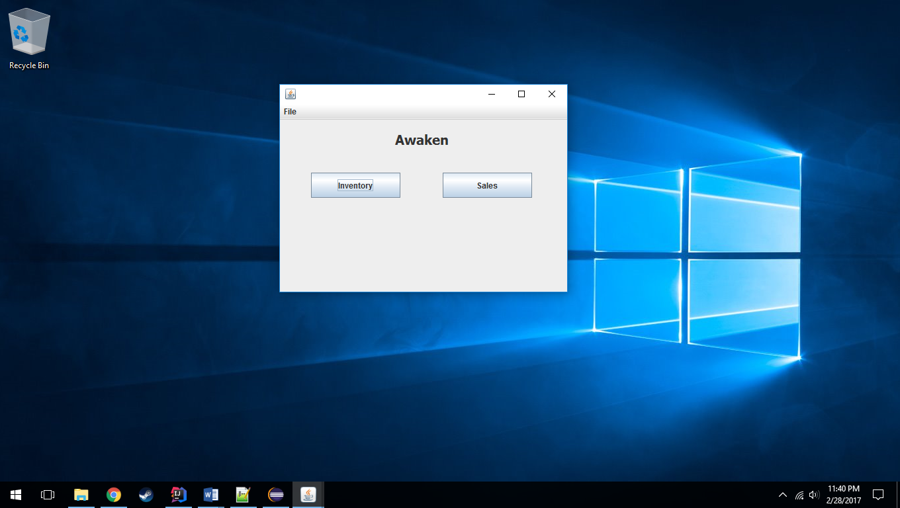

* 1. Inventory

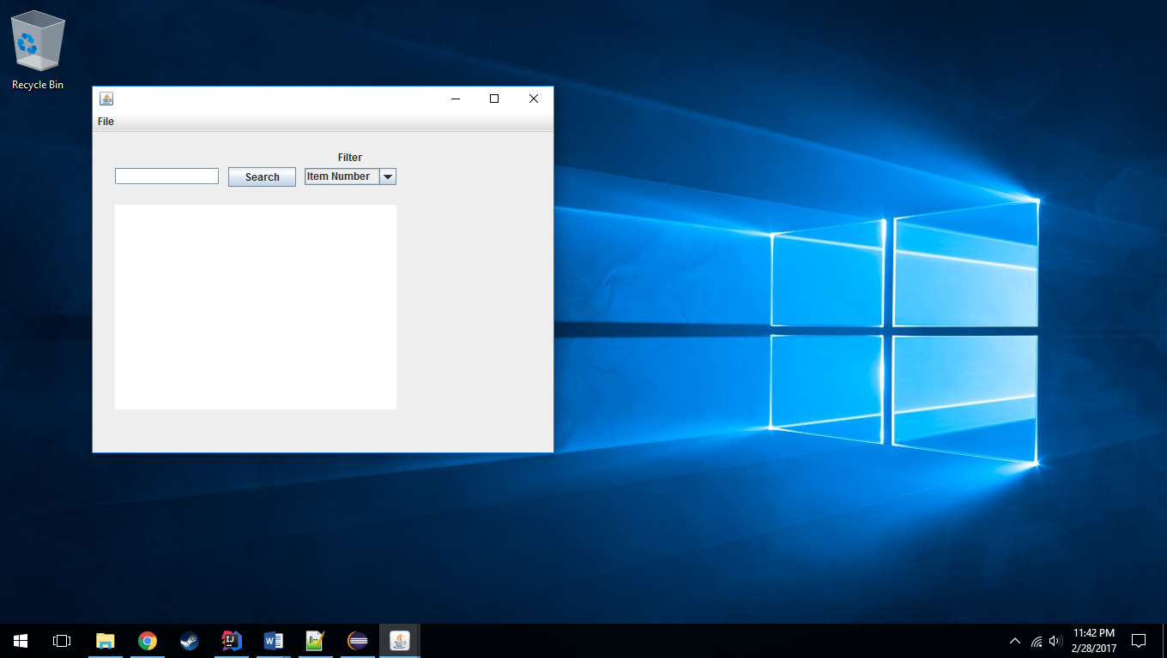

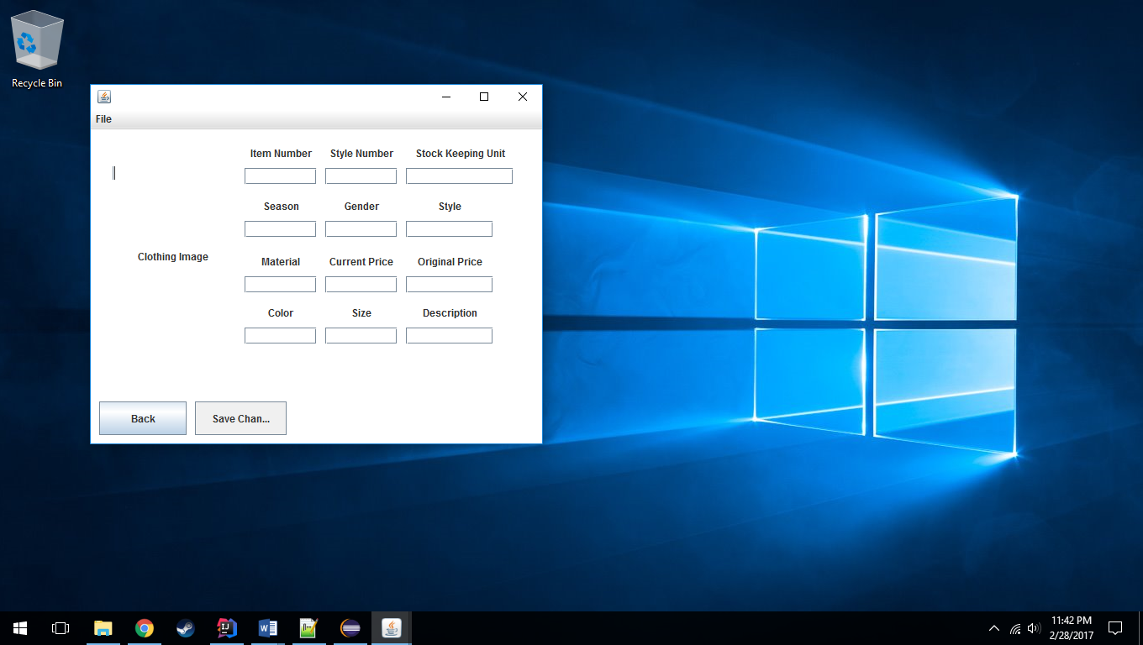

* 1. Sales

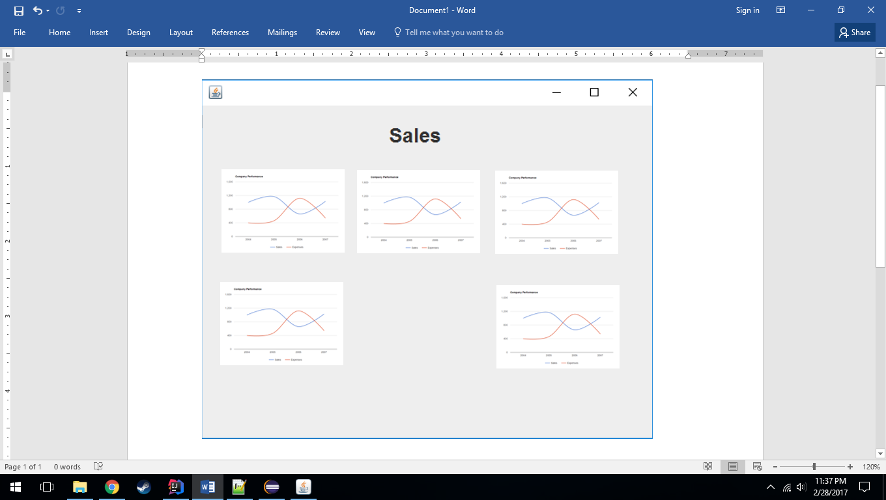

1. Object-Oriented Analysis:
   1. Search an item
   2. View an item’s information
   3. Edit an item
   4. Save an item
   5. Filter the search
   6. View the sales dashboards
   7. Alter dashboard 1
   8. Alter dashboard 2
   9. Alter dashboard 3
   10. Alter dashboard 4
   11. Alter dashboard 5
2. Non-functional Requirements:
   1. Must be Java SE 8, HTML5, CSS3 or greater
   2. Nothing runs in parallel in this system
   3. Nothing can run in parallel in this system
   4. All access will be granted to all users and will be controlled locally by a door
3. Traceability Matrix: