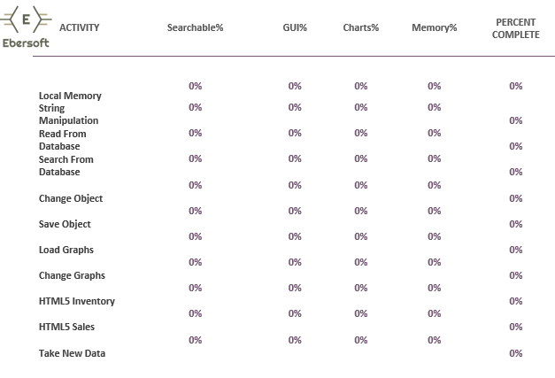

100%

100%

100%

100%

100%

100%

100%

100%

100%

100%

100%

100%

100%

100%

100%

100%

100%

100%

100%

100%

100%

100%

100%

100%

100%

100%

100%

100%

100%

100%

100%

100%

100%

100%

100%

100%

100%

100%

100%

100%

100%

100%

100%

100%

100%

100%

100%

100%

100%

100%

100%

100%

100%

100%

100%