Awaken Atelier

Inventory and Sales Management System (ISMS)

User Manual

Table of Contents

1. System Introduction 3
   1. Introduction 3
   2. Software description 3
   3. Startup Procedure 3
   4. Basic Information 3
2. High Level System View 4
   1. Home Screen 4
   2. Inventory 5
   3. Sales 5
3. Index 6
4. Appendices 7

System Introduction

* Thank you for choosing to use the Awaken Atelier Inventory and Sales Management System for your data storage needs. Over the course of this section we will establish the basic features of the software and explain how to get started.
* This software will allow you to store and access your real-time warehouse and sales information. This means that using the ISMS you can search your warehouse to find out what you have and when you got it and simultaneously you can see how that piece is performing on the floor every day.
* To get started simply start up the AwakenISMS client and search for a piece of clothing, or if this is your first time, you can select new clothes and it will allow you to add a new piece to your collection.
  + Utilizing industry standards, you can add the piece using filters such as SKU, Style, Description, etc.
* To view the sales information simply navigate to the sales page and allow the dashboards to load. From this point you can import data and edit the dashboards using the drop down menus on the respective dashboards.

High-Level System View

This is what you can expect the system to look like when you first open it

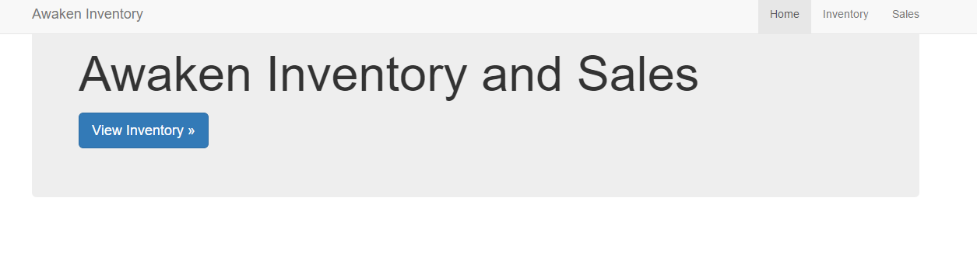

From here you can select inventory or sales in the top right or view inventory in under the title

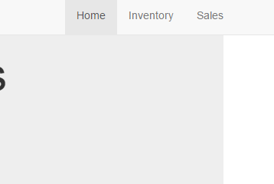

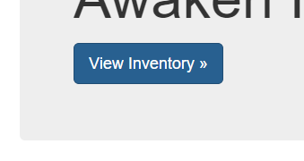

When you reach, the inventory page the search bar will appear and you can search an item of clothing

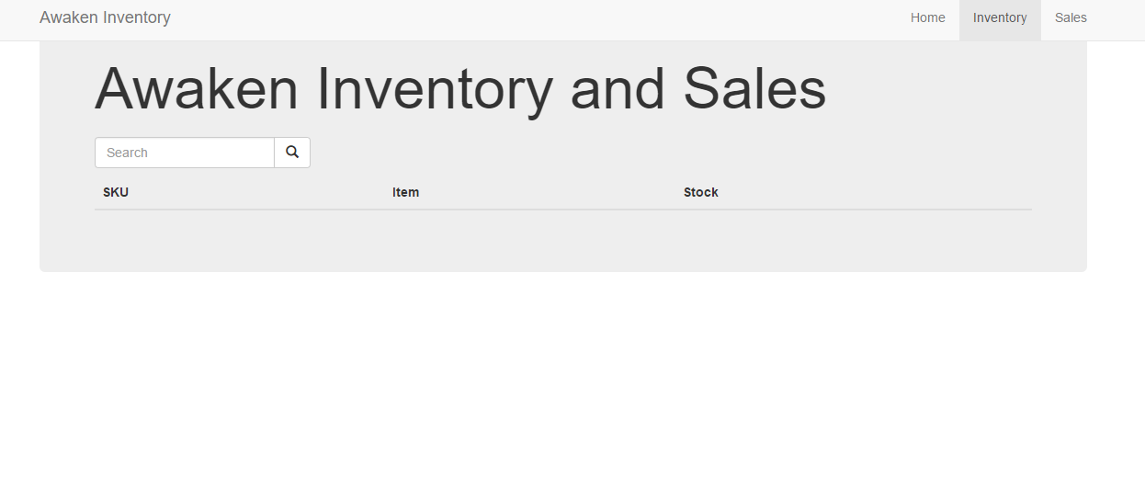

You can also view the sales screen by pressing sales. This software is simple to use and intuitive.

Index

* Table of Contents 2
* System Introduction 3
* High Level View of System 4
* Index 6
* Appendices 7

Appendices

1. To run this system, you must be using a system that has Oracle Database and Java SE 8 installed and has an updated web browser
2. For assistance with program contact:

EberSoft Group LLC

(501)581-8065

ebersoftllc@gmail.com