Testing

The main goal with the automatic testing is to ensure that any quick refactoring’s done to the project, will not damage the core functionality. Due to our project not only using a GUI, but also its use of SQLite to add a database, it makes it very difficult to conduct traditional Unit testing appropriately.
Additionally, I have attempted to incorporate DocTesting in hopes to have more success with the GUI/Database but still to no avail.
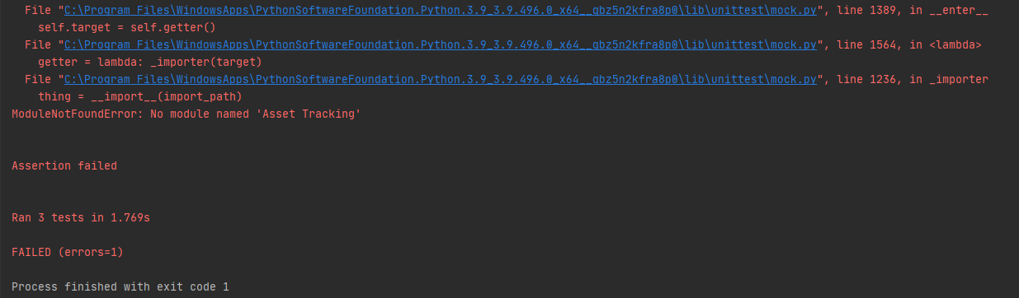

Due to the 2 external dependencies, as aforementioned, it increases the difficulty of employing these forms of testing quite significantly as you can see in the above PrintScreen. This as far as my research has shown, there is no real way for the testing suite to ‘see’ the changes made to the GUI.
We can however test that our input validation works correctly, and that the program wont crash when given values it cant handle. Essentially it is only the core logic that may be tested through these means, other areas of our program must be tested manually in order to validate their current working state.

DataBase GUI
Functions being tested:
- Add_Data()
- Search(ID)
Test Purpose:
- Check correct exceptions thrown where appropriate.
- Logic works as expected.
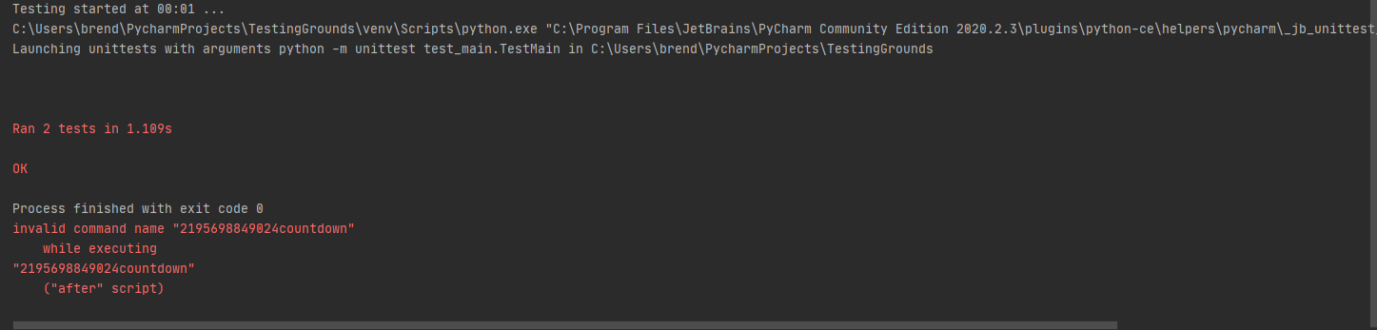

LogInForm(with DB verification)
Functions being tested:
- My_details()
Test Purpose:
- Check correct exceptions thrown where appropriate.

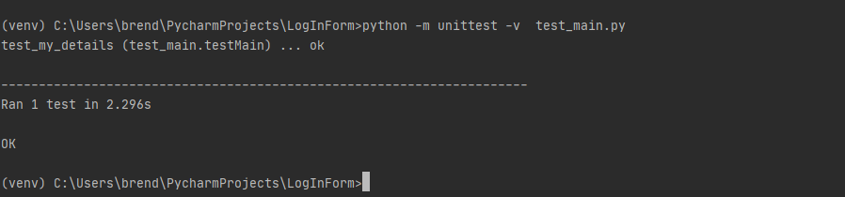

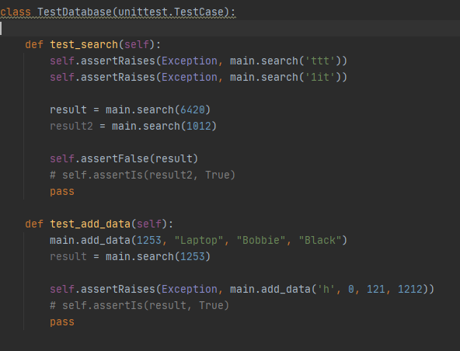
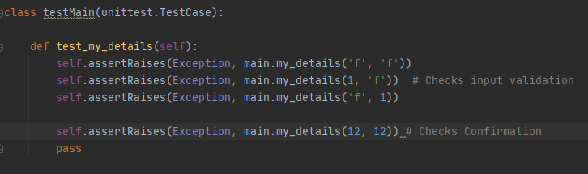
s

References/Helpful Links (Why gui test automation bad)

https://www.theregister.com/2007/10/22/gui_unit_testing/#:~:text=Of%20course%20GUI%20applications%20can,test%20GUIs%22%20because%20it's%20difficult.
Arguments that GUIs should be tested with Units in mind, however not the UI itself necessarily but rather the implemented logic of the program. Essentially confirms the methods we have followed, i.e test base logic, throwing exceptions so on, rather than the GUIs response to them.

https://softwareengineering.stackexchange.com/questions/207274/should-i-bother-to-write-unit-test-for-ui-ux-components

A forum exclaiming the same thing more or less, Unit testing has its place more for actual logic testing whereas testing the GUI and how it reacts to the code is more for ‘functional/integration’ testing.

https://agilewarrior.wordpress.com/2015/04/18/classical-vs-mockist-testing/

This is where I found the information regarding the ‘Mock’ class and how it can be used for emulating objects in code that you don’t necessarily want to run, a good way to explain it is if you were say hooking up to a website, rather than actually connecting to the site during every test case you run, it’ll instead connect to a ‘mock’ version of the website thus emulating the experience of connecting to a site.
Useful when working with something difficult to test or is legacy code/cant be refactored.
I did try to implement this also, I tried to emulate a gui framework to work with but had no real research to help with that one. I then tried to emulate the DB just to test the add_Data() functionality, but I then had issues with sql queries trying to run on the ‘fake’ DB.

A way we could actually implement the unittesting appropriately is by using an MVC pattern (cool how our modules cross over tho!). Due to it being split into, you could say, ‘units’ it makes it far simpler to test. Again only the core functionality of a given function can be tested, GUI testing still proves to be best done by human eye (as far as my research shows so far anyway, it can be done in other frameworks quite easily but so far nothing for tkinter within reason)

https://www.semicolonworld.com/question/59599/how-do-i-run-unittest-on-a-tkinter-app

So this link is the closest to a solution ive found, and it entails essentially setting the GUI to execute in another thread while the testing continues in the main thread. Of course, my knowledge of threading is stretched as it is, but in this sense I was completely lost on what to do. However it does seem like a viable option for the future.

Here I will chuck some of my attempts at setting other tests for the program just in case you find any use for them:

This was an attempt to create a fake database just to test the add_data function but with a separate database not to edit our original. This did not work, at all.
class TestDatabase(unittest.TestCase):
def setUp(self):
"""
Setup a temporary database
"""
conn = sqlite3.connect("testDatabase.db")
cursor = conn.cursor()
# create a table
cursor.execute("""CREATE TABLE test
(id text, name text, surname text,
options text)
""")
# insert some data
cursor.execute("INSERT INTO test VALUES "
"('1012', 'Dave', 'Parkhouse',"
"'Laptop'")
# save data to database
conn.commit()
# insert multiple records using the more secure "?" method
testVals = [('1654', 'Andy', 'Hunter',
'Laptop'),
('9865', 'Red', 'Davies',
'Laptop'),
('6545', 'Krutch',
'Jones', 'Tablet'),
('7845', 'Lee', 'Evans',
'Laptop')]
cursor.executemany("INSERT INTO test VALUES (?,?,?,?)",
testVals)
conn.commit()
def tearDown(self):
os.remove("mydatabase.db")

This was then an attempt at using ‘mock’ to emulate a database, again this did not work, at all. The sql queries were not able to execute on my ‘test’ DB sadly so would just get constant exceptions.

