First Last, Welcome to Poolesville High School!  
Here is your schedule for the evening:

|  |  |
| --- | --- |
| 6:00 - 6:10 | Auditorium |
| 6:15 - 6:45 | ROT1 |
| 6:50 - 7:20 | ROT2 |
| 7:25 – 7:55 | ROT3 |
| 8:00 – 8:30 | ROT4 |

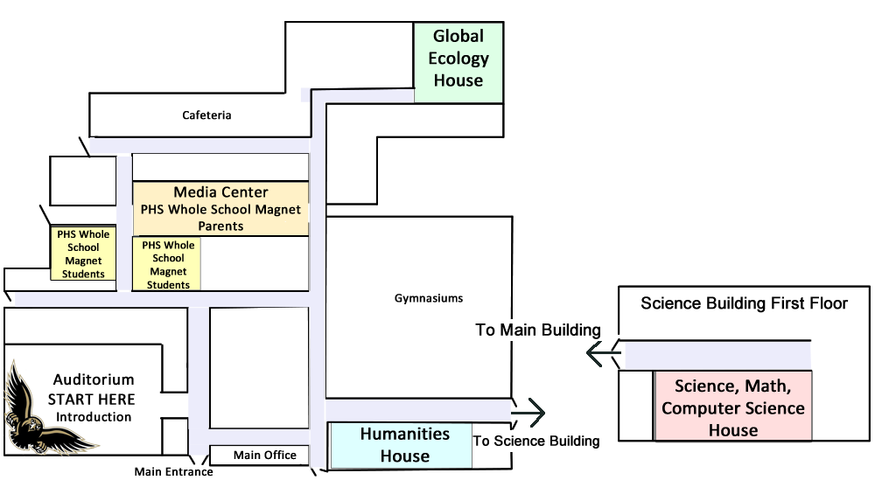**Poolesville High School   
Invited Meeting Map**

**Poolesville High School-  
More Than the Magnets!**

**Getting to School - Transportation**



**Where Do PHS Students Go?  
-College and University Acceptance List**



**Where can you Innovate?  
Recreate? Advocate  
(Clubs and Activities)**



**Communication Options-List  
Serves and Parent Forums**



**Sports! Sports! Sports!**



**For the Compete Story -  
PHS Website**

