Jim John, Welcome to Poolesville High School!  
Here is your schedule for the evening:

|  |  |
| --- | --- |
| 6:00 - 6:10 | Auditorium |
| 6:15 - 6:45 | Room 8 - Humanities House |
| 6:50 - 7:20 | Room 195 - Science, Math, Computer Science House |
| 7:25 – 7:55 | Room 33 - Global Ecology House |
| 8:00 – 8:30 | Media Center - PHS Whole School Magnet: Parents Room 41 - PHS Whole School Magnet: Students |

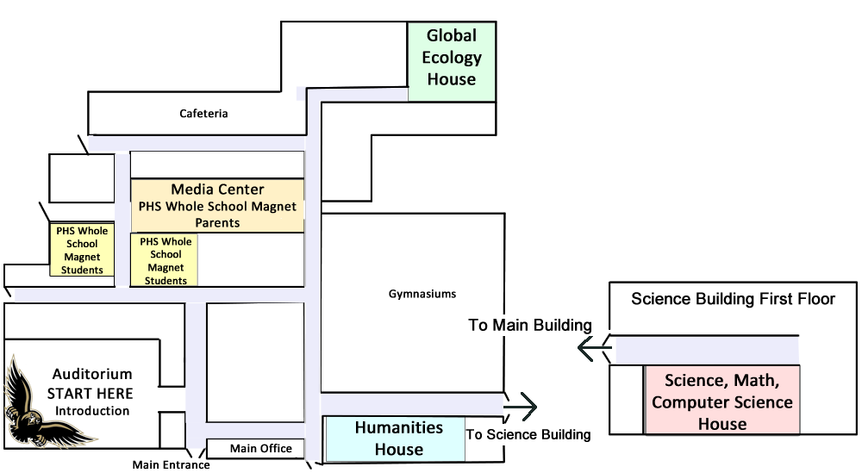**Poolesville High School   
Invited Meeting Map**

On this page, updated weblinks need to be retrieved from the Magnet Office. New QR codes will need to be generated if there is a change in the website addresses.

**Poolesville High School-  
More Than the Magnets!**

**Getting to School - Transportation**



**Where Do PHS Students Go?  
-College and University Acceptance List**



**Where can you Innovate?  
Recreate? Advocate  
(Clubs and Activities)**



**Communication Options-List  
Serves and Parent Forums**



**Sports! Sports! Sports!**



**For the Compete Story -  
PHS Website**

