The Compaignye of the Pilgrim Souldiours

Societas Militum Peregrinorum

Motto: Peregrini in Via, Fratres in Armis ("Pilgrims on the Road, Brothers in Arms")
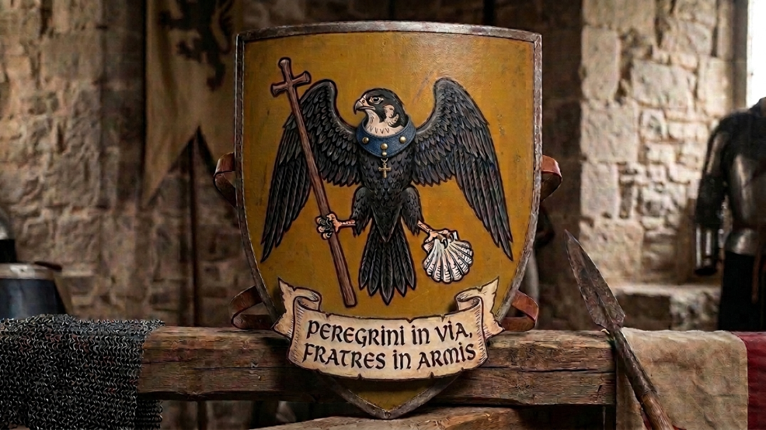

Shield Blazon: Or, a falcon displayed proper, wearing about its neck a collar Azure secured with three bezants, bearing in its dexter claw a bourdon terminating in a cross potent, and in its sinister claw an escallop shell Argent.

Hail, members of the Chapter and good fellows of the Compaignye! As we ready our harness and pack our scrips for the road, let us establish the foundational narrative and operational roster for our living history company.
While inspired by the social texture and diverse fellowship immortalized by Geoffrey Chaucer, we are a living history organization portraying a real, functional company of late-fourteenth and early-fifteenth-century English travelers (1375–1425 AD).

I. Purpose
The Compaignye of the Pilgrim Souldiours is a living history organization dedicated to the research, reconstruction, and education regarding the life, material culture, and martial arts of late medieval England (1375–1425 AD). Drawing inspiration from the diverse social strata of Geoffrey Chaucer’s Canterbury Tales, we portray the "diverse folk" of the era, preserving this cultural legacy through historical accuracy, safe martial practice, and fraternal cooperation.

II. Code of Conduct
- Safety First: All martial activities must be conducted with the highest regard for safety. Negligence will result in suspension.
- Historical Integrity: Members strive to maintain a high standard of kit and persona representation specific to the 1375–1425 period. Documentary evidence (manuscripts, effigies, archaeological finds) is required to justify kit.
- Fraternity: We operate as a "Brotherhood in Arms." Disputes shall be resolved through the Chapter.
- Professionalism: Members must conduct themselves with professional historical awareness when in public view.
- Inclusivity & Respect: Discrimination has no place in our ranks.

III. Membership Requirements
- All members must demonstrate an ongoing commitment to historical research.
- New members serve a probationary period to ensure their kit and persona align with our high standards before being granted full voting rights.
- Members must comply with all insurance/safety requirements of the ALHF and adhere to the QLHF Harnischfechten By-law v2.0 for all martial practice.

IV. Governance
The Compaignye is governed by a Chapter led by the Host (President), the Clerk (Secretary), the Yeoman (Marshal), and the Franklin (Treasurer). Decisions are reached through the democratic consensus of the Reenactor Members.

