**How to use the Comparative Pathology OMERO Server**

**Registration**

See the administrator ( Mike Wicks / Mark Arends / Kate Britton / Ewan McDowall ) to set up an account for you.

***NOTA BENE!***

If you do NOT have an account on an OMERO Server, you will NOT be able to “see” any Images from that OMERO server in the Comparative Pathology Workbench! Instead you will only see the Names of the images referenced in the Workbench.

When you have obtained an account on the Comparative Pathology OMERO server, login in here: <https://omero-czi-cpw.mvm.ed.ac.uk/webclient/>

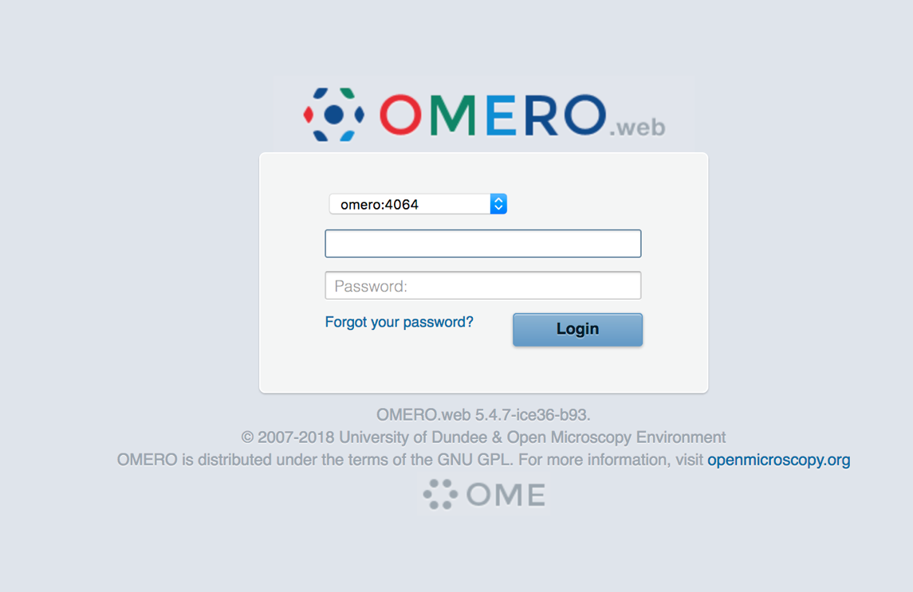

When you log in successfully, you should see the following screen:

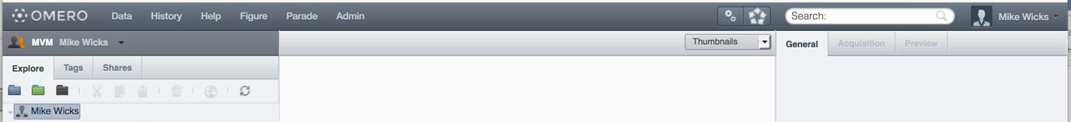

PLEASE change your password by using the User, User Settings Main Menu Option, in the top right hand corner - Check that your Default Group is “MVM”

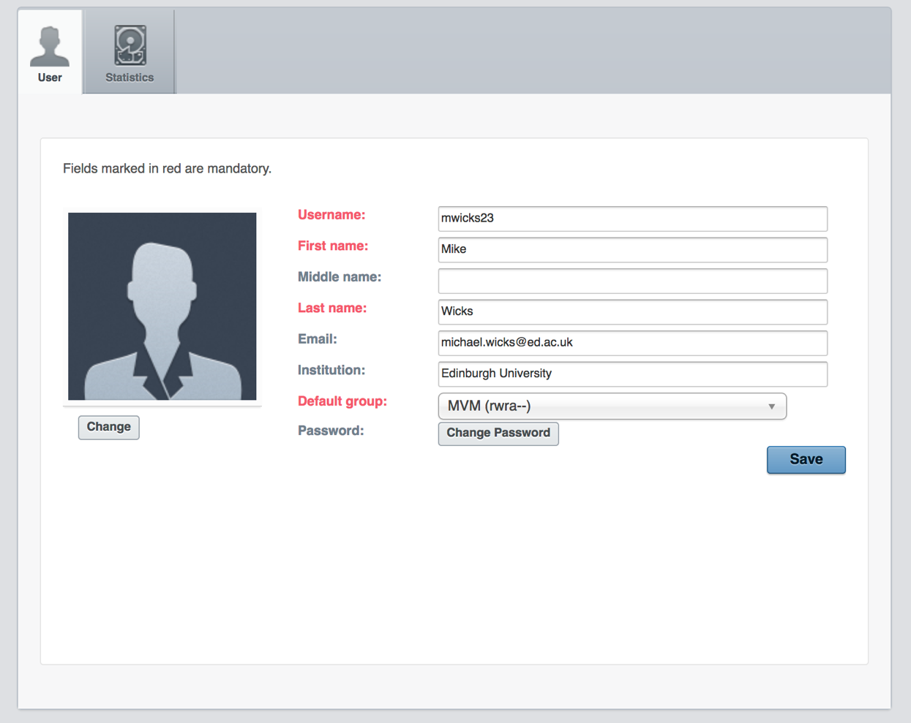

**Loading Data to the Comparative Pathology OMERO Server**

Download and install “OMERO Insight” from here: <https://www.openmicroscopy.org/omero/downloads/>

**Run OMERO Insight**

Run Insight, and you should see the Login Dialog, thus:

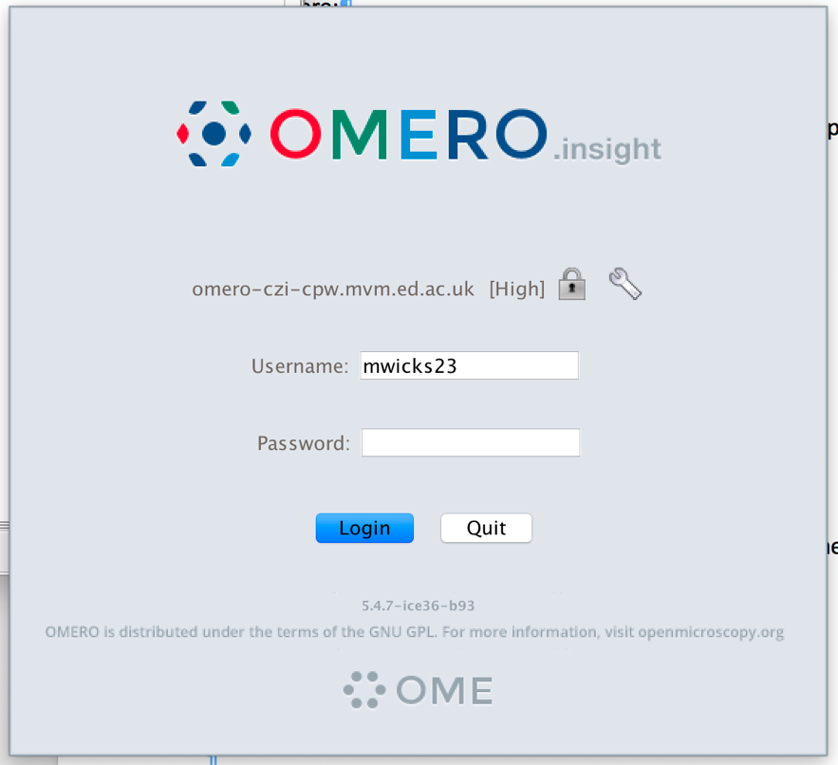

Add the URL “omero-czi-cpw.mvm.ed.ac.uk” to Insight using the “Spanner” icon.

Ensure the Padlock is SHUT

Supply your OMERO Credentials – Username and Password

When you successfully log in, you should see a screen like this:

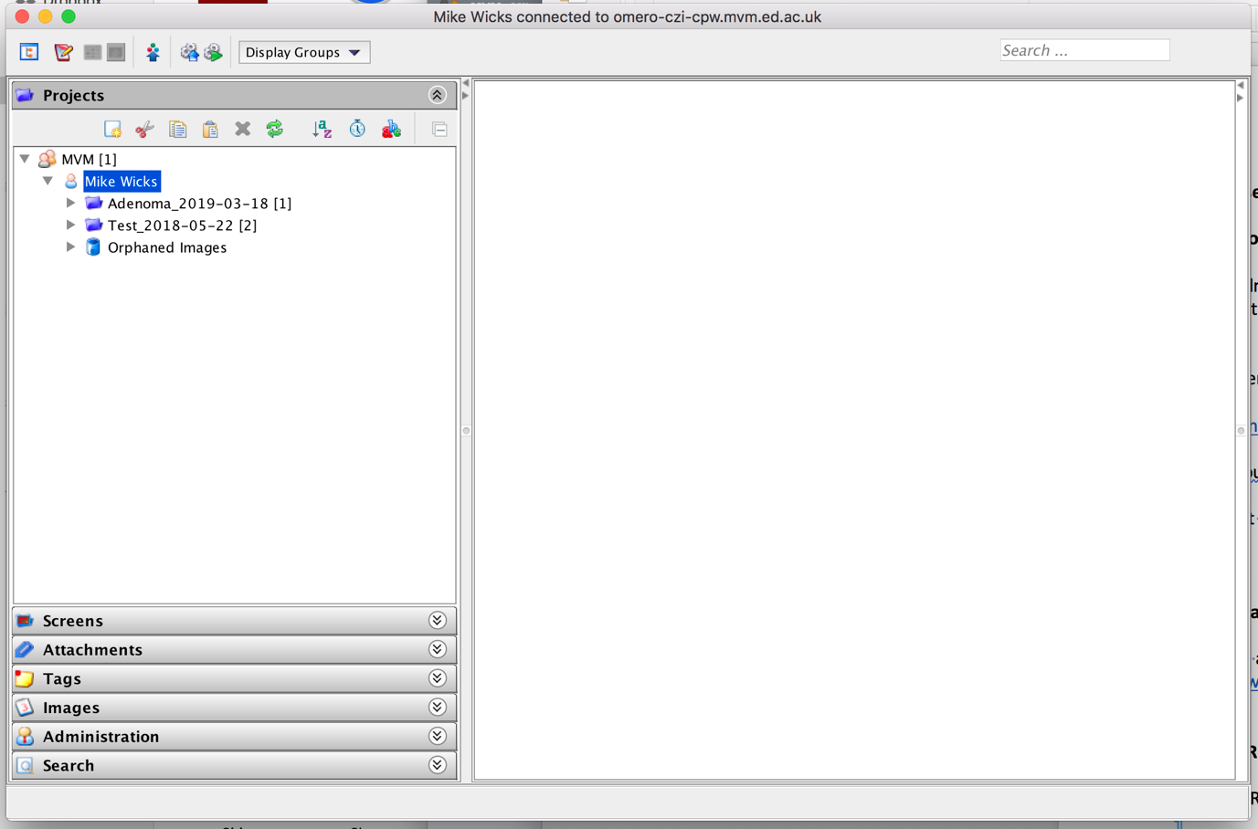

To upload data, press the “Importer” icon:



You will then see the Importer Dialog, thus:

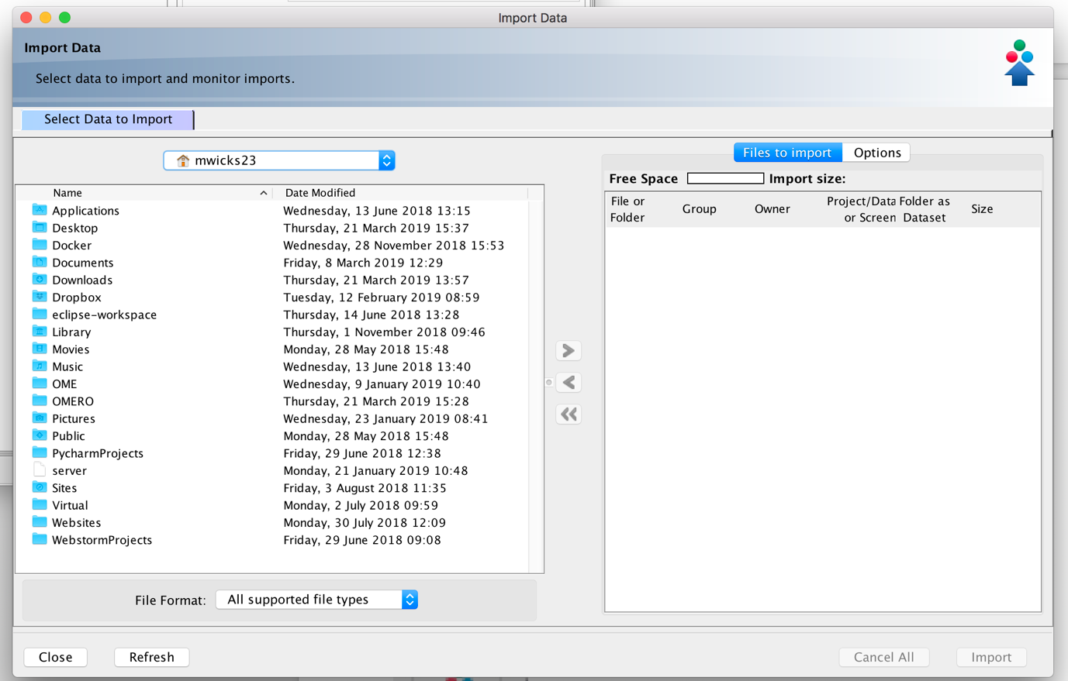

Simply navigate to the location of the data you want to upload, using the controls on the Left-Hand Side of the screen, and press the “>” or “>>” icons to select your required data.

You are then presented with a further Dialog, requesting you to define the destination of your upload.

Define the destination of your upload, using the next dialog:

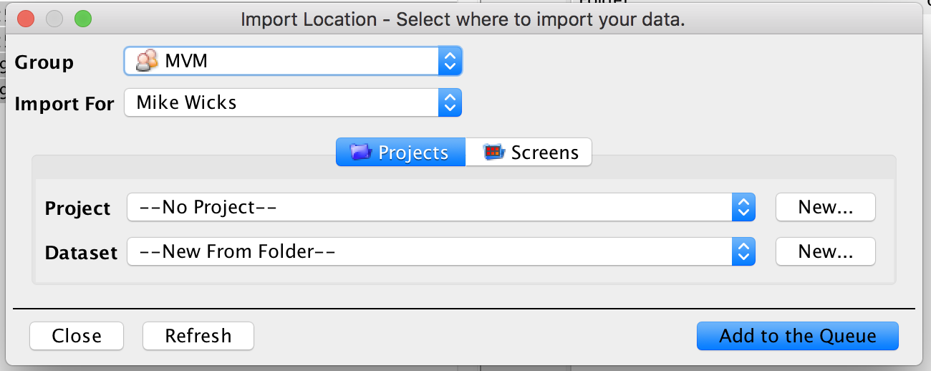

***NOTA BENE!***

* I recommend creating Project and Dataset Names and Descriptions that are as FULLY DESCRIPTIVE as possible;
* I recommend avoiding using SPACES or any “special” characters in the Project & Dataset Names!
* I recommend appending/prepending a full date in the format YYY-MM-DD to the end of the Project/Dataset Name – this helps you to discover the correct data in future, as it is obvious WHEN you created it; it also helps when you sort Names, as ascending alphabetical order is then the same as ascending Creation Date.

You WILL be prompted to select both a new or existing Project and Dataset, thus:

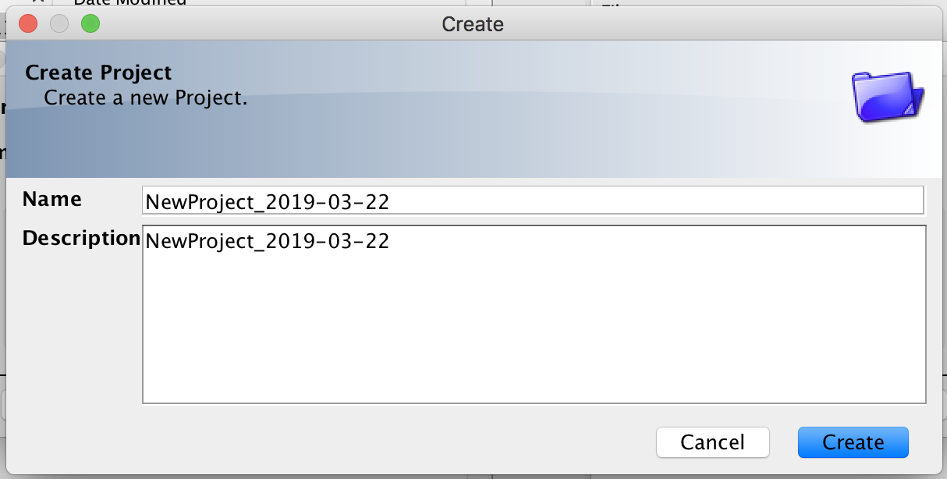

AND

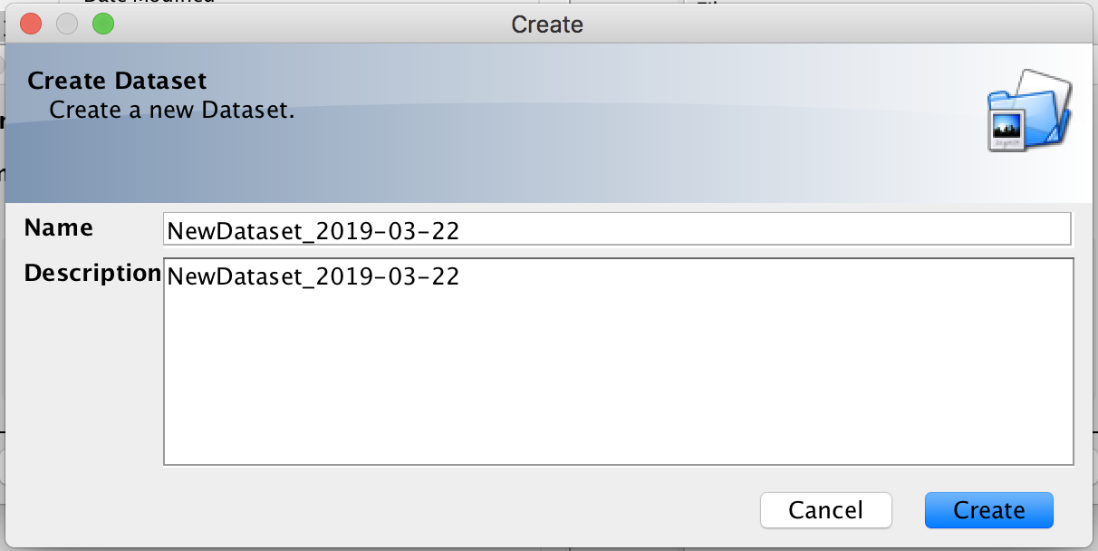

When ready to upload, press the “Add to the Queue” button.



Then from the “Import Data” dialog press the “import” button to start the Upload



The Import is now underway ….

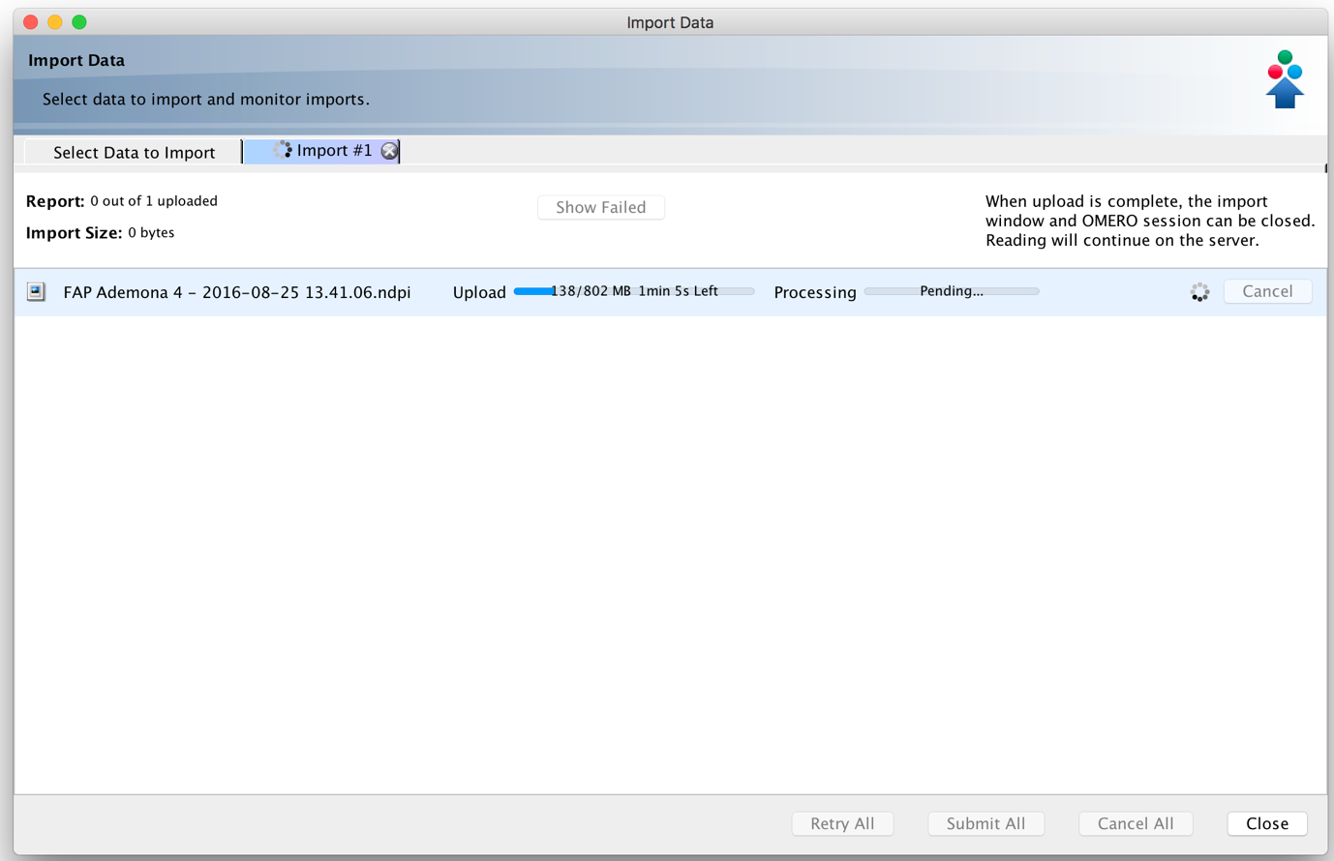

When the Import has successfully completed, you should see the screen like this …

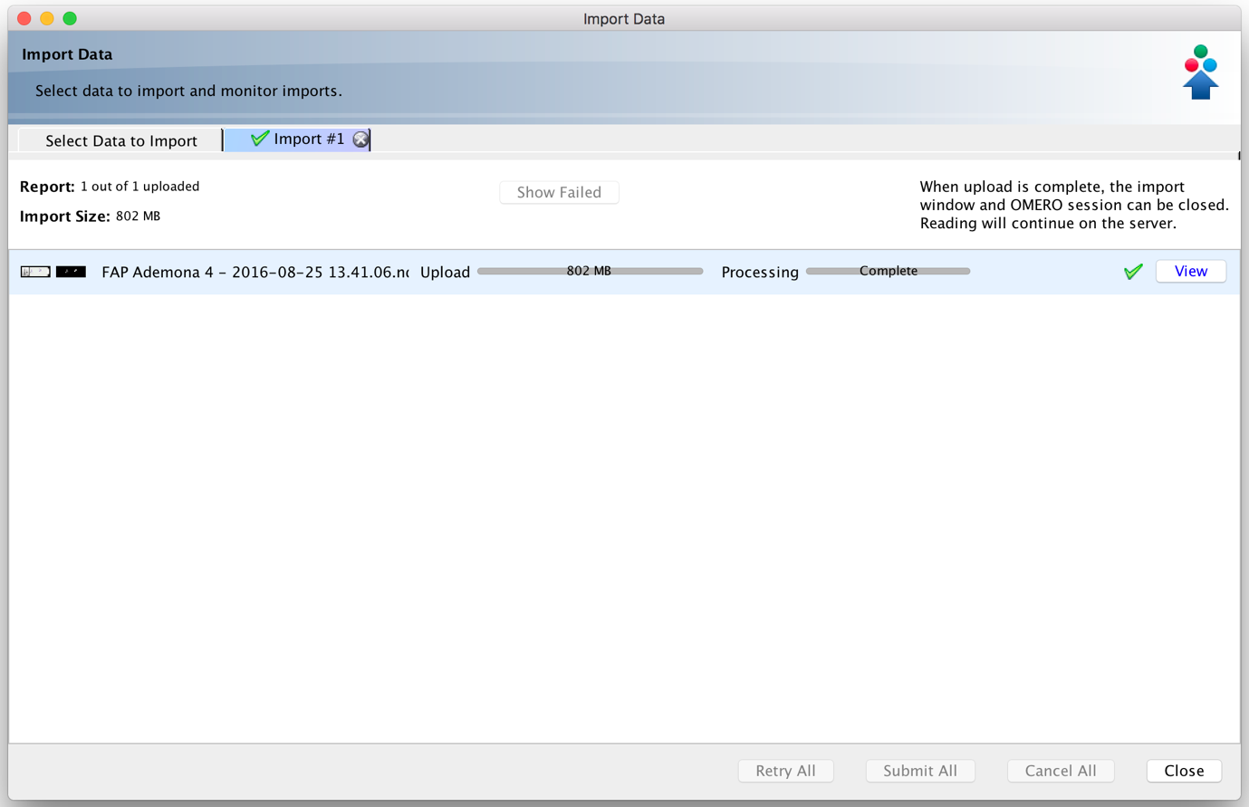

If for any reason you do not get a GREEN TICK indicating SUCCESS, contact your local OMERO Administrator!

Close the Import Dialog, and refresh the window in “OMERO Insight” to check that the uploaded images are where you expect them to be, thus:

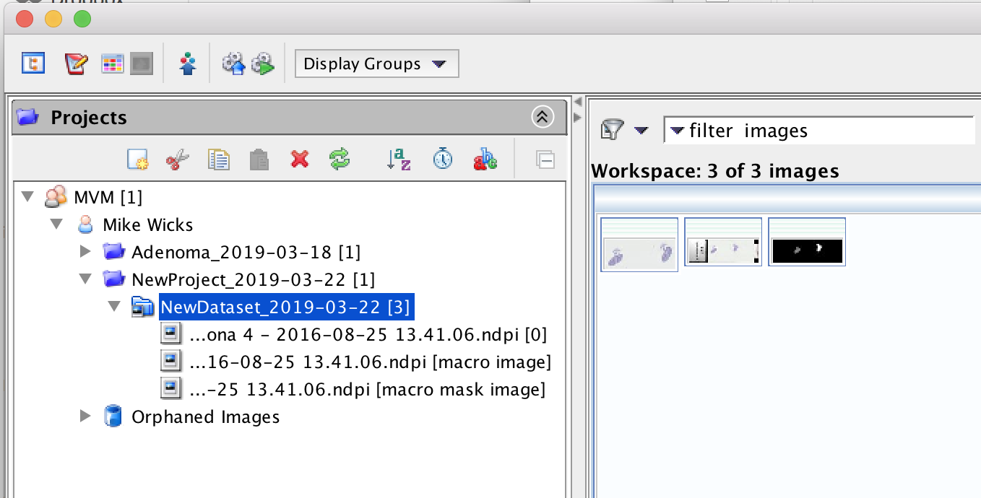

Then check you can see them via the OMERO Web Client:

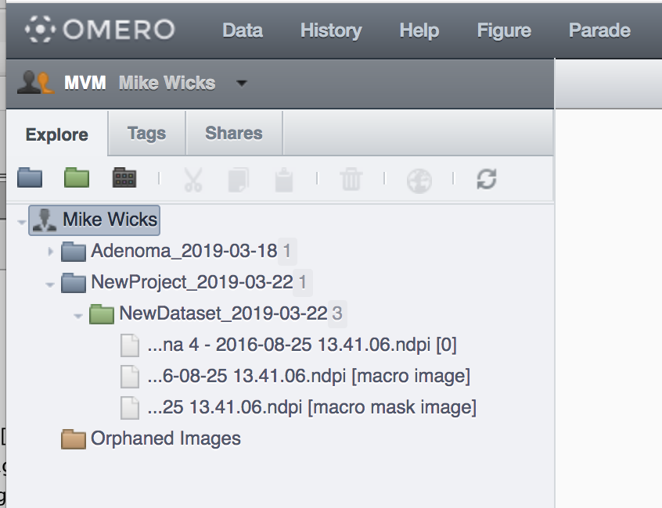

You can also check them in the Workbench itself!

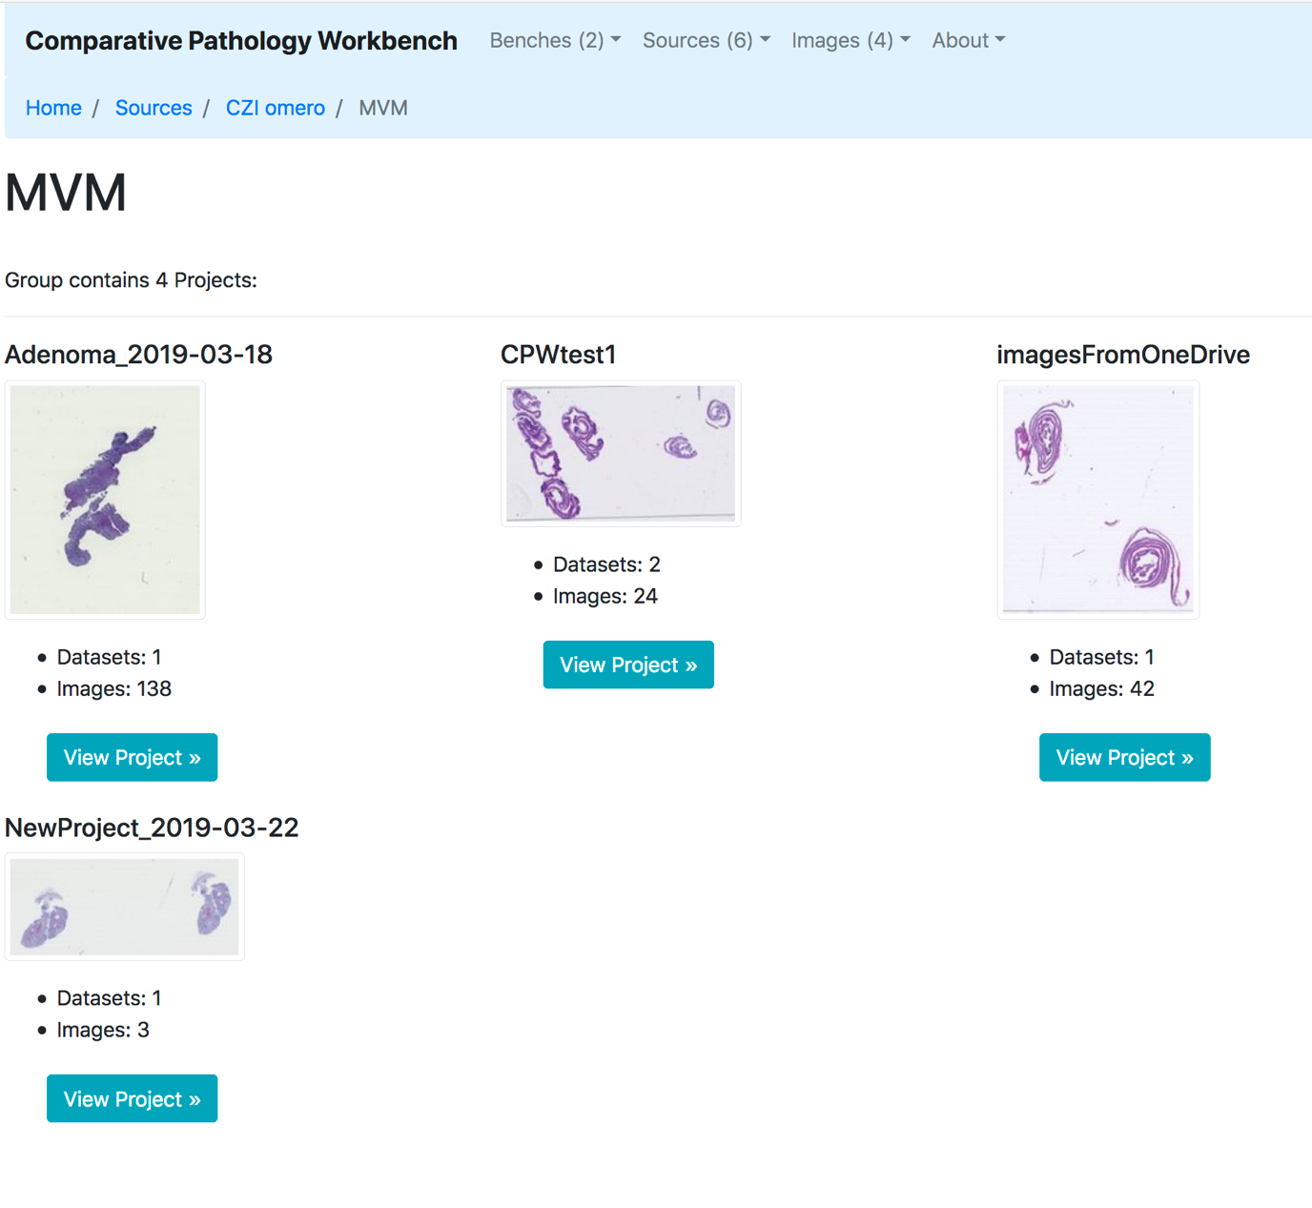

WELL DONE!

If you have got this far, you can now add your own images to your “Benches” int the Comparative Pathology Workbench!

Mike Wicks

21st March 2019