EDL generic

There are several methods for placing devices in EDL Mode. Some of these methods require unlocked device

1. Key combinations – e.g. holding Vol Up and Vol Down (locked and unlocked devices)

2. EDL cables (locked and unlocked devices)

3. ‘adb reboot edl’ (unlocked devices)

4. ‘fastboot oem edl’ (unlocked devices)

5. Test points (on some devices) (locked and unlocked devices)

6. eMMC fault injection (shorting) (locked and unlocked devices)

Note: must be added more examples how to use each of these methods

ASUS ZC520KL

This phone must be disassembled for using test point method

1. Power of the device

2. Connect the microUSB cable to the device but not to the PC

3. Short the test point from the picture and ground then connect the USB cable to PC

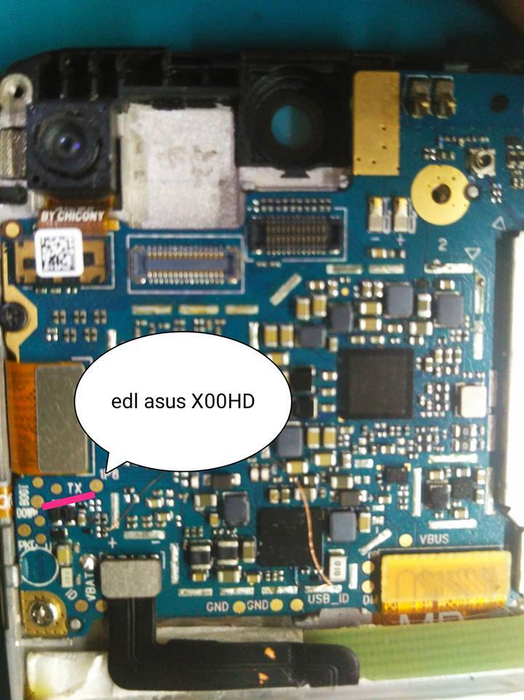

4. Windows will notify about a new device being connected and it will download the necessary driver for the Qualcomm HS-USB QDLoader 9008 under the Ports (COM & LPT) on the Device Manager (the correct driver MUST be installed)

5. Then click next and the phone will be detected by MFE

Alcatel 7048X (A, S, W also supported)

1. Turn off the device that you want to make a physical dump and hold the **Volume Up** key and connect it to the computer with the USB cable.
2. The smartphone should now be in **EDL Mode** (Emergency Download Mode) and ready for the physical dump extraction.

MTK - Connect Phone

1. Power off the phone
2. Select the download agent for your device

* MTK_AllInOne_DA is the most common working DA
* If MTK_AllInOne_DA is not working try another one

1. Click next
2. Connect the turned off phone to the PC

* The device should be connected in Preloader mode

Connect Spreadtrum Phone

Spreadtrum based phones offers possibility to connect the device in special Bootloader mode – it allows forensics specialists to make a physical dump of eMMC or UFS memories without passcode (pattern) lock.

Spreadtrum – Connect Phone

1. Power of the device

* Remove the battery and insert it back (if it is possible)

1. Load the firmware for the investigated device in pac file format

* The Base and Size values should be parsed from the loaded pac file automatically

1. Connect the device in Bootloader mode - Special Bootkey is needed very often

Bootkey tips

* There is not universal Spreadtrum boot key
* Each phone/vendor has its own bootkey
* For Android devices Volume Up or Volume Down is used very often
* More key combinations are for Spreadtrum feature phones, try
  + Call key
  + Left/right soft key
  + Central button
  + * or 0