Compendium Quick Reference

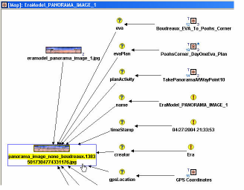
Compendium is a set of templates, methods, and tools used for applications such as issue mapping in meetings; requirements generation and analysis; meeting management (agendas, minutes); action item and issue tracking; requirements management; classification; management templates; testing and reference databases.

Web site: http://compendium.open.ac.uk/institute/
Software copyright © Verizon and The Open University

Connecting: Through File / Database Administration you may choose to work with the built-in Derby database manager, or with a MySQL database, either on the local machine or externally. Then, create a project (File / New or Ctrl + n) or open an existing project (File / Open or Ctrl + o).

Nodes, links and views: Ideas are expressed as icons (or Nodes). They can be moved around, and connected to other ideas via Links. Nodes are contained in Views. There are two kinds of view: a Map, in which nodes can be placed anywhere in a 2D space, and a List, which organizes nodes in a sortable column. Views can contain other views.

Creating nodes: Drag from node dock; choose from right-click menu, or use keyboard shortcuts (shown below).

Standard node types:
 | Node Type |  | Shortcut
 | Question: Ask a question or raise an issue. |  | q, ?, /
Answer (or Idea): Provide a possible answer or alternative to a question. |  | a,i,p,!,1
List View: (a) Create a sortable list of nodes (b) Hold the results of a search (e.g. create a catalogue of items) (c) Create a collection of nodes that don’t need to be linked with each other (via associative links). |  | l
 | Map View: (a) Create a “picture” of the relationships between ideas (b) Group questions and ideas together in meaningful clusters (c) Create associative links between nodes. |  | m
 | Pro: Support an idea. |  | + , =
 | Con: Argue against an idea. - |  | -
 | Note: Provide extra information about another node or the current view. |  | n
 | Decision: Resolve a question ± link it to an idea, or right-click on idea to change directly to a decision node. d
 | Reference: Bring in a link to an external file (such as a spreadsheet, picture or document). (or drag and drop the file directly onto the map) |  | r
 | Argument: Present a general argument, usually in response to an answer or position. |  | u

Create new linked nodes: Use Alt + the shortcut key to create a new node linked to the selected node.
Change node type: Shift + Alt + the shortcut key

Images can be placed directly into a view, or assigned to a node as the icon or map background picture.
If image rollover is enabled, a larger view appears when mouse moves over an image node.

Reference nodes link in documents and websites. Drag a file from anywhere into a map or list. Or, create node by hitting the R key or dragging the reference icon from the node toolbar, and then specifying file or URL manually. Double-click to open link or document.

Reference icons:











Generic, Web link, Word, Excel, PowerPoint, Access, PDF, Java, XML, Text, Multimedia

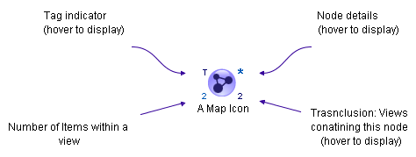
Anatomy of a Node:

Relationships

You can create 3 types of relationships -- associative, transclusive and categorical

    - Associative relationships (arrows) show connections between two or more ideas. Right-click and drag from start icon to finish icon. These links have properties such as labels and colors. Use Tools / Manage Link Groups... to predefine types of links.
- Transclusive relationships (node copies) show the same idea in multiple contexts (i.e. in different Maps or Lists). Right-click a node and copy it to the clipboard, then paste it in another map or list. Editing a node in one view instantly updates the same node in all other views. If you have the Transclusion Indicator checked on (under the View menu), then a number in the lower right corner of the icon shows in how many contexts that idea has come up (e.g. 4). Right-click on a node and select Views to display all maps or lists in which that idea appears. The Favorites menu lists nodes you may want to use in several places. Right -click a node and Add to favorites.
- Categorical relationships associate tags with multiple icons. Views / Tag View opens the Tag side bar. There is also a Tag toolbar for quick tagging. Tags enable searches, cross-references and on-the-fly creation of specialized maps and lists.

Navigation and editing
Zoom: Select from View / Zoom menu, or use F2 to zoom in stages (loops round); F3 to zoom to fit, or F4 to focus on selected node
Aerial view: View / Aerial view shows miniature version of map. It can be manipulated like the full map.
Home view to top-left of window: Home key. Close view: Ctrl + w or Ctrl + Enter.
Add some space: Alt + drag in an open area. Close up space: Alt + Shift + drag .
Arrange icons: View / Arrange or Ctrl + r.

Select node and all children: Alt + click on node.
Select node and parents back to root node: Alt + shift + click
Select multiple nodes: Drag box around them.

Searching
(Edit / Search or Ctrl + f) Search all maps and lists and find each matching node. Search by keyword, by author, by type of node, by creation or modification date, etc.

Importing and Exporting

Exporting data: ( File / Export ) Compendium can convert its databases into two HTML-based web formats:
1. A textual listing of nodes (a hierarchical map becoming an indented outline), viewable through a web browser or Word. 2. Visual maps that can be viewed through the Internet Explorer web browser (for Windows only). Additionally, there are options to export as a JPEG image or as XML.

Importing data: (File / Import) Import options include importing from an XML file, or bringing in the contents of an image folder.

Other

Stencils (Tools / Open Stencil or Manage Stencils...) are collections of images defined for use as custom icons.
Workspaces offer a way to name a grouping of open windows and instantly recall it later.
The Scribble Pad (Tools / Activate Scribble Pad) provides a toolkit to draw directly in a map.

Design by Steve Auerweck, updated by Michelle Bachler  

