**Gizmo Specification**

**Translation and Scale**

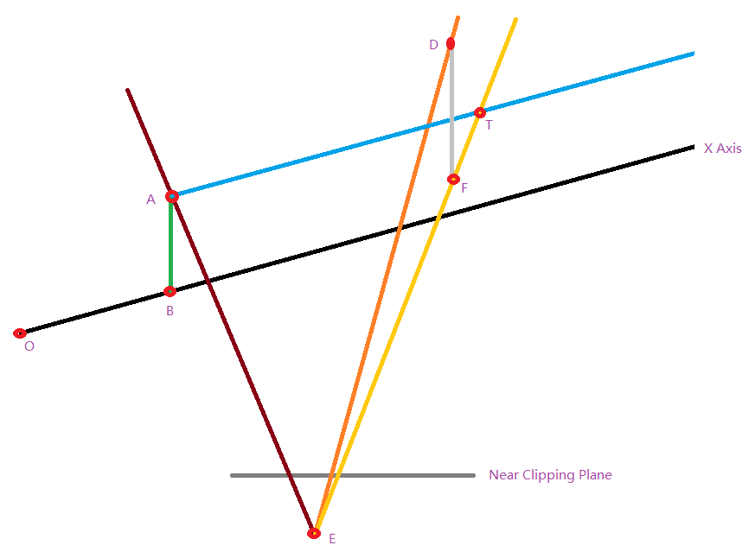

**Condition:**

point E is the eye position

line EA is the ray when the mouse clicks

line ED is the ray when the mouse moves to

point O is the origin position

point B is one of the sample points on X axis

point A is the foot of a perpendicular from B to line EA

if the min length of AB is less than tolerance, set this axis selected

line AT is parallel with X axis

point D is a random point on line ED

point F is the foot of a perpendicular from D to plane AET

point T is intersect point between line EF and AT

point T is the target need to get

**Algorithm:**

bool axisSelected = false;

float distanceMin = floatMax;

point A, B, foot;

for(each sample point P on X axis)

{

float distance = DistanceFromPointToLineWithFoot(P, EA,foot);

if(distance < distanceMin)

{

distanceMin = distance;

B = P;

A = foot;

}

}

if(distanceMin < tolerance)

{

axisSelected = true;

}

point F = GetFootFromPointToPlane(D, AET);

point T = GetIntersectBetweenLines(AT, ET);

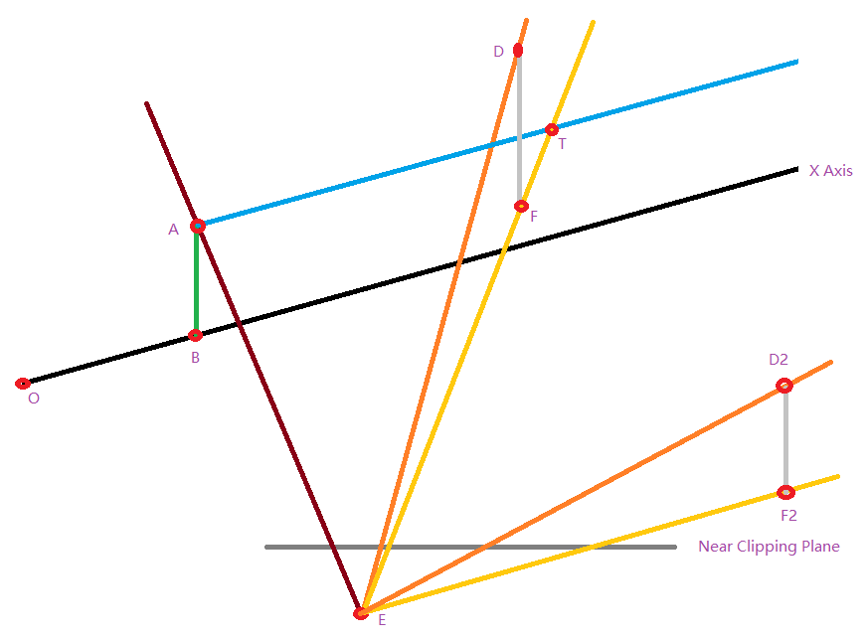

**Note:**

point T maybe null if line EF is parallel with line AT, such as the point D2 and F2

**Rotation**

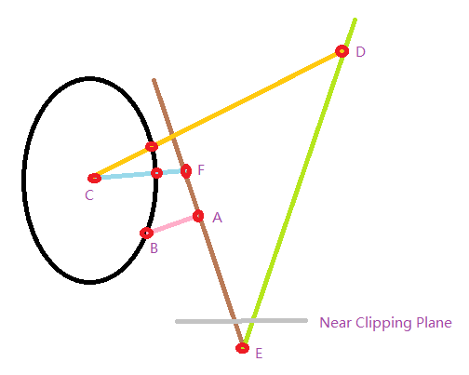

**Condition:**

point E is the eye position

line EA is the ray when the mouse clicks

line ED is the ray when the mouse moves to

point C is circle center position

point B is one of the sample points on circle

point A is the foot of a perpendicular from B to line EA

if the min length of AB is less than tolerance, set this circle selected

point D is intersect point between line ED and circle plane

point F is intersect point between line EA and circle plane

angle DCF is the target need to get

**Algorithm:**

bool circleSelected = false;

float distanceMin = floatMax;

for(each sample point P on circle)

{

float distance = DistanceFromPointToLine(P, EA);

if(distance < distanceMin)

{

distanceMin = distance;

}

}

if(distanceMin < tolerance)

{

circleSelected = true;

}

point D = GetIntersectBetweenLineAndPlane(ED, DCF);

point F = GetIntersectBetweenLineAndPlane(EA, DCF);