Generate OTP and Create/Update user -

1. With valid Email ID -

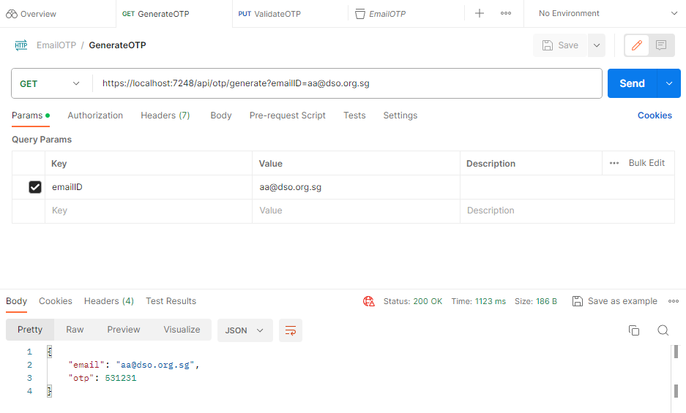

1. With invalid Email ID –

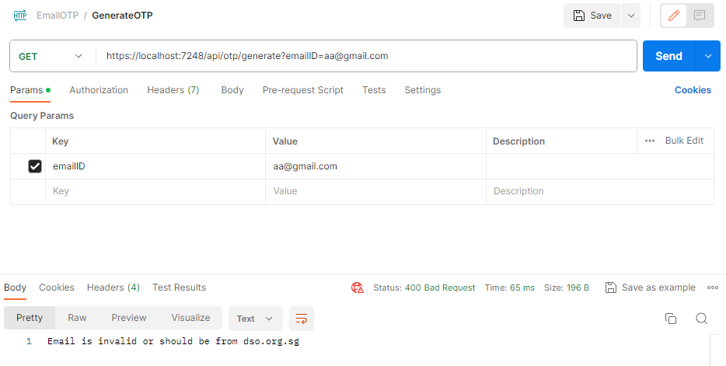

1. With no Email ID –

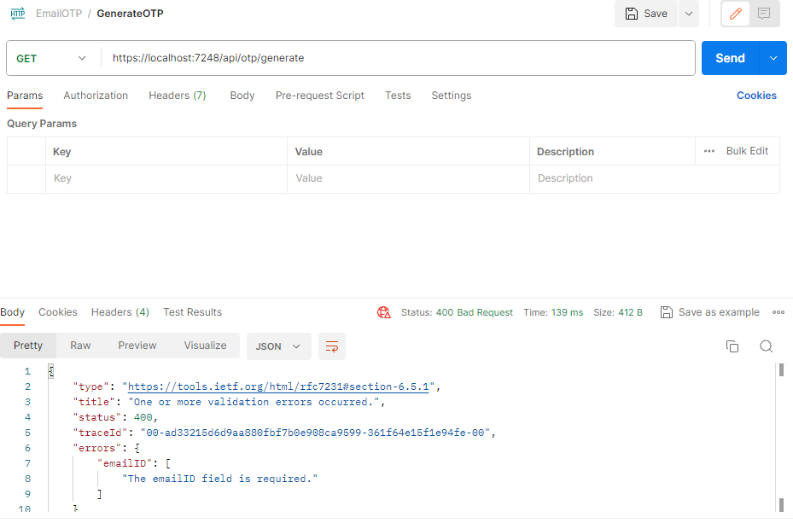

Validate OTP and Update Try Count –

1. With valid email ID and OTP –

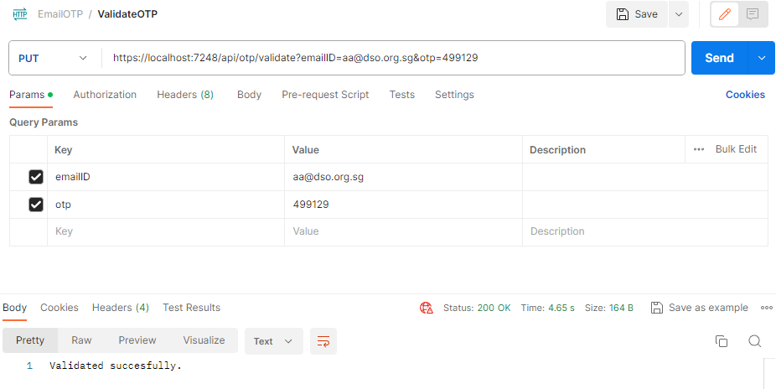

1. With valid email ID and incorrect OTP –

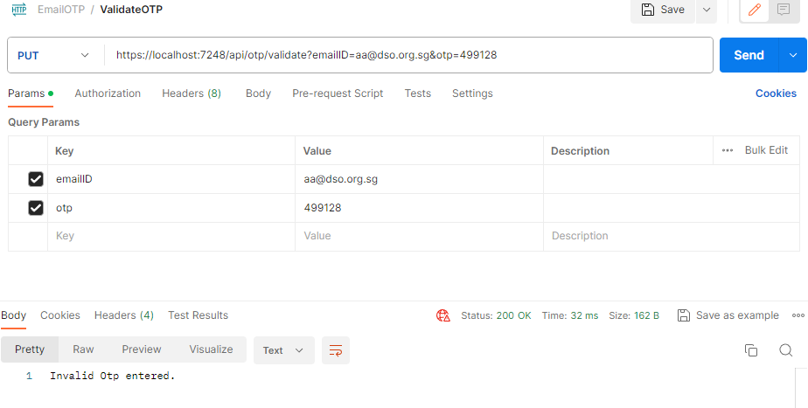

1. User trying to validate after 1 minute –

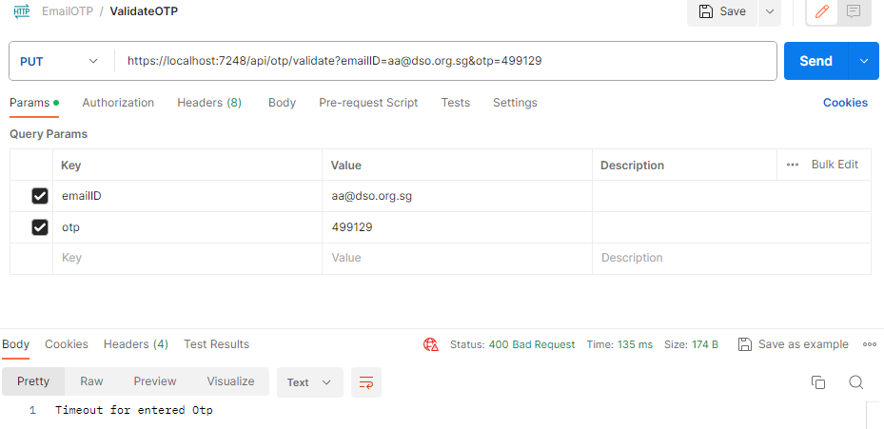

1. With valid email ID and non-numeric OTP –

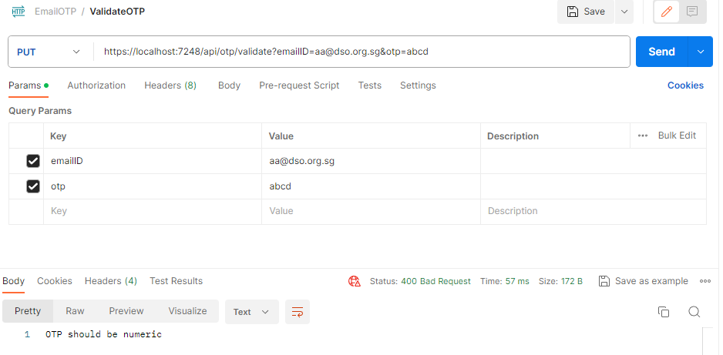

1. Without email ID and OTP –

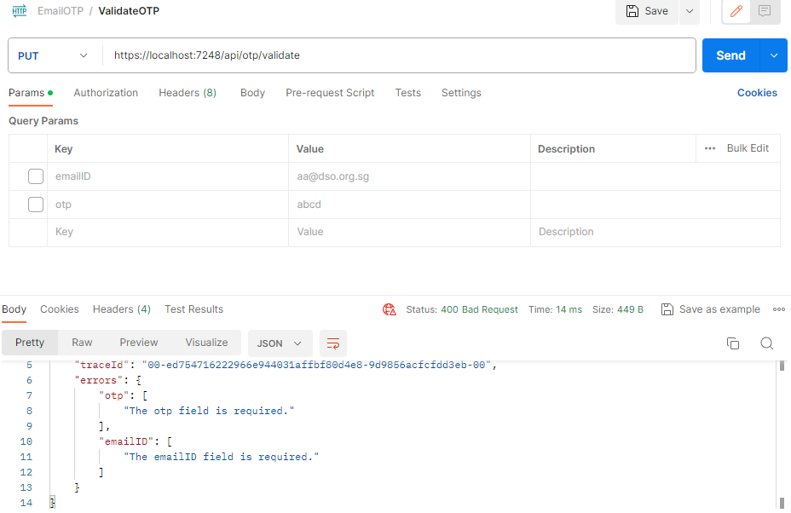

1. Updated Try Count in the back end on entering incorrect OTP –

