|  |
| --- |
| **Diabetes analysis**  **Spreadsheet and form documentation** |

This document explains how to use the spreadsheet and form, tools that will help tagging the websites.

Link for the spreadsheet: <https://docs.google.com/spreadsheets/d/1yJGSB4WqzU1_oWZoWxObEDfYz9iupeCcRpeVzdws4lY/edit?usp=sharing>

Link for the form: <https://docs.google.com/forms/d/e/1FAIpQLSck728g9iFVDFwWT0q2KhvsguPkvkQPUT8-yyatEpwisJHCvg/viewform>

This will allow you to use your computer to visit the website and tag it on your mobile phone using the form. No need to change tabs with many opened windows on your screen now.

1. Go to the spreadsheet, on the tab “Sheet 1”.

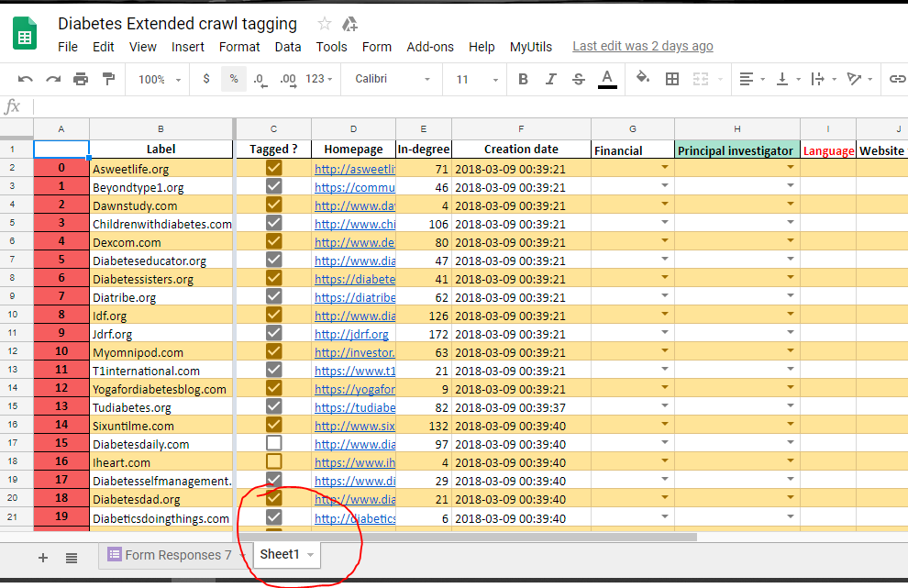

1. Click button function “MyUtils”, allowing you to use the function “Next website to tag”.

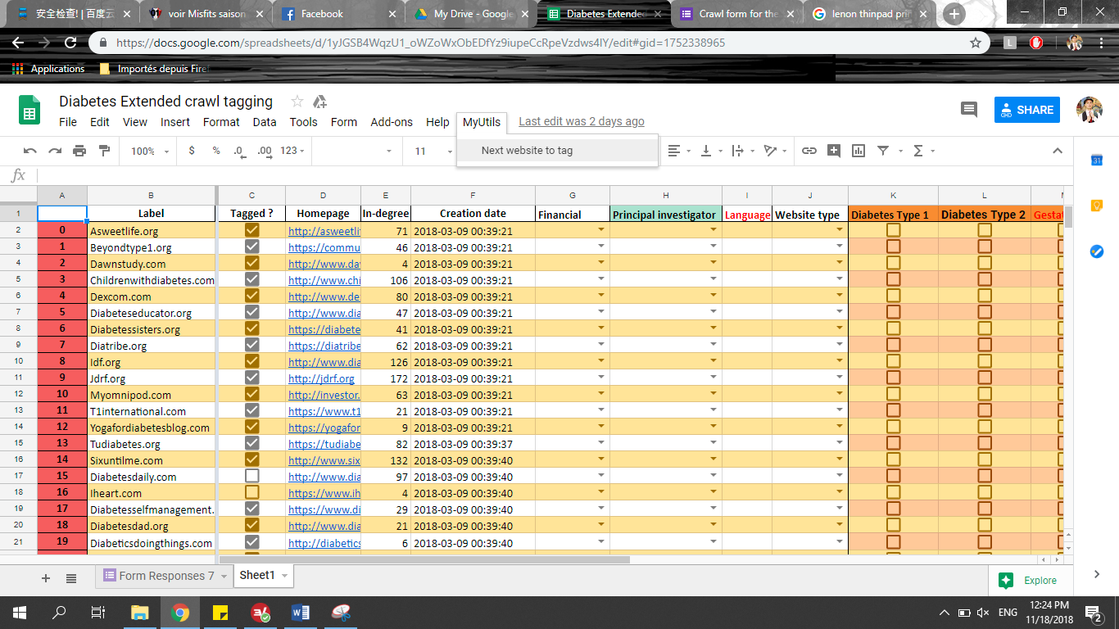

1. This will select in the column A the next website to tag. Note the number in column A and click on the website link. Don’t forget to check the website in the column C

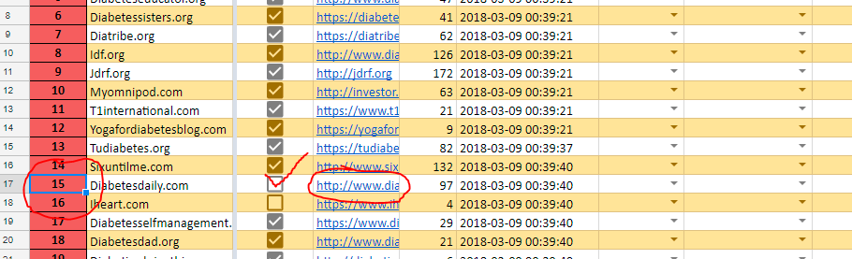

1. Open the form on your mobile (or whatever device you prefer) and type the number of the website (here 15) at the first question.

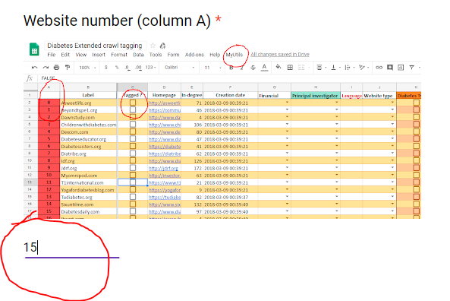

1. You can now fill the form while browsing the website. At the end, submit the answer. They will appear on the spreadsheet Form responses.

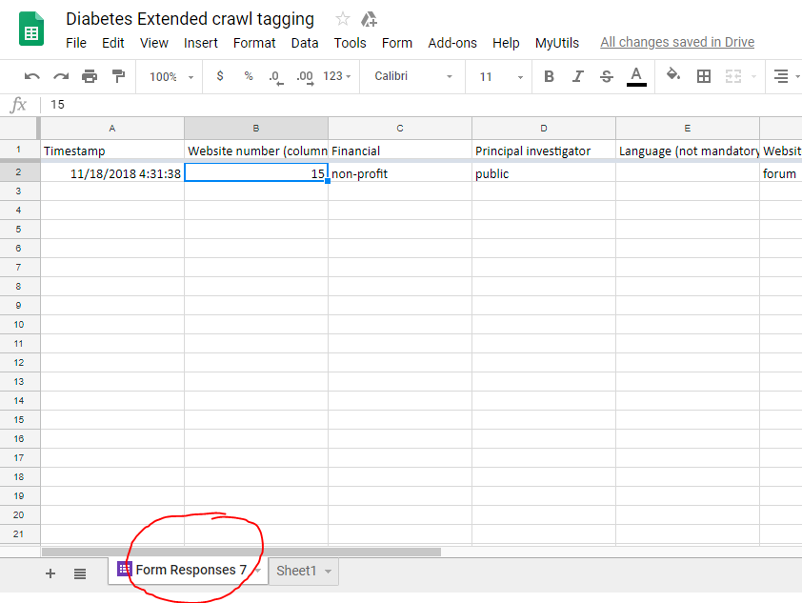

1. When the project is over, we will order the form responses with column B and simply copy paste all the answer in the tab Sheet 1, this is why you need to make sure the website number is corresponding with the one given on the Sheet 1.

If you have any question, contact me by mail at [romain.fay2@gmail.com](mailto:romain.fay2@gmail.com) or on wechat id: faya_59.

Romain Fayolle