Immune Deconvolution Benchmark

# 3-tier analysis

## Spillover Analsysis

* Pure samples of the given cell types
* Ideally: microarray and RNAseq on which the methods have not been trained
* + negative control
* + blood (should contain everything)
* Final Chart: Barplot of Signal2noise ratio for each method and celltype

*See quanTIseq Supplementary tables for a compendium of such datasets.*

## Deconvolution of in-silico mixtures

* Accumulate classified single-cell data (from Schelker et al. 2017)
* 17 melanoma samples from tirosh (single cells but no bulk tissue)
  + 6 matched bulk samples?
* Known proportions

## Deconvolution of bulk RNAseq data with known gold standard

* Can derive from matched scRNAseq, IHC or FACS
* Datasets
  + 3 ovarian samples from Schelker et al. 2017 + single cell
  + 4 Melanoma samples from EPIC + FACS
  + 12 PBMC samples from Zimmermann et al 2016 + FACS
  + quanTIseq IHC staining

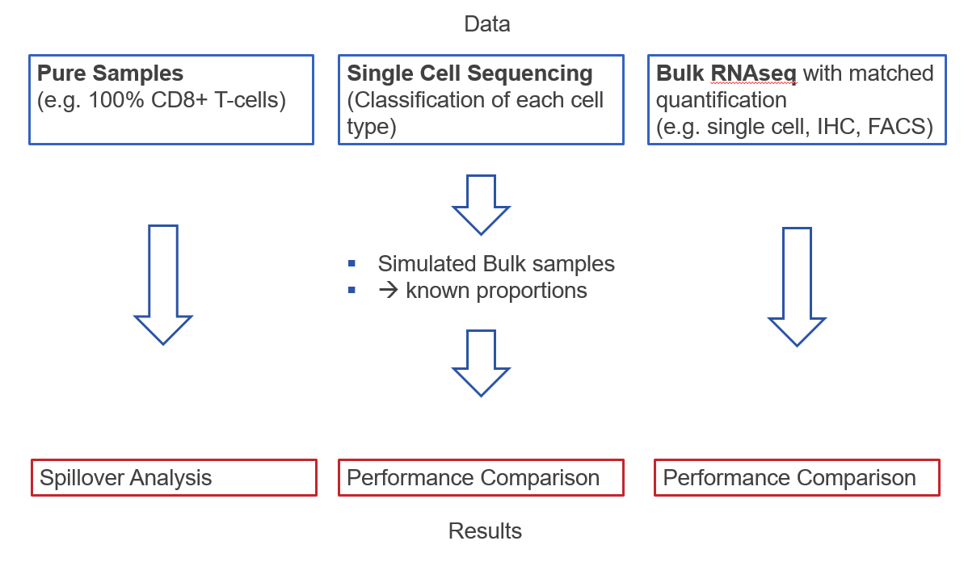

# Discussion

* Deconvolution vs GSEA

# Ideas

* Agreement score: David said that either the methods all agree or don’t work at all.
* Make reproduceable pipeline that can easily be ran with new methods and new datasets
* Are the signatures or the methods the limiting factor? Run the signature of the best-performing method with an inferior methodology.