**Rot**

**Rot**

**Rot**

**Rot**

**Left**

**Right**

**Desti**

**Org**

**Onext**

**Onext**

**Dual Vertices**

**Dual Edges**

**Primal Vertices**

**Primal Edges**

**ITK**

**Edge**

**QE**

**Cell Container**

**Point Container**

**Cell ID**

**Cell ID**

**Point ID**

**Point ID**

Figure QuadEdgeMesh Data Structure

**Dual Cell ID**

**Dual Cell Container**

**Primal Cell Container**

**Primal Point ID**

**Primal Point ID**

**Primal Cell ID**

**Primal Point Container**

**QE**

**Edge**

**ITK**

**Dual Point Container**

**Dual Cell ID**

**Dual Point ID**

**Dual Point ID**

**Primal Cell ID**

**Vertex of triangulation**

**Vertex of Simplex Mesh**

**Dual of boundary**

**(a)**

**(b)**

**(c)**

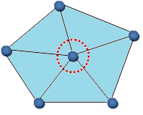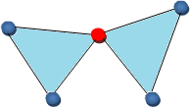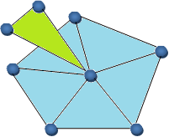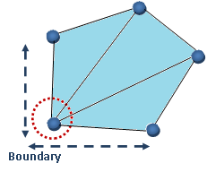

**ii- Open Fan**

**i- Closed Fan**

**i- non-manifold**

**ii- non-manifold Boundary**

1. **Manifold Meshes**
2. **Non-manifold Meshes**

**Boundary**

**Mesh A**

**Mesh B**

**Mesh A & B**

**Mesh B**

**Mesh A**

**Mesh A & B**

**Dual Point ID**

**Point ID**

**Point ID**

**Cell ID**

**Cell ID**

**Point Container**

**Cell Container**

**Dual Point ID**

**Dual Cell ID**

**Dual Cell ID**

**Dual Cell Container**

**Dual Point Container**

**Primal**

**Point ID**

**Primal Point ID**

**Primal Cell ID**

**Primal Cell ID**

**QE**

**ITK**

**QEGeom**

**QEGeomm**

**ITK**

**QE**

**Primal Point Container**

**Primal Cell Container**

**Rot**

**Rot**

**Rot**

**Rot**

**Left**

**Right**

**Desti**

**Org**

**Onext**

**Dual Vertices**

**Dual Edges**

**Primal Vertices**

**Primal Edges**

**Dual Face /Point**

**Dual Face /Point**

**Primal Point**

**/Face**

**Primal Point**

**/Face**

**QEGeomm**