**Step 1:**  
Create a 1-page site using Bootstrap which will contain two input fields (login, password) and submit button.

Interface example for the page:

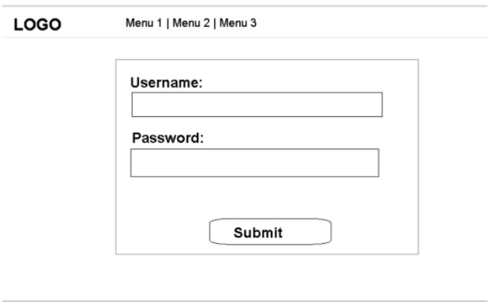

**Step 2:**  
On submit, call login function from our web service (WSDL SOAP)  
[**http://isapi.icu-tech.com/icutech-test.dll**](http://isapi.icu-tech.com/icutech-test.dll)   
   
If login successful, display green success message and entity details.  
If error, display a red error message.

To create a test account, use the **RegisterNewCustomer** function.

**Step 3:**  
After functionality is complete, the page must pass google page speed test. The result must be for mobile 100/100 for desktop minimum 90 level. [**https://developers.google.com/speed/pagespeed/insights/**](https://developers.google.com/speed/pagespeed/insights/)

Mobile speed should be 3 second maximum, [**https://testmysite.withgoogle.com/intl/en-gb**](https://testmysite.withgoogle.com/intl/en-gb)