Open Project Gallery

Registry + Directory Service

Current MIT/law Prototype:

Prior Relevant Work: Codex Hackdash at MIT Media Lab.

Screenshots:

Project “Collection” Gallery

Individual Project Page:

# Current MIT/law Prototype:

[**https://github.com/OpenInnovationNetwork**](https://github.com/OpenInnovationNetwork)

See repositories and various code and project content of (soon to be re-labed) current prototype at link above:

# Prior Relevant Work: Codex Hackdash at MIT Media Lab.

* <https://hackdash.org/dashboards/codex2015>
* <https://github.com/OpenInnovationNetwork/2016-MIT-IAP-PrototypeJam/tree/master/projects>
  + Also:
  + <http://codexhackathon.com/>
  + <https://plympton.submittable.com/submit/44587>
  + <https://law.mit.edu/CodexHack>

# Screenshots:

## Project “Collection” Gallery

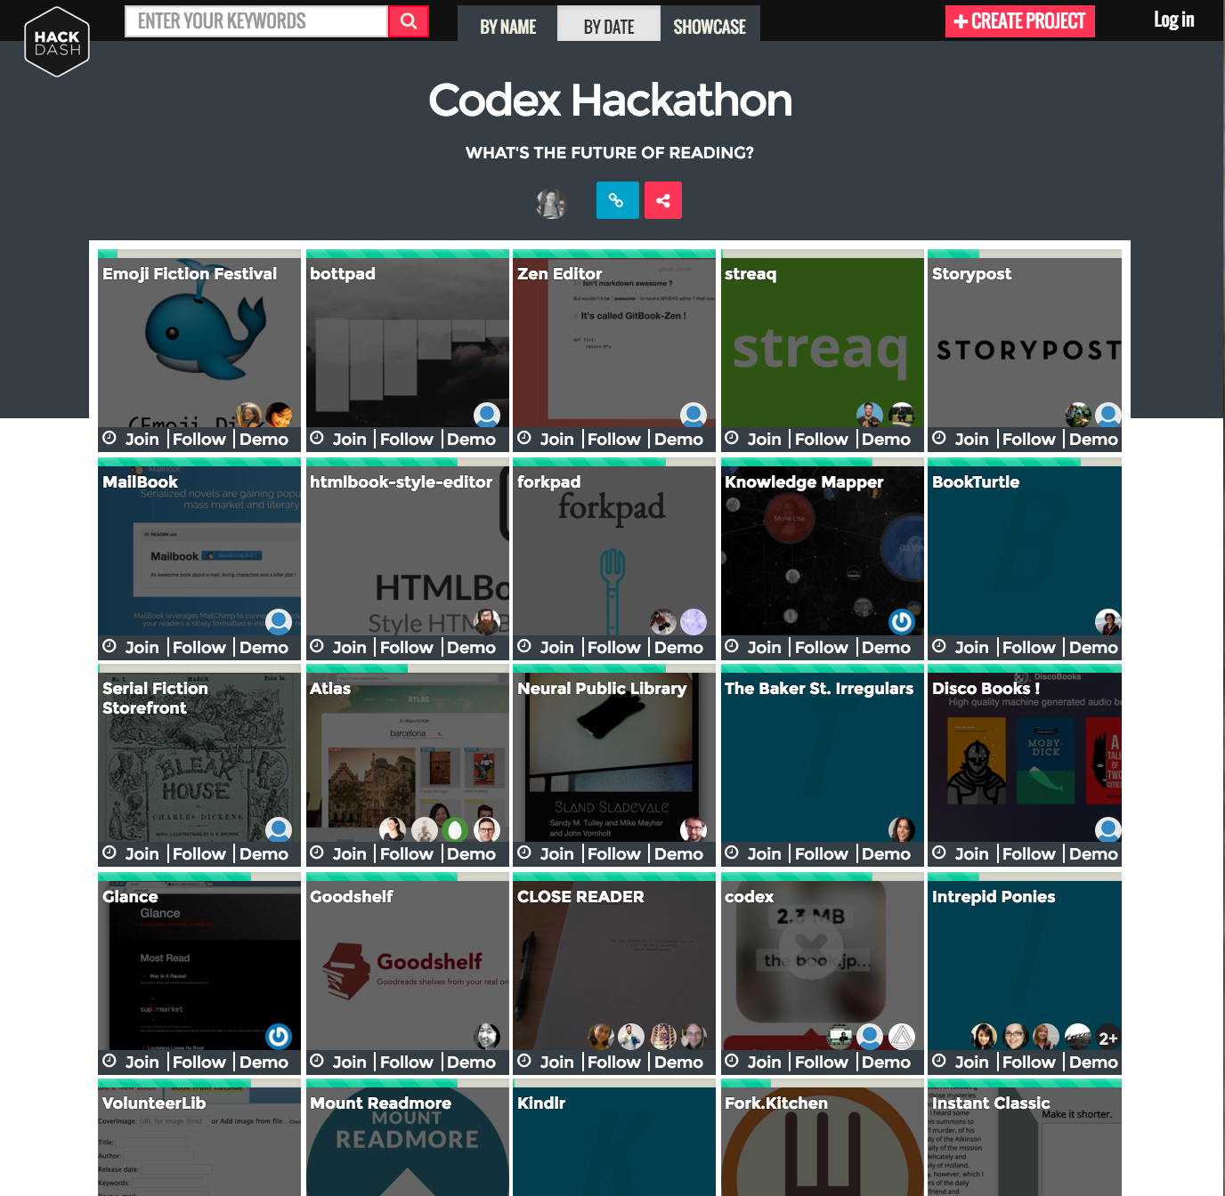

## Individual Project Page:

