Softmax: loss precision and epsilon matrix
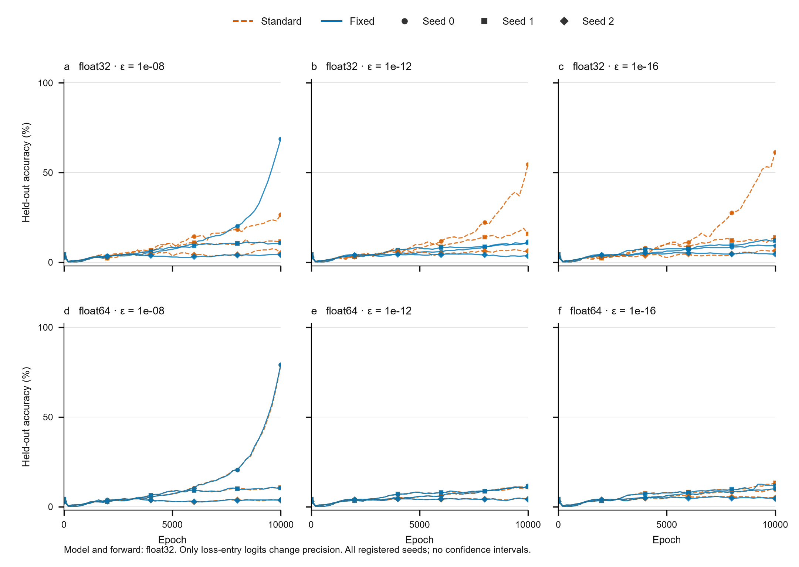
All seeds and both repair arms across the supported matrix.

Loss precision × epsilon: paired reconstruction
All 36 specified training trajectories completed, with independently checked final models and gradient endpoints.
Observed result: fixed CE is higher in 5/18 paired endpoints, lower in 12/18, and tied in 1/18. The best final held-out accuracy across all arms is 79.210%. These runs do not reproduce the paper’s high-generalization table and do not establish a uniform finite-budget generalization benefit.
At the model interface, the fixed arm’s maximum target-zero count is 0 across 918 producer-recorded checkpoints; standard CE reaches 243/480. Final gradient counts are independently reloaded; intermediate counts are recorded by the producer.
Locally registered follow-up; three seeds, float32 model/forward, two supported loss precisions and three epsilon values. Not an exact paper reproduction. bfloat16 remains UNQUALIFIED.
All cells below are retained. Delta is fixed minus standard in percentage points; no population inference or significance test.
Loss dtype | Epsilon | Seed | Standard test (%) | Fixed test (%) | Delta (pp)
float32 | 1e-08 | 0 | 26.611 | 68.815 | +42.204
float32 | 1e-08 | 1 | 11.435 | 10.603 | -0.832
float32 | 1e-08 | 2 | 4.990 | 4.158 | -0.832
float32 | 1e-12 | 0 | 54.470 | 11.435 | -43.035
float32 | 1e-12 | 1 | 15.800 | 10.811 | -4.990
float32 | 1e-12 | 2 | 6.237 | 3.534 | -2.703
float32 | 1e-16 | 0 | 61.331 | 9.356 | -51.975
float32 | 1e-16 | 1 | 13.721 | 12.058 | -1.663
float32 | 1e-16 | 2 | 6.445 | 4.574 | -1.871
float64 | 1e-08 | 0 | 79.002 | 79.210 | +0.208
float64 | 1e-08 | 1 | 10.603 | 10.395 | -0.208
float64 | 1e-08 | 2 | 3.742 | 3.742 | +0.000
float64 | 1e-12 | 0 | 11.019 | 11.642 | +0.624
float64 | 1e-12 | 1 | 11.019 | 11.227 | +0.208
float64 | 1e-12 | 2 | 4.366 | 4.158 | -0.208
float64 | 1e-16 | 0 | 9.563 | 9.979 | +0.416
float64 | 1e-16 | 1 | 13.306 | 11.642 | -1.663
float64 | 1e-16 | 2 | 4.990 | 4.574 | -0.416

Evidence and limitations
Six float32/epsilon=1e-8 final model hashes exactly replay the parent experiment. All cells reuse that parent’s original initial models and splits.
Each trajectory records 51 checkpoints, including actual training-batch target-gradient zero counts before and after the loss-to-model precision boundary. Final counts are independently replayed from all 36 saved models on the recorded CUDA runtime. Intermediate counters remain producer logs, not an independently reloaded trajectory.
Final held-out predictions, margins and float64 cross-entropy are independently recomputed from raw saved tensors by NumPy. Cross-entropy comparisons use relative error with no absolute floor.
The full loss-precision/epsilon grid of supported kernels is covered; the paper’s bf16 grid, additional baselines, unspecified architecture/initialization choices and further tasks remain outside this reconstruction. Generalization can depend strongly on seed and implementation choices.
Source paper, section 6 and Table 1. The protocol and source hashes define this local study; completed cells are not selected for favorable outcomes.
Downloads: trajectories, paired endpoints, protocol, raw evidence, final gradient audit, source and checkpoints.
Publication masters: editable SVG, PDF at 183 mm.
CPU acceptance: python reference/softmax_matrix/verify.py. Retraining needs the recorded CUDA runtime and a separately registered output location; the original producer refuses overwrite.

