An exact edit-rate repair in an independent forensic project
2026-11-01

Abstract
A metric can be executable and repeatable while measuring a different quantity from the one its documentation names. In an existing Unicode forensic project, an edit rate described as normalized Levenshtein distance used the cost of a SequenceMatcher alignment. A retrospective complete-file audit found two differences among 1,033 paired records; the largest excess was 112 unit edits. Separating visual alignment from minimum edit-distance calculation repaired the metric. An independent C++ implementation agreed with all repaired distances. Exhaustive edit graphs, deliberate wrong metrics and input-change controls bounded the acceptance claim. This case demonstrates a metric repair and an independently reusable verification path; it establishes neither attack success nor a new scientific discovery.

Metric contract and repair
The original engine used difflib.SequenceMatcher(None, source, target) with default automatic-junk handling. Insertions and deletions contributed their run lengths; replacements contributed the larger run length. This defines a valid opcode-script cost, but Python explicitly does not guarantee minimal edits. The contract error lies in calling that cost Levenshtein distance.
Keep the visual diff unchanged. Compute the quantitative numerator separately using the minimum number of unit-cost insertions, deletions and substitutions. The adapter supplies a two-row dynamic program. Preserve the original denominator: distance divided by max(len(source), 1). The resulting rate is directional and can exceed one. Units are Unicode code points without Unicode normalization, not bytes or grapheme clusters. Similarity ratios remain separate outputs.

Methods: independent checks and controls
The validator uses RapidFuzz 3.14.6’s explicit C++ Levenshtein backend with weights (1, 1, 1) and no preprocessing. It does not import the producer’s metric. An exhaustive breadth-first edit graph checks all 225 ordered pairs over alphabet {a, β} with lengths zero through three. The producer is executed on the same 225 pairs and ten additional benign/Unicode examples. An experimental unit here is one deterministic string-pair setting, not an independent random trial. These are finite qualification sets, not a proof over arbitrary strings.
The graph rejects the legacy cost on 40 pairs and a zero-distance control on 210 pairs. Separate acceptance tests reject legacy-as-exact results, wrong normalization, missing rows, Boolean distances, changed source, changed data, missing evidence and malformed/unpaired input. Source, configuration, lock and corpus hashes bind each execution. No seed applies to deterministic enumeration.

Complete-file results
Table 1. Before/after comparison against independently calculated minimum edit distances. Counts describe every record in the two supplied files; records are not independent experimental replications. There is no significance test or population inference. Maximum excess is legacy cost minus minimum edit distance.
Supplied corpus | Pairs | Legacy unequal | Max. excess | Repaired unequal
LLM perturbations | 513 | 2 | 112 | 0
Unicode edits | 520 | 0 | 0 | 0
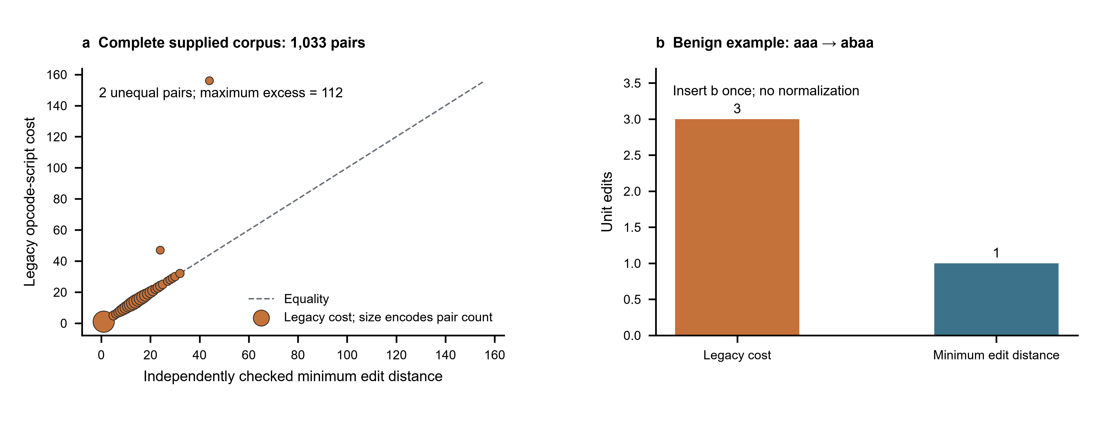
Figure 1 | Separate visual alignment from quantitative distance. a, Complete-file joint counts of independently checked minimum edit distance and legacy opcode-script cost for 1,033 pairs. Marker area increases with pair count; the dashed line denotes equality. Two pairs differ and the maximum excess is 112 edits. b, In the public benign example aaa to abaa, inserting b once suffices, whereas the legacy alignment costs three edits. All repaired local distances match the independent C++ reference. No sampling, error bars or model inference apply.

Reproduction, provenance and limits
Original HPAF source SHA-256: 29281aa2b8ac8380e7df7ff5e39bf425b39dbf89d8f34b2be0a8db1ed4052b2e. The actual original diff_runs function was checked on all 1,033 records and matched the adapter’s legacy numerator. Original code and data were unchanged. The private corpus hashes and public aggregate counts are in the local audit record. The original raw strings and original HTML reports are not distributed. Thus public replay independently reproduces the 235 benign qualification pairs, not the inaccessible private corpus.
Use the standalone case instructions and public reproduction bundle. Install from the included lock, run eidos-reproduce.py in a fresh copy and inspect its execution record. Required outputs, deliberate wrong evidence and input invalidation are separate from a successful process exit. A report or a green gate does not establish EIDOS completeness, scientific novelty or journal acceptance.

Data availability
The public fixture, source, protocol, exact dependency lock and acceptance controls are distributed in reproduce.zip; only newly created benign strings enter it. Aggregate local-corpus evidence is provided in local-audit.json. Local original corpora remain private; their complete-file findings cannot be independently recomputed without authorized access. All unfavorable metric discrepancies remain in the aggregate record. Full local replay and public-fixture replay have distinct acceptance scopes.

Code availability
The producer, independent validator, protocol, lock, controls and public fixtures are in reproduce.zip and the EIDOS repository. HPAF’s original README.md, line 48, supplies the metric promise; the preserved forensic engine supplies the old implementation. The adapter repairs the metric separately without overwriting that original project.

Reporting and submission metadata
This technical validation report follows the shared manuscript and figure policy. Human authorship, affiliations, funding, contributions and competing interests remain to be completed before submission. Scientific and editorial review remain separate; submission_ready is false.

References
- Python Software Foundation. difflib: SequenceMatcher contract.
- RapidFuzz. Levenshtein distance, version 3.14.6.
- Nature. Research figure guide.
- Nature. Formatting guide.

