LIMEN Phase I — Stage 2 figures
Each figure is followed by its caption, set in the document's type as a manuscript sets it. Captions are generated from the same data as the plots and are not part of the images.

Figure 1. The three pre-registered hypotheses across the noise grid
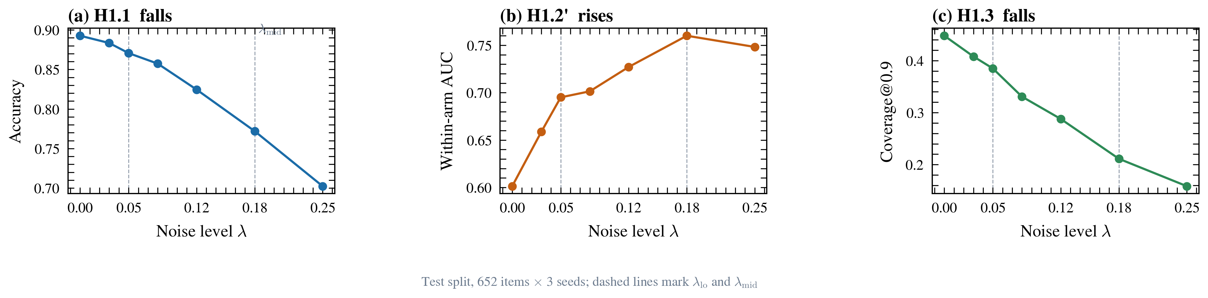
The three pre-registered hypotheses across the noise grid. Typo noise costs accuracy and coverage while making the confidence gate MORE discriminative, not less. Each panel is one pre-registered hypothesis, tested with the exact paired permutation of the protocol and Holm-corrected across the three-hypothesis family; all three were confirmed with no direction violations. (a) Accuracy falls by 12.1 percentage points from lambda = 0 to lambda_mid (H1.1, p = 4.4e-36). (b) The within-arm AUC between correct and incorrect trials RISES from 0.601 to 0.760 (H1.2', p = 2.0e-04) -- the gate separates right from wrong more sharply under noise. (c) Coverage at tau = 0.9 falls by 23.7 points (H1.3, p = 5.0e-05), so far fewer trials are answered at all. All panels use the test split of the pre-registered window: 652 items x 3 frozen noise seeds = 13,692 trial records from the pinned instrument, 0 failures. The confidence rule is `answer if c >= tau else defer`. Dashed vertical lines mark the two calibrated noise levels, lambda_lo = 0.05 and lambda_mid = 0.18. Every plotted value is read from `data/processed/stage2_lambda_summary.csv`, which `scripts/build_stage2_figures.py` derives from `measurement/out/confirm_trials.jsonl`. No point is interpolated or modelled.

Figure 2. Where the errors go: the gate rejects most of what noise breaks
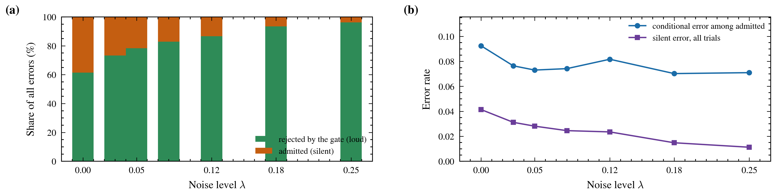
Where the errors go: the gate rejects most of what noise breaks. The errors noise creates arrive below the gate: they are loud, not silent. Panel (a) decomposes every error at each noise level into the share the gate rejects and the share it admits. Under noise the rejected share rises from 61.4% to 93.5%, so the gate catches most of what noise breaks. Panel (b) shows the two error measures diverging: the conditional error among admitted trials is flat (0.092 to 0.070), while the all-trial silent error FALLS (0.041 to 0.015). A fixed-threshold silent-error rate cannot rise under a manipulation that deflates confidence, which is why the original H1.2 was refuted and replaced by H1.2'. All panels use the test split of the pre-registered window: 652 items x 3 frozen noise seeds = 13,692 trial records from the pinned instrument, 0 failures. The confidence rule is `answer if c >= tau else defer`. Dashed vertical lines mark the two calibrated noise levels, lambda_lo = 0.05 and lambda_mid = 0.18. Every plotted value is read from `data/processed/stage2_lambda_summary.csv`, which `scripts/build_stage2_figures.py` derives from `measurement/out/confirm_trials.jsonl`. No point is interpolated or modelled.

Figure 3. Why the gate separates better under noise
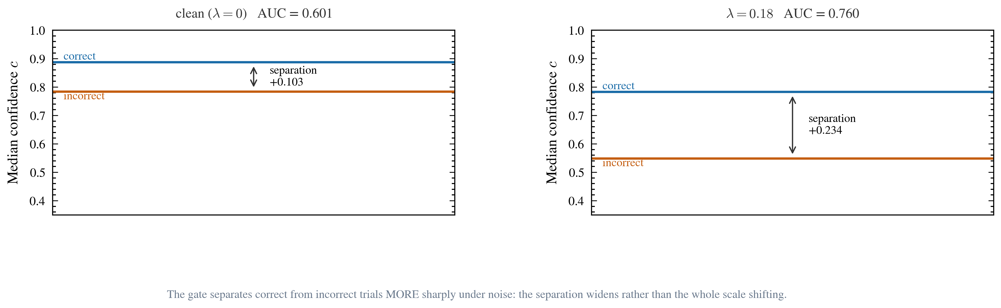
Why the gate separates better under noise. The gate does not merely shift down with noise -- it separates correct from incorrect trials more sharply. Median confidence for correct and for incorrect trials, at the clean level (left) and at lambda_mid (right); the double arrow is the separation between them. Correct-trial confidence falls from 0.888 to 0.783, but incorrect-trial confidence falls more than twice as far, from 0.784 to 0.549. The separation therefore widens from +0.103 to +0.234, and the corresponding within-arm AUC rises from 0.601 to 0.760. The estimand reads only the ORDER of confidences, so it is invariant to any monotone rescaling of the instrument's confidence scale -- machine-checked in the formalization repository. All panels use the test split of the pre-registered window: 652 items x 3 frozen noise seeds = 13,692 trial records from the pinned instrument, 0 failures. The confidence rule is `answer if c >= tau else defer`. Dashed vertical lines mark the two calibrated noise levels, lambda_lo = 0.05 and lambda_mid = 0.18. Every plotted value is read from `data/processed/stage2_lambda_summary.csv`, which `scripts/build_stage2_figures.py` derives from `measurement/out/confirm_trials.jsonl`. No point is interpolated or modelled.

