Additional file for
Simulating the Landscape Eco-Evolution of Host-Pathogen Systems with CDMetaPOP

Authors
Erin L. Landguth, Allison Williams, Marissa Roseman, Miracle Amadi, Marcel Kouete, Rhys Farrer, Amy Haeseler, Orly Razgour, Chris Richardson, Byron Weckworth, Julie Weckworth, Flora Whiting-Fawcett, Duncan Wilson, Casey Day

Correspondence to: Erin Landguth erin.landguth@mso.umt.edu

This file includes:

Text A.1 - User manual description for implementing disease module
Table A.1 - List of parameters and options for implementing disease module
Figure A.1 - CDMetaPOP life cycle flow diagram.

Text A.1 - User manual description for how to model disease dynamics in CDMetaPOP (Section 5.4)
This section describes how to use the flexible, compartmental disease module within CDMetaPOP to simulate the spread of infectious diseases. This module integrates eco-epidemiological dynamics into the existing individual-based, eco-evolutionary framework, allowing for analyses of host-pathogen systems in complex landscapes.

Core Concepts: The disease module in CDMetaPOP is built upon the logic of classical Susceptible-Infected-Recovered (SIR) compartmental models but is implemented at the individual level. Instead of tracking the proportion of the population in each state, CDMetaPOP assigns a disease state to each individual agent. Transitions between these states are probabilistic, allowing for the natural emergence of demographic and spatial stochasticity.

Key features include:
- Flexible State Definitions: You can define any number of disease states (e.g., Susceptible, Exposed, Infected, Recovered, Vaccinated, etc.).
- Direct and Indirect Transmission: The model can simulate host-to-host transmission as well as transmission from an environmental reservoir.
- Eco-Evolutionary Dynamics: You can link disease parameters (e.g., transmission or recovery rates) to an individual's genotype, allowing you to model the evolution of disease resistance or tolerance.
- Spatio-temporal Dynamics: Disease parameters can be modified through time and can vary by patch, enabling the simulation of changing environmental conditions or targeted interventions.

Getting Started: A Basic SIR Model
To begin modeling disease dynamics, you first need to activate and parameterize the module. This involves three main steps:

Activate the Disease Module in PopVars.csv
In your main population variables file, you must first enable the disease module.
File header in csv file | Description & Arguments | Example
Implement disease | Turns the disease module on and specifies when in the life cycle state transitions occur.  'N': Off (Default)  'Back': During the first DoUpdate() module  'Out': During the second DoUpdate() module  'Both': During both DoUpdate() modules | Back

Specify the Disease Parameter File in PatchVars.csv
Next, for each patch (or set of patches), you must point to a file containing the specific disease parameters. This allows for spatial variation in disease dynamics.
File header in csv file | Description & Arguments | Example
Disease file | The path and name of the disease-specific parameter file for that patch. | ../diseasefiles/DiseaseVars_SIR.csv

Define the Disease Dynamics in DiseaseVars.csv
This is the core file where you define the structure of your disease model. For a simple SIR model, you would specify three states and the initial proportion of the population in each.
File header in csv file | Description & Arguments | Example
Number of states | The total number of states. State 0 is always assumed to be the initial susceptible state. | 3
State initial conditions | The proportion of individuals to be initialized in each state at t=0, separated by semicolons. Must sum to 1. | 0.9;0.1;0.0
Transition matrix file | The path and name of the transition matrix file. | ../diseasefiles/TransitionMatrix_SIR.csv
Infection states | The state(s) considered infectious. This is used to calculate the force of infection. | 1
Offspring states | How to initialize offspring states.  'Susceptible': All are born in state 0 (Default).  'Random': Drawn from initial conditions.  'Vertical_X:Y': Vertical transmission from infected mothers with mean rate X and standard deviation Y. | Susceptible

Create the Transition Matrix (TransitionMatrix_SIR.csv)
This file defines the mean probabilistic rates of moving from one state to another. The matrix must be square (Number of states x Number of states). For a simple SIR model where individuals move from Susceptible (S, state 0) to Infected (I, state 1) at rate β, and from Infected (I, state 1) to Recovered (R, state 2) at rate γ, the file would look like this:

# TO (rows) FROM (cols)
# S, I, R
0.0, 0.0, 0.0
0.5, 0.0, 0.0 # This is β, the S -> I transition rate
0.0, 0.2, 0.0 # This is γ, the I -> R transition rate
Note: The S -> I transition rate (β) is treated as the transmission rate and is multiplied by the proportion of infected individuals (I/N) in the patch to determine the final probability of infection for a susceptible individual.

Advanced Features: Eco-Evolutionary & Indirect Transmission Models
Beyond basic SIR models, the module allows for more complex scenarios, including transmission from the environment. For example, you can model indirect transmission - scenarios where individuals become infected from a pathogen in the environment (e.g., a contaminated water source or soil).

In DiseaseVars.csv, set the Transmission mode to 'Indirect'. This enables the environmental reservoir functionality.

In PatchVars.csv, add a column Environmental Reservoir to set the initial pathogen load or contaminant value for each patch.
File header in PatchVars.csv | Description & Arguments | Example
Environmental Reservoir | The initial concentration/load of the pathogen in the patch's environmental reservoir. This column is only used when 'Indirect' transmission is specified in the DiseaseVars.csv file. | 1.0

- In TransitionMatrix.csv, add the last row/column information for transition rates for the environmental reservoir. For example, SIR-P model where individuals move from Susceptible (S, state 0) to Infected (I, state 1) at rate β_{d} for direct transmission, and from Infected (I, state 1) to Recovered (R, state 2) at rate γ. Then, individuals can shed to the environment by considering a transition rate from I, state 1, to Environmental Reservoir (P, state 3) at rate α and vital dynamics on the P, state 3, can be considered through μ. The file would look like this:

# TO (rows) FROM (cols)
# S, I, R, P
0.0, 0.0, 0.0, 0.0
0.5, 0.0, 0.0, 0.9 # This is β, the S -> I transition rate for direct and indirect (P -> I)
0.0, 0.2, 0.0, 0.0 # This is γ, the I -> R transition rate
0.0, 0.0, 0.0, -0.1 # This is μ, the decay rate for P

Advanced Features: Modeling Disease Response (Resistance & Tolerance)
Beyond basic SIR models, the module allows for more complex scenarios, including the evolution of host disease responses. A key feature of this module is the ability to link an individual's genotype to disease parameters, allowing you to model the evolution of disease response strategies like resistance (reducing infection probability) or tolerance (reducing negative fitness effects).

In DiseaseVars.csv, you must first specify which transition rate in your model corresponds to a disease response strategy. Use the Transition rate between states parameter. For example, to model resistance that reduces the S -> I transition, you would set this parameter to 0_1.
File header in DiseaseVars.csv | Description & Arguments | Example
Transition rate... #1 | Specifies which transition (FROM_TO) is governed by the first disease response locus. | 0_1
Transition rate... #2 | Specifies which transition (FROM_TO) is governed by the second disease response locus. | 1_3

In PatchVars.csv, you then provide the specific transition rates for each genotype at that locus. This requires three columns for each disease response locus, corresponding to the three possible genotypes (e.g., AA, AB, BB). The values in these columns will override the single value provided in the TransitionMatrix.csv file for the specified transition.
File headers in PatchVars.csv | Description & Arguments | Example Values
dd1_AA, dd1_AB, dd1_BB | The transition rates for individuals with each genotype at the first disease response locus. The column headers must be unique. | 0.1, 0.4, 0.8
dd2_AA, dd2_AB, dd2_BB | The transition rates for individuals with each genotype at the second disease response locus. | 0.05, 0.05, 0.2

By setting up these parameters, you can simulate how selection acts on these loci, potentially leading to the spread of resistance or tolerance alleles through the population and altering the course of the epidemic.

Table A.1. List of all input parameters in each of the 4 primary input files along with example inputs and explanations for each option. †Indicates a parameter that can vary over time using pipe delimiter (‘|’). Please note that Python counts from 0, so that the first state would be indicated with ‘0’, the second state would be indicated by ‘1’, and so on.

File header in csv file | Input csv file | Description with possible arguments
Implement disease | PopVars | The answer to turn disease processes on and where in CDMetaPOP’s life cycle they are applied.  ‘N’ - Do not implement disease module  ‘Back’ - Implement disease module in first DoUpdate()  ‘Out’ - Implement disease module in second DoUpdate()  ‘Both’ - Implement disease modules in both DoUpdate()
Disease file | PatchVars | The location and file name for each patch of the disease-specific parameters and options. Note, each patch can link to a different or same DiseaseVars file.  ‘../diseasefiles/DiseaseVars.csv’ - Example of named csv file ‘DiseaseVars.csv’ located in a folder ‘diseasefiles’.
Environmental Reservoir | PatchVars | When indirect transmission is specified, then this value is used for the population of the environment reservoir (containment value, pathogen load, etc). This column is ignored unless ‘indirect’ is specified in the DiseaseVars file.  ‘1’ - Any float value is accepted here.
Disease Response #1 genotype | PatchVars | 3 additional columns are used to specify what transition value should be used when this disease response mechanism is specified (in the DiseaseVars file). For example, CC - 0.8,  Cc - 0.1, cc - 0.1 would say that individuals with the given allele combination at that locus would have the given transition rate.
Disease Response #2 genotype | PatchVars | 3 additional columns are used to specify what transition value should be used when this disease response mechanism is specified (in the DiseaseVars file). For example, DD - 0.8,  Dd - 0.8, dd - 0.1 would say that individuals with the given allele combination at that locus would have the given transition rate.
Number of states | DiseaseVars | The total number of states considered.  ‘3’ - Consider 3 states for 0, 1, and 2. 0 will always be considered as the Susceptible state.
State initial conditions | DiseaseVars | The distribution used to initialize an individual's state at t = 0. A binomial outcome is simulated for each individual.  ‘0.9;0.1;0.0’ - 90% of the population will be in state 0, 10% of the population in state 1, and 0% of the population in state 2. Note, this distribution must sum to 1.
Transition matrix file | DiseaseVars | The location and file name for the transition matrix. This file must be square of size ‘number of states’ x ‘number of states’. Rows read TO and columns read FROM.  ‘../diseasefiles/TransitionMatrix_SIR.csv’ - Example of named csv file for ‘TransitionMatrix.csv location in the folder ‘diseasefiles’.
Infection states | DiseaseVars | Indicate what state(s) are involved in the infection process.  ‘1’ - State 1 indicates the infected individuals, e.g., SIR.  ‘2’ - State 2 indicates the infected individuals, e.g., SEIR.  Note, State 0 will be assumed to be the susceptible individuals, S.
Death states | DiseaseVars | Indicate what state(s) are involved in death. That is, if this state compartment is given, these individuals will be removed from the population, and the population will no longer be in equilibrium (N does not have to equal 0).  Default = 1  ‘3’ - State 2 indicates the individuals that will be removed from the simulation, e.g., SIRD.
Offspring states | DiseaseVars | Indicate what option to use for initializing the offspring (age 0) states.  Default = ‘Susceptible’  ‘Susceptible’ - All offspring added to the population will be assigned state 0.  ‘Random’ - Offspring will be initialized from the ‘State initialize conditions’ field given in this file.  ‘Vertical_0.1:0.05’ - Vertical transmission with mean rate 0.1 and standard deviation 0.05. Infected state will be used to initialize the offspring’s state if a) the mother was infected and a random draw outcome is less than 0.1. When the standard deviation is specified, then at the beginning of each time step, this variable will be updated around the given mean and standard deviation.
Time to start transitions | DiseaseVars | Indicate the time step at which the disease module will be turned on.  Default = 0  ‘0’ - Initialize disease module upon start of simulations.  ‘10’ - Initialize disease module after some amount of burn-in time 10.
Transmission mode | DiseaseVars | Transmission mode for modeling. Note that direct transmission will always be assumed. If only indirect transmission is wished, then direct transmission rates can be set to 0 in the transition matrix.  Default = ‘Direct’  ‘Direct’ - Direct transmission from host to host.  ‘Indirect’ - Indirect transmission from environment to host/individual.
Transition rate between states X_Y that correspond to disease response strategy #1 | DiseaseVars | Indicate the disease transition rate that this disease response strategy operates on. Note, if this option is used, then the PatchVars values for the transition rate will be used for each individual with the given genotype (i.e., the Transition Matrix file will ignore the given transition rate, but instead use the values in the PatchVars).  Default = ‘N’  ‘N’ - No disease response is on and associated with genotypes  ‘X_Y’ - e.g. 0_1 would correspond to the transition rate FROM state 0 TO state 1 given in the transmission matrix file that would be modified with given genotype. Genotype - disease transition rate values are then given in the PatchVars file.
Transition rate between states that correspond to disease response strategy #2 | DiseaseVars | Indicate the disease transition rate that this disease response strategy operates on.  Default = ‘N’  ‘N’ - No disease response is on and associated with genotypes  ‘X_Y’ - e.g. 0_1 would correspond to the transition rate FROM state 0 TO state 1 given in the transmission matrix file that would be modified with given genotype. Genotype - disease transition rate values are then given in the PatchVars file.

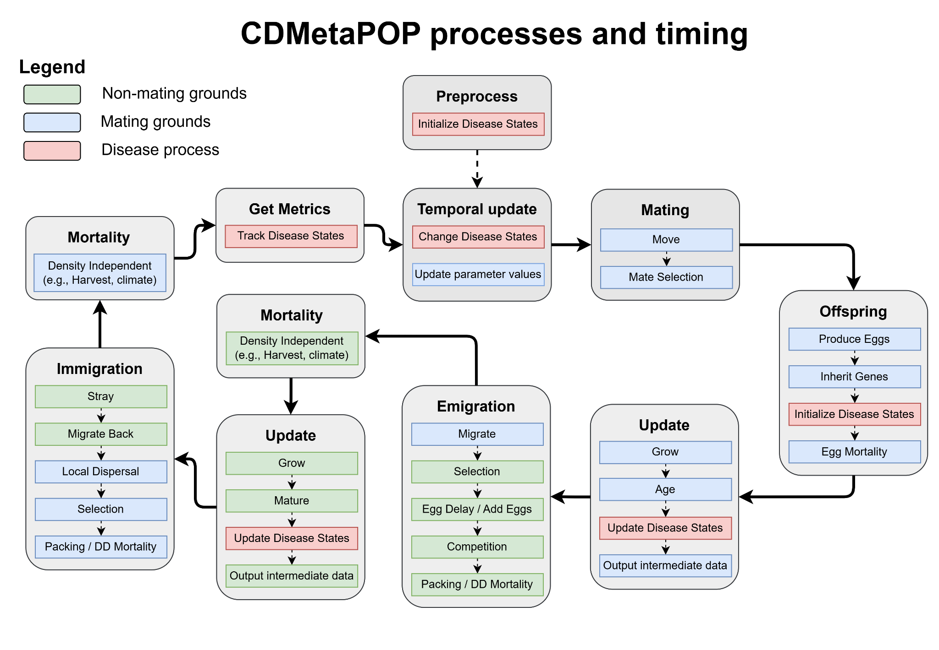
Figure A.1 - CDMetaPOP’s basic process cycle and flow diagram. Rectangle boxes illustrate CDMetaPOP existing modules and parallelograms highlight specific functions. Red parallelograms point towards new disease functions. Initialization of disease states occurs at the model onset (PreProcess()) and also when offspring join the population (DoOffspring()). Disease states are updated in either one or both of the DoUpdate() modules. Disease variables can be modified through time (CDClimate()) and tracking of disease states occurs throughout the program, e.g., GetMetrics(). Green and blue shapes point towards different life history strategies and split the time unit between two different sub-units. See user manual for more details.

