**Table S1.** List of parameters used in CDMetaPOP simulation runs of the westslope cutthroat trout system model. Parameters derived from SCL data are based on sampling from standard multiple pass depletion electrofishing surveys conducted during 2013-2017 in select 200-m sampling units. Patch-specific abundances were based on site-specific capture probabilities.

|  |  |  |  |
| --- | --- | --- | --- |
| **Input parameter** | **Description** | **Values** | **References** |
| ***Patch-level controls*** | | | |
| **Patches, (X,Y)** | Number of patches and location | 390 patches comprised of ~200 m reaches | SCL data (WFE 2019) |
| **K** | Carrying capacity | Variable: based on multi-pass depletion surveys from 2013 – 2017 and set so that N from the simulation model = estimated abundance. | SCL data (WFE 2019); Lukacs and Landguth 2018 |
| **N** | Initial abundance | N = K (Model output is not sensitive to initial abundances) | SCL data (WFE 2019); Lukacs and Landguth 2018 |
| **Natal Grounds** | Spawning locations | Based on electrofishing surveys indicating WCT presence/absence in summer/fall | SCL data (WFE 2019) |
| **Over-wintering grounds** |  | N/A, migration not simulated | - |
| **Genetics** | Initial allele frequency | Allele frequencies derived from 27 sampling locations from 2011-2014, with approximately 30 individuals per sample | Small et al. 2018 |
| **Mortality** | Patch-level mortality | N/A | - |
| **Migration probability** | Emigration probability | N/A | - |
| **Local dispersal distribution** | Distance moved each year | Based on observed annual distance and resistance movements, fit to Pareto and Weibull distributions, respectively (Figure S1) | SCL data (WFE 2019); Lukacs and Landguth 2018 |
| **Temperature Winter** | Temperature values used to grow individuals during overwintering | Based on sensor data and environmental variables, 2013 - 2017 | (Holden et al. 2011, Isaak et al. 2013; Day et al. 2018) |
| **Grow Days Winter** | Grow days during this period | N/A | - |
| **Temperature Summer** | Temperature values used to grow individuals during spawning | Based on sensor data and environmental variables, 2013 - 2017 | (Holden et al. 2011, Isaak et al. 2013) |
| **Grow Days Summer** | Grow days during this period | 365, all growth was based on summer temps | - |
| ***Class-level controls*** | | | |
| **Age class** | Number of age classes | 8 (0-7) | - |
| **Body Size** | Mean length (mm±SD) of each age class at initialization | 49 (3), 82 (11), 122 (17), 157 (18), 178 (17), 188 (19), 198 (20), 217 (20) | SCL data (WFE 2019) |
| **Distribution** | Initialize size classes within stands | Model is insensitive to initial size distribution | - |
| **Percent female** | Proportion of offspring born female | 50% | - |
| **Mortality** | Class-specific mortality | As an age check on old fish, 50% mortality applied on all individuals age 7+ | SCL data (WFE) 2019 |
| **Migration probability** | Probability that individual becomes migrant at each size class | N/A | - |
| **Straying probability** | Straying probability per individual per generation | N/A, only applicable to migrants | - |
| **Maturation** | The probability of becoming reproductive | P(mature) = exp(A + B * Length) / (1 + exp(A + B * Length))  A (female/male):0.06/0.13  B (female/male):-8.09/-20.28 | SCL data (WFE 2019); modeled after Downs et al. 1997 |
| **Fecundity** | Number of eggs per female | Mean number of eggs = A*exp(B*length (mm))  A = 9.56  B=0.018 | SCL data (WFE 2019); modeled after Downs et al. 1997; |
| **Size Control** | Processes can either operate based on size or age relationships | Size control | - |
| ***Run parameters and output*** | | | |
| **MCruns** | Replicate runs | 10 per simulation scenario | - |
| **Runtime** | Total years | 500 | - |
| **Start genes** | Year at which genetic exchange begins | 25 (allows for demographic burn-in) | - |
| **Output years** | Years individual data produced | Every 10 years | - |
| **Output format** | Format of genetic output | CDPOP format | - |
| **Population model** | Population growth model choice | packing | Landguth et al. 2017 |
| ***Landscapes and movement rules*** | | | |
| **Migration, mating, and straying movement** | Resistance to movement surface | All movement was for annual local dispersal or mating, no migration or straying.  Isolation-by-distance OR Isolation-by-resistance + physical barriers (i.e., dams, culverts). Max mating movement = 400 m. | UNICOR (Landguth et al. 2012; (Landguth and Cushman 2010) |
| **Home attempt** | Option for case when migrant fails to return to natal patch | N/A – no migration | - |
| ***Reproduction options*** | | | |
| **Sexual reproduction** | Asexual or heterosexual reproduction | Heterosexual | - |
| **Selfing** | Consider selfing | No | - |
| **Freplace, mreplace** | Mating with replacement | Males mate with replacement | - |
| ***Offspring options*** | | | |
| **Offno** | Draw choice for eggs produced | Poisson draw (mean is based on fecundity equation) | - |
| **Equal Clutch Size** |  | Yes (i.e., # of offspring does not increase with # of mating events) | - |
| **Egg Frequency** |  | Annual | - |
| **Egg mortality** |  | 68% (SD = 19%) | - |
| ***Genetic options*** | | | |
| **Loci/alleles** | Number of loci/alleles | 187 SNPs, 13 MSATs with 247 total alleles | Small et al. 2018 |
| ***Growth options*** | | | |
| **Growth option** | Modified Von Bertalanffy | Newsize(mm) = 72 * (1 – exp( -0.19 * (age + 1-5.0))); maxtemp = 10.12; tempcv = 0.47 (see CDMetaPOP user’s manual) | Landguth et al. 2016;  von Bertalanffy 1938; Seattle City Light unpublished data |

**Table S2.** Comparison of landscape genetics analyses using three different measures of pairwise genetic distance and two different sets of genetic markers. Analyses were performed using the R package ResistanceGA using multi-surface optimization.

|  |  |  |  |  |  |  |  |  |  |  |  |
| --- | --- | --- | --- | --- | --- | --- | --- | --- | --- | --- | --- |
| Distance Metric | Marker | % Elev. | % Grad. | Marginal R2 | Cond. R2 | Coefficient | SE | t value | Intercept | SE | t value |
| Hedrick | all | 62 | 38 | 0.31 | 0.91 | 0.0729 | 0.0052 | 13.96 | 0.300 | 0.040 | 7.43 |
| Hedrick | msat | 44 | 56 | 0.27 | 0.8 | 0.0798 | 0.0071 | 11.25 | 0.442 | 0.044 | 9.92 |
| Hedrick | snp | 57 | 43 | 0.31 | 0.91 | 0.0761 | 0.0053 | 14.27 | 0.305 | 0.042 | 7.31 |
| Jost | all | 78 | 22 | 0.42 | 0.89 | 0.0271 | 0.0022 | 12.49 | 0.071 | 0.011 | 6.31 |
| Jost | msat | 47 | 53 | 0.36 | 0.71 | 0.0729 | 0.0075 | 9.70 | 0.282 | 0.028 | 9.92 |
| Jost | snp | 83 | 17 | 0.4 | 0.88 | 0.0237 | 0.0020 | 11.65 | 0.061 | 0.010 | 5.83 |
| Nei | all | 93 | 6 | 0.24 | 0.92 | 0.0482 | 0.0040 | 12.02 | 0.182 | 0.032 | 5.65 |
| Nei | msat | 63 | 37 | 0.14 | 0.89 | 0.0267 | 0.0029 | 9.30 | 0.142 | 0.024 | 5.98 |
| Nei | snp | 69 | 31 | 0.24 | 0.92 | 0.0519 | 0.0043 | 11.97 | 0.197 | 0.035 | 5.68 |

**Figure S1.** Observed dispersal distances and resistances moved fit to a Weibull distribution (top panel) and a Pareto distribution (bottom panel).



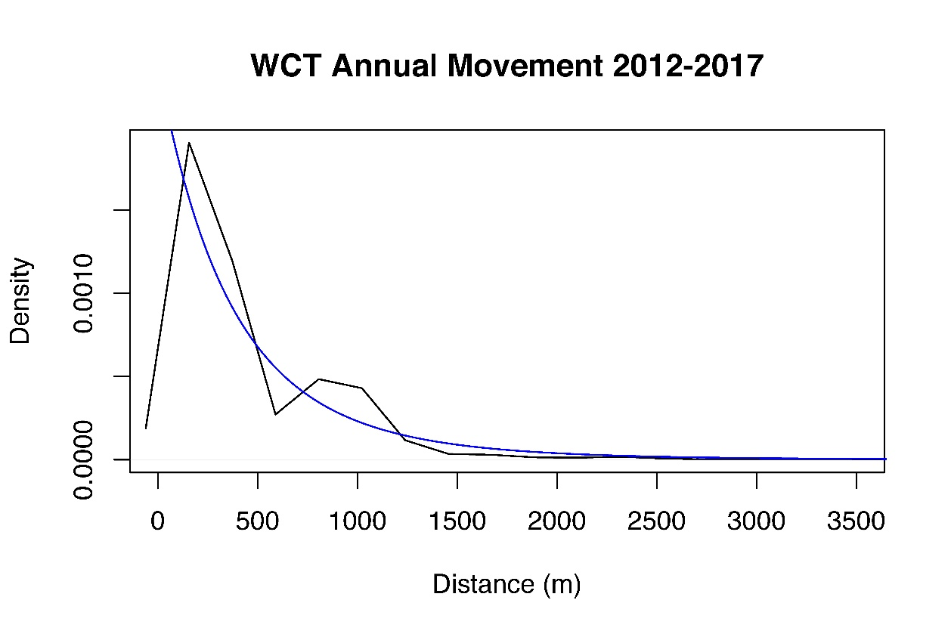

**Figure S2**. Single-surface optimization plots from resistanceGA. Elevation on left and gradient on right. The steep decline on the x-axis of the gradient plot is due to a single raster cell (gradient = 116) that fell outside the least cost path and thus contributed no resistance to movement.

**Figure S3 –** Genetic heterozygosity and structure following 500-year simulations of Westslope Cutthroat Trout populations in northwestern Washington, USA. Both microsatellites and single nucleotide polymorphisms are displayed.

MSATs

SNPs

MSATs

SNPs

**References**

Day, C.C., Landguth, E.L., Bearlin, A., Holden, Z.A., and Whiteley, A.R. 2018. Using simulation modeling to inform management of invasive species: A case study of eastern brook trout suppression and eradication. Biological Conservation **221**:10-22.

Holden, Z. A., J. T. Abatzoglou, C. H. Luce, and L. S. Baggett. 2011. Empirical downscaling of daily minimum air temperature at very fine resolutions in complex terrain. Agricultural and Forest Meteorology **151**:1066-1073.

Isaak, D., D. Horan, and S. P. Wollrab. 2013. A simple protocol using underwater epoxy to install annual temperature monitoring sites in rivers and streams. United States Department of Agriculture, Forest Service, Rocky Mountain Research Station.

Landguth, E. L., A. Bearlin, C. C. Day, and J. Dunham. 2016. CDMetaPOP: an individual‐based, eco‐evolutionary model for spatially explicit simulation of landscape demogenetics. Methods in Ecology and Evolution.

Landguth, E., B. Hand, J. Glassy, S. Cushman, and M. Sawaya. 2012. UNICOR: a species connectivity and corridor network simulator. Ecography **35**:9-14.

Landguth, E. L., and S. Cushman. 2010. CDPOP: a spatially explicit cost distance population genetics program. Molecular Ecology Resources **10**:156-161.

Lukacs, P.M., Landguth, E.L. 2018. Boundary Hydroelectric project area westslope cutthroat trout capture update 2012-2018. Seattle City Light, Seattle, WA, USA.

Small, M.P., Kissler M., Bearlin, A., Simmons, R. 2018. 2018 Boundary hydroelectric project native salmonid genetics program report: SNP genetic analyses of westslope cutthroat trout in Sullivan Basin and nearby tributaries of the Pend Oreille River. Draft Report. Washington Division of Fish and Wildlife, Olympia, WA, USA.

West Fork Environmental. 2019. Salmonid sampling, Boundary hydroelectric project area, NE Washington. 2018 Boundary Tributary Surveys submitted to Seattle City Light. Seattle, WA, USA.