Instructions on how to install TC_calibration repository (MAGEMin development branch) and Julia MAGEMin_app (Linux or Mac)

To download the repositories, as they are in private mode, you may have to be logged to github.

0. Download last Julia version

https://julialang.org/downloads/

- add Julia path to bashrc:
- export PATH="$PATH:/home/your_path_to_Julia/julia-1.9.4-linux-x86_64/julia-1.9.4/bin"

(the path has to be adjusted to your system)
This allow to execute Julia by typing “julia” in a terminal.

1. Download repository for MAGEMin (TC_calibration repo)

- create TC_calibration directory
- inside directory type:

git clone https://github.com/ComputationalThermodynamics/TC_calibration.git

- change active branch to the variable-buffer branch. This branch takes into account the last opx changes, and also allow to compute PX and TX diagrams with variable buffer values.

git checkout variable-buffer
git pull

(a repository may have several branches, the “git checkout” command allow to explore the different branches. The “git pull” command synchronize the local version of the branch with the online one)

- Compile MAGEMin

Information on how to perform a local compilation are available here:
https://computationalthermodynamics.github.io/MAGEMin/stp/Linux.html
For mac, if you are having troubles, Owen has experience and can help (I have a Linux machine and can help with that)

- Once successfully compiled check if MAGEMin works properly using:

./MAGEMin

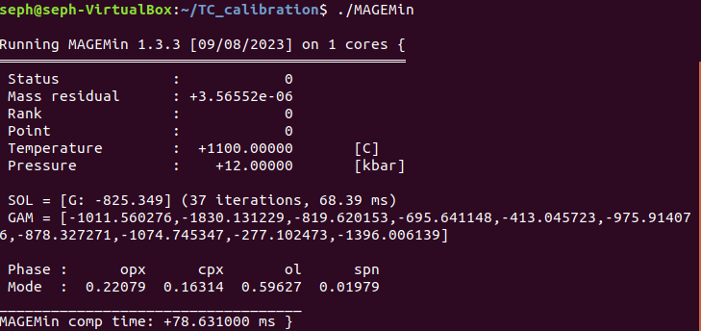
This should result in:

- Once MAGEMin is working, we need to create the Julia binary wrapper:

make lib

This will create a file called “libMAGEMin.dylib” (This file will be later copied in the MAGEMin_app directory)

2. MAGEMin_C

MAGEMin_C is the public (online) Julia wrapper. Because MAGEMin_app uses MAGEMin_C we need to override the public version and use a local version that synchronized with the dev branch of MAGEMin (TC_calibration). This is the slightly tricky bit, but should work just fine.
- Open Julia terminal (] opens the package manager)

] add MAGEMin_C
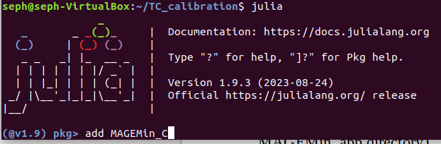

This will install the public version of MAGEMin_C. However we want a “dev” MAGEMin_C
To do so we first set MAGEMin_C as a “dev” package (a local development version will be used instead of the online one):

] dev MAGEMin_C

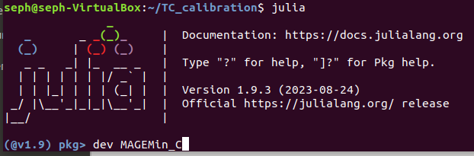

The operation creates a “dev” directory in

~/.julia/dev/MAGEMin_C

- Inside that directory should be copied several directories from the MAGEMin repository downloaded and compiled during step 1 (TC_calibration). Place yourself in the directory (cd ~/.julia/dev/MAGEMin_C), then copy the needed directories:
cp -r ~/TC_calibration/gen .
cp -r ~/TC_calibration/test .
cp -r ~/TC_calibration/julia .

(you might need to adjust the path to your own system)

3. Download repository MAGEMin app (Julia GUI)

- create MAGEMin_app directory
- inside directory type:

git clone https://github.com/ComputationalThermodynamics/MAGEMin_app.git
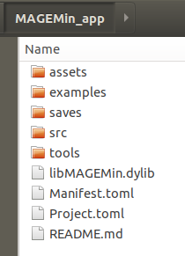
- Copy the “libMAGEMin.dylib” file from the TC_calibration directory into MAGEMin_app directory:

- From within the MAGEMin_app directory launch julia as:

julia -t 5

(the above command tells julia to run with 5 threads, this can be adjusted to your machine, the more threads available the better)

using MAGEMin_C (it is important to load MAGEMin_C first, as this loads the local version)
] activate .
instantiate (should only be done the first time to get all necessary packages)
hit “backspace”
using MAGEMin_app
App()
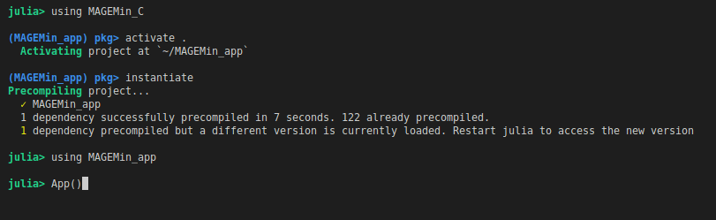

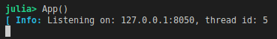

Here MAGEMin_app is successfully running on local address 127.0.0.1:8050.
Simply copy and paste this address to a web-browser:
