Results
Table from Bullinaria’s article
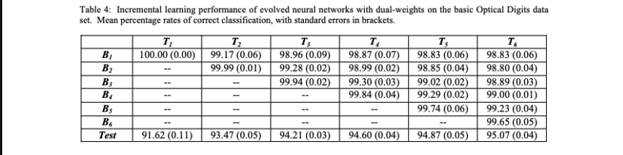
Table obtained from the Bullinaria version in PyTorch
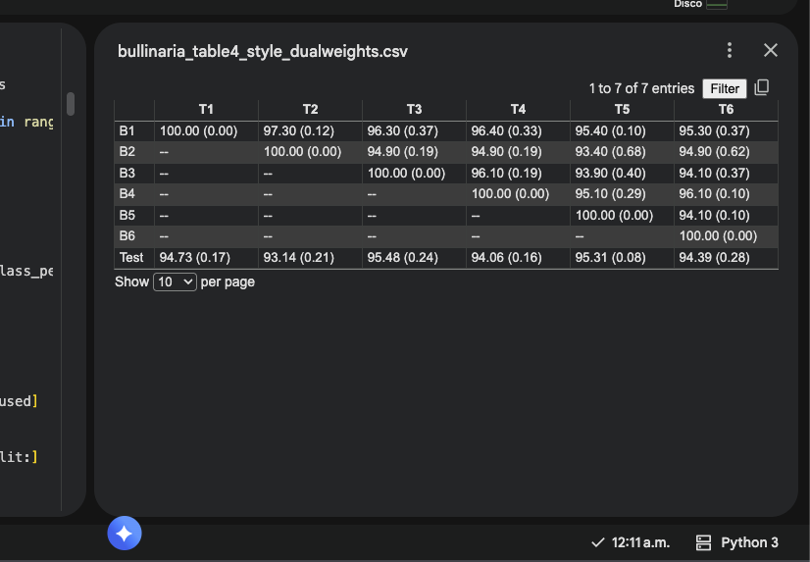
Table of my algorithm
