3. What will be the output if quickselect algorithm is applied to the array arr={1,5,4,3,7} with k given as 4?  
a) 1  
b) 3  
c) 4  
d) 5

Answer: d  
Explanation: Quickselect algorithm finds the kth smallest element from the given list. So as here the given value of k is 4 so we need to find the fourth smallest element which is 5 in the given array.

4. What is the auxiliary space requirement of the quickselect algorithm?  
a) O(n2)  
b) O(n)  
c) O(n log n)  
d) O(1)

Answer: d  
Explanation: Quickselect algorithm requires no extra space in order to calculate the desired result. It performs manipulations in the given array itself so its auxiliary space requirement will be O(1).

5. Quickselect is an in-place algorithm?  
a) true  
b) false

Answer: a  
Explanation: Quickselect’s auxiliary space requirement is O(1). So quickselect qualifies as an in-place algorithm.

9. What is the average case time complexity of quickselect?  
a) O(n log n)  
b) O(n2)  
c) O(n)  
d) O(log n)

Answer: c  
Explanation: In quickselect, we don’t recur for both portions of the array. Only that portion is considered where the smallest element lies. So this causes the average time complexity to be O(n).

11. Which of the following correctly represent the algorithm of quickselect?  
a)

**function** quickSelect(list, left, right, k)

if left = right

return list[left]

Select a pivotIndex between left and right

pivotIndex := partition(list, left, right, pivotIndex)

if k = pivotIndex

return list[k]

else if k < pivotIndex

right := pivotIndex - 1

else

left := pivotIndex + 1

Answer: a  
Explanation: In quickselect algorithm if index of partitioned element is more than k, then we recur for left part. If index is same as k, we have found the kth smallest element and we return. If index is less than k, then we recur for right part.

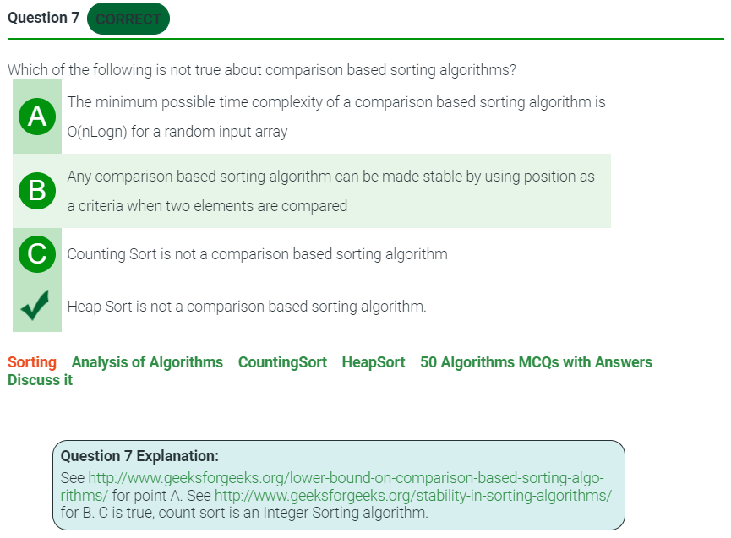

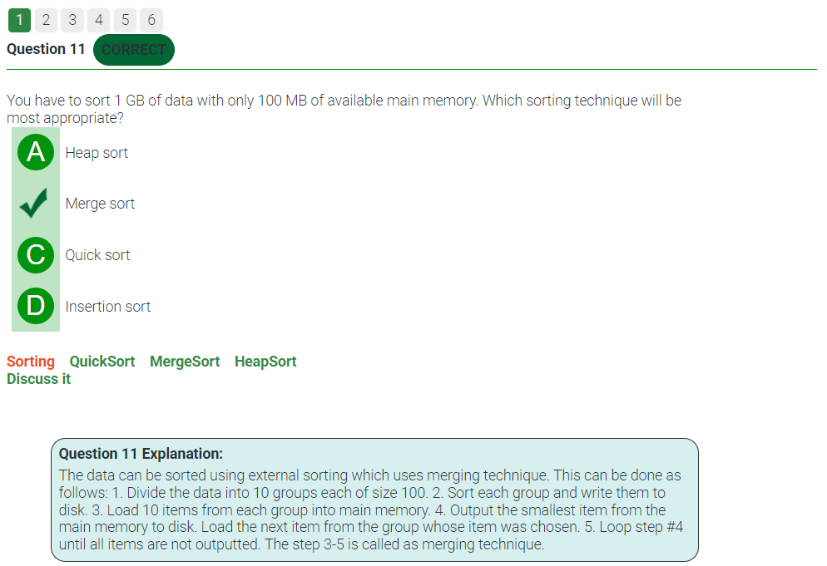

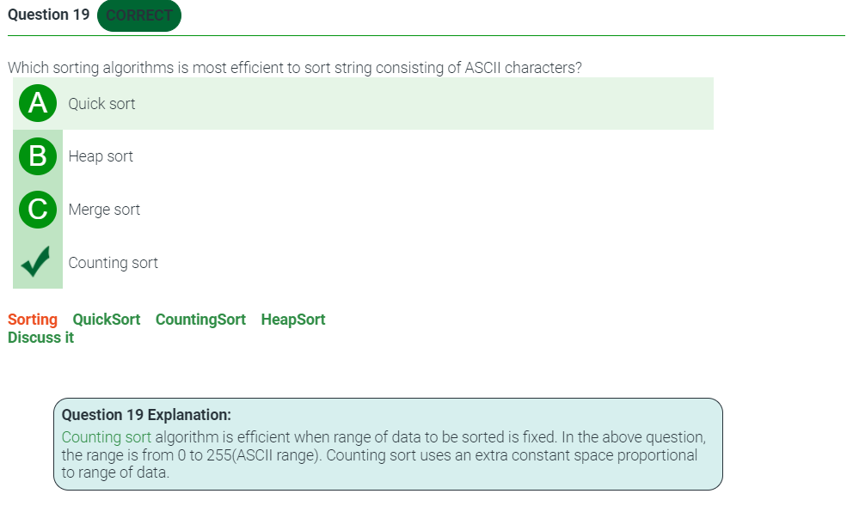

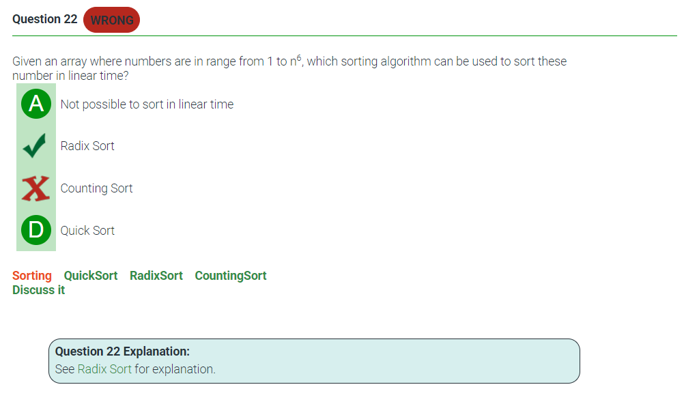

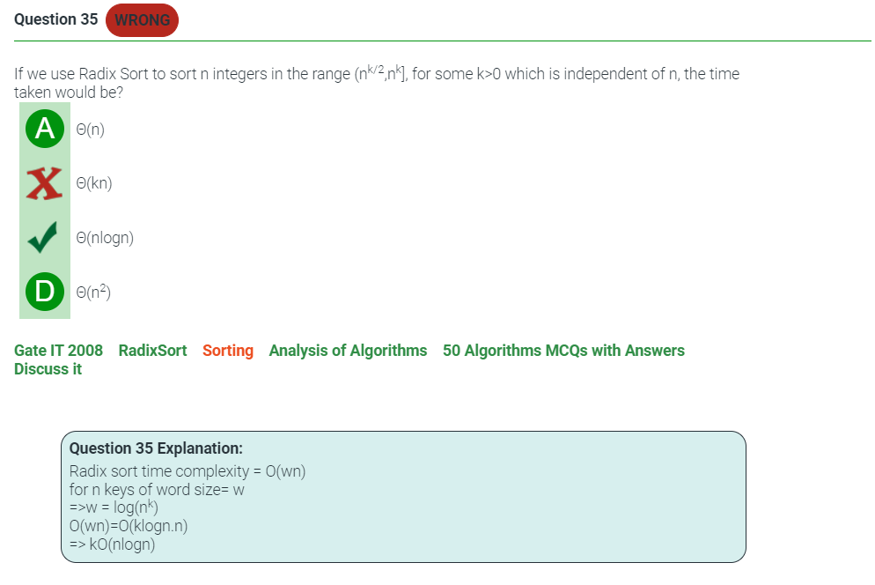

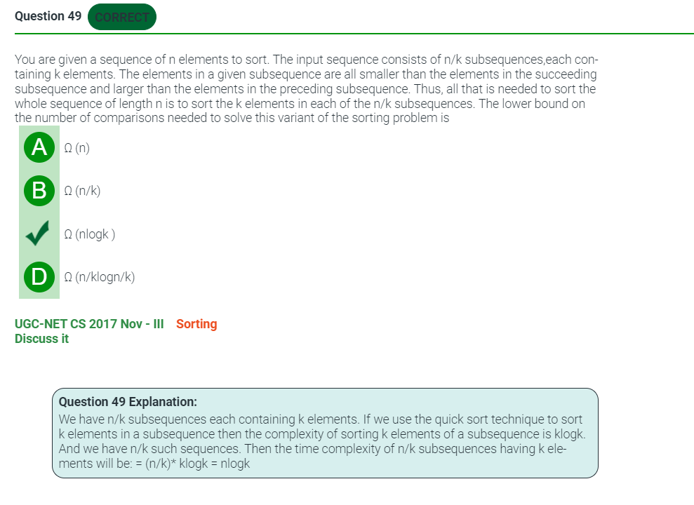

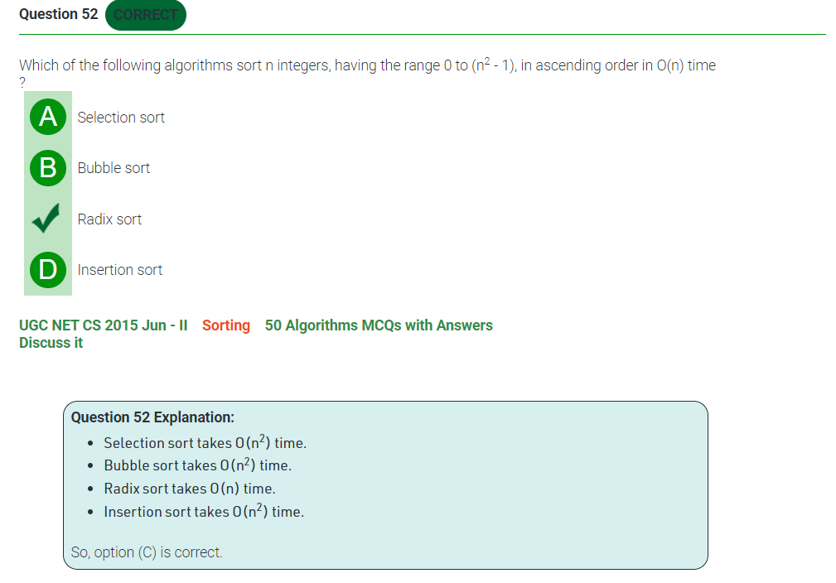

**1. Which of the following is not a stable sorting algorithm?**  
  
a) Insertion sort  
b) Selection sort  
c) Bubble sort  
d) Merge sort

**7. The time complexity of heap sort in worst case is**  
  
a) O(logn)  
b) O(n)  
c) O(nlogn)  
d) O(n2)

**11. Time complexity of bubble sort in best case is**  
  
a) θ (n)  
b) θ (nlogn)  
c) θ (n2)  
d) θ (n(logn) 2)

**14. Which of the following sorting algorithms is/are stable**  
  
a) Counting sort  
b) Bucket sort  
c) Radix sort  
d) All of the above

**14. Which of the following sorting algorithms is/are stable**  
  
a) Counting sort  
b) Bucket sort  
c) Radix sort  
d) All of the above

Answer: c  
Explanation: Time complexity of counting sort is given as O(n+k) where n is the number of input elements and k is the range of input. So if range of input is not significantly larger than number of elements in the array then it proves to be very efficient.

6. Which of the following sorting techniques is stable?  
a) quick sort  
b) counting sort  
c) heap sort  
d) selection sort

Answer: b  
Explanation: Counting sort is an example of stable sorting algorithm as the elements with identical values appear in the same order in the output array as they were in the input array.

7. Which of the following uses the largest amount of auxiliary space for sorting?  
a) Bubble sort  
b) Counting sort  
c) Quick sort  
d) Heap sort

Answer: b  
Explanation: Counting sort requires auxiliary space of O(n+k) whereas quick sort, bubble sort and heap sort are in place sorting techniques. Thus counting sort requires most auxiliary space.

1. How many comparisons will be made to sort the array arr={1,5,3,8,2} using counting sort?  
a) 5  
b) 7  
c) 9  
d) 0

Answer: d  
Explanation: As counting sort is an example of non comparison sort so it is able to sort an array without making any comparison.

11. Counting sort is often used as a sub routine for radix sort.  
a) true  
b) false

Answer: a  
Explanation: Counting sort is used as a sub routine for radix sort as it is a stable and non comparison based sorting algorithm.

14. What is the disadvantage of counting sort?  
a) counting sort has large time complexity  
b) counting sort has large space complexity  
c) counting sort is not a comparison based sorting technique  
d) counting sort cannot be used for array with non integer elements

Answer: d  
Explanation: Counting sort can only be used for arrays with integer elements because otherwise array of frequencies cannot be constructed.

3. LSD radix sort requires _____ passes to sort N elements.  
a) (w/logR)  
b) N(w/logR)  
c) (w/log(RN))  
d) (wN/log(N))

Answer: a  
Explanation: LSD radix sort sorts the N elements in (w/logR) passes where w is the number of digits in largest number and R(radix) is extra space required for performing the sorting operation.

6. LSD radix sort is faster than comparison sorts.  
a) True  
b) False

Answer: b  
Explanation: LSD radix sort is faster than comparison sorts when the word size is less than logn. But LSD radix sort runs slowly for elements with larger word size and smaller radix.

7. Which of the following should be used to sort a huge database on a fixed-length key field?  
a) Insertion sort  
b) Merge sort  
c) LSD radix sort  
d) Quick sort

Answer: c  
Explanation: LSD radix requires only w passes to sort a fixed-length string, where w is a length of the strings. So, LSD radix sort is best suited to sort a huge database on a fixed-length key field.

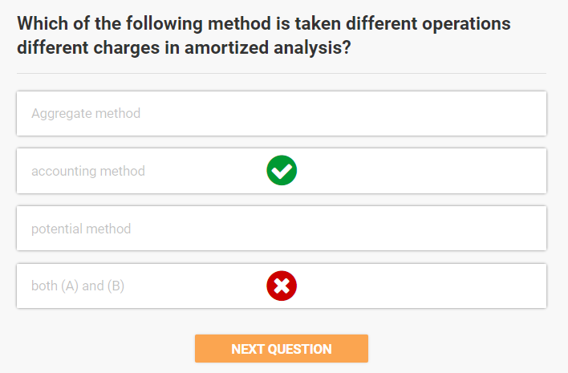

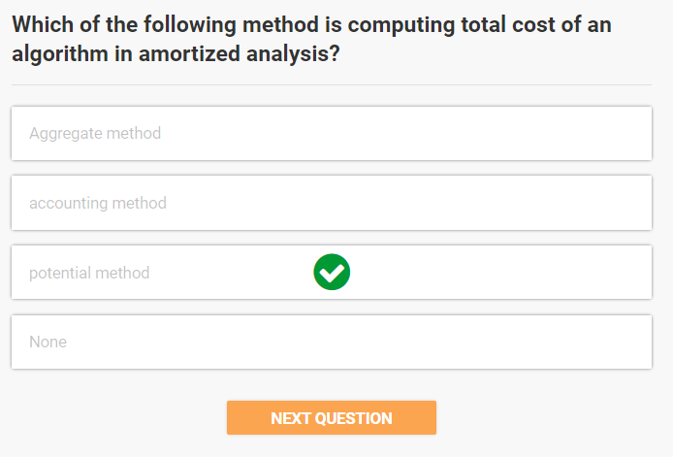

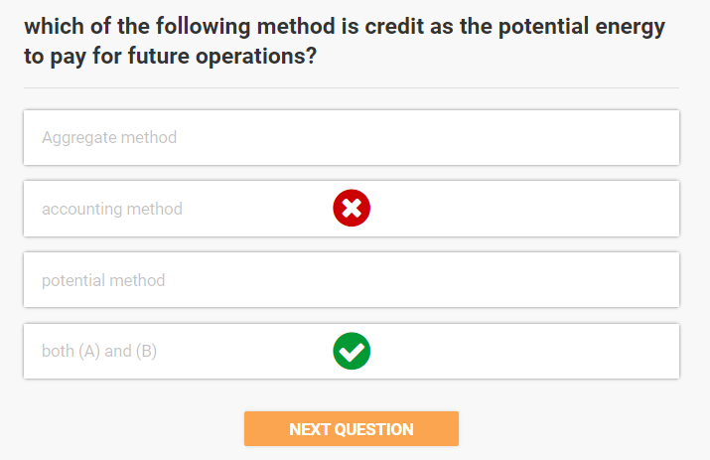

**6. Which of the following is not a noncomparison sort?**  
  
a) Counting sort  
b) Bucket sort  
c) Radix sort  
d) Shell sort

**21. Time complexity to sort elements of binary search tree is**  
  
a) O(n)  
b) O(nlogn)  
c) O(n2)  
d) O(n2logn)

**22. The lower bound on the number of comparisons performed by comparison-based sorting algorithm is**  
  
a) Ω (1)  
b) Ω (n)  
c) Ω (nlogn)  
d) Ω (n2)

**26. For merging two sorted lists of size m and n into sorted list of size m+n, we require comparisons of**  
  
a) O(m)  
b) O(n)  
c) O(m+n)  
d) O(logm + logn)