MOBILE APP DEVELOPMENT.

Have you ever wondered how your favorite mobile applications are built/developed?

Today we begin a journey through the Mobile development landscape. Some of the main things we need to consider before writing the first code include:-
- Our target operating system e.g Android OS or iOS.
- The programming language in use(what we are good at) e.g. Java or Swift.

We can classify the mobile apps into:
- Native applications
- Hybrid Applications
Whats the difference?

Native Application
Native application is a software or program which has been developed to perform some specific task on particular environment or platform.

Native application is built using software development tools (SDK) for a certain software framework, hardware platform or operating system.

Like Android app built using Java Development Kit on Java platform, iOS app built using iOS SDK, Swift and Objective C. Similarly, .NET required for Windows platform.

Hybrid application(Cross-platform)
Hybrid apps are native apps only because it can be downloaded from platform’s app store like native app. It can get access to all the native platform features. It can have performance close to native app

Whats our aim?
Our aim is to develop Cross-platform apps since we will only have a single code base and be able to ship our apps to both appstore(iOS) and Playstore(Android). Even though its not what we will begin with.

Our options on Hybrid apps(2019)
There are two major frameworks used for cross-platform mobile app development, one of them has been around for quite sometime and uses (javascript technology), the other one was introduced by google some few years back and uses one of Google’s Own programming language.

They are namely:
- React Native ( Uses Java script)
- Flutter (Uses Dart programming language)---This is our choice for cross-platform apps.
-Xamarin(from Microsoft Uses C#)---we wont be using xamarin anytime soon.
Before we dive into cross-platform
Lets learn some Native android programming using Java. If you take a look at most of our previous posts we did some introduction to java, thats the reason we felt it could be a good practice to use some of that knowledge first.

The Android Platform:

Introduction to the Android platform and the Android Studio IDE, Android components, Activities

Android is An open source platform for mobile, embedded and wearable
devices. Google is the principle maintainer while Other companies only contribute to the system. Each device manufacturer can customize Android to suite their needs.

Why open source
-Android operating system source code is freely available to the public
- Android’s development kits are freely available(Google ensures updates are also available to the general public).
- Community - Development community for this platform has no rival.

Android Architecture
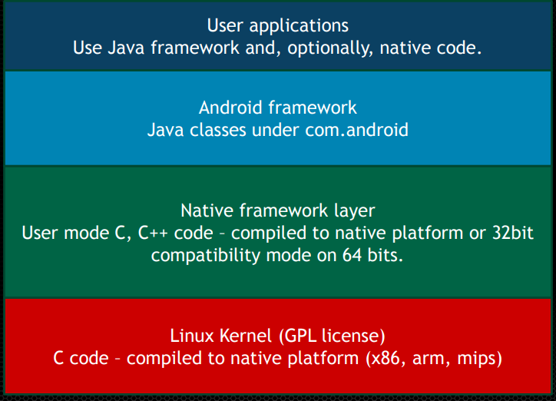

1. At the top level we have the “user Applications”
2. Android Framework layer
3. Native framework layer
4. Kernel
Our main point of concern will be the User applications

What do we need to write our first Android App?
1. Android SDK
- Provides the Java framework classes
-Compiles to java bytecode
-Class framework is updated with every OS release
2. Android NDK (Not really must while begining)
-C/C++ toolchain for compiling to machine code
3. Android platform tools
-adb (android debug bridge) : runs and debugs apps from your development machine.
4. Android developer tools
-Android studio IDE(Integrated development Environment)
NB: You also need JDK(java development Kit Installed)

Installation and Setup of Android Studio IDE

Before we proceed You will need some good Internet connection from here henceforth.

Step 1: Java Development Kit(JDK)
You will need to download JDK from (www.oracle.com), its free.
https://www.oracle.com/technetwork/java/javase/downloads/jdk8-downloads-2133151.html

Step 2: Install Android Studio from (https://developer.android.com/studio/install)
What comes with android studio?
- A flexible Gradle based build system( The IDE will download the latest Gradle version)
- Code templates
- Github integration
- Downloads the latest Android SDK components

After the download below is a series of steps you’ll have to encounter.

First: Click Next to proceed
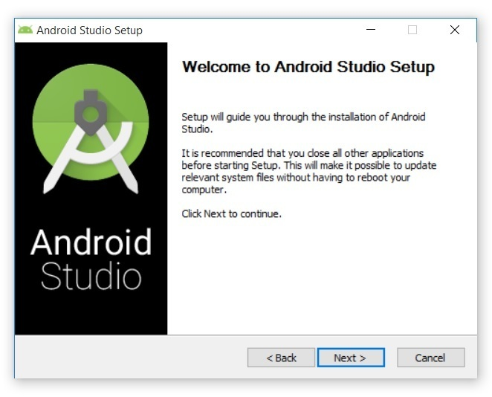
Second: You will go through several steps
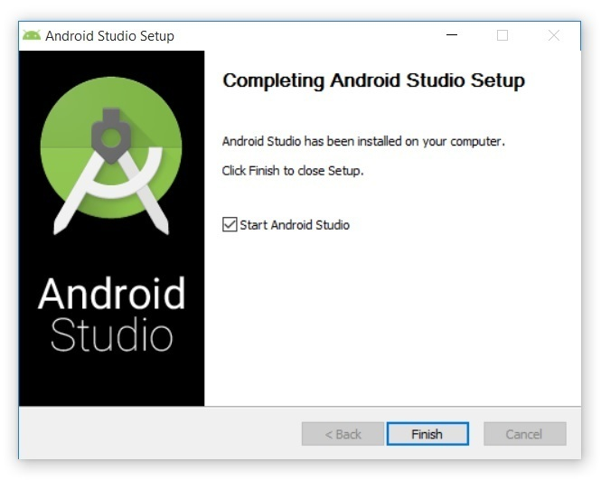

Third: You will encounter such, thats why you need some good Internet 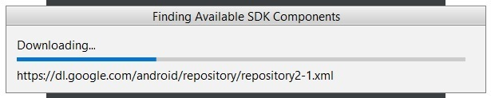
Fourth: You will be required to select the theme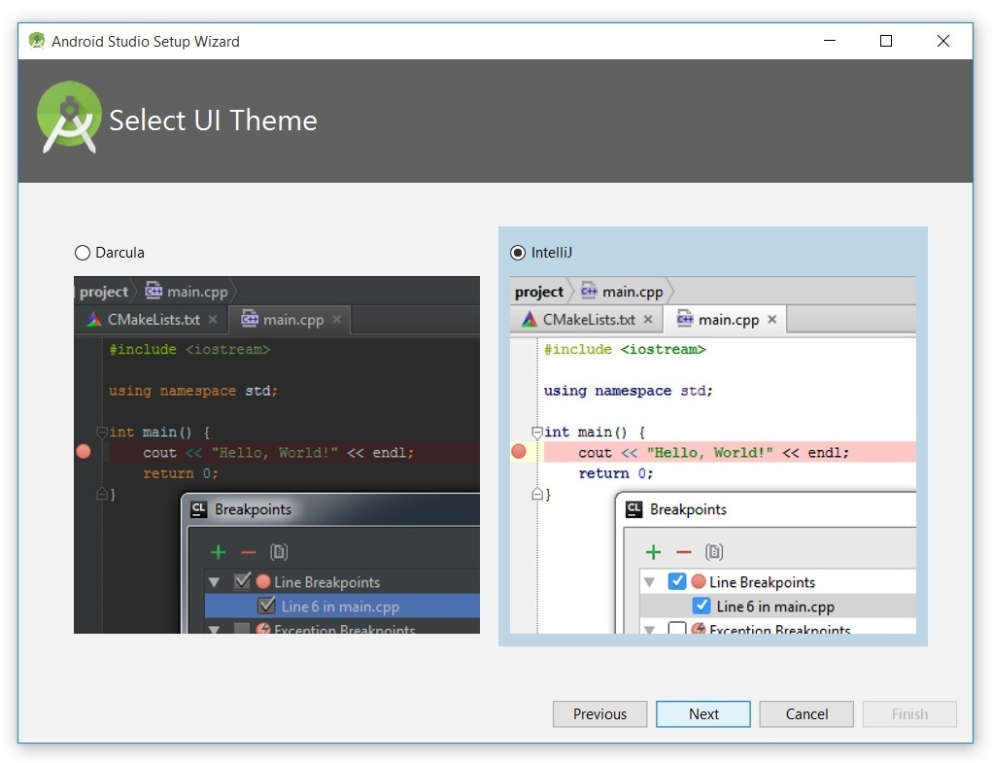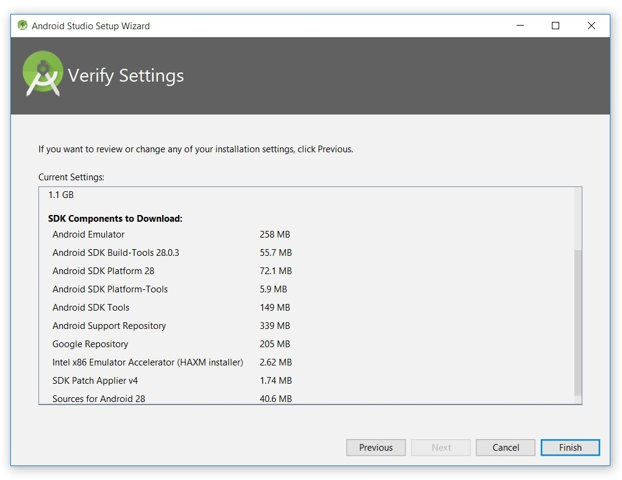

N/B: The above step is quite important, but all you need is allow android studio to download all the components.

LETS CODE OUR FIRST ANDROID APP:

New “Android Studio Project
Starting Android studio IDE you will be required to create a new “Android Studio Project” , the following window will be displayed containing templates which includes:
1. Basic Activity
2. Empty Activity
3. Bottom Navigation Activity
4. Full screen activity
5. Master/Detail
6. Navigation Drawer Activity
7. Google Maps Activity
8. Login activity
9. Scrolling Activity
10. Tabbed activity.
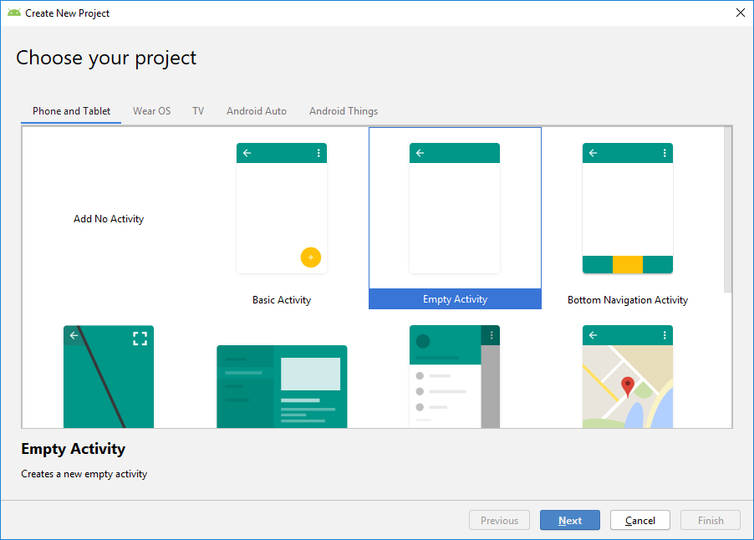

Why Templates?
These templates only give you ahead-start on development. Instead of you personally trying to setup the project, these templates do setup the project for you. You can even select a template and deploy/ run the app on your device or an emulator.
We’ll explain later how to deploy your app on a real device or an emulator.

For this tutorial we are going to select an empty activity.

Configure your project.
The next step is to configure your project, under this option there are specific points you need to consider.
1. Your Application Name
Lets call our app - Awesome App
2. The package name
The package name is a unique name to identify a specific app. Generally, the package name of an app is in the format domain.company.application. The domain part includes toplevel domain names like(com,org), the company name can be any name you choose. Application part- simply the app name. Package names are usually lowercase
For example our package name will be- com.computerscienceprojects.awsomeapp
N/B: package names ought to be unique because once we publish the app on playstore, the package name becomes the unique identifier that differentiates all the apps on playstore
3. Save location
You need to specify where the location of your project. For example my project will be located in the Github directory(folder), since after i will later on publish the project on github.

4. Language
You ought to specify which programming language you intend on using. Either Java / Kotlin.

5. Minimum API Level

