EarthOverView

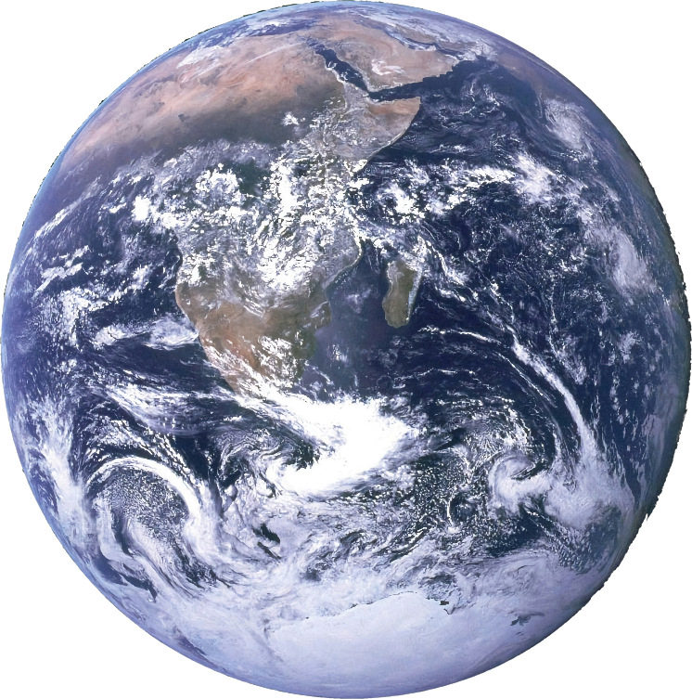

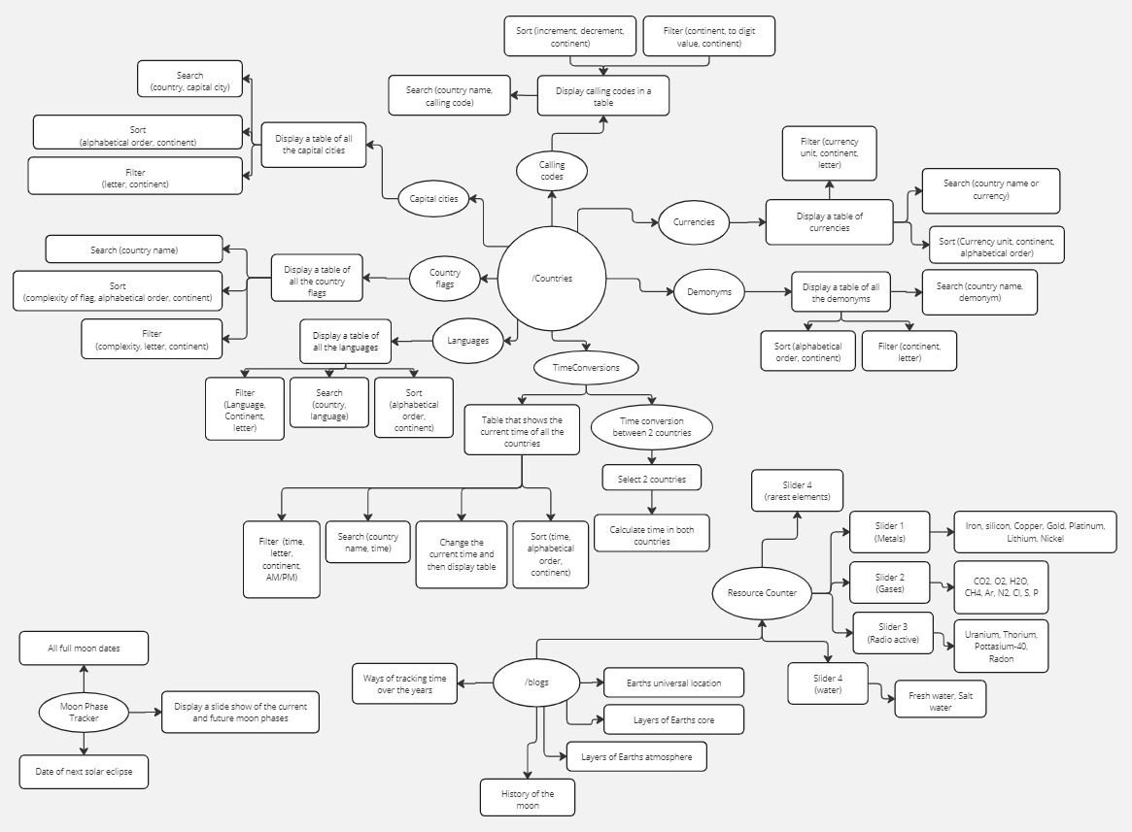

Miro.com view link: <https://miro.com/welcomeonboard/V3R3cmw2UWZPTm9kR1Q0d25NckttWGxscWpKa1RQYktyekNkeHB6a0dEdlQwdlJZSjhJR3NJNHMxbkM1M2FGenwzNDU4NzY0NTk1Mjk0MDgwNDMxfDI=?share_link_id=184347047932>

Linking hierarchy:

* EarthOverView
  + Countries
    - CallingCodes
    - Currencies
    - Demonyms
    - TimeConversions
    - Languages
    - CountryFlags
    - CapitalCities
  + Blogs
    - UniversalLocation
    - Core
    - Atmosphere
    - Moon
    - Time
    - ResourceCounter
  + MoonPhaseTracker

Calling Codes

Main Scenarios:

1. User searches up a country and obtains the relevant calling codes
2. User searches up a calling code and obtains the relevant country
3. User sorts the calling codes in ascending/descending order
4. User filters only the calling codes in Asia

Design requirements:

Search bar, search selector, filter and sort buttons, A table with the following columns: Country, Continent, Calling code.

Technical requirements:

RestAPI: [https:/restcountries.com/](https://restcountries.com/), Javascript, tailwind

Currencies:

Main Scenarios:

1. User filters a currency unit and obtains the countries with the currency unit
2. User filters a continent and find the currencies used
3. User sorts the countries in alphabetical order and obtain the currencies
4. User searches a country and obtains the currency
5. User copies a currency symbol

Design requirements:

Search bar, search selector, filter and sort buttons, A table with the following columns: Country, Continent, Currency, Currency Unit, Currency shorthand name, symbol.

Technical requirements:

RestAPI: [https:/restcountries.com/](https://restcountries.com/), Javascript, tailwind

Demonyms:

Main Scenarios:

1. User searches a country and obtains demonyms
2. User searches a demonym and obtains the country
3. User sorts demonyms to alphabetical order
4. User filters demonyms with a certain starting letter

Design requirements:

Search bar, search selector, filter and sort buttons, A table with the following columns: Country, Continent, Demonym.

Technical requirements:

RestAPI: [https:/restcountries.com/](https://restcountries.com/), Javascript, tailwind

Time Conversions:

Main Scenarios:

1. User selects 2 countries (his own and another) and will convert the time between the 2.
2. User types in a name of a country to find the time of that country
3. User filters countries depending on weather it is day or night

Design requirements:

2 selectors to select 2 countries.

Search bar, search selector, filter and sort buttons, A button to switch between 12 hour and 24 hour time formats A table with the following columns: Country, Continent, Time, AM/PM.

Technical requirements:

WoldTimeAPI: <https://worldtimeapi.org/> ?, Javascript, tailwind

Languages:

Main Scenarios:

1. User enters a language and views the countries speaking that language
2. User enters a country and finds the language spoken by that country
3. User filters a continent and finds all the languages spoken in that continent
4. User finds the language code of a country

Design requirements:

Search bar, search selector, filter and sort buttons, A table with the following columns: Country, Continent, language name, language code (ISO 639-1, ISO 639-2).

Technical requirements:

RestAPI: [https:/restcountries.com/](https://restcountries.com/), Javascript, tailwind

Country flags:

Main Scenarios:

1. User searches a country and gets the flag
2. User sorts the flags to complexity and scrolls through them
3. User filters flags depending on their complexity.

Design requirements:

Search bar, search selector, filter and sort buttons, A table with the following columns: Country, Continent, country flag, flag complexity rating.

Technical requirements:

Javascript, tailwind

Country flags:

Main Scenarios:

1. User searches a country and gets the flag
2. User sorts the flags to complexity and scrolls through them
3. User filters flags depending on their complexity.

Design requirements:

Search bar, search selector, filter and sort buttons, A table with the following columns: Country, Continent, country flag, flag complexity rating.

Technical requirements:

Javascript, tailwind

Capital cities:

Main Scenarios:

1. User searches a country and gets the capital city
2. User obtains co-ordinates of the capital city

Design requirements:

Search bar, search selector, filter and sort buttons, A table with the following columns: Country, Continent, capital, longitude, latitude.

Technical requirements:

RestAPI: [https:/restcountries.com/](https://restcountries.com/), Javascript, tailwind