THE EARTHIAN CIVILIZATION

The Earthian Civilization is a website that provides an overview of planet Earth and the human civilization to all humans and all those who live among the stars.

The webpage consists of these major features:

* Planetary data – Information about the location of Earth in the solar system
* Planetary core data – Information about Earths rock structure
* Atmospheric data – Information about the Earth’s atmosphere
* Lunar tracker – Information about the Earth’s moon and its current and future positions
* Civilization search browser – Search up countries and view information about them
* Economic status – View the economic status of the civilizations of planet Earth
* Population data – Information about population of countries
* Time zone converter – Converts the time zone in each country

*Homepage*

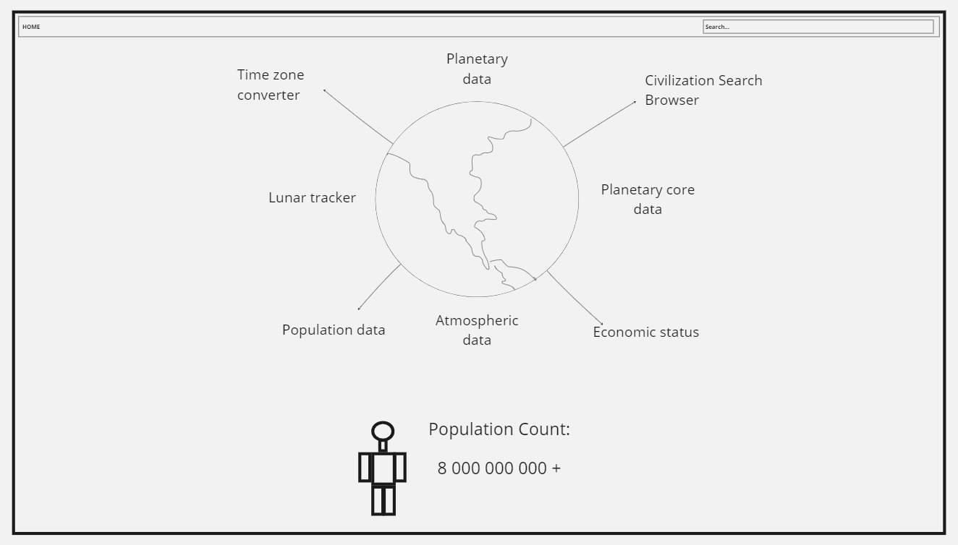

Each of the features are represented to the user using clickable icons and text in the homepage.

The Giant Earth drawn above will be animated to rotate.

The total human population count will be obtained by this API:

Planetary data

This page is more like a blog post and offers the following information:

* Location in the universe
* Location in the milky way
* Location in the solar system
* Distance from the sun
* The orbit that it travels in
* The 24 hour day and night cycle
* Tilting of the Earth and the reason for that

You might realize that this list starts from the location of the Earth in the universe and goes into more and more accuracy from there.

Planetary core data

This page is also more like a blog post and shows information about the rock layers of Earth.

A picture of the Earths rock layers would be presented and users will be able to click on the layers and a giant text box would appear and provide information.

These are the contexts:

* Crust
* Mantle
* Outer core
* Inner core

Atmospheric data

This page is also like a blog post and shows information about the atmosphere of Earth.

A picture of the Earths atmospheric layers would be shown and users will be able to click on each layer and a giant text box would appear and provide information.

It includes information on the following layers:

* Troposphere
* Ozone layer
* Stratosphere
* Mesosphere
* Karman line
* Thermosphere
* Ionosphere
* Exosphere
* Magnesphere

Lunar Tracker

This provides a live service but also serves to provide information about the moon.

The page first starts off with live information on the moon provided by an API. Then it will shift down to showing information about the moon like:

* Theories on how the moon was formed
* Resources on the moon
* Impacts of the moon on planet Earth
* Future plans for making a civilization on the moon