Validation Testing

Vanya Bays, Kyle Ingersoll

5-12-2024

SDEV265

## 

## 

## Blank Reservation Test Case:

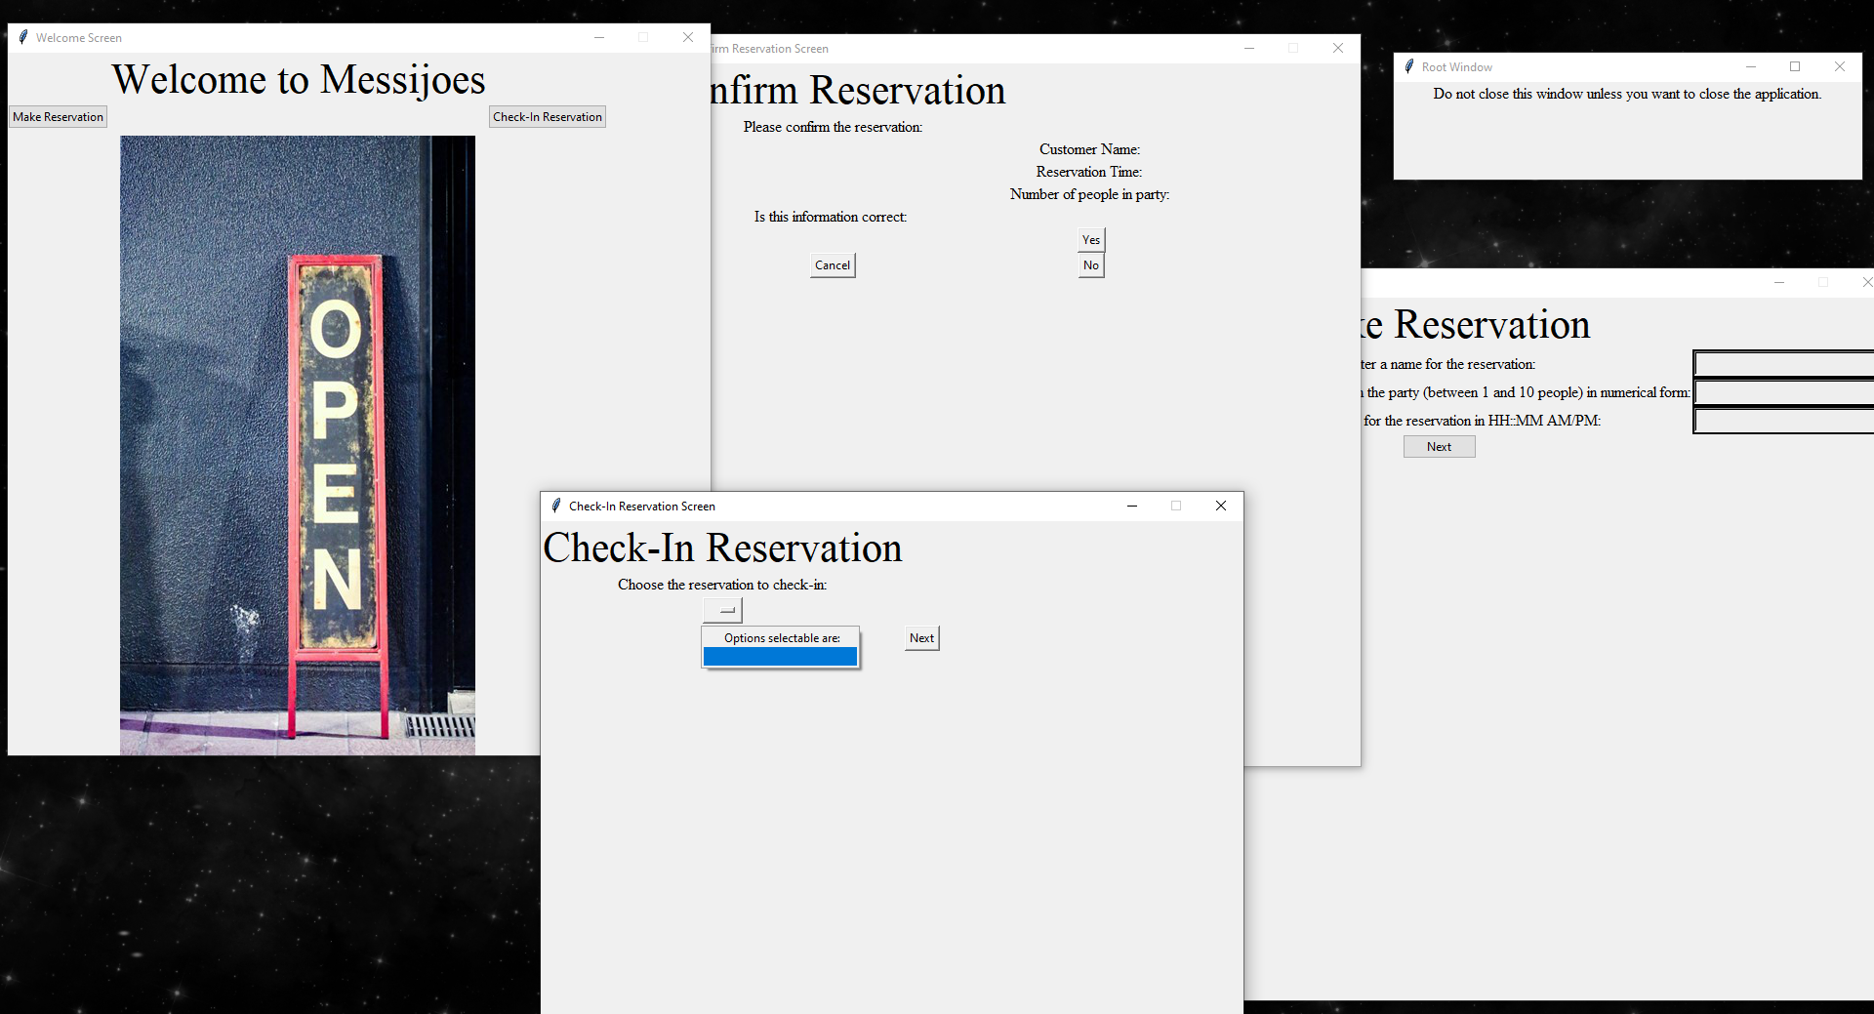

## Filled Out Resevation Test case:

## 

## 

## 

## 

## 

## 

## Multiple Reservations Test Case: