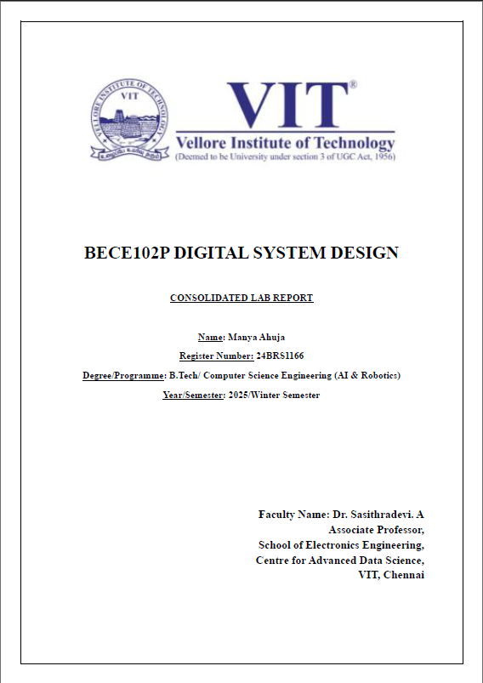
SUBMITTED TO: Ms. Shalini Supriya
SUBMITTED BY:
Manya Ahuja (24BCE5554)
Sucharita Karmakar (24BCE5143)
Yash Sharma (24BCE5459)
Murudkar Kaushik Mandar (24BCE5250)
Vidhan Jain (24BCE5353)
Topic: Cinema & Literature

Degree/Programme: B.Tech/Computer Science Engineering
Year/Semester: II/Fall Semester

DIGITAL ASSIGNMENT
BESP101L SPANISH

