# INFO5100 Application Engineering Development

University Management Portal

|  |  |
| --- | --- |
| **Project Name:** | University Management Portal  **Project in Java** |
| **Abstract** | It’s a GUI-based project used with the Swing module to organize all the elements that work under library management. |
| **Language/s Used:** | Java |
| **IDE** | Eclipse |
| **Java version (Recommended):** | **Java SE 18.0.** **2.1** |
| **Database:** | MySQL |
| **Type:** | Desktop Application |

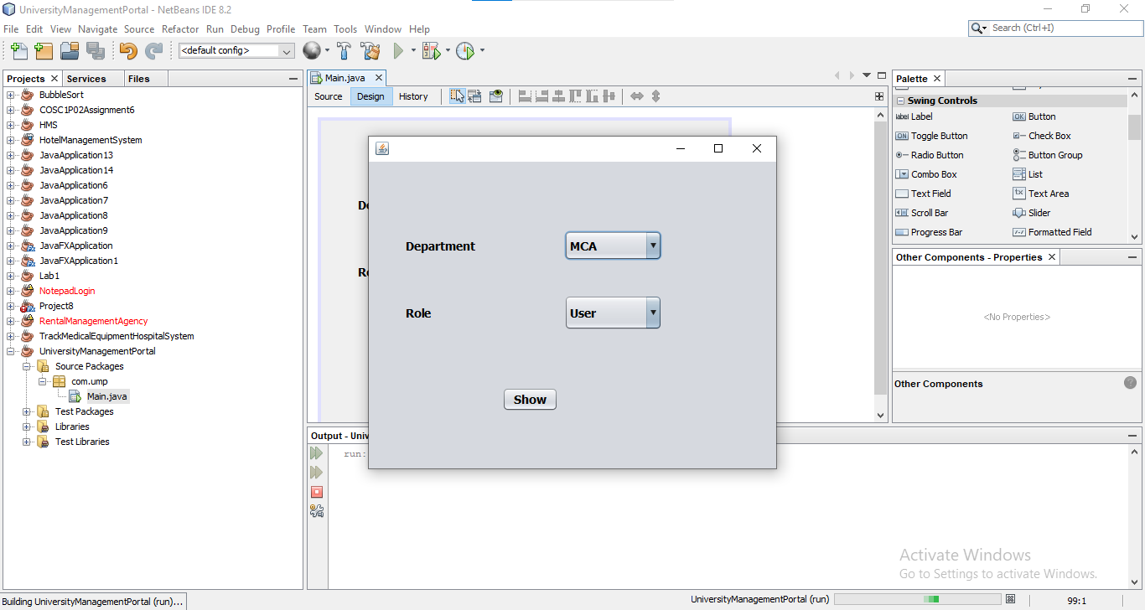

**Why are we creating the University Management Portal Project in Java?**

Java is an object-oriented programming language that is similar to C++ but has additional capabilities such as free access and can run on all systems. Some of the distinguishing characteristics that make it the finest alternative for such software development are as follows:

* **Easy to understand:** It does not have issues like operator overloading or pointers, which might make the job more difficult.
* **Object-oriented:** An object-oriented program is thought to have a state and behavior and to provide output accordingly.
* **Security**: To prevent data manipulation from untrusted sources, it runs the application in the sandbox and transforms it to bytecode after compilation.

### ****The Output Design****:

The output design aims to produce a precise and efficient result to the query entered by the user. Because they are the provider’s direct source of information, they must produce satisfactory answers that answer the inquiry. The specific outputs for the questions are set along with their forms during the program’s logical design.

### ****The Database Design****:

The database is where users’ interrelated data is saved in order to present them with an effective solution. As one of the process’s inputs and outputs, database design is critical to making information accessible and adaptable for users to retrieve.

* **`student_id`**  – An unique id for each record which will be AUTO_INCREMENT
* **`student_name`** – Name of the student
* **`student_mobile`** – The **student mobile`** of the student
* **`student_address`** – Address of the student
* **`student_id`** – An unique ID that will help to track a particular student.

This application is a **JFrame** and **MySQL** project that runs on GUI Window it may also be run in Eclipse and Netbeans. We created this JFrame and My SQL Project on University Management Portal to automate the procedure of the University Management.

The primary functions of this project are to manage user, Admin, Super Admin.

