**Instructions to Download R, RStudio, and Packages**

1. You must download base R first, since it must be installed on your computer for RStudio to work.
   1. Go to this webpage: <https://cloud.r-project.org/>
   2. Under “Download and Install R,” click the link that corresponds to your computer’s operating system.
   3. FOR WINDOWS:
      1. In the first line (after “base”), click the link “install R for the first time”.
      2. Click “Download R 4 …” at the top of the page.
   4. FOR MAC:
      1. Under “Latest Release”, click on the first file name that ends in “.pkg”.
   5. After downloading, proceed as you normally would to complete installation of a program.
2. Next, install RStudio – this requires base R to already be installed on your computer.
   1. Go to this webpage: <https://www.rstudio.com/products/rstudio/download/#download>
   2. Under “All Installers,” click the link that corresponds to your computer’s operating system.
   3. After downloading, proceed as you normally would to complete installation of a program.
3. 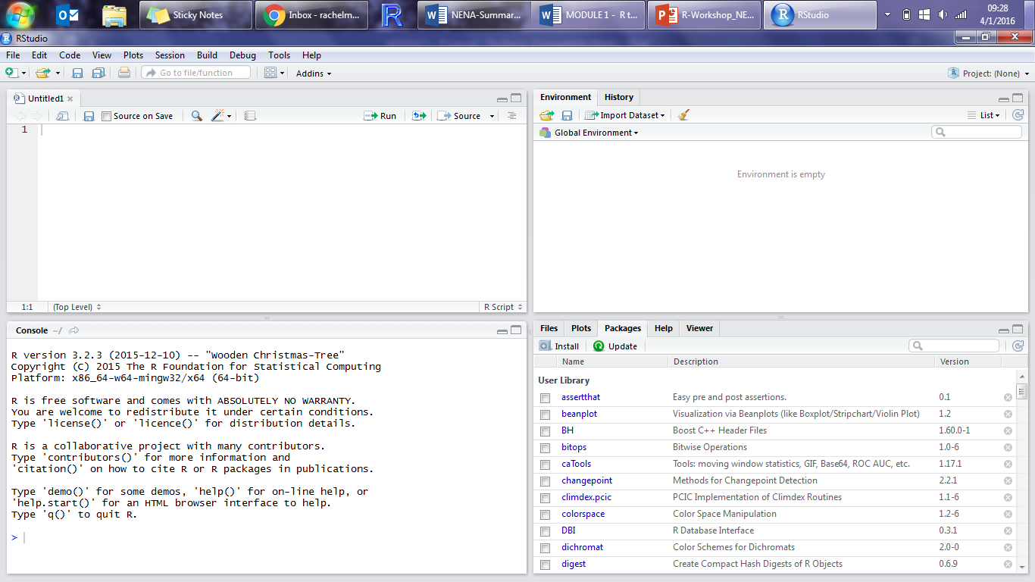I recommend opening RStudio after installation is complete to ensure it runs correctly. You should see a screen that looks something like this:
4. Install four packages in RStudio that we will use during the workshop.
   1. Open RStudio.
   2. Click the “Tools” toolbar at the top of the screen.
   3. Click “Install Packages…”.
   4. Make sure “Repository (CRAN)” is selected in the “Install from:” box.
   5. Type the names of packages to install in the “Packages” box:  
      ggplot2, ggpubr
   6. Make sure “Install dependencies” is checked.
   7. Click “Install”.
   8. 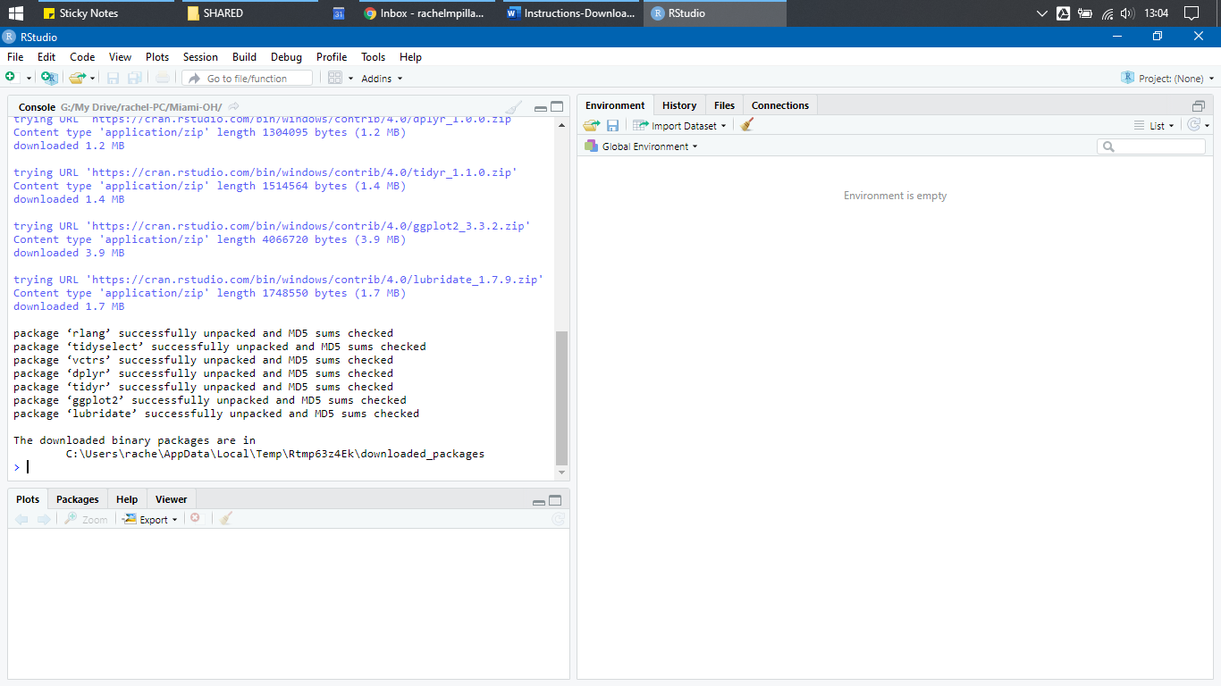If successfully installed, you should see something like this in the “Console” panel:

***If you have any problems during the installation,   
please email me (***[***zeisleaa@miamioh.edu***](mailto:pillarm@miamioh.edu)***) and I’ll do my best to help you out!***