# Café management system

### A MINI PROJECT REPORT

#### Submitted by

#### Group/Team No: G20/T6

**ANAMVEEN KAUR 2210990106**

**ANAND KAUSHIK 2210990107**

**ANANT SINGH 2210990108**

**ANANYA 2210990109**

#### in partial fulfillment for the award of the degree of

## BACHELEOR OF ENGINEERING

***in***

COMPUTER SCIENCE & ENGINEERING



**CHITKARA UNIVERSITY**

**CHANDIGARH-PATIALA NATIONAL HIGHWAY**

**RAJPURA (PATIALA) PUNJAB-140401 (INDIA)**

### MAY 2023

Group/Team no: G20/T6

TABLE OF CONTENTS

|  |  |  |
| --- | --- | --- |
| Sr.no | Section | Page no |
| 1 | Introduction | 4 |
| 2 | Problem Statement | 5 |
| 3 | Advantages | 5 |
| 4 | Key features | 6 |
| 5 | Technical Details | 7 |
| 6 | Conclusion with future scope | 13 |

Introduction:

In today's age where the technologies are developing at a breakneck speed, there is a need for ordinary works like accounting , managing employees data etc. to also be done using advanced technologies. An online presence is vital for any business not just to attract customers but also for managing business operation.

Cafes and restaurants are no exception, and many of them are investing in building a strong digital presence to make the task of performing business operations frictionless.

For this we have created a HTML and CSS project of a cafe management site which is an essential component of building such a digital presence.

This project involves designing and developing the front-end of a website that is visually appealing, user-friendly, and responsive across different devices. This project is responsible for creating the overall look and feel of the website and ensuring that the content is well-organized and easy to navigate.

This report aims to provide an overview of the HTML and CSS project for a cafe management site, outlining the objectives, methodology, and outcomes of the project. It will discuss the tools and techniques used to design and develop the website and highlight the key features and functionalities that were incorporated to enhance the user experience.It will also discuss the potential for future improvements and enhancements to the website to cater to the evolving needs of the business and its customers.

Overall, the HTML and CSS project of a cafe management site is crucial for managing café operations. This report will provide valuable insights and recommendations for businesses looking to enhance their website's design and functionality, ultimately leading to increased traffic and revenue.

Top of Form

Bottom of Form

Problem Statement:

Cafes and restaurants need to have an online presence to manage customers related and business operations and remain competitive in today's digital age where there is a new demand of online orders created by the advancement of technology and frictionless logistics. However, many businesses struggle to create a website that is visually appealing, user-friendly, and responsive across different devices. The lack of expertise in HTML and CSS often leads to poorly designed websites that fail to engage users and showcase the cafe's menu, services, and ambiance effectively.

The problem is further exacerbated by the increasing use of mobile devices, which require websites to be optimized for different screen sizes and resolutions. Businesses that fail to adapt to these changes risk losing potential customers who prefer to use their smartphones or tablets to browse the web.

Therefore, the problem statement for the HTML and CSS project of a cafe management site is as follows: How can we create a visually appealing, user-friendly, and responsive website for a cafe that effectively showcases and manages its business operations and optimizes the user experience across different devices?

Advantages:

Enhanced User Experience: With an attractive and user-friendly website design created through HTML and CSS, staffs can navigate the website easily and post updates about the business operations. This can lead to an increase in the speed of business operations and ultimately higher customer satisfaction levels.

Cost-Effective: Building a website using HTML and CSS is a cost-effective option, especially for small businesses with a limited budget. It eliminates the need for expensive software or tools, making it an affordable option for creating a professional-looking website.

Mobile Responsiveness: With the increasing use of mobile devices, it's essential to have a website that is responsive across different screen sizes. HTML and CSS can be used to create a mobile-responsive website that adapts to different devices screen sizes, ensuring that users can access the site from any device & anywhere.

Overall, the HTML and CSS project of a cafe management site provides several advantages, including an enhanced user experience, improved SEO, cost-effectiveness, mobile responsiveness, and customizability. By leveraging these benefits, businesses can build a strong online presence, attract more customers, and improve their bottom line.

Key Features:

Responsive design: The website should be designed to be responsive across different devices, including desktops, laptops, tablets, and smartphones, to ensure that users can access it easily and conveniently from any device.

Account of total sales made: The website should showcase the cafe's sells in an easy-to-read and visually appealing format, with clear descriptions and revenue generated from each item.

Account of Online orders: The website should allow users to take the orders online, and storing customer instruction and pick-up or delivery options.

Reservation accounting system: The website should include a reservation system that enables staffs to reserve a table at the café at the selected date, time, and instructions of the customer and indicate the number of guests in their party.

Contact information: The website should store clear and concise contact information, including the cafe's staff and customers phone number, email address, and physical address, to make it easy for the management to get in touch with everyone on need if any.

User-friendly navigation: The page should be easy to navigate, with clear and intuitive menus and links that guide users to information & features they are looking for.

Technical Details:

Document type declaration: In our HTML file, a document type declaration at the beginning is added. For example, <!DOCTYPE html> .It is a useful instruction for the browser rendering the page.

Browser compatibility: Our website is compatible with many browsers, such as Google Chrome, Firefox, and Safari.

HTML and CSS: To create the front-end of our search engine look alike, HTML & CSS has been used.

HTML CODE:

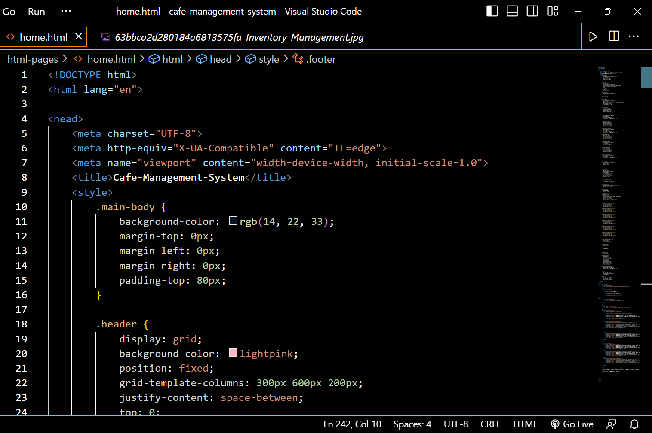

This is an HTML code that defines the structure and content of a web page. Here is a brief explanation of each section:

The first line of code (<html lang="en">) declares the language of the document to be English to the browser rendering the page.

The <head> section contains Meta tags and links to external resources that the page requires. In this code, there are four meta tags: charset, http-equiv, viewport, and title. The charset tag specifies the character encoding used in the document (UTF-8, in this case). The http-equiv tag provides information about how the browser should handle certain features, such as compatibility mode. The viewport tag sets the width of the viewport to match the device's screen width, and the title tag sets the title of the page that appears in the browser's tab. Additionally, there is one link to external resource linking the Google fonts API.

The <body> section contains the visible content of the page. In this code, there is a <style> tag that defines a style rule for the HTML elements. The basic structure of the page is in three parts a header , main content & the footer.

The <div class=”div-2-header”> defines the header of the page.



The <div class="div-2-header">

The <img> tags with src attributes of "63bbca2d280184a6813575fa_Inventory-Management.jpg", "1600w-YASJJho2Kzw.png", and "1600w-YASJJho2Kzw.webp" are used to display images of logos in the header and in the main body.

The style attribute with display:grid,and justify-content:between is used to style the header.

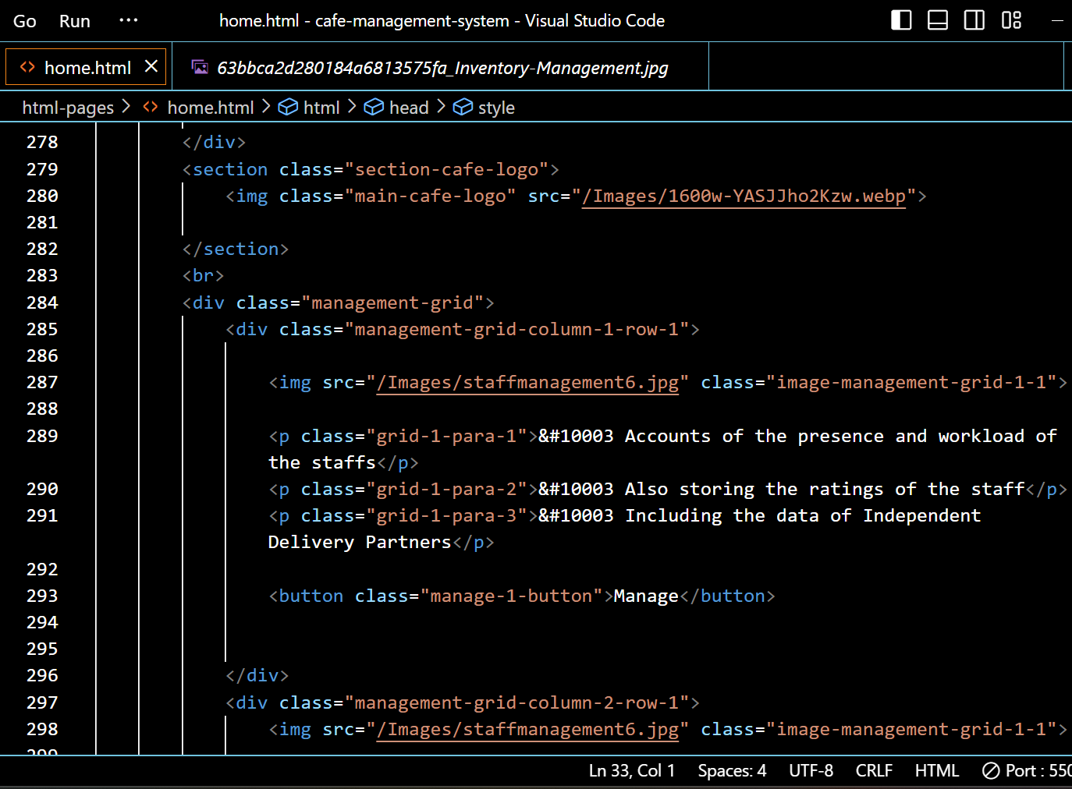

The <section class=”main-café-logo”> contains an image of the café’s logo.

Then we used an img tag, the image in this <imgsrc tag is the inventory management image.In the next step a div class named “management-grid” is created.This container is a set to display:grid so all these div containers under it will form a grid and get properly vertically alligned.

At the end there is a div class=”footer” in which general information is displayed, and if the information is above a certain height property overflow:scroll will let users scroll the footer.

CSS CODE:

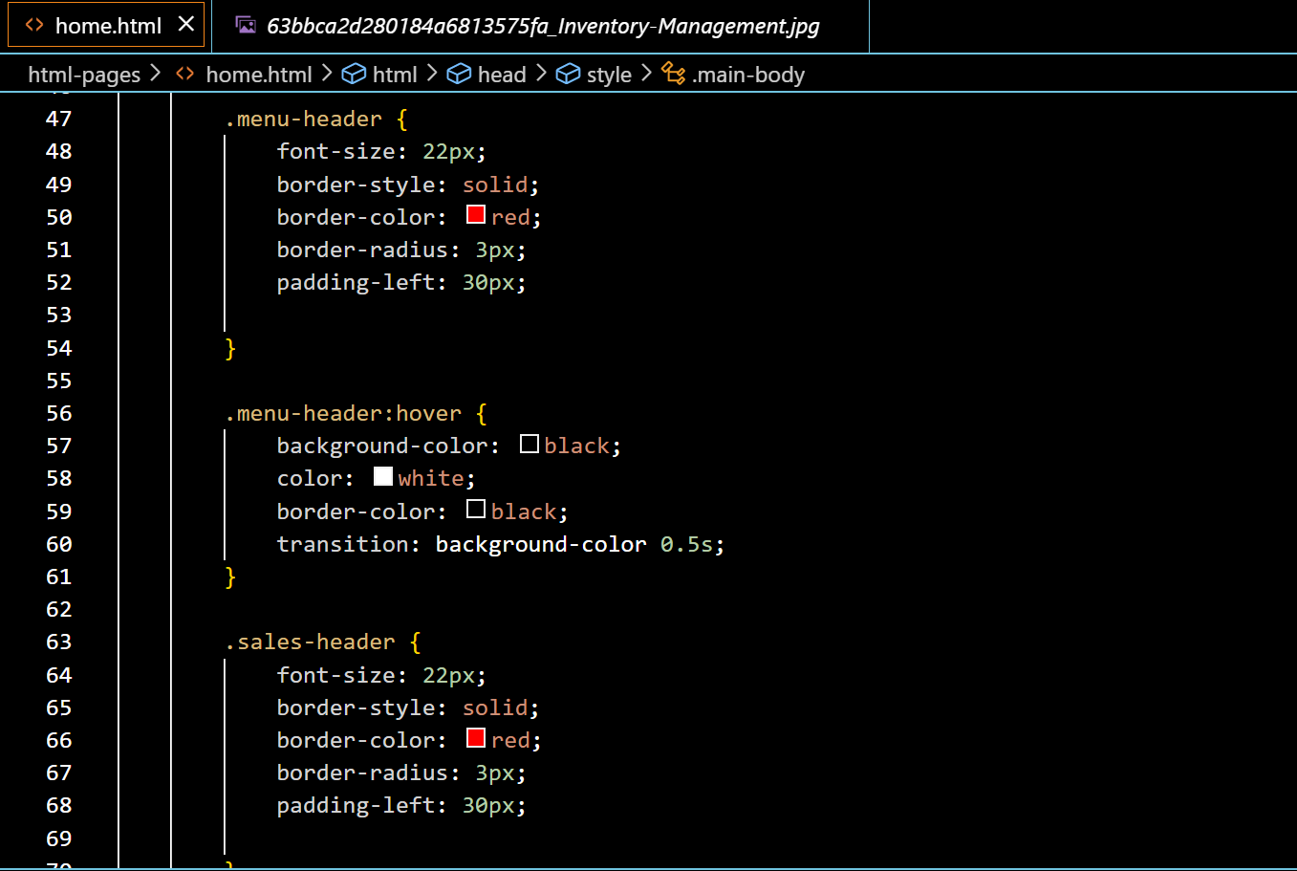

This is a CSS code that styles the HTML elements of a web page. Here's a breakdown of what each section does:

- * { padding-top:80px;}: This sets the content to be shown 80px down so there is enough space for the header and also no content remains hidden from the user’s view.

- *.header { display: grid;background-color: lightpink;position: fixed; grid-template-columns: 300px 600px 200px; justify-content: space-between; top: 0; left: 0; right: 0; height: 80px;}

This styles the `div ` element which is performing as the header, setting it to use a grid layout with a column direction. It also sets the height of the header to 80px of the viewport height and sets the background color to lightpink.

The justify-content to space-between, which means the elements inside the container will be spaced out evenly with the first element at the start of the container and the last element at the end. It also adds padding to the top and bottom of the container and centers the elements vertically using align-items.

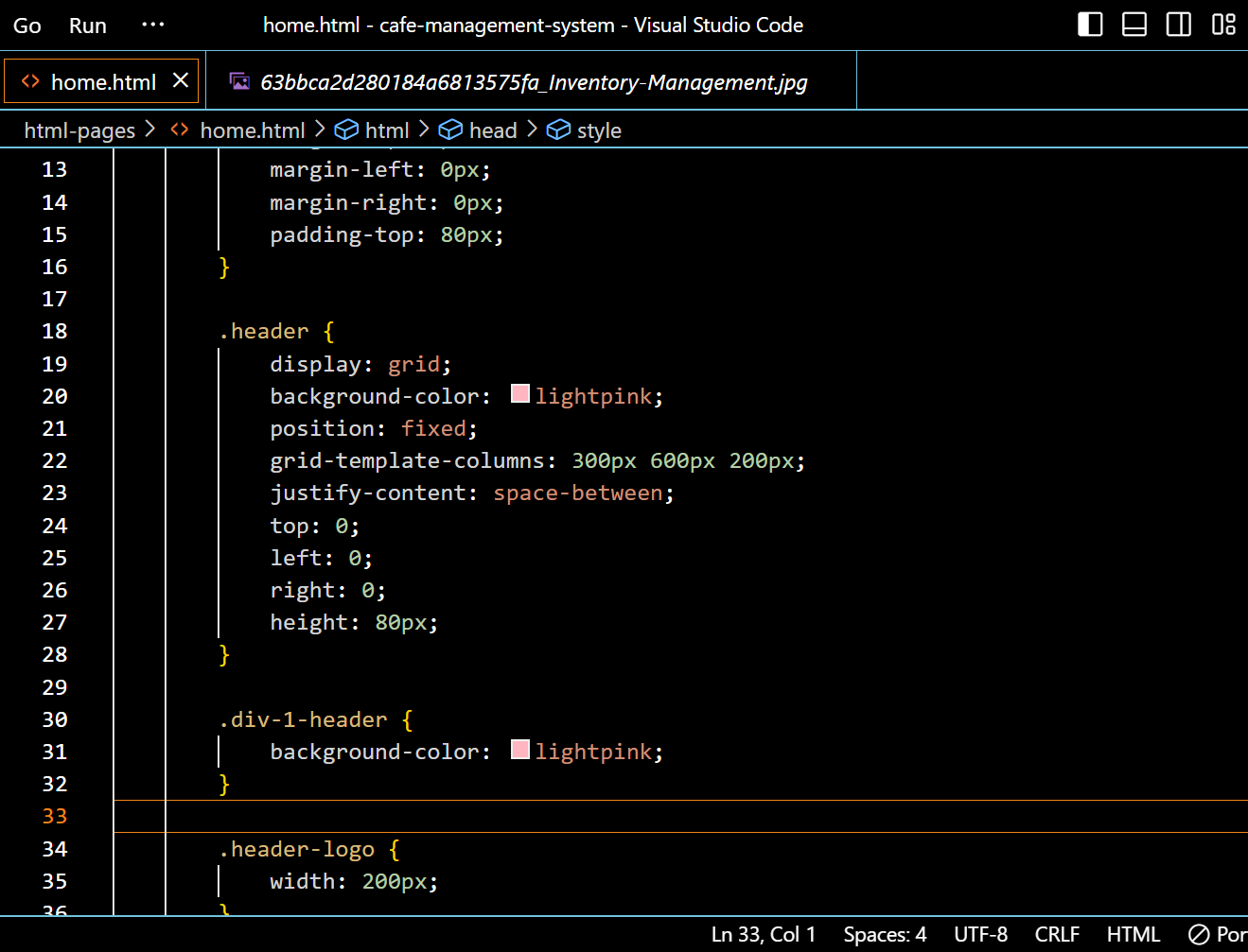

The first block of code sets the background color of the header to be pink and it’s position to be fixed at the top of the page. Also it sets the display to grid and adds space between the elements using justify-content: space-between.

The final block of code styles the header. It sets the grid-template-columns to 300px 600px 200px, which allows the main body section to expand and take up all available space. It also sets the display to grid, aligns the content to the top using top:0px.

The third block of code targets the .header_logo element within the .div-1-header and applies it’s width to be 200px.

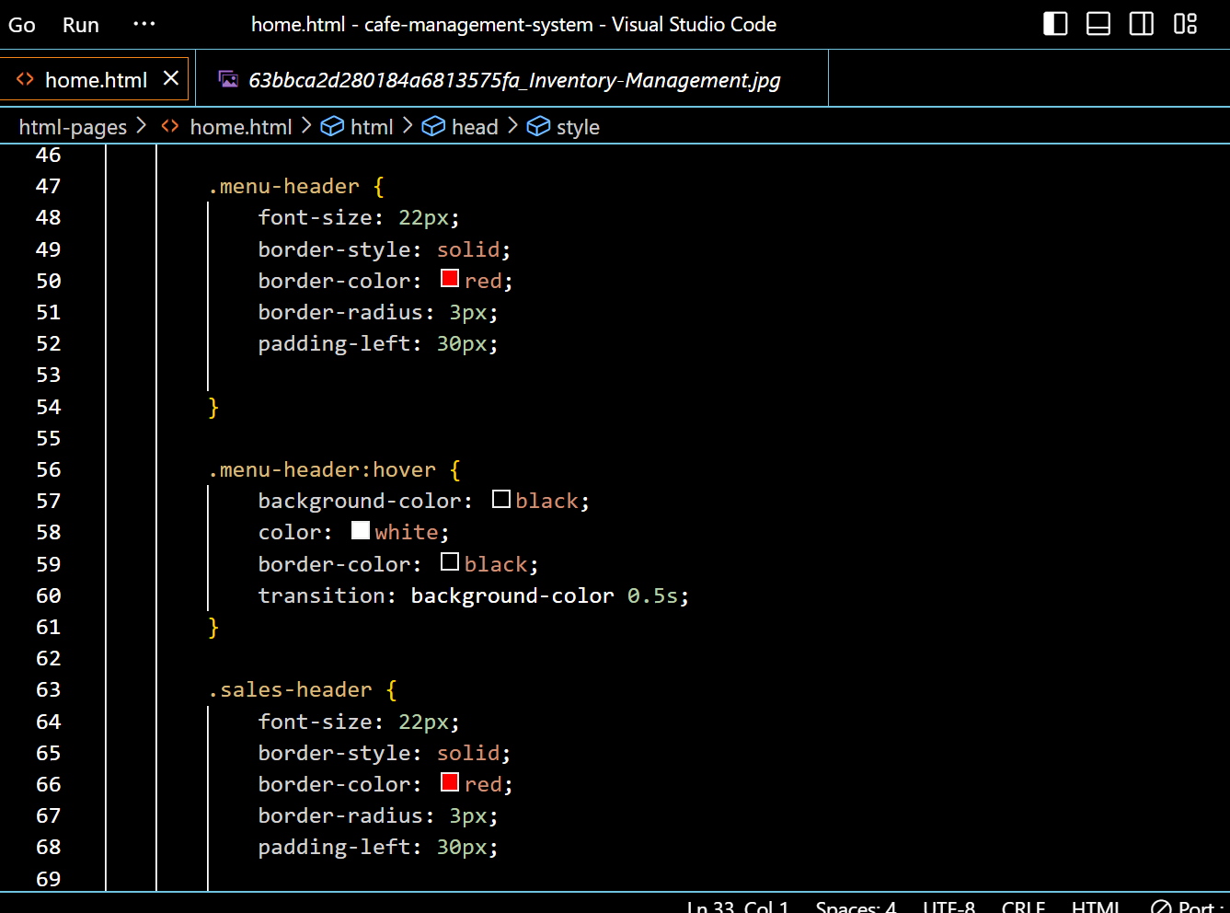

The first selector `.menu-header ` selects all elements with the class ‘menu-header’. It applies a border color red to the selected icons.

The font-size sets font size of the menu icon to be 22px and pushes the content inside it using `padding-left:30px `.

The hover pseudo-class applies some styling to the button element if they are hovered `. It sets the border color to black, sets the background color to black, text color to white, and sets the cursor to a pointer.

Conclusion with Future Scope:

In conclusion, this project of a cafe management site is an essential component of managing the business operations. Through this project, we were able to design and develop a visually appealing and user-friendly website that showcases the cafe's menu, services, and ambiance. The website is responsive across different devices, ensuring that customers can access the site from their desktops, tablets, or mobile devices.

Throughout the project, we utilized various tools and techniques to create the website's overall design and layout, such as using CSS to create an aesthetically pleasing color scheme and layout, and implementing HTML to ensure that the website's content is well-organized and easy to navigate.

We also incorporated key features and functionalities, such as tax-management, logistics-management, to make some of the business operations easier and improve the overall productivity of the café staff.

Overall, the success of the project can be seen in the increased speed of business operations. While there is always room for improvement and enhancement, this project serves as a strong foundation for the cafe's online presence, allowing the business to remain competitive and continue to manage the business operations.

In conclusion, the HTML and CSS project for a cafe management site is a vital component of building a strong digital presence, and it is essential for businesses to invest in creating a visually appealing and user-friendly website to manage their operations easily.

Result (figures with explanation):

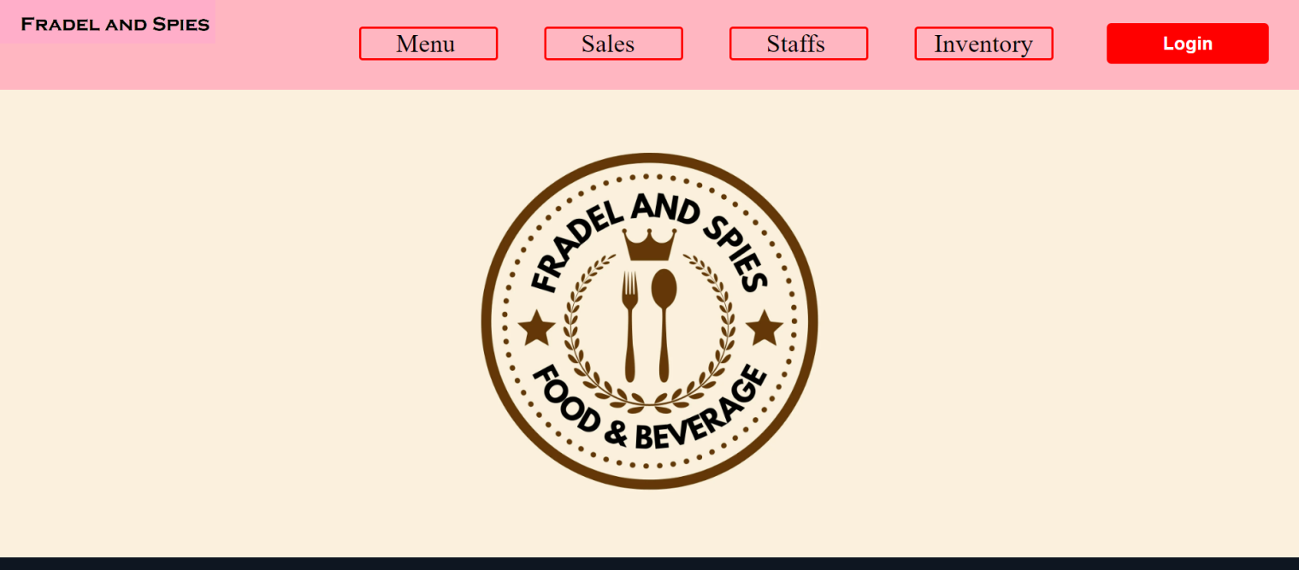

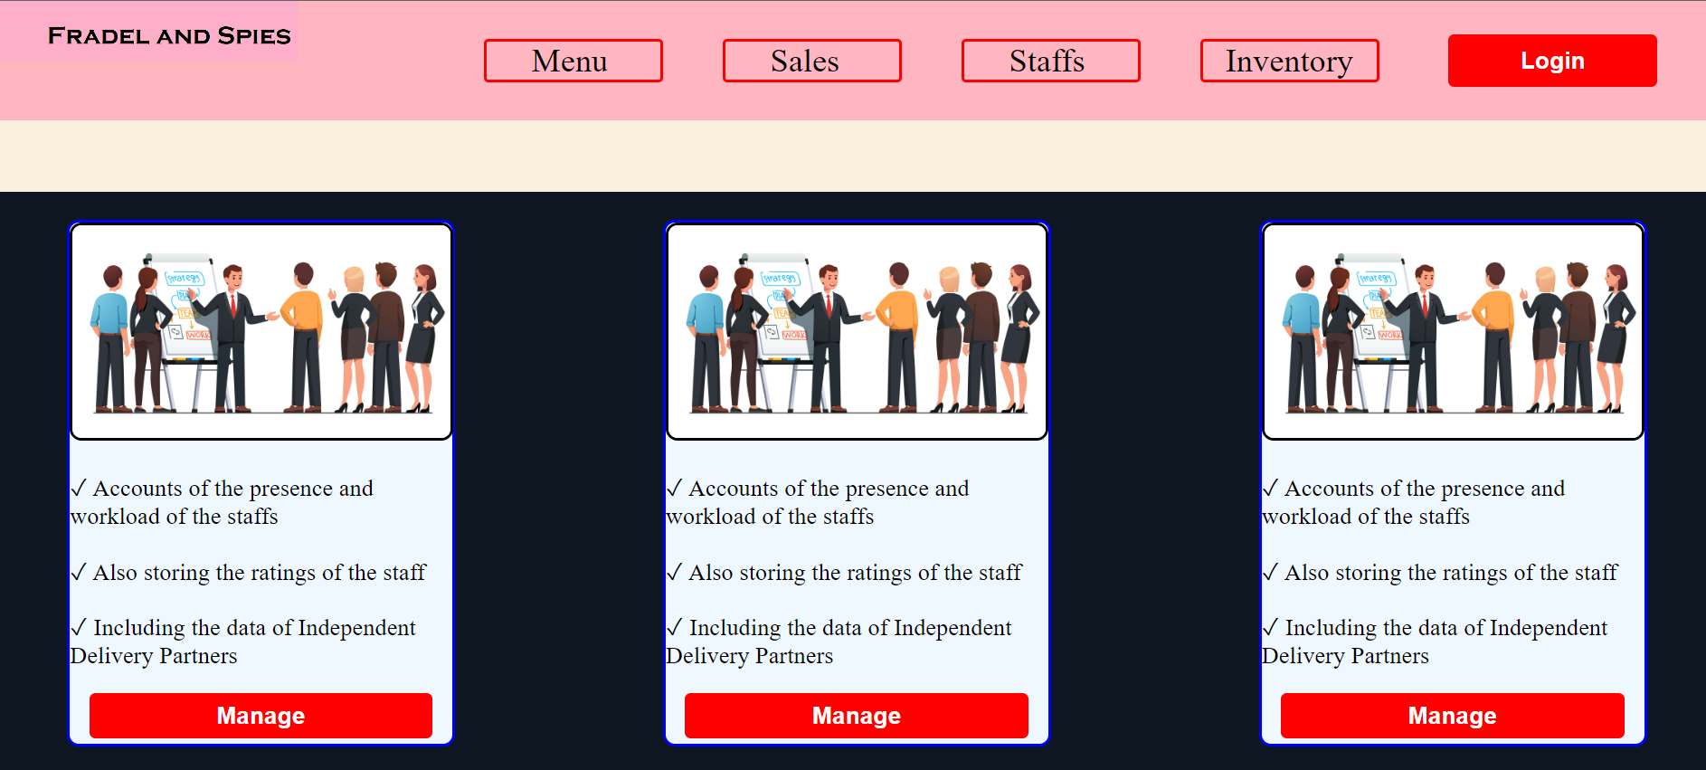

FUTURE SCOPE OF THE PROJECT:

The HTML and CSS project for a Cafe management site is an ongoing process that requires continuous updates and improvements to keep up with the evolving needs of the business and its customers. Some potential areas for future enhancements and expansions to the website include:

Mobile responsiveness: With an increasing number of customers accessing websites on their mobile devices, it is essential to ensure that the website is fully responsive across all screen sizes. Future updates could include optimizing the website for mobile devices and adding features such as mobile ordering and payment options.

Online reservation system: Providing customers with the option to make reservations online can help streamline the reservation process and enhance the customer experience. Future updates could include integrating an online reservation system into the website, allowing staffs to reserve tables for the customers.

Online ordering accounting: With the increasing popularity of online ordering, integrating an online ordering system into the website can provide customers with a convenient way to order and pay for their meals. Future updates could include adding an online ordering accounting feature, allowing staffs to manage orders for pickup or delivery.

In conclusion, the HTML and CSS project for a cafe management site has vast potential for future enhancements and expansions to improve the website's functionality and overall business operations. By keeping up with emerging trends and technologies and continuously updating and improving the website, businesses can stay ahead of the competition and provide their customers with the best possible service.