1. **The news feed on mobile doesn’t look optimal, and one page is missing.** 
   1. [Austria | Homecare](https://www.freseniuskabi-homecare.at/)

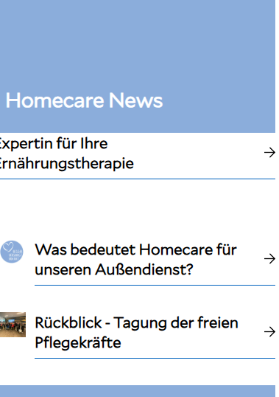

------------------------------------------------------------------------------------------

1. **Carousel display is not optimal (text is partially cut off, images jump) - It depends on the zoom factor**
   1. [Patient:innen | Homecare](https://www.freseniuskabi-homecare.at/patient-innen/patient-innen#carousel-c8b8421e1d-item-07b43df03c-tabpanel)
   2. [Fachkräfte | Homecare](https://www.freseniuskabi-homecare.at/fachkraefte/fachkraefte#carousel-c10f3289f6-item-c61b4f8540-tabpanel)

------------------------------------------------------------------------------------------

1. **There is too much space between the pictograms.** 
   1. [Patient:innen | Homecare](https://www.freseniuskabi-homecare.at/patient-innen/patient-innen#carousel-c8b8421e1d-item-07b43df03c-tabpanel)
   2. [Fachkräfte | Homecare](https://www.freseniuskabi-homecare.at/fachkraefte/fachkraefte#carousel-c10f3289f6-item-c61b4f8540-tabpanel)

