CRAIGSLIST
Students Names :
Nawaal Syed
Soud Alshowaiea

Instructor Name :
Dr. Seyed Saatchi

Course Name :
Software Development Project

Date :
27th February 2026

INDEX
S. no | TOPIC | PAGE NUMBER
1 | Introduction | 3
2 | Project Description | 3
3 | Requirements Analysis | 4
4 | Problem Statement | 5
5 | Objectives | 5
6 | Business Process Flow | 6
7 | Gantt Chart | 7
8 | Development And Planning | 7
9 | Test Environment Setup | 8
10 | Testing and Bug Fixing | 8
11 | Deployment And Production | 9
12 | System Features | 10
13 | Project Structure | 11
14 | Results And Screenshots | 12
15 | Challenges And Lessons Learned | 15
16 | Conclusion | 16

Introduction
Craigslist is a modern web-based job portal that allows users to browse and post job opportunities in different categories such as IT, Marketing, Accounting, and Medical.
The system provides secure authentication using Google OAuth and allows partial access to job details for guest users while full details require login.

Project Description
Craigslist is a category-based job portal that allows users to:
- Browse job opportunities
- Filter jobs by category (IT, Marketing, Accounting, Medical)
- View job details
- Log in using Google authentication
- Post job listings
- Manage posted jobs through a personal dashboard

The system uses PHP for backend processing, MySQL for database management, and HTML/CSS/JavaScript for frontend development.
The website contains more than 9 functional pages including:
- Homepage
- Category pages
- Login page
- Profile page
- Post job page
- Job details page

Requirements Analysis
Functional Requirements
The system must:
- Allow users to sign in using Google OAuth
- Allow visitors to browse job listings without logging in
- Restrict full job details to logged-in users
- Allow authenticated users to post job listings
- Allow users to view and manage their posted jobs
- Store all job postings in the database
- Categorize jobs into IT, Marketing, Accounting, and Medical

Non-Functional Requirements
- The system must be secure
- The interface must be responsive and clean
- The database must maintain referential integrity
- System performance must allow fast job filtering
- Data must be stored with minimal redundancy

Problem Statement
Many job seekers require a simple and category-based system to browse and post job opportunities without complex registration processes.
Craigslist solves this by:
- Allowing quick Google login
- Providing category filtering
- Offering a clean, modern interface
- Enabling job posting and management

Objectives
- Allow users to browse job listings
- Allow secure login using Google OAuth
- Enable users to post job ads
- Provide category-based job filtering
- Allow users to manage their posted jobs
- Display job details dynamically

Business Process Flow
USER POSTING A JOB
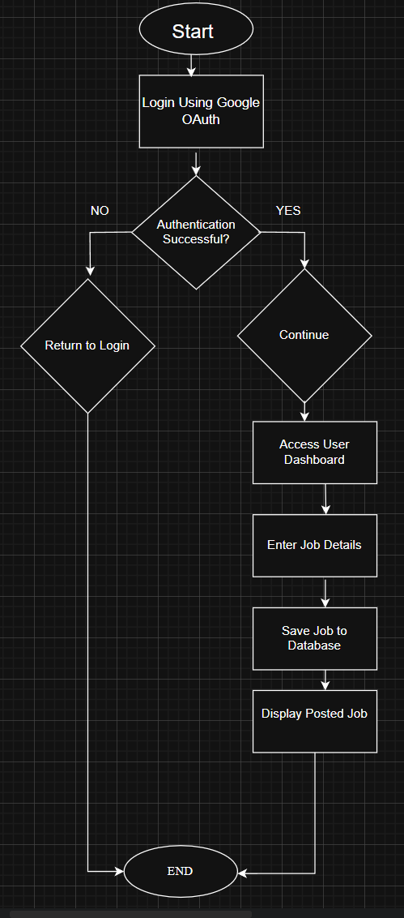
VISITOR BROWSING JOBS 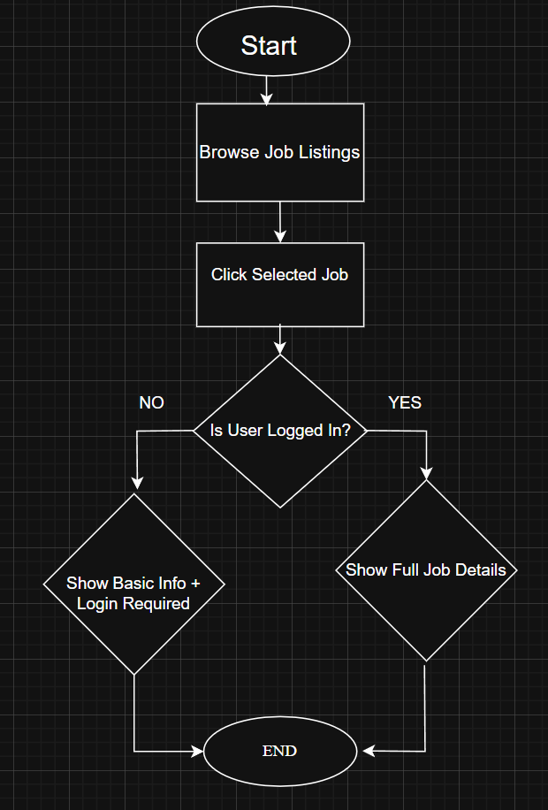

Gantt Chart

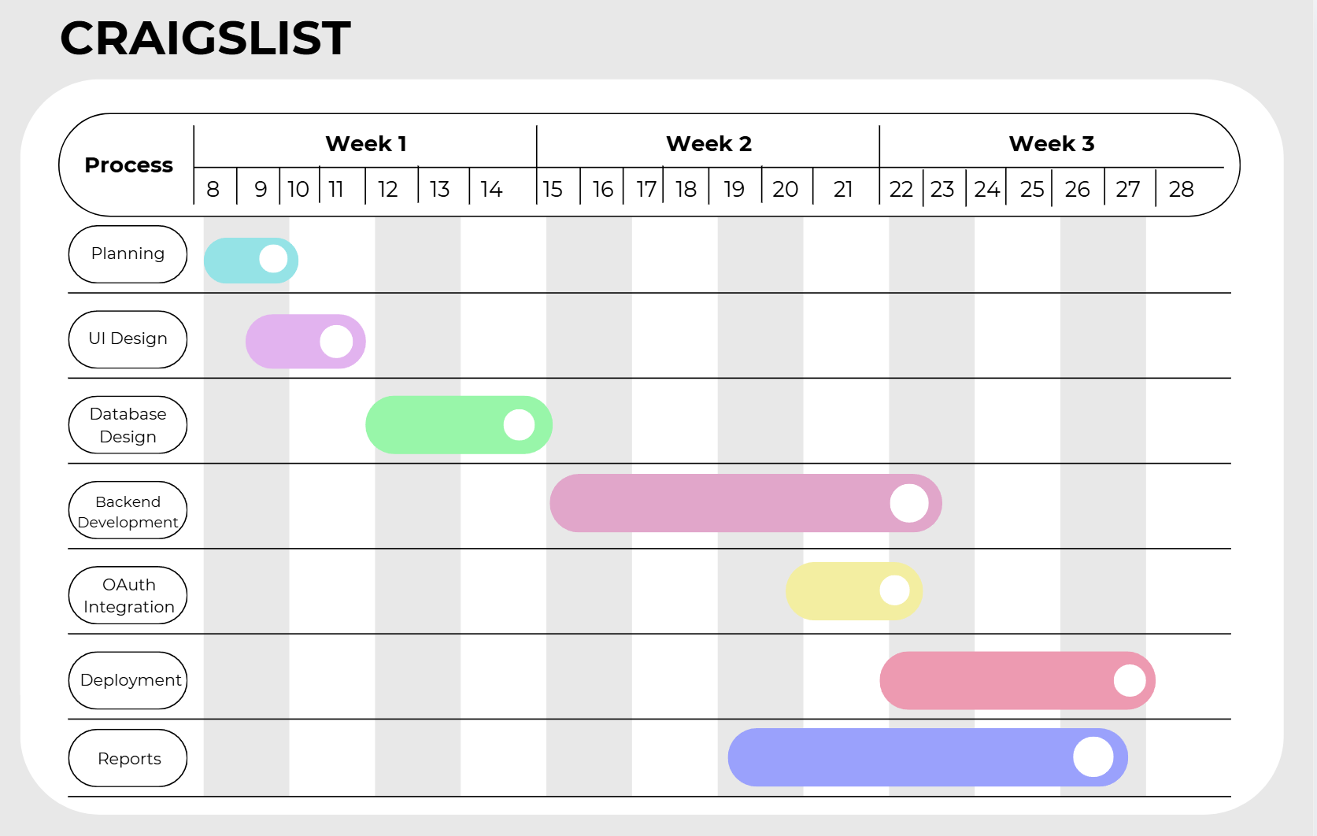
Development and Planning
The project was developed in the following stages:
- Planning the project structure and required features
- Designing the database schema in MySQL
- Creating frontend layout using HTML and CSS
- Implementing backend logic using PHP
- Connecting the database using MySQL
- Integrating Google OAuth authentication
- Implementing category filtering
- Implementing session control and access restriction
- Testing system functionality
- Preparing system for deployment

Test Environment Setup
The project was developed and tested using:
- XAMPP (Apache + MySQL)
- PHP
- MySQL Database (jobfinding)
- Google OAuth API
- Web browser (Google Chrome)

Testing & Bug Fixing

Several test cases were performed to ensure system reliability:
- User login with valid Google account
- Invalid logins attempt handling
- Job posting with missing fields
- Successful job creation
- Category filtering working correctly
All identified bugs were fixed by:
- Correcting SQL queries
- Improving session validation
- Fixing redirect logic
- Adjusting CSS layout issues

Deployment to Production
The Craigslist Job Portal was deployed in a local production environment using XAMPP. Although the system is not publicly hosted online, it is fully functional within a local server environment.
The application was deployed using the following setup:
- XAMPP (Apache Server + MySQL)
- PHP runtime environment
- MySQL database (jobfinding)
- Google Chrome browser for testing
- Operating System: Windows

The web server was started using the Apache module in XAMPP, and the MySQL service was activated to enable database connectivity.

System Features
🔐 Authentication
- Google Sign-In integration
- Secure session handling
- Logout functionality
📂 Job Categories
- IT
- Marketing
- Accounting
- Medical
Each category has its own page:
- it.php
- marketing.php
- accounting.php
- medical.php
📌 Job Posting
- Users can post new jobs
- Jobs stored in SQLite database
- Linked to user account
👤 User Dashboard
- View personal posted jobs
- Manage listings
🔎 Job Details
- Public users: Basic info
- Logged-in users: Full job description

Project Structure
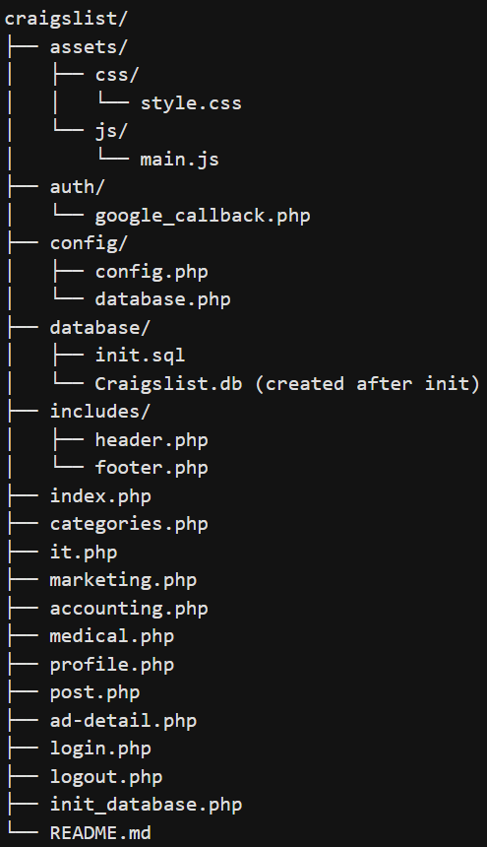

Results & Screenshots
The final system successfully:
- Displays categorized job listings
- Allows secure Google authentication
- Supports job posting functionality
- Maintains user-job relationship integrity
- Restricts access based on login state

HOME PAGE
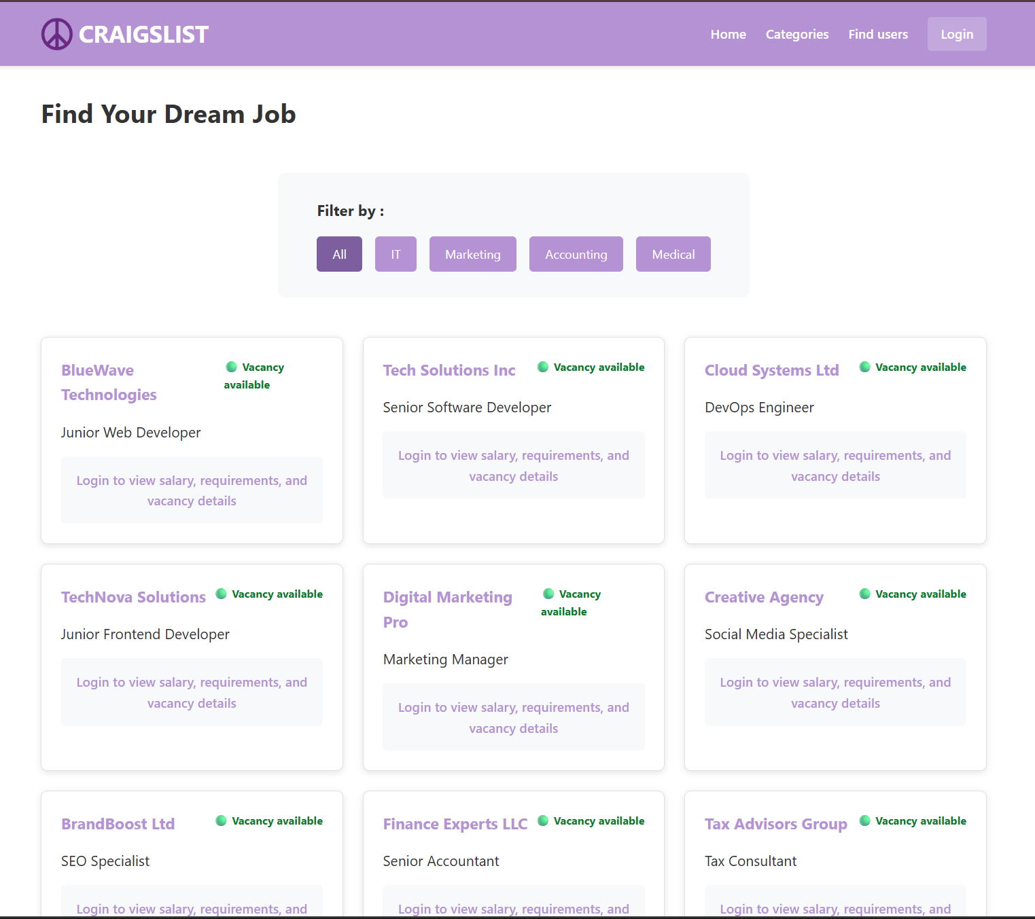
AFTER LOGIN
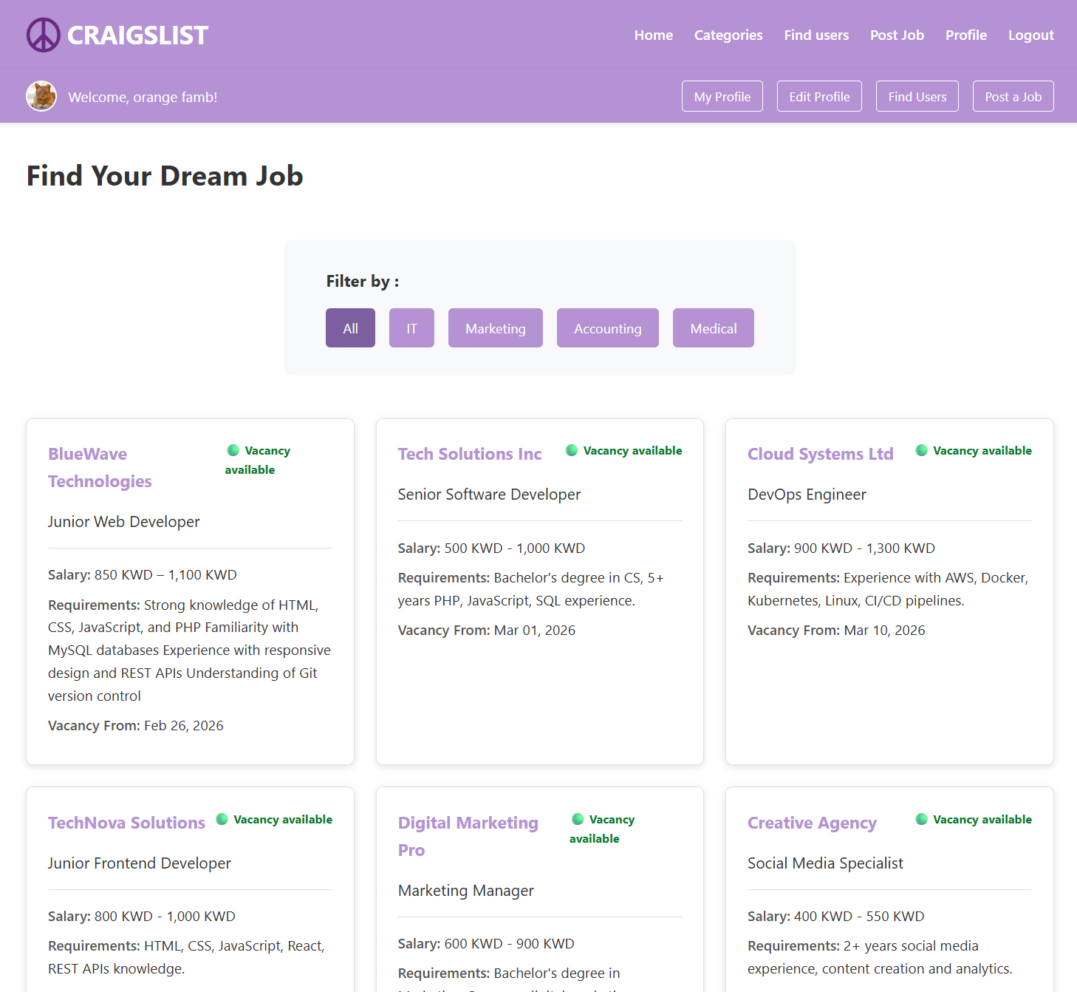
JOB POSTING
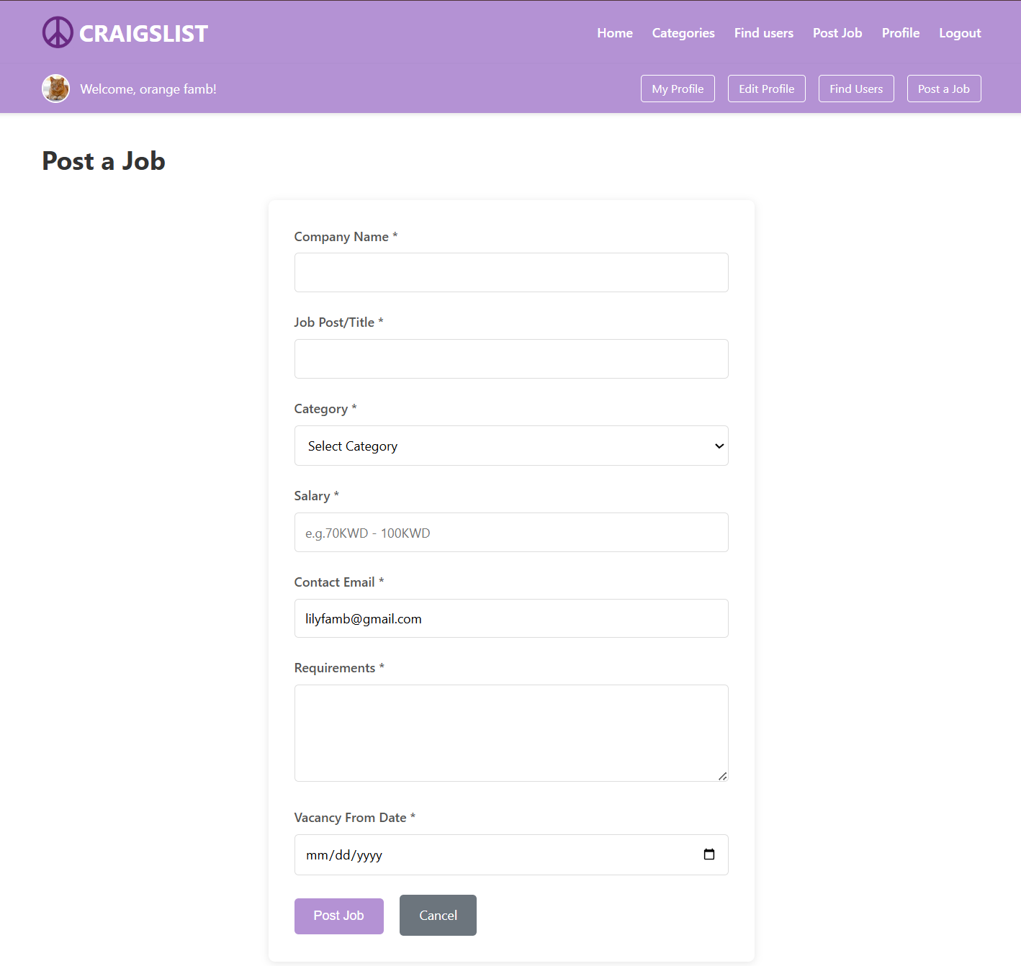

Database Tables
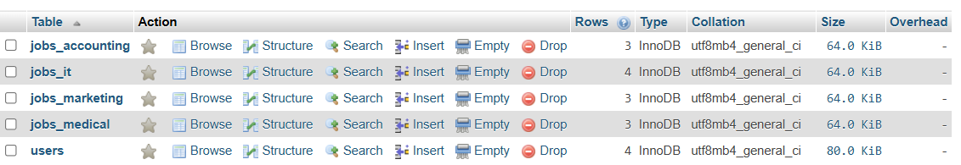
Data from Accounting Table
Categories Page
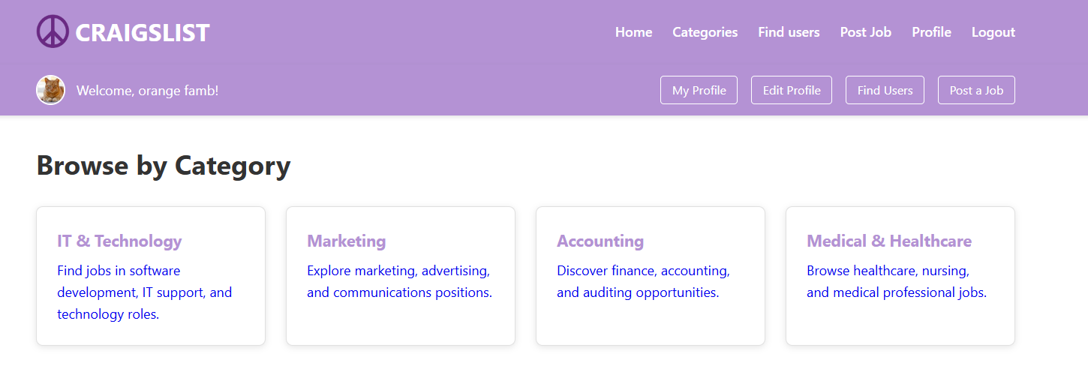
Edit User Information
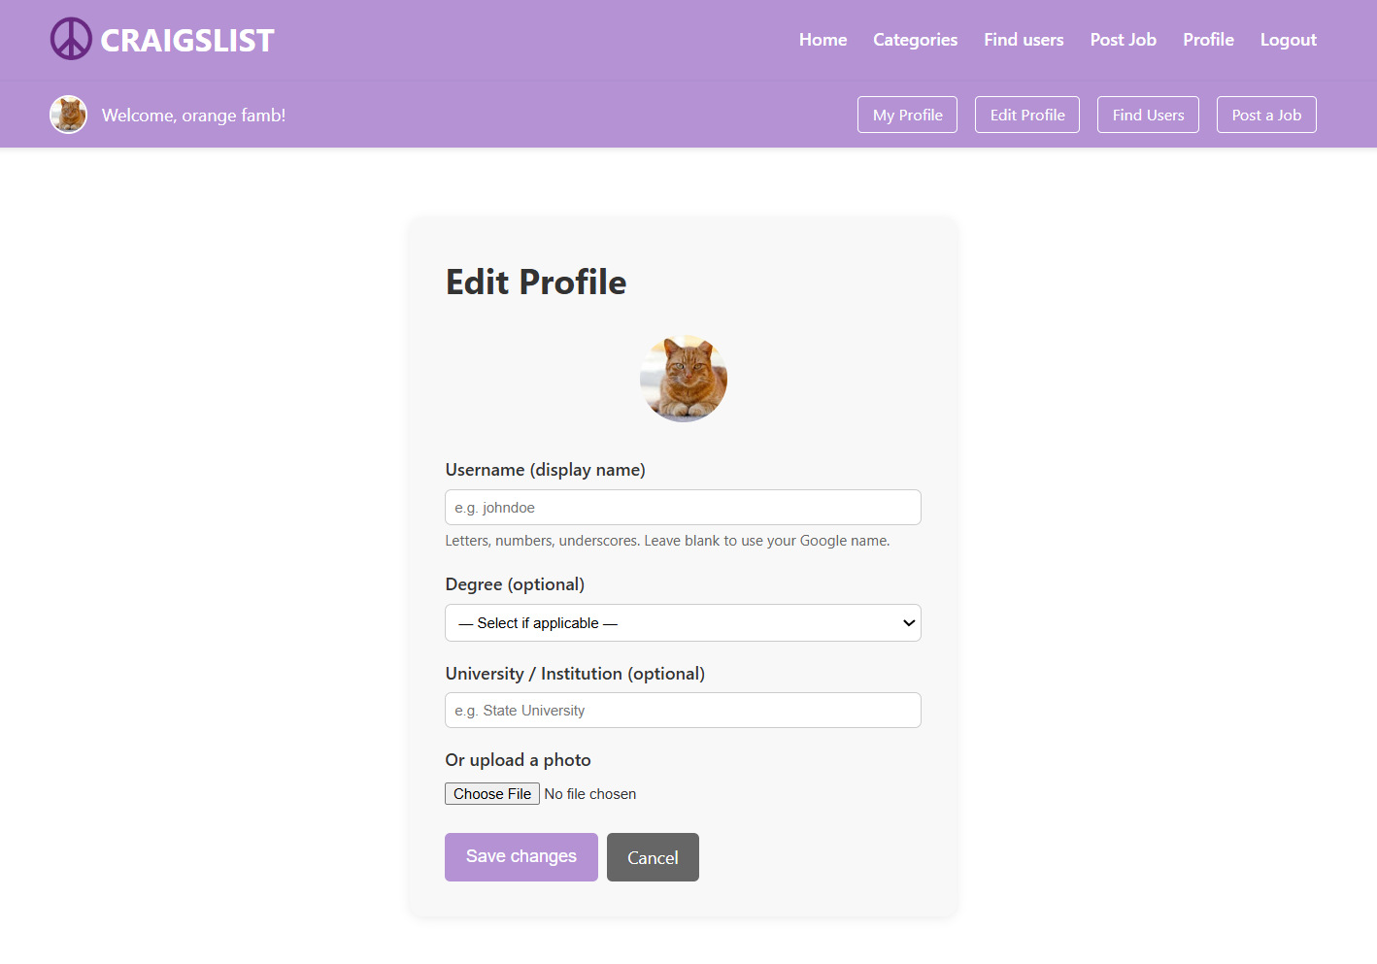
Challenges & Lessons Learned

Challenges Faced:
- Configuring Google OAuth correctly
- Managing session handling securely
- Implementing foreign key relationships properly
- Ensuring category-based separation of job tables
- Preventing unauthorized access to job details

Lessons Learned:
- Importance of database normalization
- Secure authentication practices
- Structuring a PHP project professionally
- Debugging SQL and session errors
- Importance of testing before deployment

Conclusion
The Craigslist Job Portal successfully achieves its objective of providing a structured and secure job listing system.
The platform integrates frontend design, backend logic, database management, and third-party authentication into one complete working system.
The project demonstrates understanding of:
- Web development architecture
- Database relationships
- Authentication systems
- System deployment

