Variable, Data Types and Operators

* What is variable?

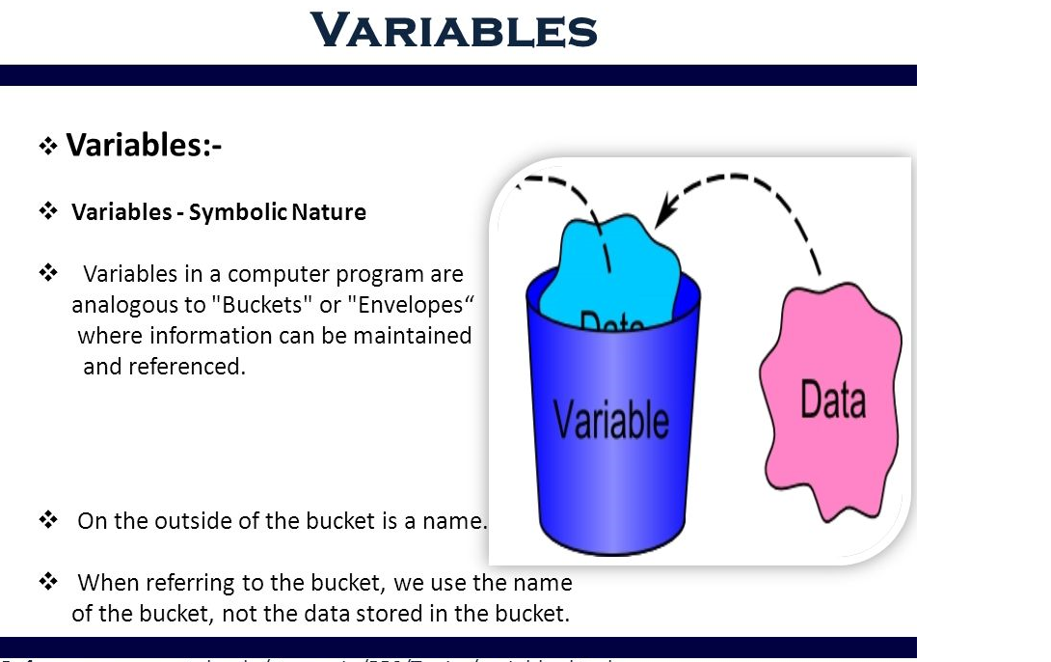

* How to initialize variable?

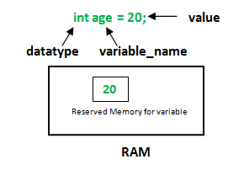

* What are the types of variables?

E:\Java_Tutorials\All_Images\types-of-variables.png

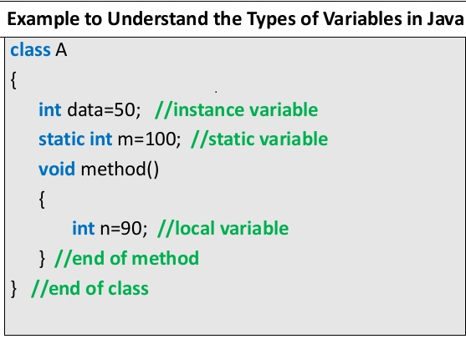

* Data Types in Java

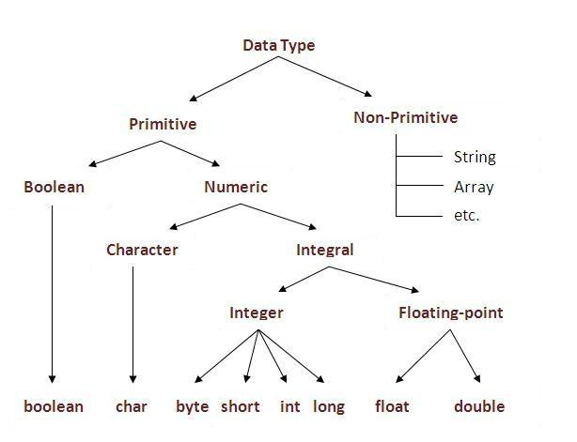

* Primitive Data Types

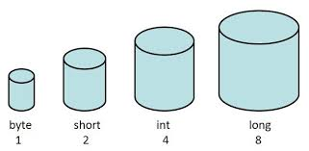

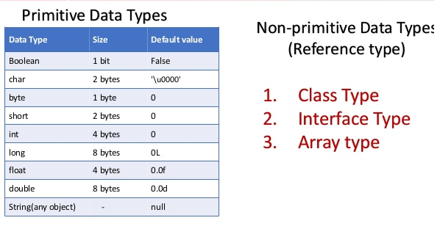

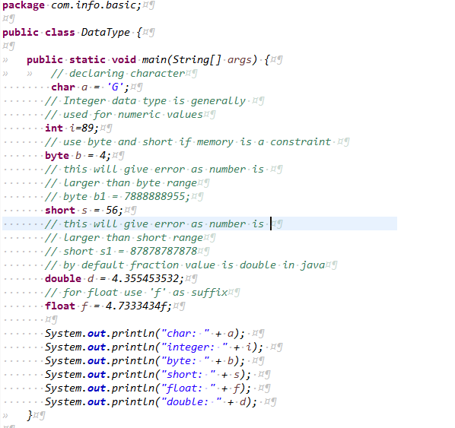

Operators in Java

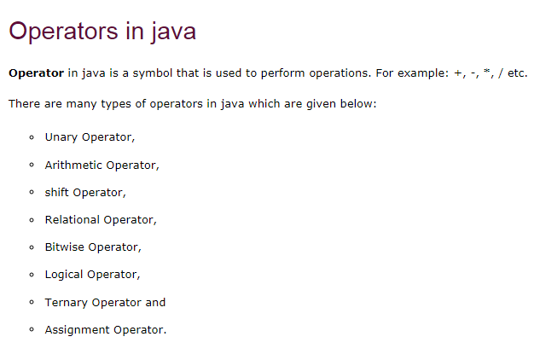

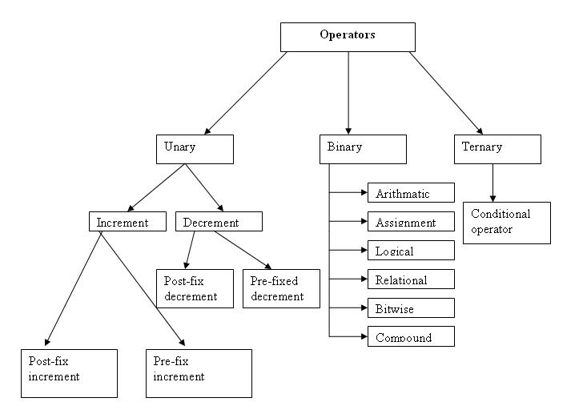

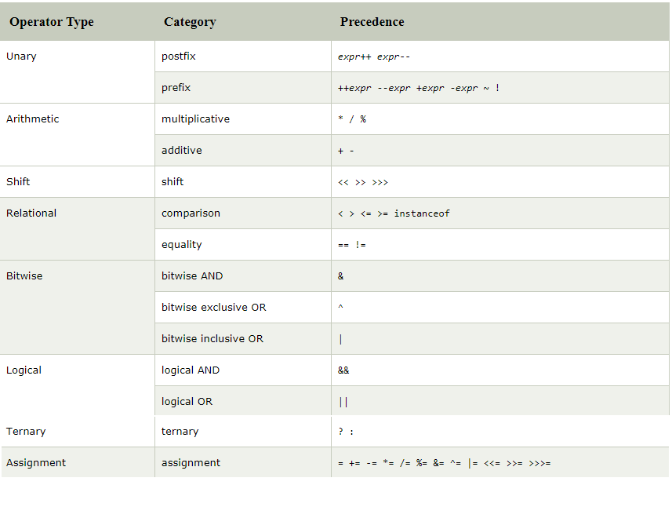

* Unary Operator:-

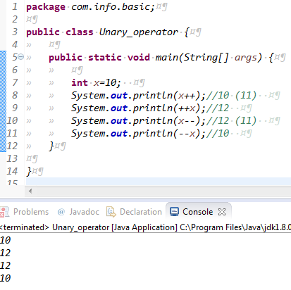

* Java AND Operator Example: Logical && and Bitwise &
* **&&, Logical AND:**returns true when both conditions are true.
* **||, Logical OR:**returns true if at least one condition is true.

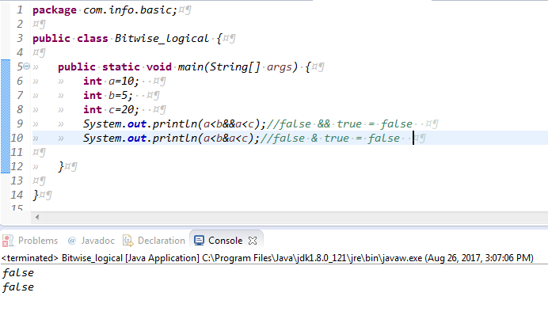

### Java OR Operator Example: Logical || and Bitwise |

* The logical || operator doesn't check second condition if first condition is true. It checks second condition only if first one is false.
* The bitwise | operator always checks both conditions whether first condition is true or false.

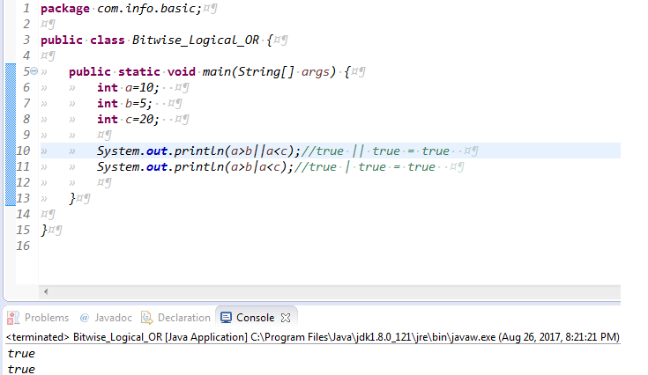

* **Relational Operators:-**
* These operators are used to check for relations like equality, greater than, less than. They return boolean result after the comparison and are extensively used in looping statements as well as conditional if else statements. General format is,

Syntax:-variable **relation\_operator** value

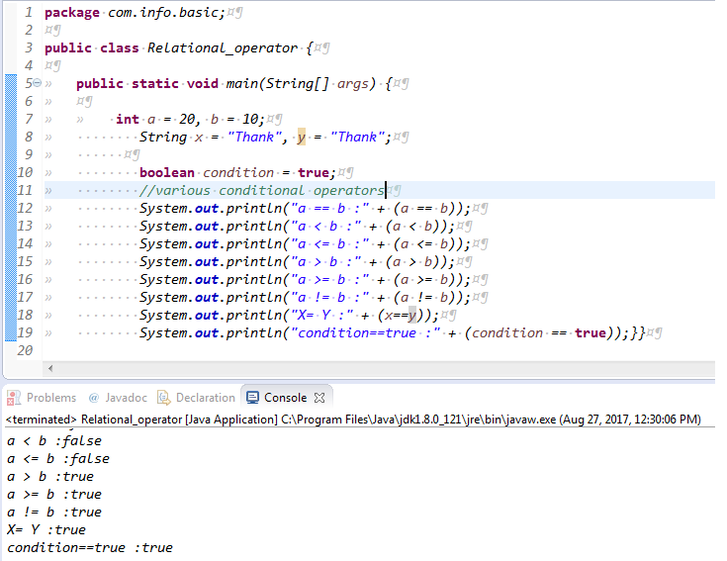

* **Assignment Operator :**

**‘=’** Assignment operator is used to assign a value to any variable. It has a right to left associativity,

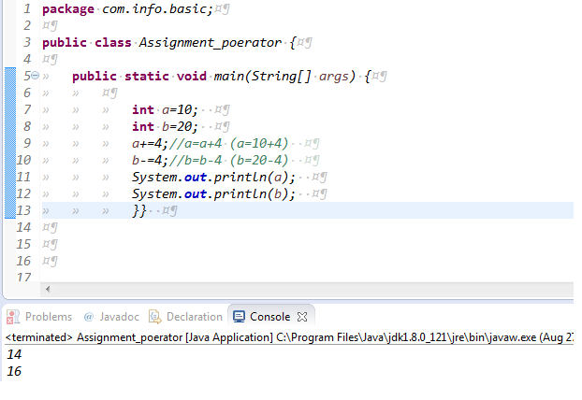

Access Modifiers in Java

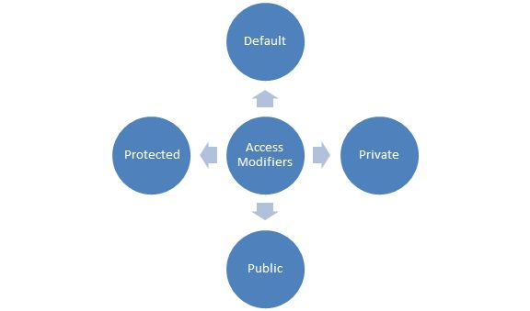

* Modifiers Scope

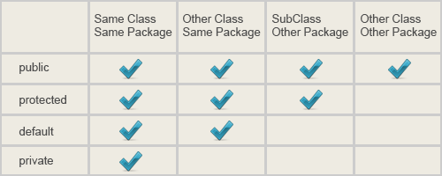

* The access modifier in java specifies accessibility (scope) of a data member, method, constructor or class.

There are 4 types of java access modifiers:

1. private
2. default
3. protected
4. public

* There are many non-access modifiers such as static, abstract, synchronized, native, volatile, transient etc. Here, we will learn access modifiers.

1) Private access modifier

|  |
| --- |
| The private access modifier is accessible only within class. |

Simple example of private access modifier

|  |
| --- |
| * In this example, we have created two classes A and Simple. A class contains private data member and private method. We are accessing these private members from outside the class, so there is compile time error. |

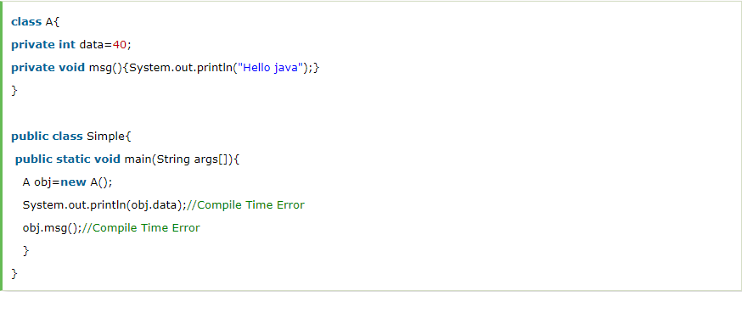

### Role of Private Constructor

|  |
| --- |
| * If you make any class constructor private, you cannot create the instance of that class from outside the class. For example: |

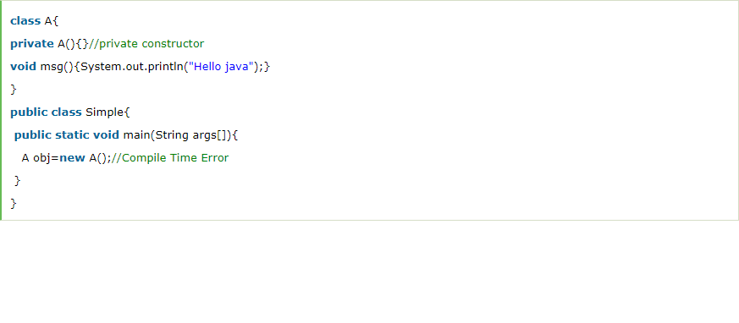

### 2) default access modifier

|  |
| --- |
| * If you don't use any modifier, it is treated as **default** by default. The default modifier is accessible only within package. |

### Example of default access modifier

|  |
| --- |
| * In this example, we have created two packages pack and mypack. We are accessing the A class from outside its package, since A class is not public, so it cannot be accessed from outside the package. |

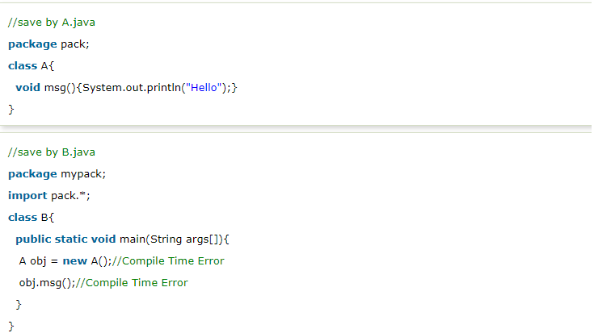

### 3) Protected access modifier

* The **protected access modifier** is accessible within package and outside the package but through inheritance only.
* The protected access modifier can be applied on the data member, method and constructor. It can't be applied on the class.

### Example of protected access modifier

* In this example, we have created the two packages pack and mypack. The A class of pack package is public, so can be accessed from outside the package. But msg method of this package is declared as protected, so it can be accessed from outside the class only through inheritance.

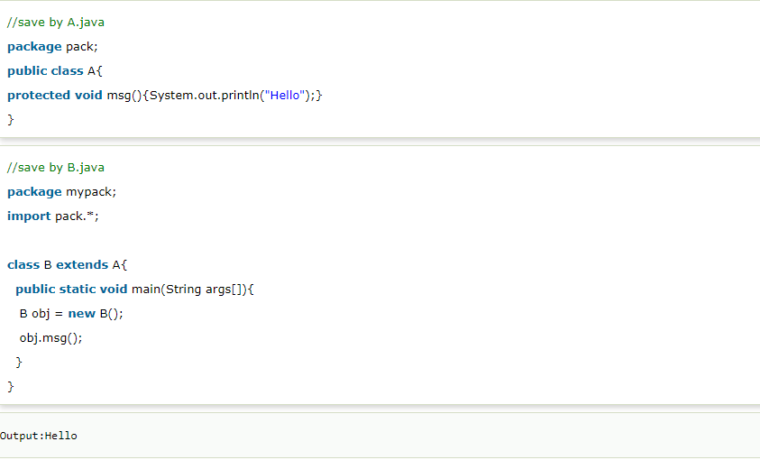

### 4) public access modifier

|  |
| --- |
| * The **public access modifier** is accessible everywhere. It has the widest scope among all other modifiers. |

### Example of public access modifier

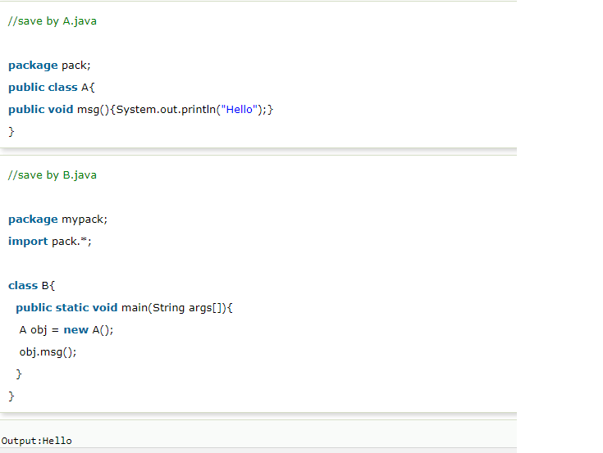

Function/Methods in Java

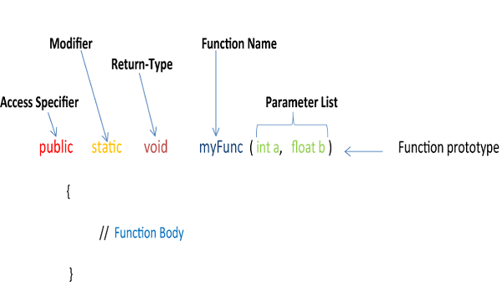

* What is method in Java?
* Methods are collections of statements for performing actions.
* Method consists of name, return type, access modifier and parameters.
* Method can return value Or can return nothing in which case type is void
* Way to write method in Java
* Method with no return type no parameter
* Method with parameters
* Method with return type and parameters.

