**QUESTION 1**

Estimate the effect of age, sex, and marital status uptake of COVID 19 vaccination.

**1. Introduction**

This report provides a comprehensive statistical analysis of factors influencing the uptake of COVID-19 vaccination of 90,468 individuals, examining associations with age, sex, and marital status. The dependent variable is a binary indicator of whether the individual received a COVID-19 vaccine. Key metrics include summary statistics, cross-tabulations, logistic regression results and diagnostic tests.

**2. Summary Statistics**

|  |  |  |  |  |  |
| --- | --- | --- | --- | --- | --- |
| Variable | Obs | Mean | Std. Dev. | Min | Max |
| age | 90468 | 35.81 | 17.279 | 15 | 95 |
| sex | 90468 | .479 | .5 | 0 | 1 |
| Marital status | 90468 | 2.682 | 1.866 | 1 | 5 |
| covid vaccinated | 90468 | .621 | .485 | 0 | 1 |
|  | | | | | |

**Key Observations:**

* Most of the respondents (62.1%) reported having received the COVID-19 vaccine.
* The average age of participants was 35.8 years, with ages ranging widely from 15 to 95.
* The sample had a nearly even gender distribution, with 47.9% identifying as female.

**3. Cross Tabulations**

**COVID Vaccination by Marital Status**

|  |  |  |  |  |  |  |
| --- | --- | --- | --- | --- | --- | --- |
| Uptake of COVID-19 Vaccination | Marital Status | | | | | |
| Married or living together | Divorced | Separated | Widowed | Never married / never lived together | Total |
| No | 18567 | 641 | 1703 | 2479 | 10870 | 34260 |
|  | 54.19 | 1.87 | 4.97 | 7.24 | 31.73 | 100.00 |
|  | 38.70 | 52.98 | 42.02 | 41.34 | 34.81 | 37.87 |
| Yes | 29415 | 569 | 2350 | 3517 | 20357 | 56208 |
|  | 52.33 | 1.01 | 4.18 | 6.26 | 36.22 | 100.00 |
|  | 61.30 | 47.02 | 57.98 | 58.66 | 65.19 | 62.13 |
| Total | 47982 | 1210 | 4053 | 5996 | 31227 | 90468 |
|  | 53.04 | 1.34 | 4.48 | 6.63 | 34.52 | 100.00 |
|  | 100.00 | 100.00 | 100.00 | 100.00 | 100.00 | 100.00 |
|  | | | | | | |

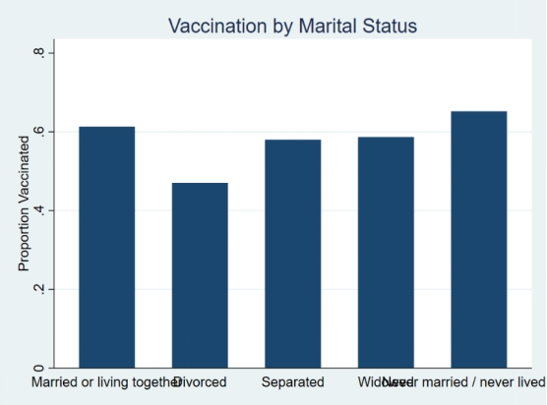

**Key Observations**

* The highestuptake was observed among individuals who were never married (65.2%) and those married or living together (61.3%).
* Lowest uptake occurred among the divorced (47.0%) and the widowed (58.7%).

**COVID Vaccination by Sex**

|  |  |  |  |
| --- | --- | --- | --- |
| Uptake of COVID-19 Vaccination | sex of household member | | |
| Female | Male | Total |
| No | 17489 | 16771 | 34260 |
|  | 51.05 | 48.95 | 100.00 |
|  | 37.12 | 38.69 | 37.87 |
| Yes | 29630 | 26578 | 56208 |
|  | 52.71 | 47.29 | 100.00 |
|  | 62.88 | 61.31 | 62.13 |
| Total | 47119 | 43349 | 90468 |
|  | 52.08 | 47.92 | 100.00 |
|  | 100.00 | 100.00 | 100.00 |
|  | | | |

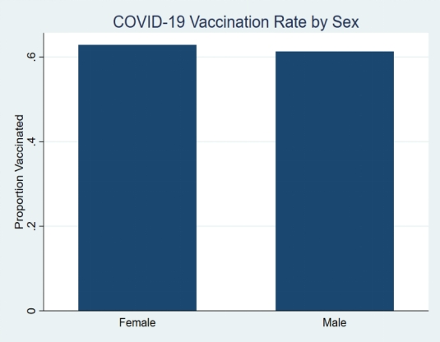

**Key Observations**

* Females had a slightly higher vaccination rate (62.9%) compared to males (61.3%).

**COVID-19 Vaccination by Age Group**

|  |  |  |  |  |  |  |  |
| --- | --- | --- | --- | --- | --- | --- | --- |
| Uptake of COVID-19 Vaccination | age_group | | | | | | |
| 15-24 | 25-34 | 35-44 | 45-54 | 55-64 | 65+ | Total |
| No | 11200 | 8847 | 5611 | 3325 | 2461 | 2816 | 34260 |
|  | 32.69 | 25.82 | 16.38 | 9.71 | 7.18 | 8.22 | 100.00 |
| Yes | 18504 | 11556 | 9802 | 6942 | 4886 | 4518 | 56208 |
|  | 32.92 | 20.56 | 17.44 | 12.35 | 8.69 | 8.04 | 100.00 |
| Total | 29704 | 20403 | 15413 | 10267 | 7347 | 7334 | 90468 |
|  | 32.83 | 22.55 | 17.04 | 11.35 | 8.12 | 8.11 | 100.00 |
| Pearson Chi2 = 467.75 Prob = 0.0000 | | | | | | | |

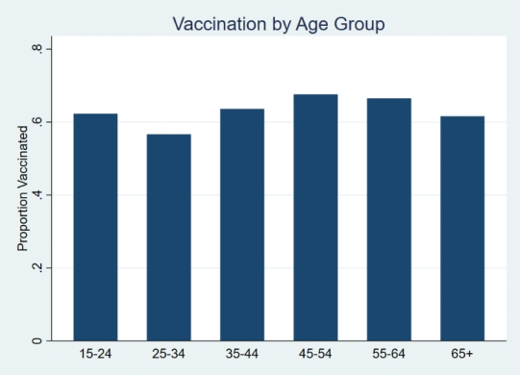

**Key Observations**

* Highest uptake observed among individuals aged 45–54, accounting for 12.4% ofthose vaccinated.
* Lowest uptake seen in the 15–24 age group, which made up 32.7% of the unvaccinated population.

**4. Logistic Regression**

A logistic regression was conducted to assess the impact of age group, sex, and marital status on COVID-19 vaccination uptake.

|  |  |  |  |  |  |  |  |  |  |  |  |
| --- | --- | --- | --- | --- | --- | --- | --- | --- | --- | --- | --- |
| covid_vaccinated | Coef. | | St.Err. | t-value | | p-value | [95% Conf | | Interval] | | Sig |
| : base 15-24 | 0 | | . | . | | . | . | | . | |  |
| 25-34 | .087 | | .023 | 3.80 | | 0 | .042 | | .132 | | *** |
| 35-44 | .475 | | .026 | 17.94 | | 0 | .423 | | .527 | | *** |
| 45-54 | .687 | | .03 | 22.97 | | 0 | .628 | | .746 | | *** |
| 55-64 | .676 | | .033 | 20.37 | | 0 | .611 | | .741 | | *** |
| 65+ | .528 | | .034 | 15.31 | | 0 | .461 | | .596 | | *** |
| sex of household m~F | 0 | | . | . | | . | . | | . | |  |
| Male | -.168 | | .014 | -11.69 | | 0 | -.196 | | -.14 | | *** |
| Marital Status : b~r | 0 | | . | . | | . | . | | . | |  |
| Divorced | -.651 | | .059 | -11.04 | | 0 | -.766 | | -.535 | | *** |
| Separated | -.163 | | .034 | -4.85 | | 0 | -.228 | | -.097 | | *** |
| Widowed | -.361 | | .031 | -11.48 | | 0 | -.423 | | -.299 | | *** |
| Never married / ne~e | .509 | | .022 | 23.23 | | 0 | .466 | | .552 | | *** |
| Constant | .171 | | .022 | 7.81 | | 0 | .128 | | .214 | | *** |
|  | | | | | | | | | | | |
| Mean dependent var | | 0.621 | | | SD dependent var | | | 0.485 | |
| Pseudo r-squared | | 0.011 | | | Number of obs | | | 90468 | |
| Chi-square | | 1353.515 | | | Prob > chi2 | | | 0.000 | |
| Akaike crit. (AIC) | | 118705.563 | | | Bayesian crit. (BIC) | | | 118809.103 | |
| *\*\*\* p<.01, ** p<.05, * p<.1* | | | | | | | | | | | |
|  | | | | | | | | | | | |

**Key Observations**

* All older age groups have p-values less than 0.05, indicating statistical significance.

For example, those aged 35–44 have a coefficient of 0.475 with a p-value of 0.000, which is well below the 0.05 threshold, meaning they are significant.

* Similarly, age groups 45–54 (p=0.000), 55–64 (p=0.000), and 65+ (p=0.000) all show strong positive and significant associations.
* Males have a coefficient of -0.168 with a p-value of 0.000. Since 0.000 < 0.05, being male is a statistically significant negative predictor, males are less likely to be vaccinated than females.
* Divorced (p=0.000), separated (p=0.000), and widowed (p=0.000) individuals all have p-values below 0.05, indicating significant negative associations with vaccination uptake.
* Those never married have a positive and significant coefficient (0.509) with a p-value of 0.000, showing they are more likely to be vaccinated than those married or living together.
* The model is statistically significant overall, as shown by the Chi-square test statistics of 1353.515 with a p-value of 0.000. Since the p-value is far below the conventional threshold of 0.05, we reject the null hypothesis that all coefficients are equal to zero. This means the model fits the data significantly better than a model with no predictors.
* The pseudo-R² is 0.011, which suggests the model explains only a small portion (1.1%) of the variance in vaccination uptake.

1. **Diagnostic Tests**
2. **Hosmer-Lemeshow goodness-of-fit test**

|  |
| --- |
| (Table collapsed on quantiles of estimated probabilities) |
| (There are only 9 distinct quantiles because of ties) |
| +-----------------------------------------------------------+ |
| | Group | Prob | Obs_1 | Exp_1 | Obs_0 | Exp_0 | Total | |
| |-------+--------+-------+---------+-------+--------+-------| |
| | 1 | 0.5238 | 5003 | 4896.3 | 4617 | 4723.7 | 9620 | |
| | 2 | 0.5641 | 6669 | 6933.8 | 5786 | 5521.2 | 12455 | |
| | 3 | 0.6172 | 5938 | 6010.4 | 4027 | 3954.6 | 9965 | |
| | 5 | 0.6253 | 10376 | 10311.5 | 6140 | 6204.5 | 16516 | |
| | 6 | 0.6454 | 3888 | 4011.0 | 2407 | 2284.0 | 6295 | |
| |-------+--------+-------+---------+-------+--------+-------| |
| | 7 | 0.6634 | 6256 | 6107.5 | 3017 | 3165.5 | 9273 | |
| | 8 | 0.6638 | 7456 | 7253.8 | 3472 | 3674.2 | 10928 | |
| | 9 | 0.6829 | 5242 | 5104.5 | 2379 | 2516.5 | 7621 | |
| | 10 | 0.7969 | 5380 | 5579.2 | 2415 | 2215.8 | 7795 | |
| +-----------------------------------------------------------+ |
|  |
| number of observations = 90468 |
| number of groups = 9 |
| Hosmer-Lemeshow chi2(7) = 104.79 |
| Prob > chi2 = 0.0000 |

**Key Observations**

* The Hosmer-Lemeshow test yields a chi2(7) = 104.79 with p < 0.001, The p – value is less than 0.05 suggesting poor model fit under this test. This poor fit may be due to omitted variables or model misspecification and improving it might require including more relevant predictors or interaction terms.

1. **Multicollinearity Test**

Variance Inflation Factor (VIF) was calculated for all independent variables to check for issues of multicollinearity.

|  |
| --- |
| Variable | VIF 1/VIF |
| -------------+---------------------- |
| age_group | |
| 2 | 1.92 0.520275 |
| 3 | 2.04 0.489001 |
| 4 | 1.81 0.552386 |
| 5 | 1.66 0.601159 |
| 6 | 1.85 0.540286 |
| 1.sex | 1.07 0.930534 |
| marital_st~n | |
| 2 | 1.01 0.986161 |
| 3 | 1.04 0.961706 |
| 4 | 1.31 0.763004 |
| 5 | 2.23 0.448972 |
| -------------+---------------------- |
| Mean VIF | 1.60 |

**Key Observations**

* All VIF values were less than 5 (which is the accepted threshold), indicating no serious multicollinearity concerns (mean VIF = 1.60).

1. **Classification statistics**

The classification statistics were performed to evaluate the performance of the logistic regression model in classifying individuals based on their COVID-19 vaccination status. These statistics assess how well the model distinguishes between vaccinated and unvaccinated individuals by calculating key metrics such as sensitivity, specificity, and the overall classification accuracy.

|  |
| --- |
|  |
| -------- True -------- |
| Classified | D ~D | Total |
| -----------+--------------------------+----------- |
| + | 55502 33461 | 88963 |
| - | 706 799 | 1505 |
| -----------+--------------------------+----------- |
| Total | 56208 34260 | 90468 |
|  |
| Classified + if predicted Pr(D) >= .5 |
| True D defined as covid_vaccinated != 0 |
| -------------------------------------------------- |
| Sensitivity Pr( +| D) 98.74% |
| Specificity Pr( -|~D) 2.33% |
| Positive predictive value Pr( D| +) 62.39% |
| Negative predictive value Pr(~D| -) 53.09% |
| -------------------------------------------------- |
| False + rate for true ~D Pr( +|~D) 97.67% |
| False - rate for true D Pr( -| D) 1.26% |
| False + rate for classified + Pr(~D| +) 37.61% |
| False - rate for classified - Pr( D| -) 46.91% |
| -------------------------------------------------- |
| Correctly classified 62.23% |
| -------------------------------------------------- |

**Key observations**

* The classification statistics show high sensitivity (98.74%) but very low specificity (2.33%).
* Correctly classified observations = 62.23%. This suggests that the model is better at identifying vaccinated individuals than those not vaccinated.

**6. Conclusion**

This analysis reveals that age, sex, and marital status are all significantly associated with COVID-19 vaccination uptake in a large population sample. Older individuals and those never married are more likely to be vaccinated, while males and individuals who are divorced, separated, or widowed show lower uptake. Although the model is statistically significant, the low pseudo R² and poor specificity suggest that important factors influencing vaccination are still missing. To improve the model, future research should consider adding more social, economic, or regional variables that may shape vaccine decisions more directly. Despite these limitations, the current findings offer valuable insight into key demographic trends behind vaccination behavior.

**QUESTION 2**

Estimate the effect of age, sex, and marital status, ownership of agricultural land on uptake of usage of mobile money: present descriptive, diagnostics and regression results

1. **Summary Statistics**

The table below presents the descriptive statistics for the key variables used in estimating the effect of age, sex, marital status, and agricultural land ownership on the uptake of mobile money services. These statistics provide a general overview of each variable's distribution and central tendencies, consisting of 90,468 observations drawn from the 2022 Kenya Demographic and Health Survey.

|  |  |  |  |  |  |
| --- | --- | --- | --- | --- | --- |
| Variable | Obs | Mean | Std. Dev. | Min | Max |
| age | 90468 | 35.81 | 17.279 | 15 | 95 |
| mobile money use | 90468 | .91 | .286 | 0 | 1 |
| sex | 90468 | .479 | .5 | 0 | 1 |
| marital status clean | 90468 | 2.682 | 1.866 | 1 | 5 |
| land ownership | 90468 | .573 | .495 | 0 | 1 |

**Key Observations**

* The average age of respondents is approximately **35.8 years**, with a minimum age of **15** and a maximum of **95**, indicating a wide age range within the sample.
* About **91%** of respondents reported using mobile money services, highlighting high penetration of digital financial tools.
* The variable sex is coded as binary (0 = female, 1 = male), and the mean value of approximately **0.48** suggests an almost equal gender distribution.
* The average value for marital_status is **2.68**, which corresponds to the categorical coding of marital status.
* About **57.3%** of respondents reported owning agricultural land, which can be important in understanding rural vs. urban differences in mobile money usage.

**Visualization**

To complement the summary statistics, the figure below visualizes mobile money usage across marital status groups. The data shows variation in usage patterns, indicating that relationship status may play a role in the likelihood of adopting mobile money services. This visual insight supports the inclusion of marital status as an explanatory variable in the regression model.

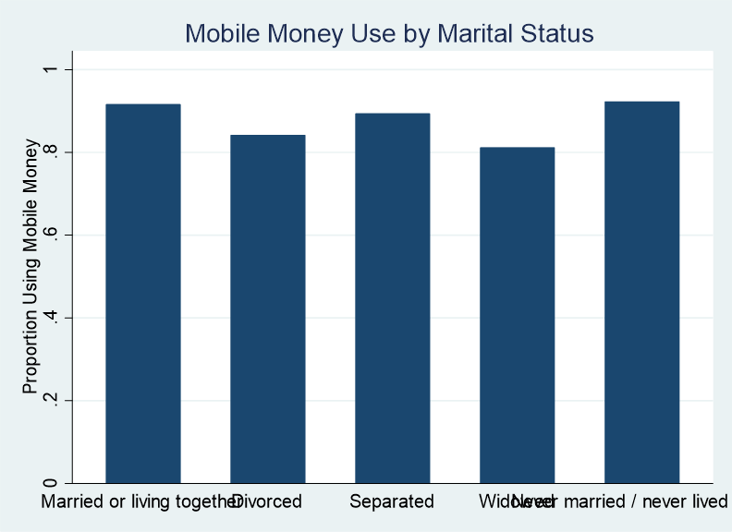

The bar chart illustrates the percentage of mobile money users across different marital status categories. Usage is highest among individuals who are married or never married, while it is slightly lower among the divorced, separated, and widowed. This suggests that marital status may influence financial behavior and access to digital financial tools.

1. **Diagnostic results**

To ensure the validity of the logistic regression model used to assess the effect of age, sex, marital status, and agricultural land ownership on mobile money usage, several diagnostic checks were conducted to ensure the model was correctly specified and free from major issues such as multicollinearity.

1. **Multicollinearity test**

The table below shows the results of an OLS regression model that was used for calculating Variance Inflation Factors (VIFs). This model includes all the explanatory variables from the logistic model.

**OLS Model for VIF Check**

|  |  |  |  |  |  |  |  |  |  |  |  |
| --- | --- | --- | --- | --- | --- | --- | --- | --- | --- | --- | --- |
| mobile_money_use | Coef. | | St.Err. | t-value | | p-value | [95% Conf | | Interval] | | Sig |
| age | -.001 | | 0 | -18.57 | | 0 | -.002 | | -.001 | | *** |
| sex of household m~F | 0 | | . | . | | . | . | | . | |  |
| Male | -.003 | | .002 | -1.31 | | .192 | -.006 | | .001 | |  |
| Marital Status : b~r | 0 | | . | . | | . | . | | . | |  |
| Divorced | -.06 | | .008 | -7.23 | | 0 | -.076 | | -.044 | | *** |
| Separated | -.02 | | .005 | -4.38 | | 0 | -.029 | | -.011 | | *** |
| Widowed | -.081 | | .004 | -18.75 | | 0 | -.089 | | -.072 | | *** |
| Never married / ne~e | -.021 | | .003 | -8.23 | | 0 | -.026 | | -.016 | | *** |
| owns land usable f~e | 0 | | . | . | | . | . | | . | |  |
| Yes | .061 | | .002 | 31.84 | | 0 | .057 | | .065 | | *** |
| Constant | .94 | | .003 | 275.39 | | 0 | .934 | | .947 | | *** |
|  | | | | | | | | | | | |
| Mean dependent var | | 0.910 | | | SD dependent var | | | 0.286 | |
| R-squared | | 0.023 | | | Number of obs | | | 90468 | |
| F-test | | 304.989 | | | Prob > F | | | 0.000 | |
| Akaike crit. (AIC) | | 28257.417 | | | Bayesian crit. (BIC) | | | 28332.719 | |
| *\*\*\* p<.01, ** p<.05, * p<.1* | | | | | | | | | | | |
| To ensure that the independent variables included in the logistic regression model were not highly correlated, a **Variance Inflation Factor (VIF)** test was conducted using an OLS approximation.  **Variance Inflation Factors**   |  |  |  | | --- | --- | --- | |  | VIF | 1/VIF | | age | 1.906 | .525 | | 1.sex | 1.072 | .933 | | 2.marital status c~n | 1.017 | .984 | | 3.marital status c~n | 1.039 | .963 | | 4.marital status c~n | 1.292 | .774 | | 5.marital status c~n | 1.665 | .601 | | 1.land ownership | 1.022 | .978 | | Mean VIF | 1.287 | . |   **Key Observations**  All VIF values were well below the conventional threshold of 10, with a mean VIF of approximately **1.29**, indicating that **multicollinearity is not a concern** in this model. This suggests that the predictors (age, sex, marital status, and land ownership) are sufficiently independent for valid inference.   1. **Link Test**   To test whether the logistic model is correctly specified, a **link test** was run. This checks for omitted variable bias or incorrect functional form by regressing the outcome on the predicted values (_hat) and their squares (_hatsq).  Iteration 0: log likelihood = -27367.4  Iteration 1: log likelihood = -26686.581  Iteration 2: log likelihood = -26407.731  Iteration 3: log likelihood = -26407.54  Iteration 4: log likelihood = -26407.54  Logistic regression Number of obs = 90,468  LR chi2(2) = 1919.72  Prob > chi2 = 0.0000 Log likelihood = -26407.54 Pseudo R2 = 0.0351   |  |  |  |  |  |  |  | | --- | --- | --- | --- | --- | --- | --- | | mobile_money_use | Coef. | Std.Err. | z | P>z | [95%Conf. | Interval] | | _hat | 1.248 | 0.132 | 9.470 | 0.000 | 0.990 | 1.507 | | _hatsq | -0.059 | 0.031 | -1.910 | 0.056 | -0.120 | 0.002 | | _cons | -0.243 | 0.137 | -1.780 | 0.076 | -0.512 | 0.025 | |  | | | | | | |   **Key Observations**  The coefficient for _hat was statistically significant (**p < 0.001**), as expected, and the squared term _hatsq had a **p-value of 0.056**. While this is just above the 5% significance threshold, it does not provide strong evidence of misspecification.  Therefore, the model appears to be reasonably well specified, though small improvements could be made by exploring potential interaction effects or non-linear terms (e.g., age²) in future models.   1. **Goodness of fit test**   To assess how well the logistic model fits the data, a **Pearson chi-square goodness-of-fit test** was performed.  **Logistic model for mobile_money_use, goodness-of-fit test**  number of observations = 90468  number of covariate patterns = 1357  Pearson chi2(1349) = 2622.25  Prob > chi2 = 0.0000  **Key Observations**  Pearson χ² (df = 1349) = **2622.25**  **p-value =**  Since the p-value is **less than 0.05**, the test suggests that the model may **not fit the data perfectly**. A significant p-value indicates that there are meaningful differences between observed and predicted values across covariate patterns.  However, with large samples, even small deviations from perfect fit can lead to significant chi-square values.  Therefore, this result should be interpreted with caution and considered alongside other diagnostic like the link test and pseudo R².  The model is still considered acceptable for analytical purposes, though adding interaction terms or nonlinear effects may improve fit.  While the goodness-of-fit test is statistically significant, this is not uncommon in large samples. The model remains useful for identifying key predictors of mobile money usage.    **IV. ROC Curve**  To evaluate the model's classification performance , a **Receiver Operating Characteristic (ROC) curve** was generated. The ROC curve plots the model's sensitivity (true positive rate) against 1 - specificity (false positive rate) across different thresholds.  The **Area Under the Curve (AUC)** is **0.6301**, which indicates that the model performs **better than random guessing** (AUC = 0.5) but falls short of strong classification power.  While an AUC between 0.6 and 0.7 reflects **poor to fair** predictive ability, this is not uncommon in behavioral survey data where unobserved factors may influence decisions. The ROC results suggest that while the model has some discriminative power, adding more predictors (e.g., income, education, urban/rural) could improve classification accuracy. | | | | | | | | | | | |

1. **Regression results**

The table below presents the results of a logistic regression model assessing the influence of age, sex, marital status, and agricultural land ownership on the likelihood of mobile money usage. The regression was performed on 90,468 individuals from the Kenya Demographic and Health Survey (2022).

**Logistic Regression on Mobile Money Usage**

|  |  |  |  |  |  |  |  |  |  |  |  |
| --- | --- | --- | --- | --- | --- | --- | --- | --- | --- | --- | --- |
| mobile_money_use | Coef. | | St.Err. | t-value | | p-value | [95% Conf | | Interval] | | Sig |
| age | -.016 | | .001 | -18.30 | | 0 | -.018 | | -.014 | | *** |
| sex of household m~F | 0 | | . | . | | . | . | | . | |  |
| Male | -.042 | | .025 | -1.71 | | .087 | -.091 | | .006 | | * |
| Marital Status : b~r | 0 | | . | . | | . | . | | . | |  |
| Divorced | -.562 | | .082 | -6.89 | | 0 | -.722 | | -.402 | | *** |
| Separated | -.239 | | .054 | -4.40 | | 0 | -.345 | | -.132 | | *** |
| Widowed | -.684 | | .043 | -15.73 | | 0 | -.769 | | -.599 | | *** |
| Never married / ne~e | -.226 | | .033 | -6.91 | | 0 | -.29 | | -.162 | | *** |
| owns land usable f~e | 0 | | . | . | | . | . | | . | |  |
| Yes | .754 | | .024 | 31.26 | | 0 | .706 | | .801 | | *** |
| Constant | 2.713 | | .042 | 65.27 | | 0 | 2.632 | | 2.794 | | *** |
|  | | | | | | | | | | | |
| Mean dependent var | | 0.910 | | | SD dependent var | | | 0.286 | |
| Pseudo r-squared | | 0.035 | | | Number of obs | | | 90468 | |
| Chi-square | | 1916.089 | | | Prob > chi2 | | | 0.000 | |
| Akaike crit. (AIC) | | 52834.712 | | | Bayesian crit. (BIC) | | | 52910.014 | |
| *\*\*\* p<.01, ** p<.05, * p<.1* | | | | | | | | | | | |

**Key Observations**

* **Age** is negatively associated with mobile money usage (**p < 0.001**), indicating that younger individuals are more likely to use mobile money. A one-year increase in age slightly decreases the odds of mobile money adoption.
* **Sex** (being male) has a negative coefficient but is **not statistically significant at the 5% level** (p = 0.087). This implies that gender differences in mobile money usage are minimal.
* **Marital status** is a significant predictor across all categories. Compared to the reference group (married or living together):
  + Divorced individuals are significantly less likely to use mobile money (**p < 0.001**).
  + Separated, widowed, and never married individuals are all **significantly less likely** to adopt mobile money services (**p < 0.001**).
* **Land ownership** is positively and significantly associated with mobile money usage (**p < 0.001**). Individuals who own agricultural land are more likely to use mobile financial services, possibly due to greater need for remote or digital transactions in rural areas.

The model has a **pseudo R² of 0.035**, suggesting that while the predictors explain a modest amount of variation in mobile money use, the model is statistically significant (**Chi-square = 1916.089, p < 0.001**). This confirms that the model provides better explanatory power than a null model.

Generally, the regression highlights that marital status, land ownership, and age are important determinants of mobile money uptake, while gender has a marginal effect.

1. **CONCLUSION**

The analysis reveals that age, marital status, and land ownership significantly influence mobile money usage in Kenya. Younger, married individuals and those who own agricultural land are more likely to use mobile money services. Gender showed a marginal effect. Overall, the model is statistically valid, though predictive power could be improved with additional socioe-conomic variables.