The first account's adress: 4gvpLYHVnpBwfdYtVzHwsY2n7WuPFzYJDhQow3sK1b9EbtMUto

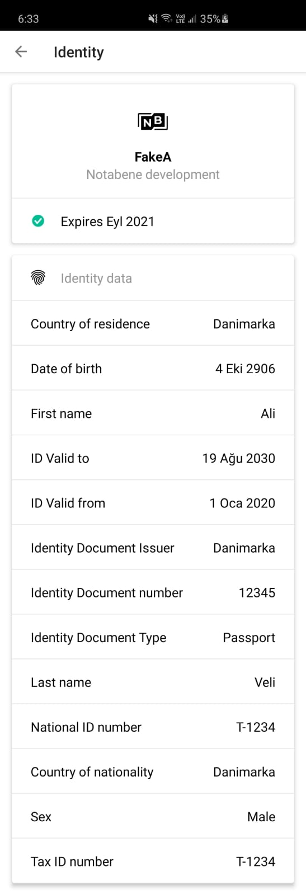

The second account's adress: 4Rtb8TqnBTQ1VdymeXotGMqUd7ECUWu6KETpNVmySBZPFYQEhF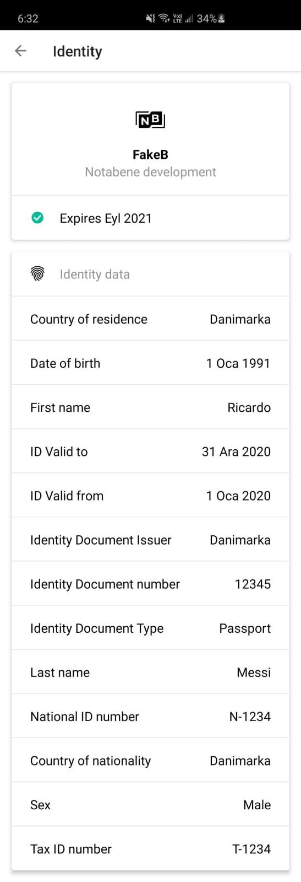 Done on Samsung Galaxy 10S Plus SM-G975U1 Android Version 10 ONU UI version 2.5