Online construction equipment rental: -

**Steps to use: -**

**1)Restore/Create Database: -**

There is a database script in sql folder of project ‘RentApp’ .

Kindly execute it. This script will create the database and all the required tables with data.

This is a kind of seed script.



**2)Browse the inventory service.**

Kindly right click the ‘InventoryService.svc’ service under ‘RentAppService’ project and click ‘view in browser’ option.

This will keep the service running.

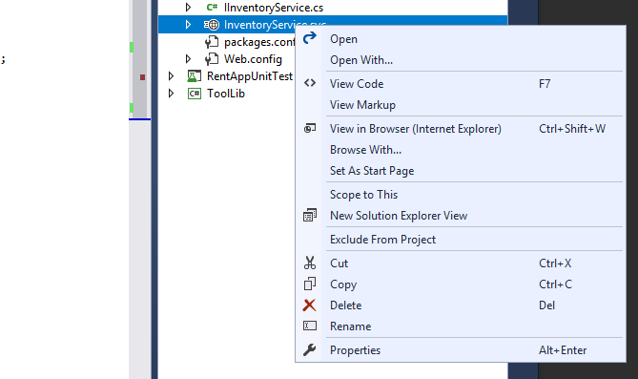

**3)Run the solution by setting up ‘RentApp’ project as startup.**