**Global Precipitation Mission (GPM)**

**Ground Validation System**

**VERTICAL CROSS SECTION DISPLAY**

**PROGRAM USER’S MANUAL**

**FOR**

**GPM VALIDATION NETWORK DATA**

**Version 3.1**

**September, 2017**

Goddard Space Flight Center

Greenbelt, Maryland 20771



**Document History**

| Document Version | Date | Changes |
| --- | --- | --- |
| Version 1.1 | July 15, 2010 | For version 1.1 of the program. |
| Version 1.2 | February, 2012 | - Updates for version 1.2 of the program. New keyword options, plot of rain type indicators on cross sections of geometry matched PR and GR data, labeling of height ticks, legend changes, new behavior when 2A-25 file is not found.  - Updated URL references. |
| Version 2.0 | September, 2012 | - Updates for version 2.0 of the program. New keyword options to plot of bright-band affected upper and lower sample boundaries on cross sections of geometry matched PR and GR data, select the width of the bright band, hide or show the rain type indications on the PPIs and cross sections, and plot a composite reflectivity PPI instead of a fixed elevation sweep.  - New interactive option to sweep across the full dataset and plot a series of cross sections in sequence. |
| Version 3.0 | June, 2016 | - Describes both the TRMM PR and GPM DPR and DPRGMI capabilities of the program.  - New options to plot a cross section along a radial extending from the ground radar location (RHI mode), to plot a cross section along the orbit track at a constant DPR scan angle (RAY mode), and to save a sequence of cross sections to an animated GIF. |
| Version 3.1 | September, 2017 | Added descriptions of options to apply site-specific GR reflectivity bias corrections and a global DPR Zcorr/Zmeas bias correction, and to comment out lines in control files. |

**Contact Information**

Additional information, including information on GPM Validation Network points-of-contact, can be obtained from the GPM Ground Validation web site:

http://pmm.nasa.gov/science/ground-validation

**Table of Contents**

1. INTRODUCTION 1

2. SYNOPSIS 2

2.1 Specification of Keyword Parameters 8

3. PRECONDITIONS AND LIMITATIONS 10

4. RUNNING THE PROGRAM 11

4.1 Prepare Control File for the cross_sections_driver Procedure 11

4.2 Starting cross_sections_driver (in the IDL Virtual Machine) 12

4.3 Starting cross_sections_driver (in IDL command-line mode, or in IDLDE) 13

4.4 The Vertical Cross Section Analysis Procedure 14

4.5 The SHOW_ORIG Option and Program Startup 15

5. PROGRAM OUTPUTS 17

5.1 The Cross-Section Selection Window 17

5.2 The Geometry-Match Cross Section Displays 21

5.2.1 PR and GR Reflectivity 21

5.2.2 PR-GR Reflectivity Difference 22

5.3 Full-Resolution PR and DPR Reflectivity Cross Sections 23

5.4 Interactions With The PPI Display 26

5.4.1 Select A New Cross Section Location 26

5.4.2 Automatically Step Through All PR Scans 26

5.4.3 Start a PPI Animation Loop 28

5.4.4 CAPPI Option for Animation Loops 30

5.4.5 Apply S-band to Ku-band Frequency Adjustment to GR Reflectivity 31

5.4.6 Apply a Calibration Adjustment to GR Reflectivity 32

5.5 Constraining Data Quality 34

5.6 Apply Bias Adjustments to GR and DPR Reflectivity 37

5.7 Customizing the Displays with Optional Parameters 38

5.8 RHI Cross Section Display Mode 43

5.9 Constant PR/DPR Ray Number (Scan Angle) Mode 45

6. RUNNING THE “RAW” CROSS SECTION ANALYSIS PROCEDURES 47

7. RUNNING UNDER WINDOWS 48

8. REFERENCES 48

# INTRODUCTION

The GPM Validation Network (VN) Vertical Cross Section Display Program consists of the IDL procedure **cross_sections_driver**, which provides the capability to interactively display and apply adjustments to vertical cross sections of TRMM Precipitation Radar (PR) or GPM Dual-Frequency Precipitation Radar (DPR), and ground radar (GR or GV) reflectivity, from geometry-matched (also referred to as “geo-match”) data produced by the GPM Validation Network. The primary input data to the program consists of a previously computed netCDF file, one file per “rainy” site overpass (a TRMM PR or GPM DPR overpass of a GR site, with precipitation echoes present, generally referred to as an “event”), containing the geometry-matched PR/GR or DPR/GR data. These data are described in detail in the *GPM Validation Network Data User’s Guide* ([http://](http://gpm.gsfc.nasa.gov/groundvalidation.html)pmm.nasa.gov/science/ground-validation ).

For purposes of describing of the usage and capabilities of the Cross Section Display Program, the descriptions will be made in terms of the TRMM PR data only (GRtoPR matchups), except where the capabilities for the GPM DPR differ from those of the TRMM PR. Likewise, the DPR descriptions apply equally to matchups based on 2A-DPR, 2A-Ka, 2A-Ku (all called GRtoDPR matchups) or the 2B-DPRGMI product (called GRtoDPRGMI matchups), except where differences are noted.

The procedure displays three vertical cross sections by default: PR reflectivity, GR reflectivity, and the difference (PR-GR) between the PR and GR reflectivity; each derived from the geometry-matched data. The cross sections display a series of adjacent vertical profiles along one PR cross-track scan line (i.e., perpendicular to the orbit track), through a point selected by the user. For DPR, the cross sections can be: (a) along a DPR scan line, (b) along a line of constant DPR ray number (scan angle), or (c) along a radial line extending from the GR location to a user-selected point. Random cross section alignments are currently not supported. Only the attenuation-corrected PR or DPR reflectivity data derived from the Level 2A product (2A-25 for TRMM; 2A-DPR, 2A-Ka, or 2A-Ku for GPM) or the GPM 2B-DPRGMI combined product are displayed and differenced against the GR data.

The **cross_sections_driver** procedure has a feature allowing a calibration offset to be applied to the GR reflectivity data. If a GR site or GR data for a particular event is known to have an error in calibration relative to the PR, the calibration of the GR reflectivity data may be adjusted up or down in 1 dBZ increments on the displayed cross sections, so that the relative vertical structures of the PR and GR reflectivity fields can be evaluated with the calibration bias removed. Another option allows the vertical cross sections to be replotted with the S-band to Ku-band frequency adjustments of Liao and Meneghini (2009) applied to the GR reflectivity values.

The procedure allows the user to launch a separate animation sequence of the PR and GR Plan Position Indicator (PPI) images while cross sections are being viewed, so that the alignment of the geometry-matched PR and GR data may be evaluated subjectively to determine whether the PR and GR cross sections represent the same precipitation echo areas. If the original Universal Format (UF) GR radar data files are available, a full-resolution PPI of the GR data can be included in the animation sequence, interleaved between the PPIs of PR and GR volume-matched data.

If the original Level 2A (2B in the case of DPRGMI) product files are available, the procedure optionally can generate and display a matching cross section of full (125m or 250m) vertical resolution PR or DPR reflectivity for comparison to the geometry-matched, volume-averaged PR/DPR and GR data. Where 2A or 2B data are available, plotting of these full-resolution PR/DPR cross sections may be enabled or disabled by specifying an IDL keyword parameter to the procedure.

Default output is to the screen only. An option exists to create and save an animated GIF file of a sequence of cross sections that sweeps through the data set. A working copy of IDL is a prerequisite for running the **cross_sections_driver** procedure. This document assumes that the user knows the basics of running programs in IDL. Beginners can become familiar with IDL by reviewing the online learning materials at http://www.harrisgeospatial.com/docs/getting_started.html.

# SYNOPSIS

The **cross_sections_driver** procedure is a user-friendly “wrapper” program which encapsulates the IDL “workhorse” procedures **pr_and_geo_match_x_sections** (for TRMM PR matchup data) and **dpr_and_geo_match_x_sections** (for GPM 2A-DPR/Ka/Ku matchup data and GPM 2B-DPRGMI combined matchup data). The latter procedures do the actual work of reading and displaying cross sections of the geometry-match data, and creating the optional plots. The two **XXX_and_geo_match_x_sections** (where **XXX** is “**pr**” or “**dpr**”) “workhorse” procedures accept a large number of optional and required IDL keyword parameters to control the functionality of the program and set up the local configuration of the host machine in terms of the data file paths, and the wrapper routine, **cross_sections_driver**, greatly simplifies the mechanism used to specify these keyword parameters.

IDL keyword parameters are of the form **KEYWORD=value**, where **KEYWORD** indicates which parameter is being specified, and **value** is the value to be assigned to the keyword parameter. The complete calling sequence of **pr_and_geo_match_x_sections** in IDL, showing all of the allowable keyword parameters, is as follows:

pr_and_geo_match_x_sections, ELEV2SHOW=elev2show, SITE=sitefilter, $

NO_PROMPT=no_prompt, NCPATH=ncpath, $

PRPATH=prpath, UFPATH=ufpath, $

SHOW_ORIG=show_orig, PCT_ABV_THRESH=pctAbvThresh, $

BBBYRAY=BBbyRay, PLOTBBSEP=plotBBsep, $

BBWIDTH=bbwidth, ALT_BB_HGT=alt_bb_hgt, $

HIDE_RNTYPE=hide_rntype, CREF=cref, PAUSE=pause, $

ZOOMH=zoomh, LABEL_BY_RAYNUM=label_by_raynum, $

RHI_MODE=rhi_mode, VERBOSE=verbose, $

GIF_PATH=gif_path, RECALL_NCPATH=recall_ncpath

The complete calling sequence of **dpr_and_geo_match_x_sections** has all the parameters listed above, and the additional keyword parameters MATCHUP_TYPE, SWATH_CMB, KUKA_CMB, RAY_MODE, CAPPI_ANIM, DPR_Z_ADJUST, GR_Z_ADJUST, and DECLUTTER:

dpr_and_geo_match_x_sections, ELEV2SHOW=elev2show, SITE=sitefilter, $

MATCHUP_TYPE=matchup_type, $

SWATH_CMB=swath_cmb, KUKA_CMB=KuKa_cmb, $

NO_PROMPT=no_prompt, NCPATH=ncpath, $

PRPATH=prpath, UFPATH=ufpath, $

SHOW_ORIG=show_orig, PCT_ABV_THRESH=pctAbvThresh, $

DPR_Z_ADJUST=dpr_z_adjust, GR_Z_ADJUST=gr_z_adjust, $

BBBYRAY=BBbyRay, PLOTBBSEP=plotBBsep, $

BBWIDTH=bbwidth, ALT_BB_HGT=alt_bb_hgt, $

HIDE_RNTYPE=hide_rntype, CREF=cref, PAUSE=pause, $

ZOOMH=zoomh, LABEL_BY_RAYNUM=label_by_raynum, $

RHI_MODE=rhi_mode, RAY_MODE=ray_mode, $

CAPPI_ANIM=cappi_anim, GIF_PATH=gif_path, $

DECLUTTER=declutter, VERBOSE=verbose, $

RECALL_NCPATH=recall_ncpath

While users can run either **pr_and_geo_match_x_sections** or **dpr_and_geo_match_x_sections** directly in IDL by entering multi-line commands as shown above, the length of the calling sequence can make this quite cumbersome depending on the number of parameters that need to be specified. The same results can be achieved by running the wrapper procedure **cross_sections_driver** which reads any/all of the necessary keyword parameters from a simple, user-editable text file, and passes them along internally to **pr_and_geo_match_x_sections** or **dpr_and_geo_match_x_sections** to produce the requested cross section displays.

Detailed instructions for running either **cross_sections_driver** and/or the three “workhorse” procedures in IDL, and detailed examples of the affect of keyword parameters on the program output are given in the next sections. The remainder of this section briefly describes the keyword parameters accepted by the procedures. Note that each keyword parameter is optional, and has a default value or behavior if left unspecified. The usage and functionality of each keyword parameter is as follows:

**ELEV2SHOW**: sweep number of PR/GR PPIs to display for selection of the cross section location (Fig. 5), starting from 1 as the lowest elevation angle in the GR radar volume. Defaults to approximately 1/3 the way up the list of sweeps if unspecified.

**SITE**: file pattern, which acts as a filter limiting the set of input files shown in the file selector (Fig. 3), or over which the program will iterate. Mode of selecting the (next) file depends on the NO_PROMPT parameter. Default=* (all files)

**MATCHUP_TYPE:** Type of matchup data to be analyzed: ‘PR’ (GRtoPR matchup netCDF files), 'DPR' (GRtoDPR matchup netCDF files) or 'DPRGMI' (GRtoDPRGMI matchup netCDF files). Also accepts 'CMB' as an alias for 'DPRGMI'. Defaults to 'PR' if not specified. *This keyword parameter is not valid keyword parameter input for the* ***pr_and_geo_match_x_sections*** *procedure itself*, but is valid for the **cross_sections_driver** control file to specify that **pr_and_geo_match_x_sections** is to be called and run.

*The following two parameters are specific to* ***dpr_and_geo_match_x_sections****, and are not accepted by the* ***pr_and_geo_match_x_sections*** *procedure:*

***SWATH_CMB:*** *designates which swath (scan type) to analyze for the ‘DPRGMI’ matchup type. Allowable values are 'MS' and 'NS' (default). Ignored if MATCHUP_TYPE is ‘DPR’, whose netCDF files contain data for only one scan type.*

***KUKA_CMB:*** *designates which DPR instrument's data to analyze for the ‘DPRGMI’ matchup type. Allowable values are 'Ku' and 'Ka'. If SWATH_CMB is 'NS' then KUKA_CMB must be 'Ku'. If unspecified or if in conflict with SWATH_CMB then the value will be assigned to 'Ku' by default. Ignored if MATCHUP_TYPE is ‘DPR’.*

**NO_PROMPT**: method by which the next file in the set of files defined by NCPATH and SITE is selected. Binary parameter (e.g., /NO_PROMPT or NO_PROMPT=1 to set to On). If unset or set to 0, defaults to using DialogPickfile (IDL’s pop-up file selector, shown in Figure 3). If set, then the program will automatically find and process the next file in the set, in order of ascending site ID and date.

**NCPATH**: local directory path to the geo_match netCDF files' location. Defaults to **/data/netcdf/geo_match** if not specified. ***This parameter MUST be specified if the netCDF files are not located under* /data/netcdf/geo_match *on the local host.***

**PRPATH**: local directory path to the original PR product files’ “root” (in-common) directory. Defaults to **/data/gpmgv/prsubsets**. By convention, the 2A-25 data files must be located in a **/2A25** subdirectory located immediately under PRPATH (e.g., under **/data/gpmgv/prsubsets/2A25**). There is one special case for the PRPATH value. If ‘prompt’ is used as the name of the directory path (i.e., PRPATH=’prompt’), then a File Selector (Fig. 4) will be displayed to allow manual selection of the PR 2A25 product file that matches the geo-match netCDF data file. PRPATH is ignored if the SHOW_ORIG keyword is set to “OFF”.

**UFPATH**: local directory path to the original GR radar UF file “root” (in-common) directory. Defaults to **/data/gpmgv/gv_radar/finalQC_in.** NOTE: The non-common part of the path to the UF files which follows after the UF_PATH value is expected to be of the form: SITE_ID/PRODUCT/YYYY/MMDD, where PRODUCT is either '1CUF' or '1CUF-cal' (as determined from examining the geo-match netCDF file name), YYYY is the 4-digit year, and MMDD is the month and day, with leading zeroes included. Example: **KHGX/1CUF/2006/0328.** Refer to Section 4 (Directory Structure of the VN ftp Site) of the *GPM Validation Network Data User’s Guide* (available from <http://gpm.gsfc.nasa.gov/groundvalidation.html>) for details.

**SHOW_ORIG**: Called NO_2A25 prior to Version 2.0 of the cross section procedure. Binary parameter (e.g., /SHOW_ORIG or SHOW_ORIG=1 to set to On). By default, SHOW_ORIG is set to Off (SHOW_ORIG=0), meaning the procedure will NOT attempt to plot full-vertical-resolution PR cross sections from the original 2A-25 HDF data file (or 2A-DPR, 2A-Ka, 2A-Ku, or 2BDPRGMI HDF5 data file for GPM) corresponding to the volume-match netCDF data file, even if the 2A-xxx files are available and PRPATH is properly specified. This means the program can be run using only the self-contained geo-match netCDF data files. If set to On, then the full-vertical-resolution PR or DPR cross sections from the 2A-25/DPR/Ka/Ku data will be plotted. Refer to the section “The SHOW_ORIG Option And Program Startup”, below. See also the PRPATH keyword.

**PCT_ABV_THRESH**: Each geometry-matched reflectivity volume consists of an average of values from one or more spatially-coincident, full-resolution PR and GR radar bins. These geo-match data have metadata fields used to derive the percent of bins included in each sample average that are above specific reflectivity thresholds (default = 18.0 dBZ for PR, 15.0 dBZ for DPR, 15.0 dBZ for GR). These “detection thresholds” are specified at the time the geo-match dataset is created. This percent above threshold is essentially a measure of "beam-filling goodness". The pctAbvThresh keyword value indicates the minimum percentage of above-threshold bins that must be present, in common, in each PR and GR volume average sample included in the statistics and displays. 100 means use only those matchup points where all the PR and GR bins in the volume averages were above threshold (the volumes are completely filled with above-threshold bin values). 0 means use all matchup points available, with no regard for thresholds (the default behavior, if no pctAbvThresh value is specified).

*The following two parameters are specific to* ***dpr_and_geo_match_x_sections****, and are not accepted by the* ***pr_and_geo_match_x_sections*** *procedure:*

***DPR_Z_ADJUST:*** *Optional parameter. Bias offset to be applied (added to) the DPR reflectivity values to account for the calibration offset between the DPR and ground radars in a global sense (same for all GR sites). Positive (negative) value raises (lowers) the non-missing DPR reflectivity values.*

***GR_Z_ADJUST****: Optional parameter. Pathname to a "|"-delimited text file containing the bias offset to be applied (added to) each ground radar site's reflectivity to correct the calibration offset between the DPR and ground radars in a site-specific sense. See Section 5.6 for details.*

**BBBYRAY**: Binary parameter, “Bright Band BY Ray”. If set, then plot individual bright band (BB) height lines for each PR ray in the full-resolution 2A-25 cross section plots, using each ray's BB height as derived from the PR 2A-25 rangeBinNums variable (for TRMM PR), the heightBB variable in the 2A-DPR, 2A-Ka, or 2A-Ku product (for the GPM DPR), or the heightZeroDeg value in the 2B-DPRGMI product (for the GPM combined DPR/GMI dataset).

**PLOTBBSEP**: Binary parameter, indicates whether to plot a delimiter between within-BB sample volumes and adjacent above- and below-BB sample volumes in PR and GR volume-match cross sections. Default = 0 (do not plot BB delimiters).

**BBWIDTH**: Height (km) above/below the mean bright band height for which a sample whose vertical bounds <touches> (is totally above) [is totally below] this BB layer is considered to be <within> (above) [below] the BB. If not specified, takes on the default value (0.750) defined in the utility modules **fprep_geo_match_profiles.pro** and **fprep_dpr_geo_match_profiles.pro.** Values outside the range of 0.2 km <= bbwidth <= 2.0 are overridden to the default value, 0.75 km. If a value of 100.0 or greater is specified, it is assumed to be in units of meters, is converted to km, and evaluated for range validity.

**ALT_BB_HGT**: Manually-specified mean Bright Band height (in km) to be used by the program in the case where a mean bright band height cannot be determined from the DPR or PR data included in the matchup data file. If a numerical value is provided it is treated as the mean BB height. If a file pathname is provided, it is treated as the name of a file to be searched for the model-sounding-based freezing height for the given site and orbit.

**HIDE_RNTYPE**: Binary parameter, indicates whether to: (1) encode rain type in the PPI plot of the cross-section selection panel by hatch patterns, and (2) plot colored bars along the top of the PR and GR cross-sections indicating the PR and GR rain types identified for the given ray. Default=0 (do not hide rain type on plots, show it).

**CREF**: (Optional) binary parameter, if set to ON, then plot PPIs of Composite Reflectivity (highest reflectivity in the vertical column), rather than reflectivity at the fixed sweep elevation 'elev2show' within the cross-section selector window.

**PAUSE**: Specifies dwell time (fractional seconds) between steps when automatically displaying a sequence of cross sections for all PR scans in the matchup set. Default=1.0 seconds if not specified. Also defines the dwell time between frames in the animated GIF when the animation sequence is written to a GIF file (see GIF_PATH parameter).

**ZOOMH**: parameter to explicitly control the width and location of how the rays are plotted in the cross section window. Valid values are 0, 1, or 2, where 0 means to configure the plot as if all 49 rays in a scan were present, regardless of the number of rays in the overlap area for any scan, and plot each ray with a fixed width and at a fixed location based on its ray number; 1 means to configure the plot according to the scan with the most number of rays in the PR/GR overlap area, and plot each ray with a fixed width, and at a fixed location based on ray number; and 2 is the legacy behavior to individually configure the cross section for each scan to be plotted according to the number of rays in the overlap area (full zoom to fit the cross section window, where the plotted ray width and location vary for each scan). If not set, then defaults to 2 (legacy behavior). The automatic display of a sequence of cross sections temporarily overrides the legacy behavior to that of a zoomh value of 1, whether or not zoomh is actually set to 2 in the inputs.

**LABEL_BY_RAYNUM**: parameter to explicitly control the type of label plotted at the endpoints of the cross section. If unset, uses the default legacy behavior to plot 'A' at the left/lowest ray number to be plotted, and 'B' at the right/highest ray number. If set, then plots the actual ray numbers at the either end of the cross section on the PPI location selector and the cross sections.

**RHI_MODE**: Binary parameter. Determines the method used to define the cross section location with the cursor. If unset (Default) then the cross section will be along the PR/DPR scan line intersecting the cursor location. If set, then the cross section will be along a radial line extending from the ground radar location through the center of the PR/DPR footprint at the location selected with the cursor and extending to the edge of the matchup data coverage. RHI_MODE overrides RAY_MODE if both parameters are set.

**RAY_MODE**: Binary parameter. Determines the method used to define the cross section location with the cursor. If unset (Default) then the cross section will be along the PR/DPR scan line intersecting the cursor location, unless RHI_MODE is set. If RAY_MODE is set, then the cross section will be along a line of constant PR/DPR ray number (i.e., sidelong scan angle) intersecting the cursor location, perpendicular to the PR/DPR scan line. RHI_MODE overrides RAY_MODE if both parameters are set.

**CAPPI_ANIM**: Binary parameter. Setting the **CAPPI_ANIM** keyword option to ON (=1) allows CAPPI (Constant Altitude PPI) images of geometry-matched DPR and ground radar (GR) data to be displayed in place of the default PPI images which are for constant GR sweep elevation angle.

**GIF_PATH:** Optional file directory specification to which an animated GIF of the automated cross section sequence will be written if an automated scan sequence is initiated. If specified, then no prompts are shown to the user in the automated sequence and the sequence runs across the full matchup area in a rapid fashion, ignoring the value of the "pause" parameter.

**DECLUTTER**: Optional binary parameter, if set to ON, then read and use the precomputed clutterStatus variable to filter out clutter-flagged volume match samples, regardless of **PCT_ABV_THRESH** status. Applies only to ‘DPR’ matchup type, and is not a valid keyword parameter for **pr_and_geo_match_x_sections**.

**VERBOSE**: Binary parameter. If set, then print position coordinates for user-selected cross-section locations on the PPIs, in terms of display window coordinates and their corresponding scan,ray coordinates in the full PR/DPR/DPRGMI product’s data array.

**RECALL_NCPATH:** Binary parameter. If set, assigns the last file path used to select a file in dialog_pickfile() to an IDL “system variable” that stays in effect for the IDL session (i.e., until IDL is exited or a .RESET_SESSION executive command is run). Also, if set and if the user variable exists from a previous selection, then the system variable value will override the NCPATH parameter value on program startup.

## Specification of Keyword Parameters

The mechanism and formats for specifying the keyword parameters differ between the “parent” **cross_sections_driver** and the “child” **XXX_and_geo_match_x_sections** procedures. For **cross_sections_driver**, the keyword parameters must be entered in a control file that will be selected by the user and read by the procedure when it starts. This process is described in detail in RUNNING THE PROGRAM in Section 4.

When running the procedure **XXX_and_geo_match_x_sections** in IDL or IDLDE (see Section 6), the keyword/value pairs must be listed on the command line following the name of the procedure, each separated by a comma. For example:

IDL> pr_and_geo_match_x_sections, $

NCPATH=’/Users/Chuck/data/netcdf/geo_match’, $

PCT_ABV_THRESH=95

The $ is a continuation character in IDL and allows you to enter a single command over several lines, for readability.

Note that two types of IDL keyword parameters are used in the procedure. The regular keyword parameters take specific numerical or text string values as the parameter value, in the format **KEYWORD=value**. For those regular keywords whose values are strings, the ***string value must be enclosed in quotes whenever specified on the IDL command line***, e.g., NCPATH=’/data/netcdf/geo_match’. For those regular keywords whose values are numbers, the keyword values do not need to be in quotes, e.g., ELEV2SHOW=3.

Binary keywords are specified in the **KEYWORD=value** format, or (***on the command line only***) in the “slash” format: **/KEYWORD**. In the **KEYWORD=value** format, the option is turned “On” by specifying a numerical value of 1 (one) for the value (e.g., SHOW_ORIG=1), and “Off” by specifying a value of 0 (zero) for the value (e.g., SHOW_ORIG=0). On the command line, specifying the keyword name preceded by a slash (/) is equivalent to specifying a value of 1 to turn the option “On”. For example, SHOW_ORIG=1 and /SHOW_ORIG are equivalent on the command line. If a binary keyword is not specified on the command line or in the control file, it is “Off” by default. ***The slash format for binary keywords is not allowed in the control file.***

***Quotes are optional for any string or numerical keyword value specified in the control file***, since the program will assign the correct variable type to the value regardless of the quotes (e.g., SITE=KAMX or ELEV2SHOW=’3’ are both valid for parameters specified in the control file). Table 1 summarizes the format rules/options for specifying each type of keyword parameter, for (a) the control file, and (b) for parameters specified on the command line. Spaces between tokens in the lines are also optional, so SITE=”KEVX” and SITE = “KEVX” are both valid in the control file or on the command line.

**Table 1. Keyword/value formatting rules and options for specification of parameters in the control file (for *cross_sections_driver*) and on the IDL command line (for directly running *pr_and_geo_match_x_sections*).**

| **Keyword Type** | **Control File Format(s)** | **Command Line Format(s)** |
| --- | --- | --- |
| String (e.g., SITE) | **SITE = KAMX**  or  **SITE = ’KAMX’**  or  **SITE = ”KAMX”** | **SITE = ’KAMX’**  or  **SITE = ”KAMX”**  (IDL rules; quotes required) |
| Numerical (e.g., ELEV2SHOW) | **ELEV2SHOW = 2**  or  **ELEV2SHOW = ‘2’**  or  **ELEV2SHOW = “2”** | **ELEV2SHOW = 2**  (IDL rules; quotes not permitted) |
| Binary (e.g., CREF) | **CREF = 1** (On)  **CREF = 0** (Off)  (with or without quotes, as above) | **CREF = 1** (On)  **/CREF**  (On, slash form)  **CREF = 0** (Off)  (IDL rules; quotes not permitted) |

# PRECONDITIONS AND LIMITATIONS

The cross section analysis procedure may be run in IDL using any of the following methods:

1. via command-line IDL or the IDL Development Environment (IDLDE), with a licensed copy of IDL
2. via command-line IDL or the IDLDE, in a time-limited evaluation mode with an unlicensed copy of IDL
3. within the IDL “Virtual Machine”, with either a licensed or unlicensed copy of IDL (precompiled program file **cross_sections_driver.sav** only).

The major limitations of each of these methods for the cross sections procedures are that:

1. when running command-line IDL or IDLDE without an IDL license, the session automatically terminates after 7 minutes. This can be very inconvenient if analyzing a large number of cases in a session, or if a large number of options need to be specified on the command line and edited between runs. As an alternative to these IDL modes, the “wrapped” procedure **cross_sections_driver** may be executed using the freely available IDL Virtual Machine, with or without an IDL license. The IDL Virtual Machine does not limit the length of a session.
2. the IDL Virtual Machine does not provide a direct mechanism to specify mandatory and keyword parameters to a procedure. The **cross_sections_driver** procedure gets around this limitation by reading the keyword parameters from a text file and handling them internally.
3. The IDL Virtual Machine allows only precompiled and saved IDL procedures to run, so modifications to the code may not be made in this mode.
4. It is not possible to output an animated GIF file unless running a licensed copy of IDL.

In any case, a working copy of IDL or the IDL Virtual Machine must be installed or available over the network on the host where the procedures will be run. The procedures cannot be run outside of IDL or the IDL Virtual Machine. In addition, the program files and (at a minimum) test data files for the cross sections program must be installed on the host where the procedures will be run. Installation procedures for the cross sections program are provided with the software bundle, and are not repeated in this document.

# RUNNING THE PROGRAM

Most users will find it much easier and more convenient to run **cross_sections_driver**, the wrapped version of the cross sections procedure. Therefore, directions for running this version of the program will be presented first. Instructions for running the “raw” procedures **pr_and_geo_match_x_sections** or **dpr_and_geo_match_x_sections** will be presented later.

## Prepare Control File for the cross_sections_driver Procedure

The **cross_sections_driver** procedure reads a plain (ASCII) text control file with the desired keyword parameters entered on separate lines in a specific format. ***A valid control file must be prepared and saved before* cross_sections_driver *can be run.*** By convention, the name of the control file should end with the file extension ‘.ctl’ (e.g., ‘StatDisplayParamsKMOB.ctl’). Any number of control files may be created and saved under different names. A sample file of the required format, which includes all necessary and allowable keyword parameters for instructing **cross_sections_driver** to run **dpr_and_geo_match_x_sections**, is shown below.

Leading and trailing spaces, and spaces either side of the assignment operator (=) in the control file, are optional and ignored. Control file lines preceded by the IDL comment character, the semicolon, are ignored (e.g., **;CAPPI_ANIM=1**). **Quote marks** around the string-valued parameters, such as the value for NCPATH, **are optional in the control file only**, except in the case where the empty string is being specified as the value (e.g., **GIF_PATH=''**). This is in contrast to specifying these parameter values **on the command line in IDL, where the keyword values for string-type variables must be placed within single or double quotes**. The keyword parameters may be listed in any order in the control file. **If a given keyword parameter is not present in the control file, or if the empty string is specified for the keyword value, then the parameter will take on its default value** (see SYNOPSIS section, above). **The “slash” form of the binary keyword parameters (e.g., /SHOW_ORIG) is not allowed in the control file.** Assign a value of 0 to unset the binary keyword parameter (e.g., **SHOW_ORIG=0**), comment out the line (e.g., **;CAPPI_ANIM=1**), or simply remove the line for the binary keyword parameter from the control file. Assign a value of 1 to set the parameter to the “On” state (e.g., **SHOW_ORIG=1**).

ELEV2SHOW=4

SITE=KMOB

MATCHUP_TYPE='DPRGMI'

SWATH_CMB=’NS’

KUKA_CMB=’Ku’

NO_PROMPT=0

NCPATH=/Users/krmorri1/Documents/GPM/data/netcdf/geo_match

PRPATH=/Users/krmorri1/Documents/GPM/data/prsubsets

UFPATH=/Users/krmorri1/Documents/GPM/data/gv_radar

SHOW_ORIG=1

PCT_ABV_THRESH=0

DPR_Z_ADJUST=0.0

GR_Z_ADJUST=''

BBBYRAY=0

PLOTBBSEP=0

BBWIDTH=0.75

ALT_BB_HGT=''

HIDE_RNTYPE=0

CREF=0

PAUSE=0.5

ZOOMH=2

LABEL_BY_RAYNUM=0

RHI_MODE=0

RAY_MODE=0

CAPPI_ANIM=0

GIF_PATH=''

DECLUTTER=0

VERBOSE=0

RECALL_NCPATH=0

At a minimum, the NCPATH parameter should be specified in the control file so that the geo_match netCDF file path is correctly set. For instance, if the netCDF files are located in the /Users/Chuck/data/netcdf/geo_match directory, then run the procedure with NCPATH set as follows in the control file (with optional quotes shown):

NCPATH=’/Users/Chuck/data/netcdf/geo_match’

## Starting cross_sections_driver (in the IDL Virtual Machine)

The wrapped version of the cross sections procedure is provided as the precompiled IDL ‘save’ file: **cross_sections_driver.sav**. To run the wrapper file, place it and the control file in a directory of your choice (preferably the current working directory) and start IDL in the Virtual Machine mode, using the procedures that apply to the host machine operating system. When IDL starts in the Virtual Machine mode, a file selector (Fig. 1) will appear and the analyst will be prompted to select an IDL save file. If the wrapper file **cross_sections_driver.sav** does not appear, then edit either the Directory field or the Filter field as needed and click ‘Filter’ until the file appears in the select list. Select the proper save file name and click OK to start the cross sections wrapper program. **NOTE: The IDL Save File Selector only appears when running IDL in the Virtual Machine mode. Only previously compiled and saved IDL procedures can be run with the IDL Virtual Machine.**

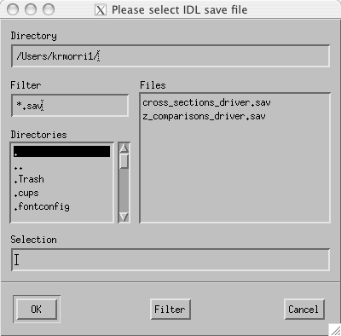

Figure 1. File selector for choosing as IDL 'save' file to be executed in IDL's Virtual Machine mode.

## Starting cross_sections_driver (in IDL command-line mode, or in IDLDE)

Start IDL (either command-line mode or Development Environment [IDLDE]), using the procedures specific to your operating system. At the IDL prompt (e.g., IDL> ), change the current directory to the one where the **cross_sections_driver.sav** file is located (the quotes in the example commands are required). For example, if the .sav file is located in the /Users/Chuck/IDL_Save_Files directory, enter the following command at the IDL prompt and hit return:

IDL> cd, ‘/Users/Chuck/IDL_Save_Files’

Then ‘restore’ the saved binary procedure so that it can be run:

IDL> restore, ‘cross_sections_driver.pro’

Note that the path and file name are required to be enclosed in quotes as in the preceding commands, and both names are case-sensitive. To run the procedure, enter its name (without the “.sav” extension) at the IDL prompt:

IDL> cross_sections_driver

and hit Return. If all is well the wrapper program should then start and the control file selector user interface should appear and the analyst will be prompted to select the control file, as shown in Fig. 2. Otherwise, edit the Directory and/or Filter fields in the file selector as needed and click ‘Filter’, until the control files appear in the select list. Select the desired control file and click OK to start the cross sections analysis program.

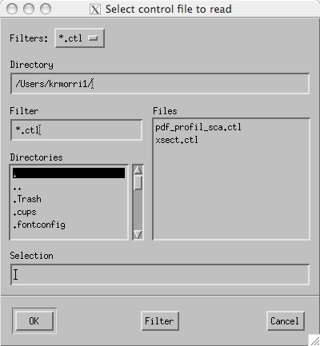

Figure 2. File selector to allow selection of the control file for a run of the cross sections wrapper program, *cross_sections_driver*.

## The Vertical Cross Section Analysis Procedure

Once a control file has been selected and read in by **cross_sections_driver**, the cross sections analysis procedure itself (either **pr_and_geo_match_x_sections** or **dpr_and_geo_match_x_sections**) is started. This occurrence is transparent to the user, other than to note that the interfaces shown in Figs. 1 and 2 only apply if starting from the **cross_sections_driver** wrapper procedure.

Once the analysis procedure itself starts the data file selector user interface should appear and be populated with the list of geo_match netCDF files, as shown in Fig. 3. By fixed convention, the geo-match netCDF file names from the TRMM PR are prefixed by “GRtoPR”, those from the GPM DPR (2ADPR, 2Aka, or 2AKu) are prefixed by “GRtoDPR”, and those from the GPM 2B-DPRGMI product are prefixed by “GRtoDPRGMI”. If the NCPATH and SITE keywords are correctly specified, one or more data files should appear in the file select list. Otherwise, edit the Directory and/or Filter fields in the file selector as needed and click ‘Filter’, until the desired data files appear in the select list. Select the desired data file name and click OK to perform the cross section analysis of the selected data set, or Cancel to quit the program.

**NOTE:** The Data File Selector will not appear if the NO_PROMPT keyword is set to 1 (On); instead, the first geo-match file matching the NCPATH and SITE filename criteria will be selected and displayed (Section 5.1). See NO_PROMPT description in the SYNOPSIS section.

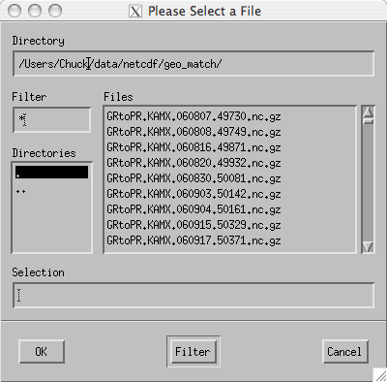

Figure 3. File selector for geometry-matched netCDF files.

## The SHOW_ORIG Option and Program Startup

If the SHOW_ORIG keyword is set to 1 (ON), then the procedure will attempt to access the PR 2A-25 product file (or GPM 2AKa, 2AKu, 2ADPR, or 2BDPRGMI file) that corresponds to the geometry-match netCDF file selected, so that matching cross section plots of full-vertical-resolution PR data (e.g., Figs. 9 a,b) or DPR data also may be displayed. The PRPATH parameter normally points to the common directory above the /2A25 directory where these files are located, so the program will search the directory PRPATH/2A25 for the matching 2A25 file, using a set of best guess values for the file name. The program will automatically look for the 2A25 file of the same PR version (6 or 7) or GPM file of the same version (e.g., V05A) as the geo-match data file.

Note that prior to the GPM era, the PR 2A25 files for all versions, orbits, and orbit subsets were stored in a single subdirectory named for the product type (i.e., /2A25). In the GPM era both TRMM PR and GPM DPR files are stored in a hierarchical file directory structure broken out by date, type, version, subset, etc. Refer to Section 4 of the *GPM Validation Network Data User’s Guide, Volume 2 - GPM Data Products* for detailed descriptions of data directory structures and file naming conventions.

If the procedure is unable to find a matching 2A25 product file, then it will display a product selector (Figure 4) to allow the user to select the correct 2A25 file. If the PRPATH value is correctly specified, one or more 2A25 data files should appear in the file select list. Otherwise, edit the Directory and/or Filter fields in the file selector as needed and click ‘Filter’, until the desired 2A25 data files appear in the select list. Select the correct 2A25 data file name and click OK to include full-resolution PR data plots in the cross section analysis of the selected data set. If the SHOW_ORIG keyword parameter is set to 1 (ON) and the 2A25 data file cannot be found automatically or no 2A25 file is manually selected, then the procedure will report an error and will proceed with the SHOW_ORIG parameter overridden to ‘OFF’ (SHOW_ORIG=0), without displaying the full-resolution PR 2A-25 cross section plots.

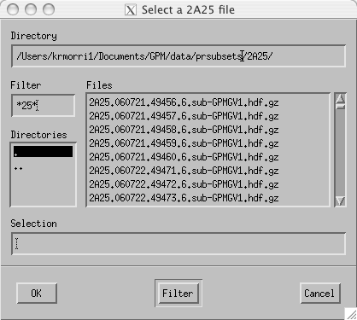

Figure 4. File selector for PR 2A-25 product files. This window only appears when the option SHOW_ORIG=1 is in effect, and either the procedure cannot find a matching PR 2A-25 file for the currently selected geometry-match netCDF file (Fig. 3), or PRPATH is set to the special value ‘prompt’ (PRPATH=’prompt’).

Note that there is one special value that may be assigned to PRPATH. If PRPATH is set to the literal value ‘prompt’ (**PRPATH=’prompt’**), this will force the 2A25 File Selector (Fig. 4) to be displayed when SHOW_ORIG is set to 1 (ON). The file selector will show the current working directory in the Directory field. As described above, the user may then edit the Directory and/or Filter fields in the file selector as needed and click ‘Filter’, until the desired data files appear in the select list. Clicking Cancel at this point will cause the program to proceed without attempting to produce full-resolution PR 2A-25 data plots, as if SHOW_ORIG is set to OFF (SHOW_ORIG=0). This option should be necessary only when the 2A25 file names do not follow the standard naming convention.

If not specified in the control file or on the command line, ***the SHOW_ORIG parameter is set to 0 (OFF) by default***, meaning the program will NOT attempt to plot the full-resolution PR or DPR 2A-xxx cross section plots.

# PROGRAM OUTPUTS

## The Cross-Section Selection Window

Once the file(s) have been selected from the list in the File Selector(s), a pair of PPI images of the PR and GR volume-matched data in the netCDF file will be displayed (Fig. 5). The data and features shown depend on the value of the parameters ELEV2SHOW, CREF, PCT_ABV_THRESH, and HIDE_RNTYPE, as follows:

* If ELEV2SHOW is unspecified and CREF is unspecified or OFF (=0), then the elevation angle that will be plotted in the PPIs will be for the sweep approximately 1/3 of the way up in the sequence of elevations in the GR volume scan, which is the 3.3 degree elevation sweep in the case shown in Fig. 5.
* If ELEV2SHOW=N is specified and CREF is unspecified or OFF (=0), then the Nth sweep in the GR volume scan will be shown in the PPIs.
* If CREF is set to ON (=1), then regardless of the value of ELEV2SHOW, the PPI will show a composite of the maximum reflectivity over all the elevation sweeps, evaluated on a ray-by-ray basis.
* By default, when HIDE_RNTYPE is unspecified or OFF (=0), areas indicated as Stratiform rain type are shown on the PPIs with a horizontally-oriented line pattern, and areas of Convective rain type are shown with a vertical line pattern. Samples where the rain type is Unknown/Other are plotted with solid fill.
* When HIDE_RNTYPE is ON (=1), then all samples are plotted with solid fill, regardless of their associated rain type.
* Samples where a pattern or black polygon appears but no color is shown indicate either: (1) a PR ray position where no valid reflectivity value is present at the displayed elevation, or (2) a sample with a valid reflectivity value, but either or both of the PR and GR data within the sample volume are below the “percent complete” criterion defined by the PCT_ABV_THRESH keyword parameter, when a non-zero percent threshold is specified.

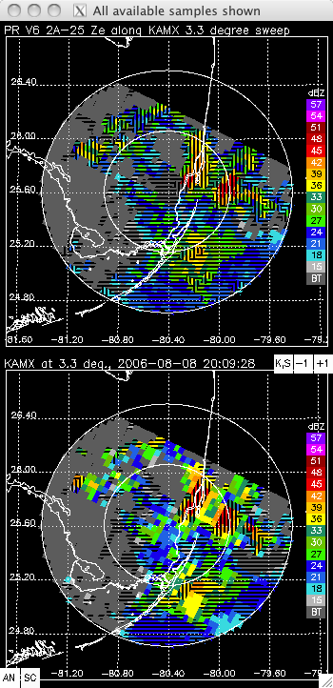

Figure 5. PPIs of PR (upper) and GR (lower) volume-matched reflectivity, used for selecting cross section locations. All available samples are shown in this example (i.e., PCT_ABV_THRESH=0), with default hatching to indicate PR and GR rain type (HIDE_RNTYPE=0), for a fixed elevation sweep (CREF unspecified or set to 0 to show data at a single elevation sweep indicated by ELEV2SHOW, not a composite of maximum reflectivity over all sweeps). The patterned areas without color assignments show the locations of PR rays without valid volume-match data for this particular sweep elevation, but where valid data exist along the ray at another sweep elevation. Hatch patterns for rain type are: Vertical=Convective, Horizontal=Stratiform, None=Other/Unknown.

To display a cross section, select a desired feature on either of the PPI images with the cursor, and click the left mouse button. A line labeled A-B (by default) will be drawn along the PR scan line through the selected point on the PPIs (Fig. 6), and vertical cross sections of geometry-matched PR and GR data will be displayed in a separate window, as shown in Fig. 7. Note that the PPI images use a different color table than the geometry-match cross sections. The color table of the PPIs aggregates the data into 5 dBZ steps, which is not suitable for viewing small gradations or differences between reflectivity of the matching PR and GR volumes. The cross sections use a smoothly varying color table that shows variations of 1 dBZ or more between displayed volumes.

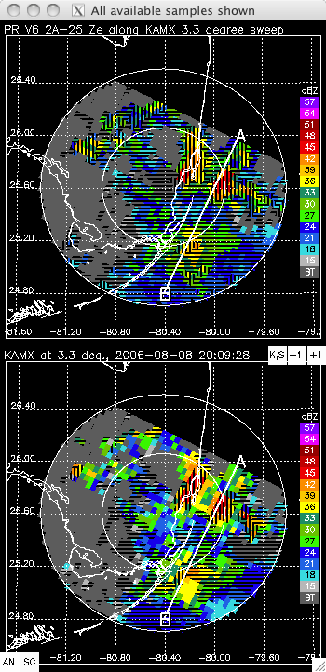

Figure 6. As in Fig. 5, but following user selection of a location for a cross section. Additional options affecting the appearance of this graphic are LABEL_BY_RAYNUM=0 (label first/last ray endpoints along the selected scan with ‘A’ and ‘B’, not actual ray numbers).

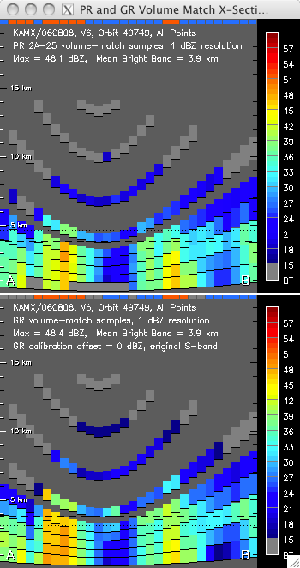

Geometry-Match Cross Section Plot Features (default case):

1. PR-indicated rain type: Orange=Convective, Blue=Stratiform, Gray=Other, Black=No Data. Located in band along top of PR cross section (upper plot)
2. Mean bright band height (heavy dashed line) and +/-750m area of BB influence (dotted lines)
3. Cross section A-B endpoints as shown on selector PPIs, at bottom corner of each cross section. Point A is always the lower ray number end of the PR scan line shown in cross section, and is always plotted on the left (i.e., PR ray number of the scan increases from left to right)
4. GR-indicated rain type (in development). Same color definitions as PR rain type. Located in band along top of GR cross section (lower plot)
5. Reflectivity color scale, 15-59 dBZ, 1 dBZ color steps. BT=below threshold
6. Height above ground level, 1‑km ticks on left and right edges of cross sections, labeled each 5 km on left side

Figure 7. Vertical cross sections of geometry-matched PR (top) and GR (bottom) data along the PR scan line through the user-selected location, with all relevant parameters set to their default values. All available samples are shown in this example (i.e., PCT_ABV_THRESH=0). Each column represents one PR ray. The graphic is configured to plot the rays between points A and B across the full width of the cross section window in the default manner (ZOOMH=2). Each parabolic-shaped band of data represents a PR scan’s slice through a GR sweep at constant elevation angle (i.e., a conical surface). Samples that overlap in the vertical are split at the midpoint of the overlap for plotting.

## The Geometry-Match Cross Section Displays

### PR and GR Reflectivity

Figure 7 shows a PR and GR geometry-match cross section pair for the cross section location selected for Fig. 6, with all display options set to their default values. The vertical tick marks on either side of the cross section plots show the height above the surface in 1-km steps. The cross section height range is from 0 to 20 km, and major tick marks are at 5, 10, and 15 km. The displayed width of the cross sections is quasi-fixed so that the plots are approximately square. Each column of data in the cross section shows one PR ray along the PR scan line being plotted, and represents approximately 5 km in the horizontal. By default (ZOOMH=2), the displayed width of each PR ray is adjusted on the plot such that PR rays between points A and B on the PPI fill the entire width of the cross section plot, and the approximately square aspect ratio of the plot is maintained. Where sample volumes along a given ray overlap in the vertical, the samples are divided at the midpoint of the overlapping area for display purposes, and a 1-pixel-deep delimiter is plotted on the image between overlapping or touching volumes to indicate the division between elevation sweeps.

The orientation of the cross section relative to the PPIs is indicated by the letters A and B (by default, when LABEL_BY_RAYNUM=0) plotted on the cross section and the PPIs. The A-B line and the cross sections are always plotted in terms of ascending ray number along the PR scan, with the lowest ray number at the “A” side. The actual PR ray numbers at the two endpoints are plotted on the PPIs and cross sections in place of the fixed values “A” and “B” when LABEL_BY_RAYNUM is set to ON (=1). PR ray numbers can range from 1 to 49.

The heavy dashed horizontal line in the vertical cross section plots indicates the mean height of the bright band, as indicated in the PR level 2 product. Light dotted lines are plotted 750 m above and 750 m below the mean bright band (using the default value of BBWIDTH=0.75 [km]). Any samples touching or falling in the layer between these two heights are considered to be affected by the bright band in statistical analyses of the volume-matched data. Those samples completely above the upper line are considered to be above bright band in the statistics, and those below the lower line are placed in the below bright band category. Note that the plotted samples may have been truncated in the vertical for display purposes where sample overlap occurs, but no truncation of top or bottom heights is performed when assigning samples to bright band proximity categories. Thus, a sample which appears to be completely above or below the bright band layer on the cross section plot may actually be assigned to the bright-band-affected category in the statistical tabulations. In order to see which samples are considered to be affected by the bright band, set the parameter PLOTBBSEP=1 and heavy dark lines will be plotted to demarcate the top and bottom of the affected samples in each ray.

### PR-GR Reflectivity Difference

A PR-GR difference field will be computed for the selected cross section and displayed in a separate window, as seen in Figure 8. The difference field uses a unique color table, where the warm colors (red, orange, yellow) indicate relatively ‘hot’ GR radar reflectivity samples (PR<GR), and cool colors (green, blue, violet) indicate ‘cool’ GR radar samples (PR>GR). Samples plotted in white are where PR and GR reflectivity are within 0.5 dBZ of each other.

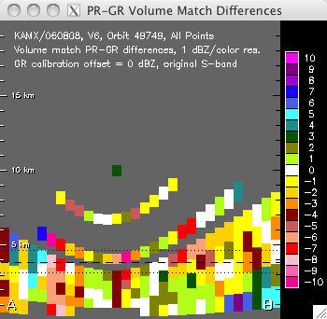

Figure 8. Cross section of PR-GR reflectivity difference (dBZ) from volume-matched data, for the case shown in Fig. 7.

PR-GR reflectivity mean differences are computed for the data in the difference field and output to the terminal (IDL command-line) or the IDLDE Console. Separate statistics are computed for points above, within, and below the bright band (melting layer). Example output for the data in Figs. 7 and 8 is shown in the following:

Product-relative scan number: 491

PR ray number: 4

ray start, end: 1 30

Current GR offset = 0.00000 dBZ

Cross Section PR-GR Mean Differences Above, Within, Below Bright Band:

-0.703722 -0.986910 0.280412

Number of Cross Section Samples Above, Within, Below Bright Band:

35 64 77

Information on the selected cross section location in terms of the PR 2A-25 product coordinates (PR ray and scan numbers), as shown in the first 3 lines in the example output, will be output only when the VERBOSE keyword option is set (VERBOSE=1). For the data displayed in the examples of Figs. 6-8, the user has clicked on ray number 4 along PR scan number 491 (relative to the first PR scan included in the data file, not to the first scan in the TRMM orbit), and rays 1 through 30 of this scan lie in the PR/GR overlap area and are plotted in the resulting cross sections.

## Full-Resolution PR and DPR Reflectivity Cross Sections

If the PR 2A-25 (for PR) or DPR 2A-DPR, 2A-Ka, or 2A-Ku (for DPR) product files are available on the local host and the SHOW_ORIG keyword is set to 1, then a second pair of vertical cross sections showing the full-vertical-resolution PR or DPR reflectivity data will be plotted in a separate display window (Fig. 9a). The upper panel in this set of cross sections shows the full (250 or 125 m) vertical resolution PR/DPR data displayed using the same color scheme as the PPI images (Figs. 5 and 6), with 5-dBZ color steps. The lower panel shows the same data displayed using the smoothed color table of the cross section plots of the volume-match PR and GR data as shown in Fig. 7, with a 1-dBZ resolution.

The full-resolution PR cross sections are not limited to only those points with data in the geometry-matching data. All PR gates with valid data along the PR ray are shown in the full-resolution PR cross sections (Fig. 9a), while the geometry-matched data (Fig. 7) exist, and are shown, only at locations where the PR rays intersect the GR elevation sweeps, which are typically discontinuous in the vertical and have a ‘cone of silence’ centered above the GR radar. Note the blanking of ground-clutter-affected, near-surface PR bins in the 2A-25 data cross sections, and its increasing height above surface at ray angles further from the nadir ray (i.e., nearer the point labeled “A”, which is ray 0 along the PR scan, ~17 degrees from nadir).

Figure 9b shows the affect of setting the BBBYRAY keyword parameter to ON (BBBYRAY=1). In this figure, the ray-by-ray PR estimates of the bright band height are plotted as individual line segments in each ray column, in black in the upper panel with the PPI color scale, and in white in the lower panel with the continuous color scale.

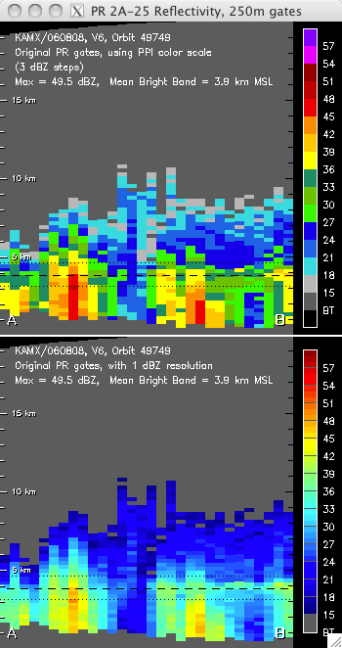

Figure 9a. Vertical cross section of full-vertical-resolution (250 m) PR reflectivity data from the original, unaveraged 2A-25 attenuation-corrected reflectivity, for the case shown in Figs. 6-8. The same data are plotted in both panels – only the color table differs between the two. The BBBYRAY keyword parameter is set to OFF, so only the domain-average bright band height line is plotted.

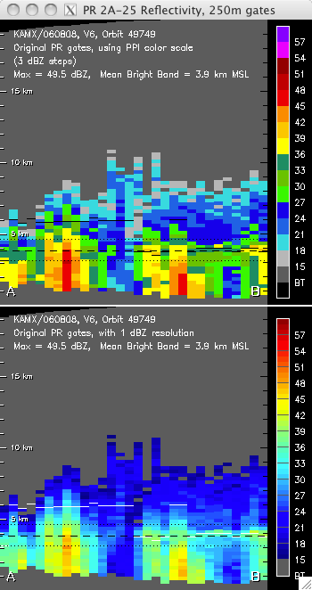

**Figure 9b.** As in Fig. 9a, but with the BBBYRAY=1 keyword option specified. Note how the ray-specific bright band heights, shown as short black (white) line segments in the upper (lower) panel cluster near the mean bright band height in the stratiform rain areas where an obvious bright band is seen in the cross section profile. Outlier bright band heights in the convective regions are excluded from the mean bright band height calculations in those cases where sufficient points with good bright band heights in stratiform regions exist in the data.

## Interactions With The PPI Display

### Select A New Cross Section Location

The A-B line on Fig. 6, and the cross section displays of Figs. 7-9 are updated each time the user selects a new point on the PPIs (Fig. 6), as long as the cursor is clicked within the PR/GR overlap area in the PPIs (dark gray or colored areas) using the left mouse button. To exit the current case and allow selection of the next case, right-click the mouse with the cursor positioned the within the overlap area.

### Automatically Step Through All PR Scans

Clicking on the small white square labeled “SC” in the lower left of the GR PPI plot (Fig. 5 or 6) will cause the program to automatically select each PR scan in the overlap area on the PPI in sequence and display the cross sections for that scan as the A-B line advances across the PPI images. The auto-scan feature operates in two distinct modes depending on the state of the GIF_PATH parameter.

First (GIF output) mode: If GIF_PATH is specified, the auto-scan will rapidly step through each PR or DPR scan in the matchup data (temporarily overriding the PAUSE value), display its location and geometry-match cross section briefly in a merged PPI/cross section window (Fig. 10), and write the displayed data in this window to a new frame of a animated GIF file created in the directory defined by the GIF_PATH value. The GIF file name will be automatically formatted using a combination of fields from the netCDF matchup file and the display options in effect, and will be listed in the terminal output. No user interaction with the cross section data will be possible during the auto-scan sequence in this mode. ***The only way to disable this mode of auto-scan is to restart the cross section program with the GIF_PATH parameter disabled (left unspecified, or with its value assigned to the empty string: GIF_PATH=’’).***

Second (interactive) mode: If GIF_PATH is not specified, then once the user clicks on the “SC” label a new window with the PPI cross section locator panel merged with the corresponding PR and GR geometry-match cross section display (Fig. 10), PR-GR cross section differences display (e.g., Fig. 8), and (if SHOW_ORIG is set) the full-resolution PR/DPR cross section plot (Fig. 9a or 9b) will appear, with the cross section line positioned along the first PR/DPR scan in the matchup dataset. At this point, the cursor control in the original PPI plots will be disabled and the user will be presented with a number of command-line options in the terminal or IDLDE window:

Stepping through cross sections of each PR scan in matchup dataset

Hit Return key to do next scan,

Enter A to step through All scans without prompt,

Enter B to step Back one scan,

Enter J to Jump forward 10 scans,

or Enter Q to Quit:

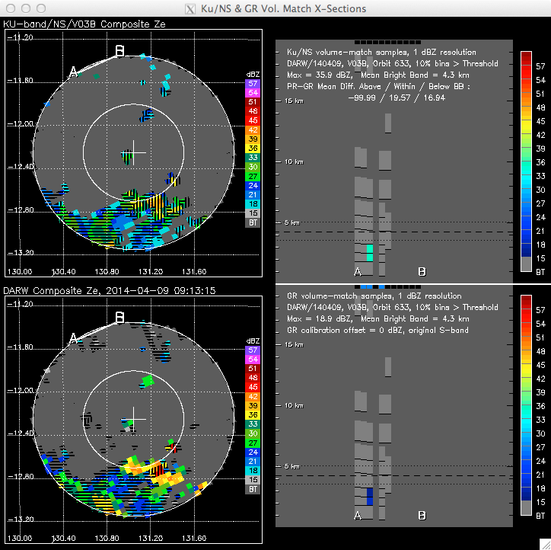

**Figure 10.** Merged PPI cross section locator plots and (D)PR and GR cross section plots for automatically displaying a sequence of cross sections for each (D)PR scan in the geometry-match dataset. Plots are positioned at the first scan in the dataset and while the program waits for a keyboard command from the user. PPI plots show the case where the CREF parameter is set to ON. Example shows DPR-GR matchups made using a 2A-Ku product as the source of the DPR data.

The displays will then take the action defined by the user’s entry on the keyboard. Once the user quits or the sequence reaches the last scan in the dataset, control returns to the cursor and the original PPI pair (Fig. 5 or 6). If the “A” (automatically step through all scans) option is selected, the amount of time each cross section is displayed before advancing to the next scan is controlled by the PAUSE parameter, which specifies the dwell time in fractional seconds. The default value for PAUSE is 1.0 seconds, if a different value is not specified in the control file or the command line. ***The PAUSE value also applies to the dwell time between frames of any animated GIF file created via the auto-scan function.*** All options in effect at the time the sequence is started (Ku adjustment, GR offsets) will stay in effect in the automatic step-through and/or GIF file creation, with the exception of the ZOOMH parameter. If ZOOMH is specified as 2 it will be overridden to a value of 1 while the sequence is running so that all PR rays retain the same plotted width and fixed locations based on the PR ray numbers.

Alternate Scan Step Types: When displaying cross sections of DPR or DPRGMI data, there are two other possibilities for how the program can manually or automatically step through the dataset. If RHI_MODE is set (Section 5.7), then the program will step in a clockwise direction through a sequence of radial lines extending from the ground radar to the edge of the data coverage. If RAY_MODE is in effect (Section 5.8) then the program will step through a series of lines along a constant ray number (DPR scan angle) in ascending ray number, perpendicular to the default mode of stepping through the DPR scan lines. In any of the three scan step types the same rules for manual and automatic scan stepping described under the previous headings apply.

### Start a PPI Animation Loop

Clicking on the small white square labeled “AN” in the lower left of the GR PPI plot (Fig. 5 or 6) will launch another IDL procedure that will create an animation loop of the PPIs in a new window. This animation loop will contain a sequence of PPI images in the following order:

1. Volume-match PR PPI at the level of the first elevation sweep
2. Volume-match GR PPI at the level of the first elevation sweep
3. As in (1), but for the second elevation sweep
4. As in (2), but for the second elevation sweep

.

.

.

2*N–1) Volume-match PR PPI for the Nth elevation sweep

2*N) Volume-match GR PPI for the Nth elevation sweep

Figures 11 and 12 show examples of PR and GR PPI animation frames in the animation loop for the same case as Fig. 5. Note that the GR PPI plot title indicates the time difference between the PR overpass and the GR sweep begin time.

The user can let the animation run on its own, but it is more useful to pause the animation, click on the slider bar, and then use the arrow keys on the keyboard to manually toggle between adjacent frames to check the alignment of the echoes between the PR and GR volume-matched data. This capability permits an analyst to make a subjective determination about the quality of the geometric alignment between the two data sources to decide whether the PR-GR values in the difference cross section represents calibration and/or measurement differences between the two data types, or is due to a misalignment or an excessive time difference between the two data sources.

The number of elevation sweeps included in the animation sequence is twice the sweep number specified in the ELEV2SHOW parameter or the number of sweeps in the volume, whichever is less; or is computed internally as the default value equal to two-thirds of the available sweeps if ELEV2SHOW is not specified.

If the original Universal Format (UF) file containing the GR radar volume for the displayed case is available and located under the directory pointed to by the UFPATH keyword parameter, then the animation sequence will interleave a plot of the full resolution GR radar PPI for each displayed sweep in the animation sequence. There will then be four PPIs displayed for each elevation sweep, in the following order:

1. Volume-match PR PPI at the level of the elevation sweep (Fig. 11)
2. Full-resolution GR PPI at the level of the elevation sweep (Fig. 13)
3. Volume-match GR PPI at the level of the elevation sweep (Fig. 12)
4. The PR PPI of item (1), repeated in the sequence (Fig. 11)

This sequence is then repeated for each elevation sweep to be displayed. This allows one to toggle back and forth between each of the data types: the volume-matched PR and full-resolution GR; the volume-matched and full-resolution GR; and the volume-matched PR and volume-matched GR.

***While the animation window is present it takes over the cursor focus and no interaction with the other PPI or cross section windows is possible. The animation window must be closed in order to select a new cross section location or a new case.***

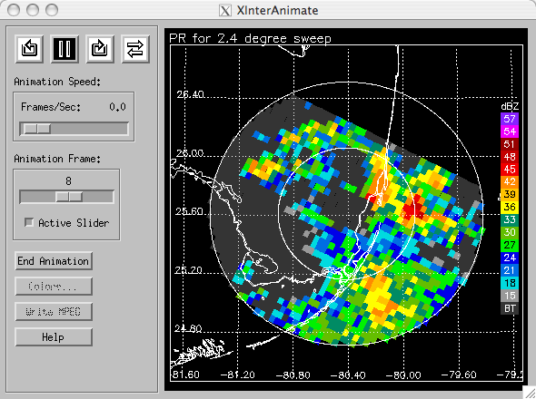

Figure 11. One PR frame of a PR and GR animation loop, showing volume-matched PR data corresponding to the 2.4 degree elevation sweep of the GR radar.

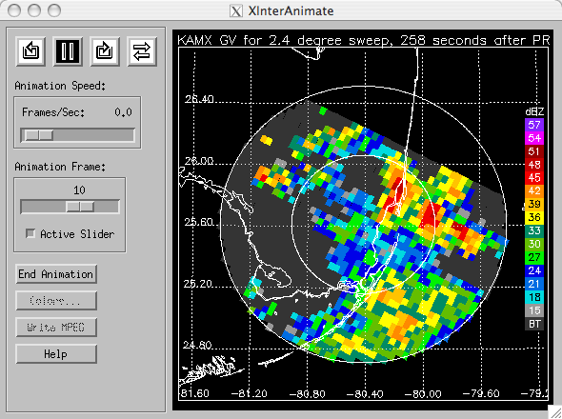

Figure 12. As in Fig. 11, but for volume-matched GR data. The time difference between the PR overpass and the GR radar sweep begin time is indicated in the plot title.

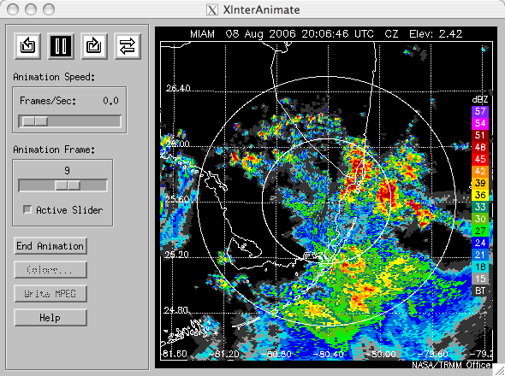

Figure 13. The full-resolution GR PPI plotted from the original UF radar data file. If the UF data file is available, these PPIs are interleaved with corresponding PPIs of PR and GR volume-matched data (Figs. 11 and 12) in the animation loop.

### CAPPI Option for Animation Loops

When displaying loops of geometry-matched DPR or DPRGMI data, then setting the **CAPPI_ANIM** keyword option to ON (=1) allows CAPPI (Constant Altitude PPI) images of geometry-matched DPR and ground radar (GR) data to be displayed in place of the default PPI images which are for constant GR sweep elevation angle. The altitudes at which CAPPI images will be generated is set internal to the code at this time, and includes the following heights in km:

1.5, 3.0, 4.5, 6.0, 7.5, 9.0, 10.5, 12.0, 13.5, 15.0, 16.5, 18.0, 19.5

The full-resolution GR data images will not be included in the animation sequence in CAPPI mode regardless of whether the original GR UF data file can be located, so the sequence of CAPPI images is always as follows:

1. Volume-match PR CAPPI at the first height level
2. Volume-match GR CAPPI at the first height level
3. As in (1), but for the second height level
4. As in (2), but for the second height level

.

.

.

2*N–1) Volume-match PR CAPPI for the Nth height level

2*N) Volume-match GR CAPPI for the Nth height level

The CAPPI_ANIM keyword and related functionality does not apply to the GRtoPR (TRMM PR) matchup data type.

### Apply S-band to Ku-band Frequency Adjustment to GR Reflectivity

The Liao and Meneghini (2009) S-band to Ku-band frequency adjustments account for the differences in reflectivity factor that occur when the same rain or snow targets are observed by S- and Ku-band radars. The snow correction is applied to data above the bright band, and the rain correction is applied to the data samples below the bright band. As a general rule, ice-phase GR reflectivity values (above bright band) are lowered by the S-to-Ku adjustment, and rain-phase GR reflectivity values (below bright band) are raised. The magnitude of the adjustment increases with increasing dBZ values.

The S-to-Ku adjustments to the GR data are toggled on and off by clicking on the white box labeled “**K,S**” on the GR PPI plots in the cross-section location selection window (Figs. 5 and 6). Figure 14 shows the PR-GR reflectivity difference cross section plot for same case as in Fig. 8, but with the S-to-Ku frequency adjustments applied to the GR data. Once a frequency correction state (On or Off) has been applied, it will automatically be applied to each new cross section location selected for the current case (current matchup netCDF file). If a different data file is selected, the frequency adjustment state will be initialized to Off (i.e., original S-band reflectivity values) for its cross section selections.

***The procedure does no validity checking on whether the GR data to which the adjustment is being applied are actually S-band ground radar data.*** It is up to the user to decide whether or not to apply the pre-programmed frequency adjustments.

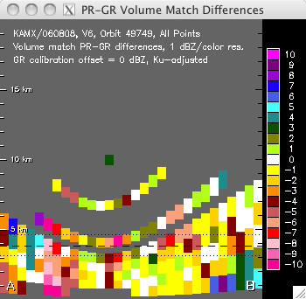

Figure 14. As in Fig. 8, but with S-to-Ku frequency adjustments applied to GR reflectivity.

### Apply a Calibration Adjustment to GR Reflectivity

A calibration offset may be applied to the GR reflectivity by clicking on the white boxes with the **+** and **–** signs on the GR PPI plots in the cross-section location selection window (Figs. 5 and 6). Once a set of cross-sections has been displayed, clicking on the **+** or **–** sign will apply a +1 or -1 dBZ offset to the GR reflectivity and re-draw the existing cross section plots with the calibration offset applied. Both the GR cross section (lower panel in Figure 7) and the PR-GR difference cross section (Figure 8) will be redrawn with the GR offset applied. The GR PPI plot does not change. The effect is cumulative, so that each time a box is clicked the GR offset increases or decreases by 1 dBZ and the existing cross sections are redrawn. Figures 14 and 15 show a difference cross section for the KGRK radar, which at times had a 2-3 dBZ low bias compared to the PR. Figure 15 shows the difference cross section with no GR correction, and Fig. 16 shows the same cross section with a +2 dBZ offset applied to the GR, to bring the above-bright-band differences to near zero.

Once an offset has been applied, it will automatically be applied to each new cross section location selected for the current case (current geo-matchup netCDF file). If a different data file is selected, the offset will be reinitialized to zero for its cross section selections.

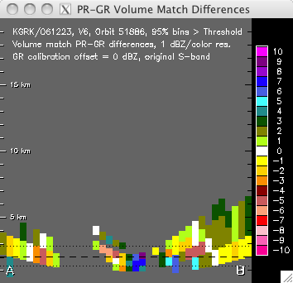

Figure 15. PR-GR reflectivity difference cross section for the KGRK WSR-88D radar with 0 dBZ GR offset. Note that these data are from a different date and site than for other figures in this document.

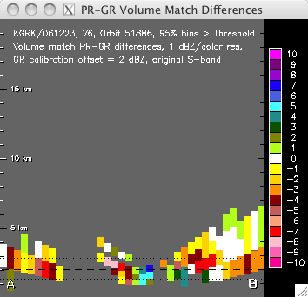

Figure 16. As in Fig. 15, but with a +2 dBZ calibration correction to the GR reflectivity.

## Constraining Data Quality

Each geometry-match data volume represents an average of the full-resolution radar bins within the 3-D volume defined by the geometric intersection of a PR ray and a GR elevation sweep. PR data are averaged in the vertical along a ray, between the top and bottom of its intersection with a GR sweep. GR data are averaged in the horizontal, over the area of a PR footprint. Each PR and GR geo-match sample carries a value indicating the number of full-resolution radar bins *expected* to be included in the volume average from a geometric standpoint (n_pr_expected for PR, n_gv_expected for GR), and another value that indicates the number of “below threshold” bins (n_2a25_rejected for PR, n_gv_rejected for GR) within the 3-D volume averages. Below-threshold bins are those geometrically within the 3-D volume to be averaged, but whose reflectivity values are below the fixed detection thresholds of 18.0 dBZ for the PR, and 15.0 dBZ for the GR. These fixed thresholds are set in the code that performs the geometry matching (POLAR2PR procedure). 18.0 dBZ is considered to be the minimum reflectivity detection threshold for the PR instrument, and any PR bins below this threshold are excluded from the PR volume averages. It is recognized that GR reflectivity for most ground radars is generally accurate to 0 dBZ or less, but to avoid biasing PR against GR at the lower reflectivity values, a 15.0 dBZ matching detection threshold is applied to the GR. This allows for a fair comparison of PR and GR for all cases where a ground radar calibration is no more than 3 dBZ too low. Only GR bins with values of 0 dBZ or less are actually excluded from the GR volume averages.

Then, for a given PCT_ABV_THRESH parameter value, only those points where the following two criteria are met will be included in the analysis:

100*( n_pr_expected - n_2a25_rejected) / n_pr_expected ≥ PCT_ABV_THRESH

100*( n_gv_expected - n_gv_rejected) / n_gv_expected ≥ PCT_ABV_THRESH

In other words, if PCT_ABV_THRESH = 95 is specified, then a data sample will be included in the analysis displays only if at least 95% of the original-resolution PR bins included in the PR volume average were 18 dBZ or greater, and at least 95% of the full-resolution GR bins included in the GR volume average were 15.0 dBZ or greater. Application of this percentage-above-threshold constraint is an attempt to limit the comparisons to points where partial beam filling of the sample volumes and biases due to the reflectivity detection cutoff of the PR are not an issue.

Figure 17 shows the PR and GR PPIs of Fig. 5, and Figures 18 and 19 show the PR and GR volume-match data cross sections of Fig. 7 and 8, but under the constraint that the displayed samples are at least 95% above threshold.

There is currently no objective mechanism for constraining or validating the quality of the matchup geometry (echo offsets between the PR and GR radars). The PPI animation loops provide a mechanism for subjective evaluation of the matchup geometry.

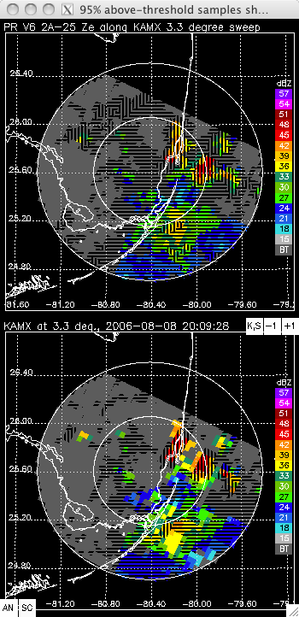

Figure 17. As in Fig. 5, but where the displayed volumes have been constrained to those where at least 95% of the bins included in the PR and GR volume averages met their reflectivity threshold values. The patterned areas without color assignments show the locations of points not meeting the completeness criteria and/or not having valid data for this sweep elevation.

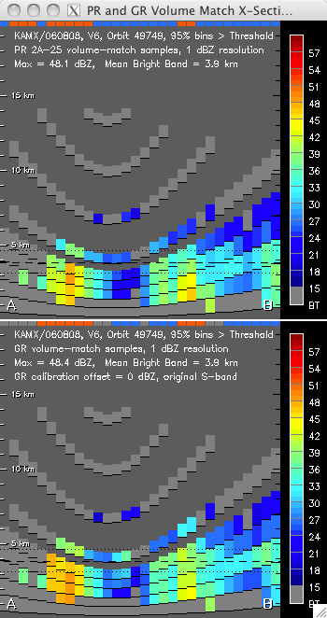

Figure 18. As in Figure 7, but limited to those samples where at least 95% of the PR and GR bins in the volume averages meet the reflectivity thresholds.

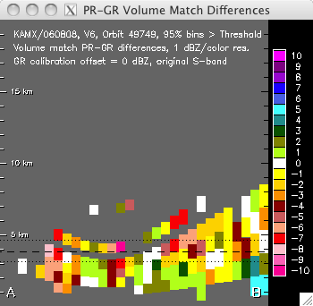

Figure 19. As in Fig. 8, but limited to those samples where at least 95% of the PR and GR bins in the volume averages meet the reflectivity thresholds.

## Apply Bias Adjustments to GR and DPR Reflectivity

The optional keyword parameters DPR_Z_ADJUST and GR_Z_ADJUST allow offsets to reflectivity values to be applied **additively** to the DPR and GR reflectivity values prior to their analysis and plotting on the displays. DPR_Z_ADJUST is specified as a single numerical value, e.g.:

DPR_Z_ADJUST=-1.4

In this case, the DPR measured and corrected reflectivity would be reduced by 1.4 dBZ for all volume-match and original-resolution samples prior to analysis and display.

GR_Z_ADJUST specifies the full pathname to a delimited text file containing GR-site-specific bias corrections to be applied (added to) a ground radar site's reflectivity to account for the calibration difference between the DPR and ground radar in a site-specific sense. Each line of the text file lists one site identifier and its bias offset value separated by the delimiter, e.g.:

KMLB|2.89

KWAJ|-0.3

PAIH|1.7

If no matching entry is found in the file for the radar site, then the GR reflectivity is not changed from the values read from the matchup netCDF file. The site-specific GR bias adjustment is applied AFTER the frequency adjustment if the S2KU parameter is set.

Only those DPR and GR reflectivity values above 0.0 dBZ are affected by the bias adjustment. In no case is an above-zero reflectivity allowed to go below 0.0 by the bias adjustments. DPR_Z_ADJUST is constrained to be within the range from -3.0 to 3.0 dBZ. There is no limitation on bias adjustment values for the GR.

## Customizing the Displays with Optional Parameters

The contents and appearance of the cross section plots and the PPIs in the cross section selection window depend on several control parameters. Table 2 lists these parameters and the type(s) of display each parameter affects.

**Table 2. Mapping between displayed cross section components and keyword parameters affecting each display.**

|  |  |  |  |  |
| --- | --- | --- | --- | --- |
| **Keyword parameter** | **Selector PPIs** | **Geo-Match Cross Sections** | **Difference Cross Sections** | **Full-resolution PR/DPR x-sections** |
| PCT_ABV_THRESH | X | X | X |  |
| BBBYRAY |  |  |  | X |
| PLOTBBSEP |  | X |  |  |
| BBWIDTH |  | X | X | X |
| HIDE_RNTYPE | X | X |  |  |
| CREF | X |  |  |  |
| ZOOMH |  | X | X | X |
| LABEL_BY_RAYNUM | X | X | X | X |
| RHI_MODE | X | X | X | X |
| RAY_MODE | X | X | X | X |

The influence of PCT_ABV_THRESH on the displays has already been described and shown in a preceding section. Figure 20 shows the affects of turning on the options HIDE_RNTYPE, CREF, and LABEL_BY_RAYNUM on the PPIs and cross section location endpoint labels in the cross section selection window. Figure 21 shows the affects turning on these same parameters on the PR, GR and PR-GR geometry match cross sections, along with the affects of turning on PLOTBBSEP and setting the parameter BBWIDTH=0.5 to change the width of the bright band influence from +/‑750 m to +/‑500 m.

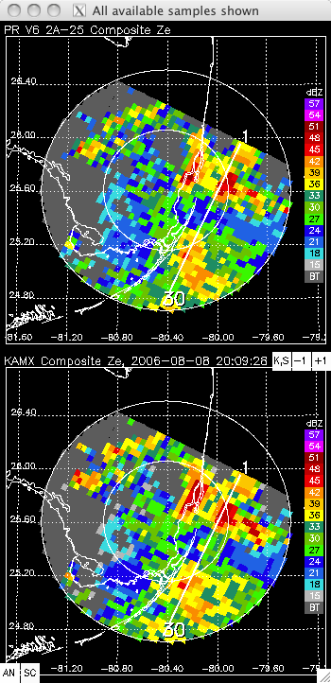

**Figure 20.** As in Fig. 5, but with the keyword options LABEL_BY_RAYNUM, HIDE_RNTYPE, and CREF set to ON. Note the endpoints of the cross section labeled with PR ray numbers 1 and 30 rather than A and B; lack of hatching (rain type hidden), and the presence of reflectivity values in areas that were below the 18 (PR) or 15 GR) dBZ threshold when only values from a single sweep were shown.

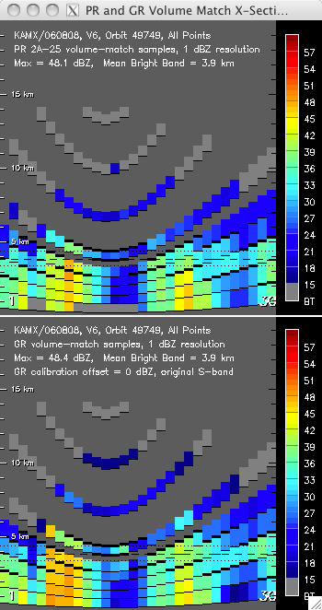

**Figure 21.** As in Fig. 7, but with the keyword options LABEL_BY_RAYNUM, HIDE_RNTYPE, and PLOTBBSEP set to ON, and setting the parameter BBWIDTH=0.5. Note the endpoints of the cross section labeled with PR ray numbers 1 and 30 rather than A and B; hiding of rain type indicator bars along the tops of the two cross sections; the narrower distance between the dotted lines around the mean bright band height line indicating a 500-m bright band half-width; and the dark bars delineating the highest and lowest bright-band-affected samples for each ray, based on a +/-500-m bright band depth of influence.

The effect of setting ZOOMH to its three different allowable values of 0 (size for all 49 rays), 1 (size for the scan with the most number of rays in the PR/GR overlap area; i.e., the “fattest” part of the PPI with geo-match data), and 2 (size to the number of rays in the selected scan to show in the cross section) is demonstrated in Fig. 22a-d. Figure 22a shows the selected cross section location on the PR PPI at a location away from the “fattest” part of the PR/GR data area, and Figs. 22b, 22c, and 22d show the resulting PR geometry match cross section plots at ZOOMH levels of 0, 1, and 2, respectively.

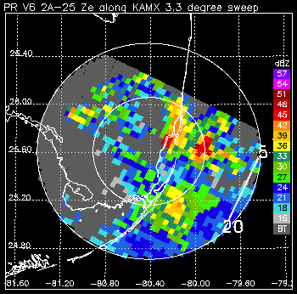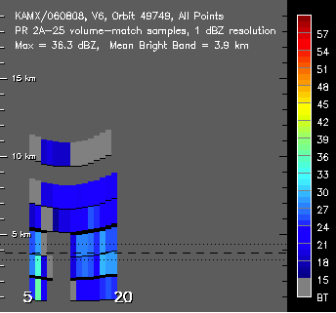

(a) (b)

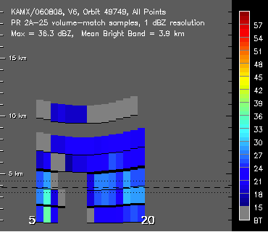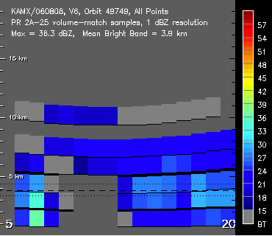

(c) (d)

**Figure 22.** Affect of varying ZOOMH parameter on plotted cross sections. Figure (a) shows the location of the cross section on a PPI of PR reflectivity. Figures (b), (c) and (d) show the resulting cross sections of PR geometry-match reflectivity at ZOOMH levels of 0, 1, and 2, respectively. At ZOOMH levels of 0 and 1 each ray is plotted with a fixed width and at a location determined by its ray number. At ZOOMH=2, the plotted width and location of the rays on the plots are configured to fill the width of the cross section window.

Figures 23a-d show the same results as Fig. 22, but for a cross-section at the widest part of the data area. Note that at this location, the cross sections for ZOOMH levels of 1 and 2 are the same, since both are configured for the same number of rays.

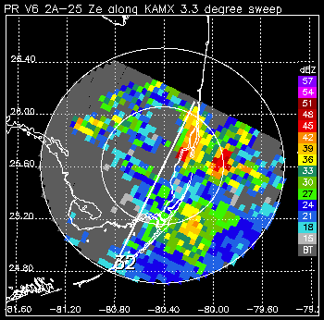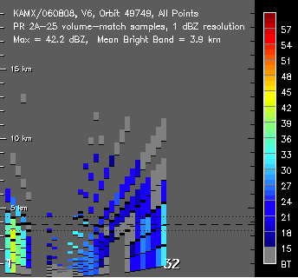

(a) (b)

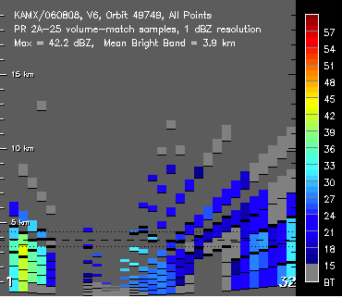

(c) (d)

**Figure 23.** As in Fig. 22, but for a cross section across the widest part of the PR/GR overlap area. Note that the cross sections at ZOOMH levels of 1 (Fig. 23c) and 2 (Fig. 23d) appear the same, since both are configured to fill the cross section with the number of rays (32) found at the widest part of the PR/GR data area, while the cross section at ZOOMH=0 (Fig. 23b) is configured to display all 49 rays of a PR scan. Note also that the plotted width of each ray at ZOOMH levels of 0 and 1 (panels b and c) are the same in both Fig. 22 and Fig. 23, with the plotted ray locations determined by ray number.

## RHI Cross Section Display Mode

If the RHI_MODE parameter is set to ON (RHI_MODE=1), then the method of determining the location of the cross section changes from selection of a PR or DPR scan line to selection of a radial line originating at the ground radar location and extending to the user-selected point to, at most, the edge of the matchup data. In this mode, the user clicks on a feature of interest in the PPI images and the program computes the radial angle of the line from the ground radar along which the cross section will be plotted. Figure 24 shows an example of the selection of a radial line in matchup data derived from the NASA NPOL radar scanning in RHI mode.

**Figure 24.** As in Fig. 5, but with the keyword options RHI_MODE set to ON, and showing 2A-DPR Ku NS scan data volume matched to NPOL ground radar running in RHI scan mode, for two discrete RHI scan regions. Note the endpoints of the cross sections with point “A” anchored at the ground radar and point “B” at the user-selected point at the edge of the data at a GR-relative azimuth of ~239 degrees.

All of the display customization and interactive functions are available in RHI mode except for the plotting of ray numbers at the endpoints of the cross section. The cross section of geometry-matched DPR and GR data for the radial line selected in Fig. 24 is shown in Fig. 25. Note the increase in vertical detail and resolution in Figure 25 compared to preceding figures (e.g., Fig. 21).

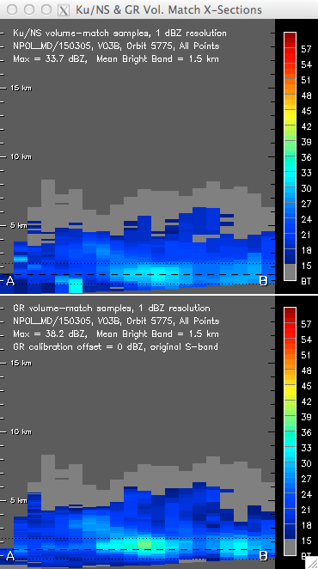**Figure 25.** Cross section plot of DPR (top) and GR (bottom) volume-matched data for the RHI mode cross section location shown in Fig. 24. Vertical overlap between sample volumes is suppressed in the plots. Example is for NPOL radar scanned in RHI mode.

## Constant PR/DPR Ray Number (Scan Angle) Mode

If the RAY_MODE binary keyword parameter is set to ON (RAY_MODE=1), then the method of determining the location of the cross section changes from selection of a PR or DPR scan line to selection of a line of constant PR/DPR ray number that is aligned perpendicular to the scan lines. In normal mode the PR and DPR scans 49 rays ranging between approximately -17 to +17 degrees from nadir, with the middle ray (number 25) looking straight down along nadir. So when a cross section is selected and generated for data having a fixed ray number, this corresponds to data with a fixed PR/DPR look angle, roughly parallel to the orbit track. Note that when both RHI_MODE and RAY_MODE are set to ON, RHI_MODE overrides the RAY_MODE setting and cross section selection is along a radial line. Figure 26 shows examples of the cross section location though the same selected point in normal mode (along a PR/DPR scan line) and in RAY_MODE (along a line of constant PR/DPR ray number).

Note that the DPR has two other scan modes (high-resolution scan, or HS; and matched scan, or MS) that have fewer DPR rays (24 for HS, 25 for MS) and scan over a narrower range of scan angles.

 

**Figure 26.**  Left panel: As in Fig. 5, but with the keyword options LABEL_BY_RAYNUM, HIDE_RNTYPE, and CREF set to ON. The DPR scan number (570) for the orbit subset area along which the cross section lies is indicated on the selector PPI plot. Right panel: As in left panel, but with the keyword option RAY_MODE set to ON. The DPR ray number (11) and associated scan angle with respect to the earth surface (79.4 deg.) are indicated on the PPI plots. In both panels the same cursor position was used to select the cross section location.

# RUNNING THE “RAW” CROSS SECTION ANALYSIS PROCEDURES

The **pr_and_geo_match_x_sections** and **dpr_and_geo_match_x_sections** procedures are the underlying procedures that provide all of the functional capabilities of the Cross Section Analysis and Display Program. These “raw” procedures are provided as precompiled and saved IDL binary files: **pr_and_geo_match_x_sections.sav** and **dpr_and_geo_match_x_sections.sav.** To run either file, place it in a directory of your choice, and start IDL (either command-line mode or Development Environment [IDLDE]). At the IDL prompt (e.g., IDL> ), change the current directory to where the **pr_and_geo_match_x_sections.sav** and **dpr_and_geo_match_x_sections.sav** files are located (the quotes in the example commands are required):

IDL> cd, ‘/Users/Chuck/IDL_Save_Files’

Then, for instance, to run the PR procedure, ‘restore’ the saved binary procedure so that it can be run:

IDL> restore, ‘pr_and_geo_match_x_sections.sav’

The procedure can then be run. At a minimum, the NCPATH parameter will probably need to be specified on the command line so that the local path to the geometry match netCDF files is set. For instance, if the netCDF files are located on the local machine under the directory /Users/Chuck/data/netcdf/geo_match, then run the procedure with NCPATH set as follows:

IDL> pr_and_geo_match_x_sections, $

NCPATH=’/Users/Chuck/data/netcdf/geo_match’

The $ is a continuation character in IDL and allows you to enter a single command over several lines, for readability. Any other keyword parameters desired should be included on the command line, separated by commas and (optionally) continuation characters, as shown above.

If all is well the procedure should then start and the file selector user interface should appear and be populated with the list of geometry match netCDF files, as previously shown in Fig. 3. Once a data file is selected, program output will be produced as directed by the keyword options specified on the command line at startup.

It is possible but not feasible to run either the **pr_and_geo_match_x_sections** or **dpr_and_geo_match_x_sections** procedures under the IDL Virtual Machine, as there is no mechanism to specify the control parameters on the command line.

# RUNNING UNDER WINDOWS

Neither the regular nor the wrapped version of the cross section display program will run in IDL under Windows. The programs “spawn” native Unix/Linux commands (cp, mv, rm) and utility programs (gzip) that are not present on Windows. The programs have been run successfully on both Linux and Mac OS X.

# REFERENCES

Liao, L., and R. Meneghini, 2009: Changes in the TRMM Version-5 and Version-6 Precipitation Radar Products due to Orbit Boost. *Journal of Meteorological Society of Japan* **87A**, No. 0, 93-107.

NASA/GSFC, 2015: *GPM Validation Network Data User’s Guide, Volume 1 – TRMM Data Products*. Available for download at [http://pmm.nasa.gov/science/ground-validation](http://gpm.gsfc.nasa.gov/groundvalidation.html).

NASA/GSFC, 2015: *GPM Validation Network Data User’s Guide, Volume 2 – GPM Data Products*. Available for download at [http://pmm.nasa.gov/science/ground-validation](http://gpm.gsfc.nasa.gov/groundvalidation.html).