**数据库系统课程第七次作业**

**Database System Concepts Homework**

19级软件工程1班 陈涵 201936380086

**11.3** Construct a B+-tree for the following set of key values:

Assume that the tree is initially empty and values are added in ascending order. Construct B+-trees for the cases where the number of pointers that will fit in one node is as follows:

1. Four
2. Six
3. Eight

**Answer:**

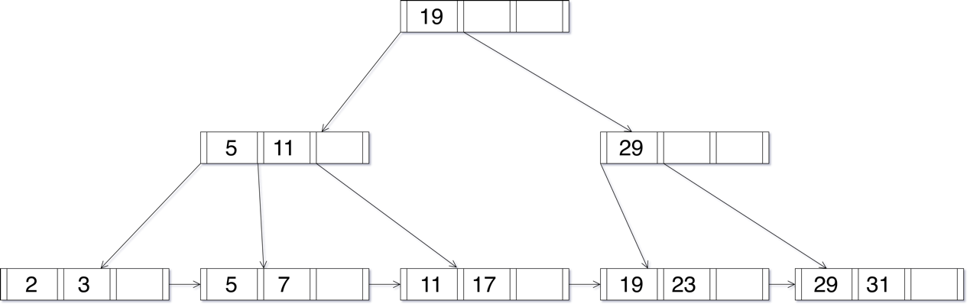a.

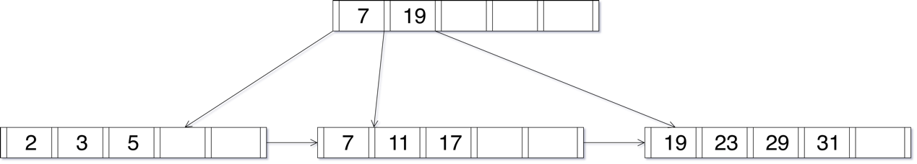b.

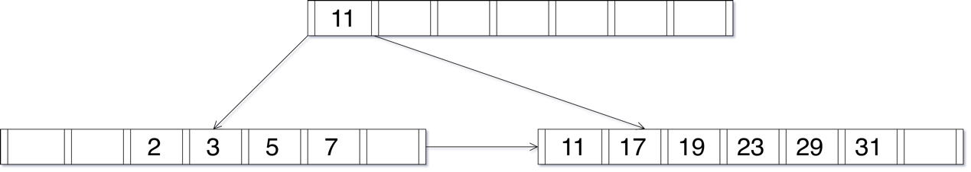c.

**11.6** Suppose that we are using extendable hashing on a file that contains records with the following search-key values:

Show the extendable hash structure for this file if the hash function is *h(x) = x* mod 8 and buckets can hold three records.

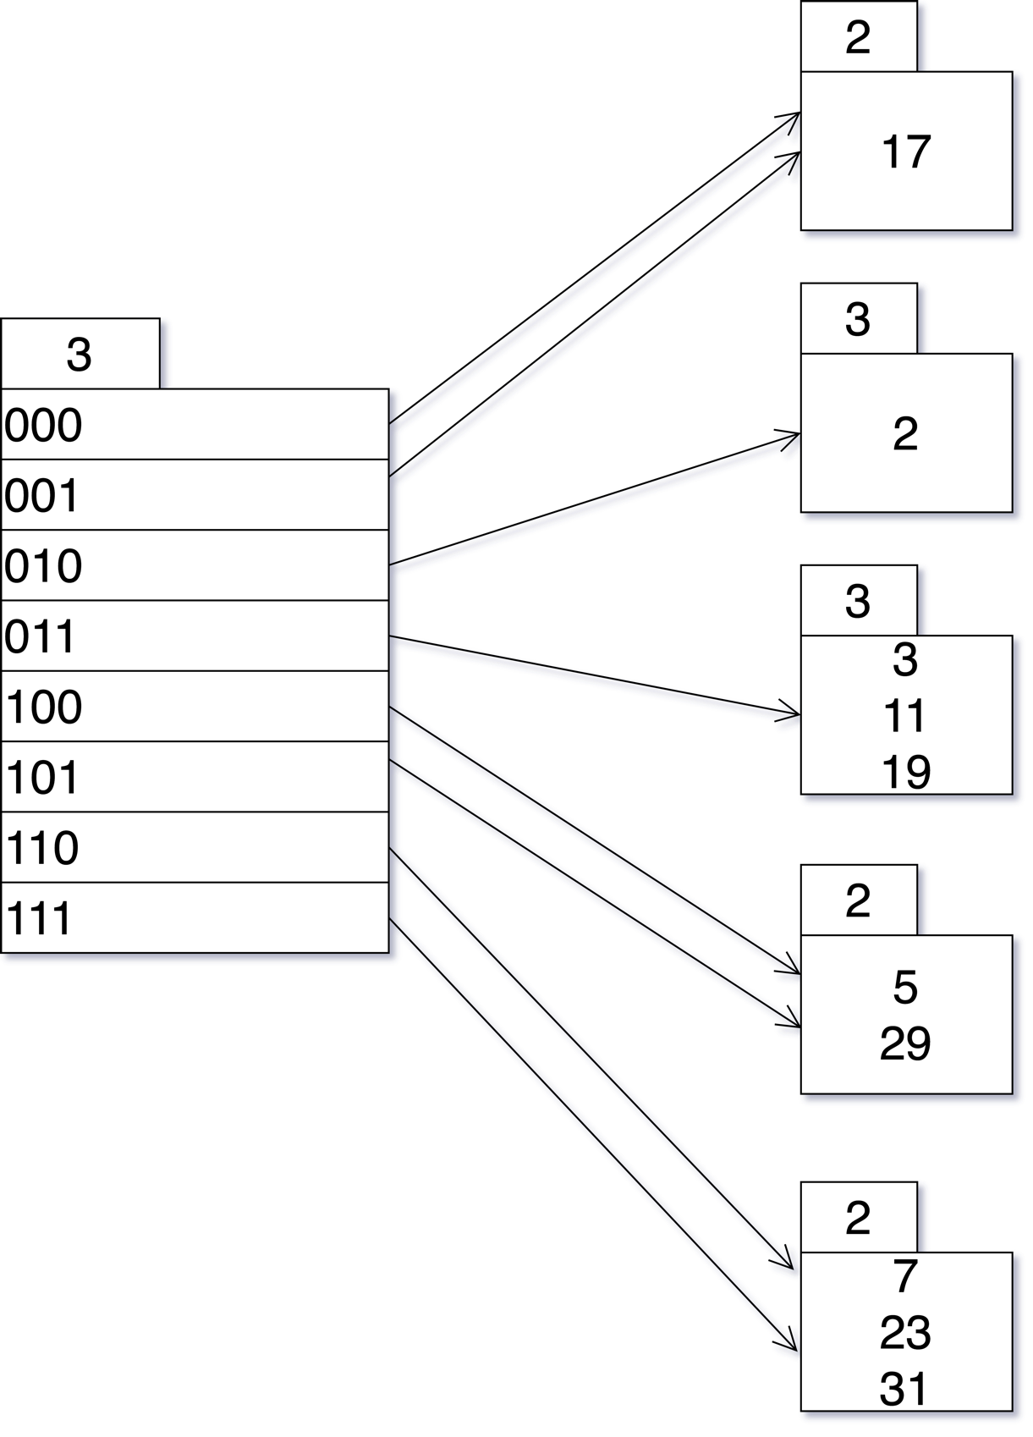**Answer:**

**11.7** Show how the extendable hash structure of Practice Exercise 11.6 changes as the result of each of the following steps:

1. Delete 11.
2. Delete 31.
3. Insert 1.
4. Insert 15

**Answer:**

a. Delete 11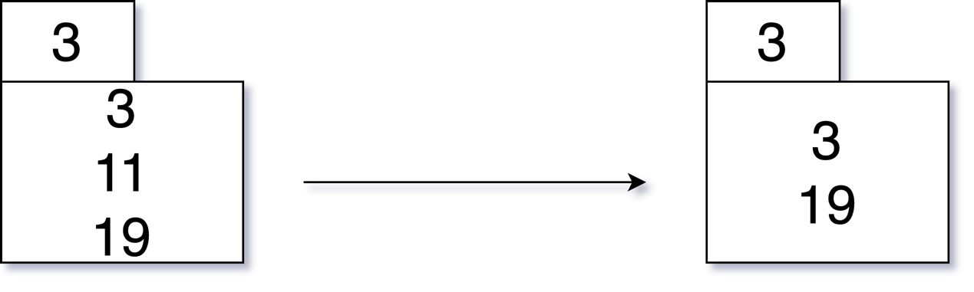will change bucket pointed by 011.

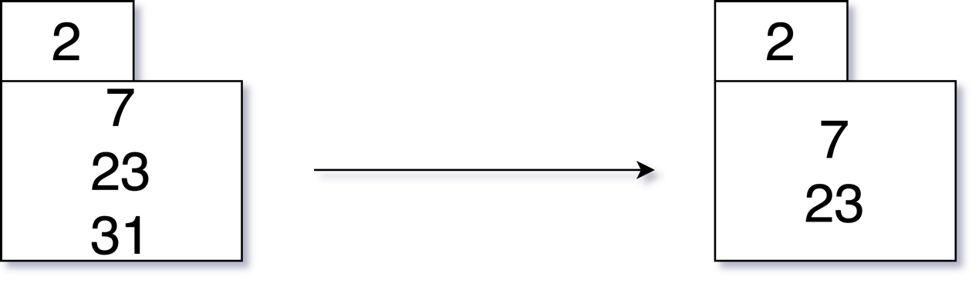b. Delete 31 will change bucket pointed by 111.

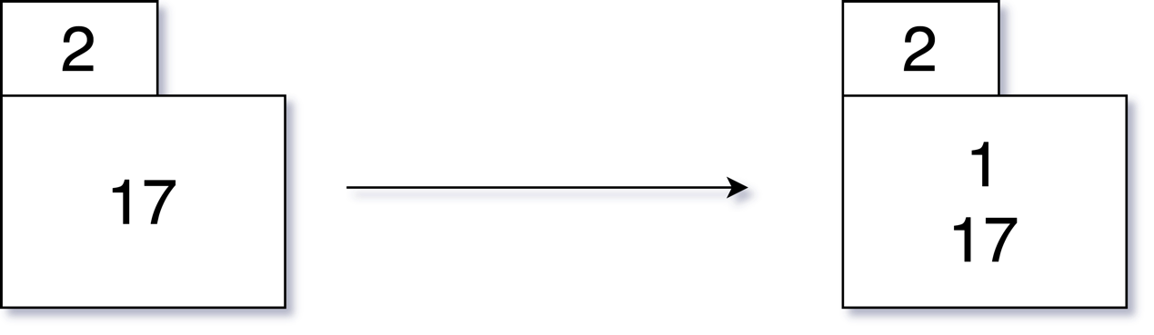c. Insert 1 will change the bucket pointed by 001.

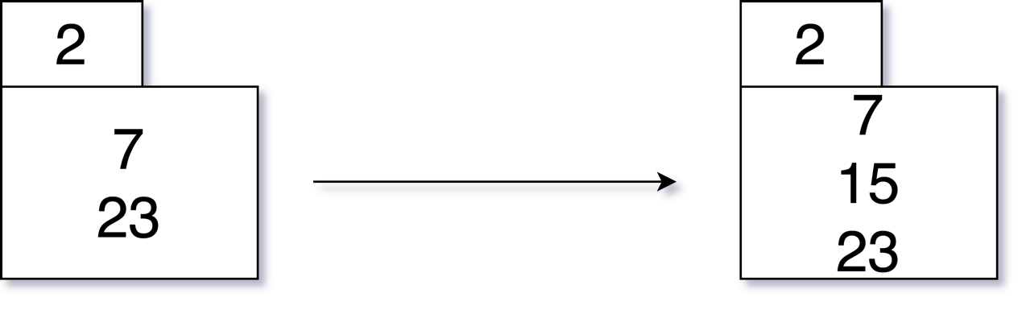d. Insert 15 will change the bucket pointed by 111.

**11.17** For each B+-tree of Practice Exercise 11.3, show the steps involved in the following queries:

1. Find records with a search-key value of 11.
2. Find records with a search-key value between 7 and 17, inclusive.

**Answer:**

a.

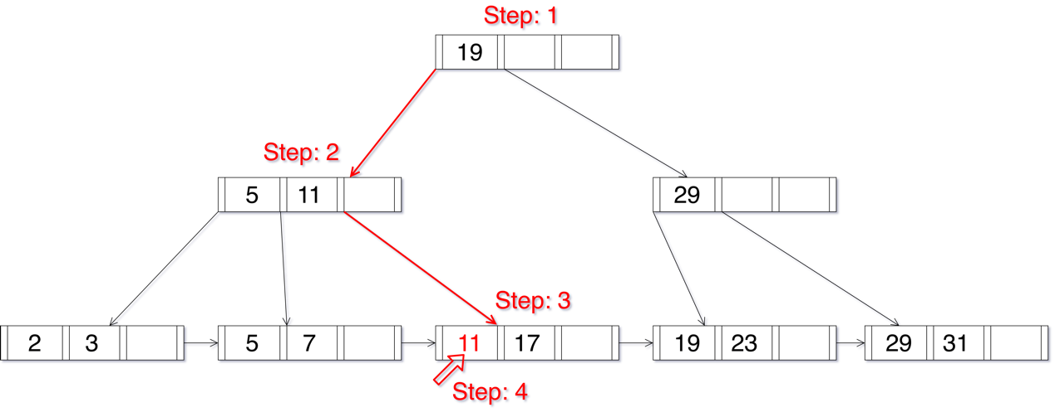For degree 4:

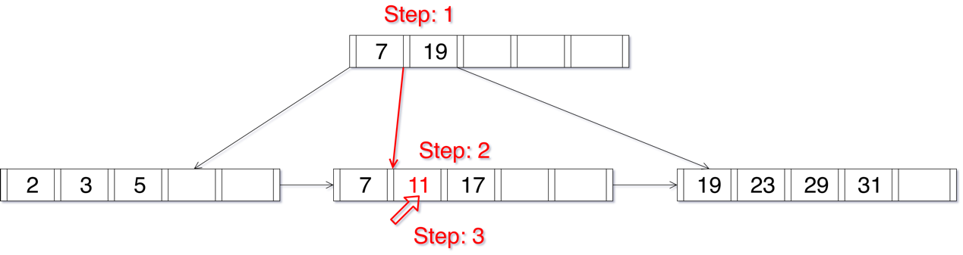For degree 6:

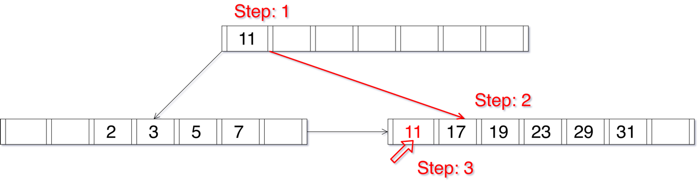For degree 8:

b.

For degree 4:

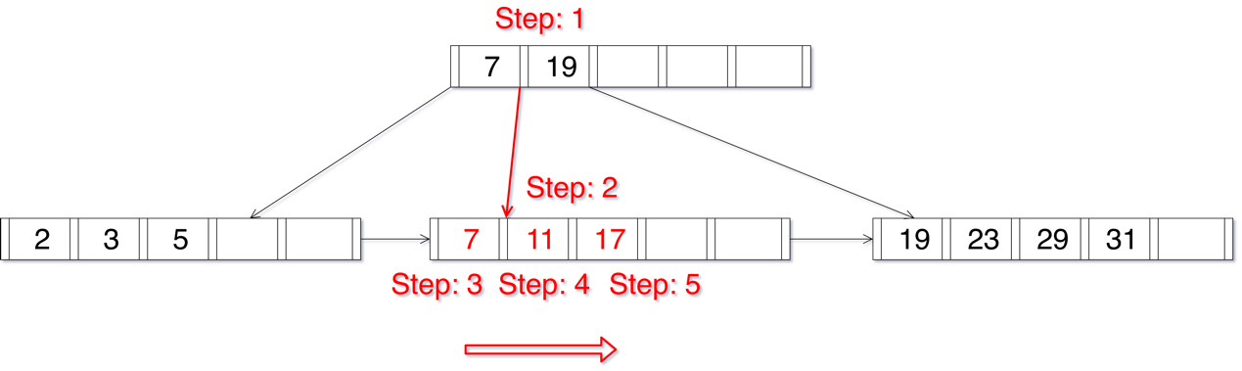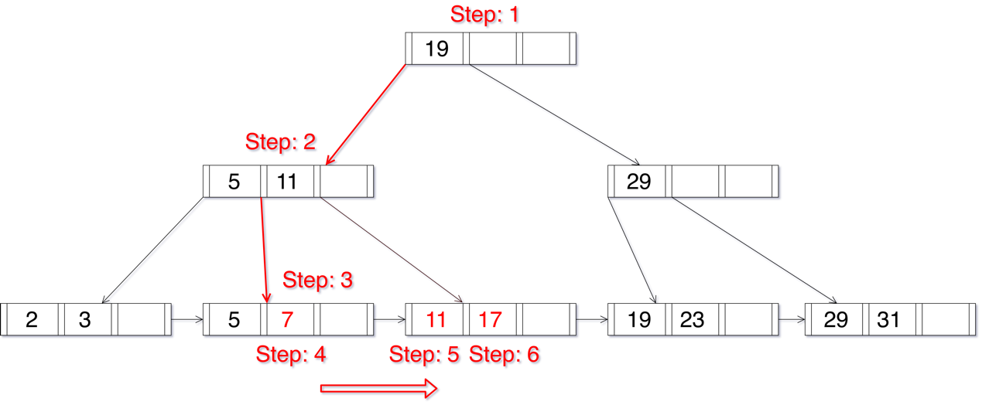For degree 6:

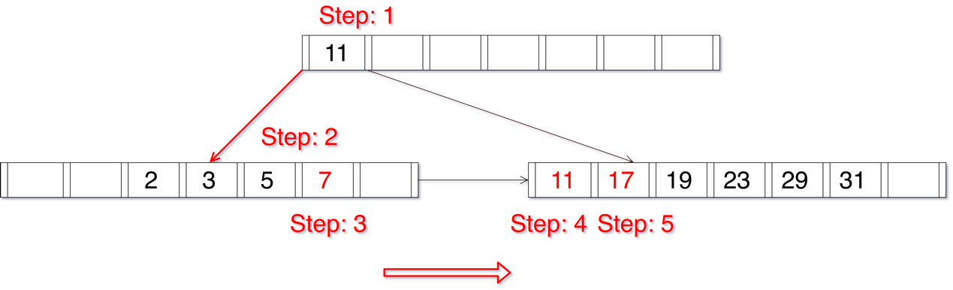For degree 8: