**数据库系统课程第四次作业**

19级软件工程1班 陈涵 201936380086

**7.21** Design a database for an automobile company to provide to its dealers to assist them in maintaining customer records and dealer inventory and to assist sales staff in ordering cars.

Each vehicle is identified by a vehicle identification number (VIN). Each individual vehicle is a particular model of a particular brand offered by the company (e.g., the XF is a model of the car brand Jaguar of Tata Motors). Each model can be offered with a variety of options, but an individual car may have only some (or none) of the available options. The database needs to store information about models, brands, and options, as well as information about individual dealers, customers, and cars.

Your design should include an E-R diagram, a set of relational schemas, and a list of constraints, including primary-key and foreign-key constraints.

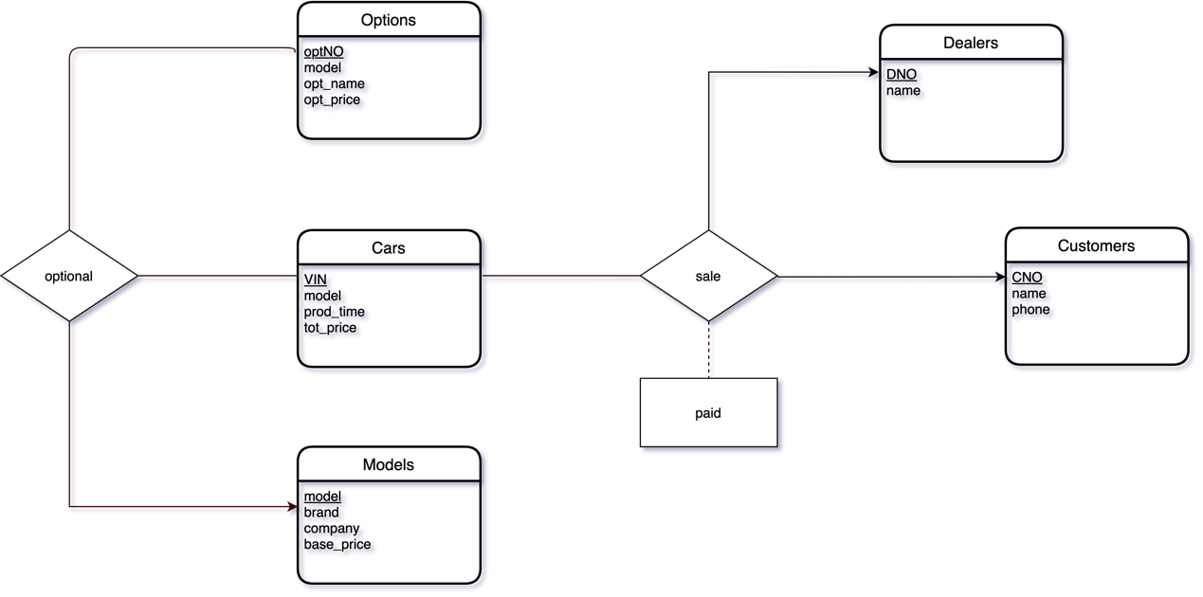**Answer:**

**Figure 1** E-R diagram for automobile company

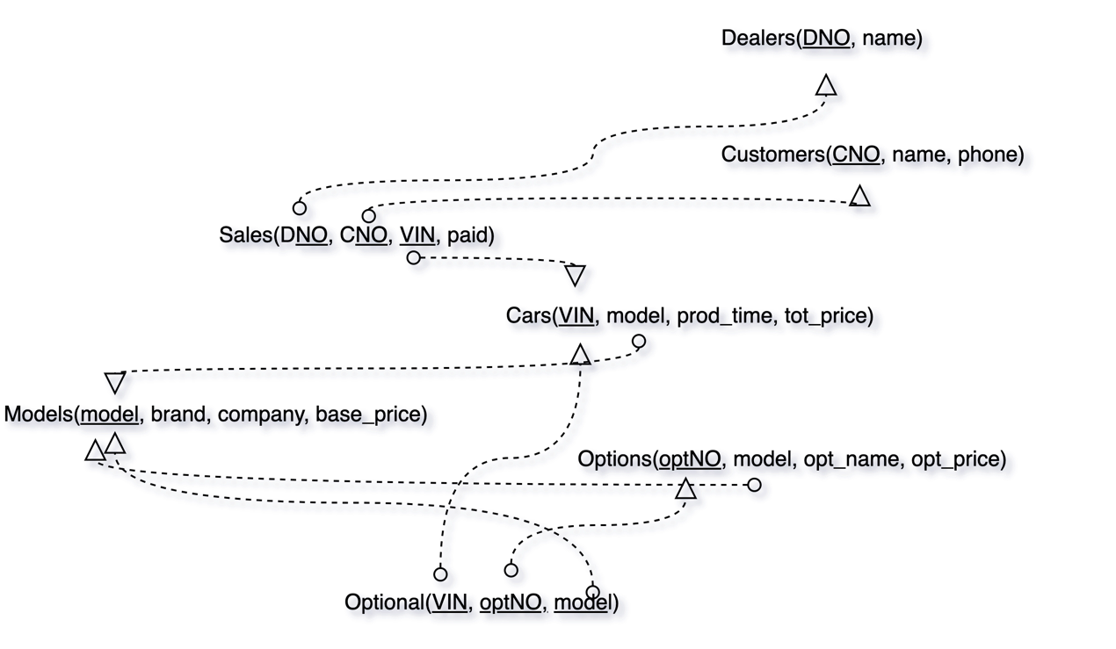

**Figure 2** schemas forautomobile company

**7.23** Design a database for an airline. The database must keep track of customers and their reservations, flights and their status, seat assignments on individual flights, and the schedule and routing of future flights.

Your design should include an E-R diagram, a set of relational schemas, and a list of constraints, including primary-key and foreign-key constraints.

**Answer:**

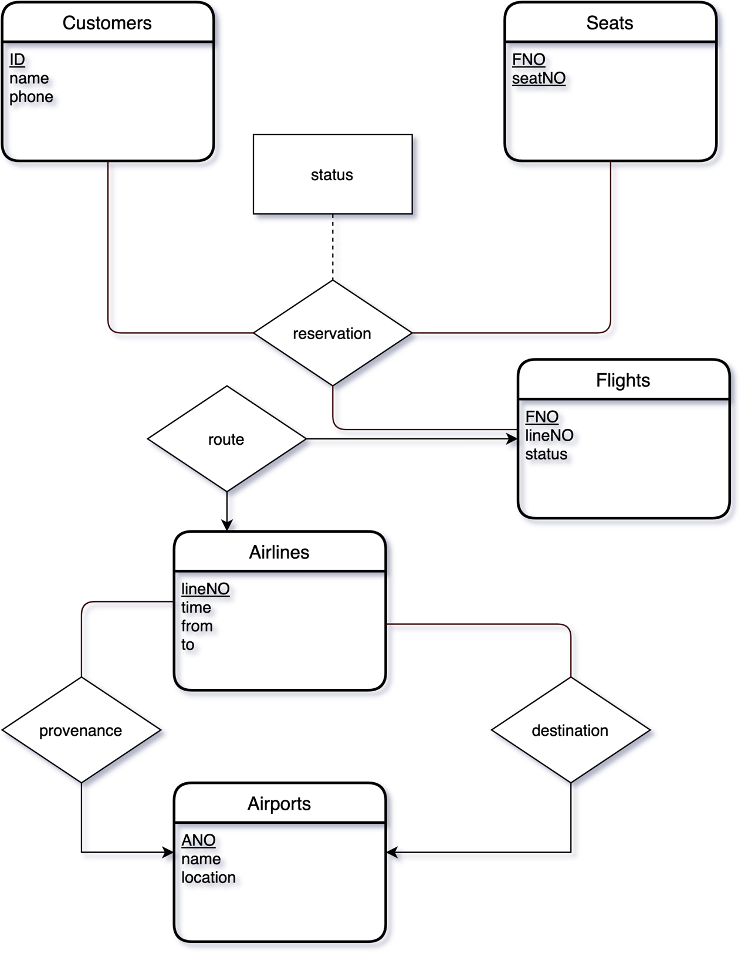

**Figure 3** E-R diagram for flights

The ‘status’ in relationship ‘reservation’ is used to store customers’ status like boarding or miss boarding.

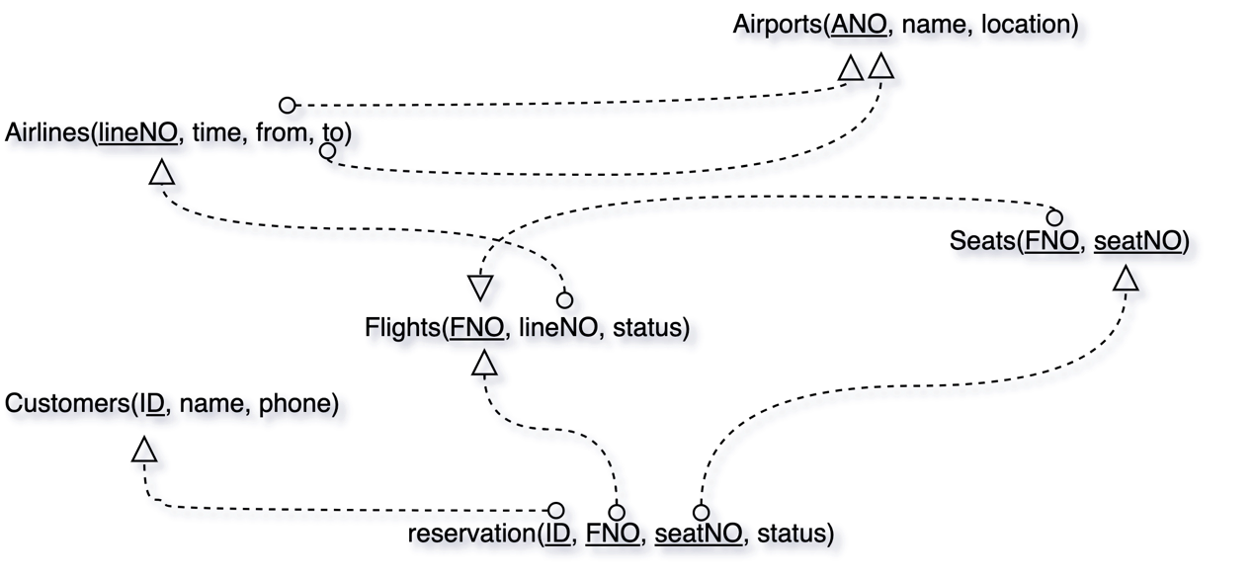

**Figure 4** schemas for flights