MERIDIAN TECHNOLOGIES, INC. | BOARD OF DIRECTORS — ANNUAL STRATEGIC REVIEW
May 2026 | Catherine Park, President & CEO | CONFIDENTIAL

Meridian has a healthy balance sheet, a strong enterprise franchise, and a growth engine that is running out of time.

These remarks accompany the financial trend analysis submitted ahead of this meeting (see chart, p. 2). I will speak to three issues and close with a single ask. I expect this to take five minutes; I want the remaining time for your questions.
ISSUE 1 Growth is decelerating — and AI monetization is not yet the offset.
ARR growth has fallen every year for three consecutive years: 28% in 2022, 19% in 2023, 16% in 2024, and 10% in 2025. Our 2026 guidance of 10–14% does not break the trend. The replacement growth engine — AI Copilot — generated $3.5M in ARR in its first year. That is proof of concept, not a growth driver. Meanwhile, the competitive environment is escalating: Asana bundled AI into its standard tier, Monday now exceeds us by ARR, and ClearAI Work raised $120M at a $1B+ valuation.
- Source: meridian_financials_2022_2025.csv — ARR growth rate by year, 16 quarters
- Source: Q4 2025 earnings call — "meaningful AI contribution starting 2026, not 2025"
- Source: meridian_kpis_2024.csv — Magic number declined from 1.20 (2024Q1) to 0.92 (2025Q4)
ISSUE 2 Mid-market — 47% of ARR — is approaching stall speed.
Enterprise is performing well: 125% NRR, 21% ARR growth, logo churn below 3%. But enterprise is 140 logos. It cannot carry the company alone. Mid-market is 47% of our ARR base and it is quietly eroding. Net retention has compressed from 115% in 2022 to 102% today. At 100%, the segment stops expanding. The customers most at risk are asking for two things we have not yet delivered: competitive AI features and a resource management module. We deferred resource management — our customers' top advisory board request — for the second year running.
- Source: meridian_kpis_2024.csv — Mid-market NRR: 108% (2024Q1) → 102% (2025Q4)
- Source: meridian_segments_overview.md — Mid-market gross logo churn rising: 9.1% → 10.2%
- Source: meridian_product_roadmap_2025.md — Resource management deferred to Q2 2026 (second deferral)
ISSUE 3 The organization is not yet ready to execute the platform pivot.
"Roadmap thrash" is the single most common theme in our 2025 employee survey — 31% of engineering and 24% of product mentioned it. Twenty-eight percent of sales say they cannot crispy differentiate us from Asana with AI. These are not morale statistics — they are operational liabilities in the year we must execute. Three specific trip-wires: Investor Day is six weeks out and the "what Meridian is" answer must be locked internally before we say it externally. The People team flags specific risk of losing 15–25 senior engineers in Q1 2026 if equity is not refreshed. And our core 2026 AI roadmap depends on retaining the Helio team through a compensation cliff that hits this year.
- Source: meridian_employee_survey_2025.md — 81% response rate; "roadmap thrash" #1 theme in eng/product
- Source: meridian_employee_survey_2025.md — People team recommends equity refresh Q1 2026; 15–25 engineers at risk
- Source: meridian_product_roadmap_2025.md — "Agent-builder roadmap depends on Helio retention; 2026 cash cliff"

MY ONE ASK Three decisions I need from the board today.
I am not asking for permission to run the business. I am asking for three explicit board commitments that will unblock execution:
1. Approve the senior engineering equity refresh before the end of this meeting. The People & Compensation Committee has the proposal. The window to act before attrition starts is weeks, not months.
2. Endorse the "agentic work platform" positioning as Meridian's durable identity. I will carry this message at Investor Day on March 11. I need the board aligned before I say it publicly, not after.
3. Set a mid-market NRR floor as a board-level early-warning metric. I propose 100%. If we cross it, I come back within 30 days with a remediation plan. This keeps the board informed without requiring a special session for every renewal headwind.

The financial trend chart on the following page summarizes the data underpinning these three issues. I am ready for your questions.

Appendix — Financial Trend Analysis
Source data: meridian_financials_2022_2025.csv, meridian_kpis_2024.csv. Generated May 2026.
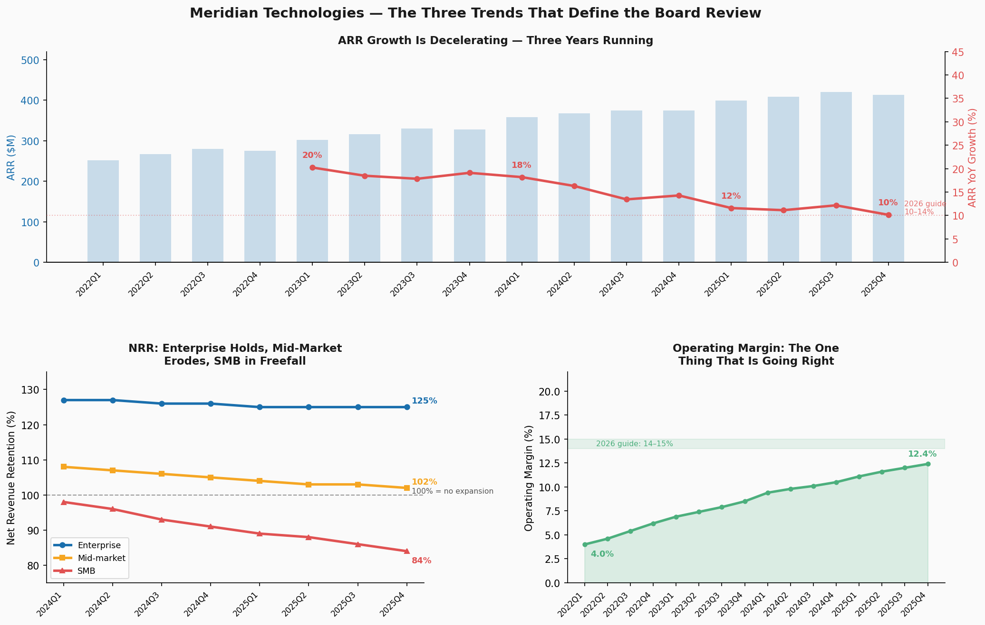
Figure 1. Left axis: ARR ($M, bars) and YoY growth % (red line). Bottom-left: NRR by segment, 2024–2025. Bottom-right: operating margin expansion.

