

**Mobile Platform Development**

**Coursework 2019/2020**

**Testing Document**

**Name:** Conner Fleming

**Matriculation Number:** S1713688

**Course:** Computer Games (Software Development)

**Video Link:** <https://github.com/Condooo/Mobile-Platform-Development-Project/tree/master/MPDProjectBACKUP>

**Android Studio Link:** <https://github.com/RachelMcGurk/McGurk_Rachel_S1620735_MPD_Coursework>

**.apk File Link:** <https://github.com/Condooo/Mobile-Platform-Development-Project/blob/master/app-release.apk>

|  |  |  |  |  |
| --- | --- | --- | --- | --- |
| **Test Description** | **Components Tested** | **Input** | **Expected Result** | **Actual Result** |
| Use map/list view icons to switch between map and list view (portrait mode) | Fragments, image handling | Select map and list icons from ribbon | Container fragment to be replaced by with correct view and display correct results; zoom extents icon to be hidden on list view | Container fragment switches between map and list views correctly; correct results retained throughout; zoom extents icon hidden on list view |
| Use Clear Results icon to clear the shown results from map and list views while results present | Map fragment, result storage, expandable list results | Selection of Clear Results icon | Results to be cleared from map and list views | Map markers removed from map view; list cleared from list view |
| Navigate to and from search screen | ViewSwitcher, layouts | Selection of search and return icon | Results view to be replaced by search screen and vice versa upon icon interaction | Screens navigated successfully; return arrow icon presented on search screen; search screen set to default search parameters upon navigation |
| Rotate device to display alternate layouts and ensure continuation of asyncTask | Fragments, asynchronous tasks, layouts | Device rotated landscape and portrait | Landscape and portrait layouts presented on screen rotation; asyncTask completes execution | Appropriate layouts presented on orientation; view switch icons hidden on landscape layout as both views visible by default; map and list search results retained between rotations; asyncTask completed during rotations; ***progress bar and text missing between rotations*** |
| Use of Zoom Extents while results empty | Map fragment, result storage | Selection of Zoom Extents icon from map view while no results shown | No action | No action |
| Use of Zoom Extents while results displayed | Map fragment, result storage | Selection of Zoom Extents icon from map view while results shown | Map centres on marker location | Centre point and bounds of all markers calculated and camera animated to position and zoom bounds |
| Selection of list item | ExpandableListView, map fragment, interface communication | Selection of group item in list results | Item to expand to display additional information about result, map to centre on selection location in landscape orientation | Selection expands to display correct additional information (duration, type, start/end dates, delay information, coordinates) |
| Use search function to display all instances of each result type | RSS feed access, XML parsing, search functionality, map marker placement | Search type: Location  Location: NULL  Data selected: Current roadworks, planned roadworks, incidents  Start date: NULL  End date: Null | All instances across each data type to returned and displayed appropriately in map and list view; map markers to be placed and coloured according to data type (current: green, planned: blue, incident: red)parsing progress to be displayed; map centre on marker locations | All 510 results returned; location markers added to map view and colours correctly assigned, search results displayed correctly in list view, expandableListView item background colour set according to duration length (0 days Green – 365 days Red); selection of item while in landscape view centres and zooms on corresponding map marker |
| Search function: Location  Search for specific location, requesting all data types | Search function, geocoding, parsing, result searching | Search type: Location  Location: M74  Data: Current roadworks, planned roadworks, incidents  Start/end date: Null | Current map markers to clear, new data retrieved and parsed. Map markers placed at correct coordinates and list view populated; search to return user to result view | Yellow map marker placed for location position.  29 results returned, all containing instances of “M74” provided text (14 planned words, 13 current works, 1 incident - closure), each marker coloured correctly |
| Search function: date  Test how the program handles incompatible date ranges | Edge case date scenario handling | Start date: 01/01/2020  End date: 31/12/2019 | Reset other date to be in-line with conflicting date | Start date readjusted to end date; toast message notified user of change made; date compared with result list, 1 matching result within date range |
| Search function: location  Test how the program handles nonsense location input | Edge case location parsing handling | EIJGH5ijsdgm69 | Input to be compared to parsed results, notify user if no results match | Results parsed and compared, Toast notification made user aware of no matching results within parameters |
| Search function: range  Determine how program returns result based on a range from location | Geocoding, distance calculation, result storage | Location: Dundee  Range: 50km  Data: Current roadworks  Start date: Null  End date: 30/12/2020 | Results to be compared, distance from location calculated and presented in list and map view | 26 results returned, all marked as current roadworks running until 30/12/2020 at latest, list view populated and map markers placed accordingly |
| Clear button | UI handling | Selection of clear button on search screen | Clear all search parameters to default values | All search values returned to their default values, ***focus still on editText object*** |
| Data saving and loading | Data storage and retrieval | Close app and load again | Save last list of results and repopulate on load | List of results saved when app closes or configuration changes, toast notification displays successful loading of 501 results upon return to app |

**IMAGES**

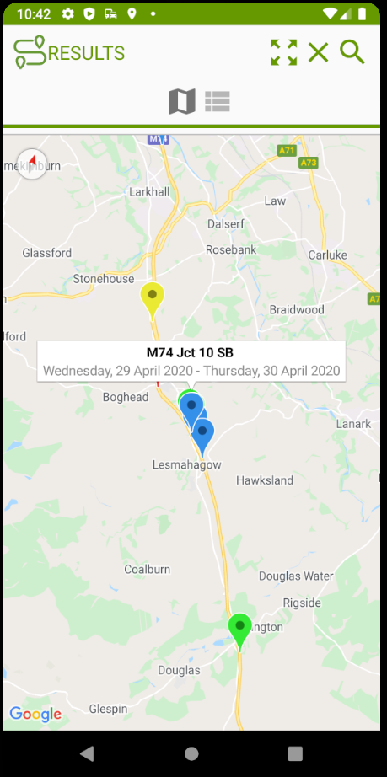 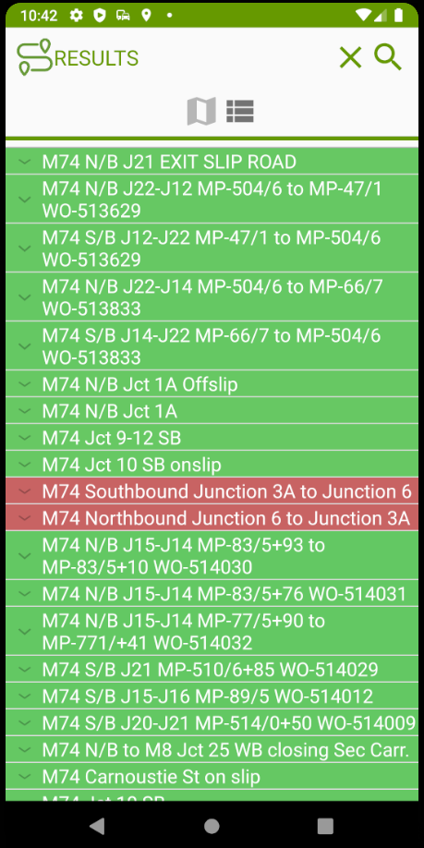 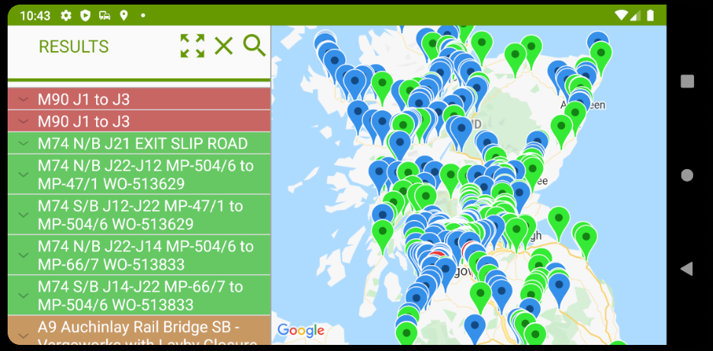

Figure 1: Map view with location results Figure 2: List view with coloured results Figure 3: Landscape layout displaying list and map view with list and map marker results

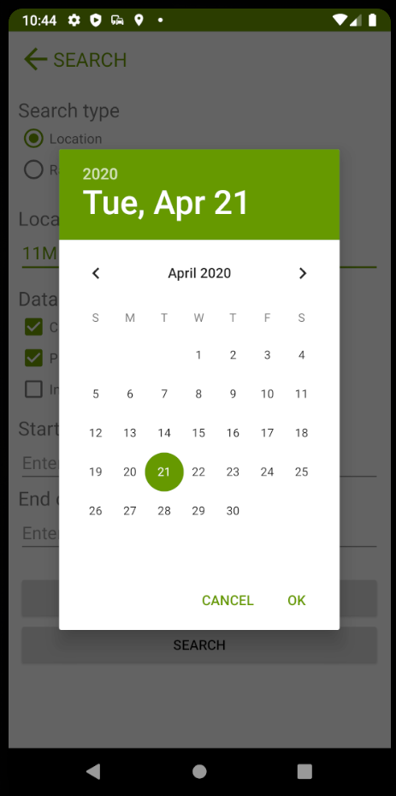 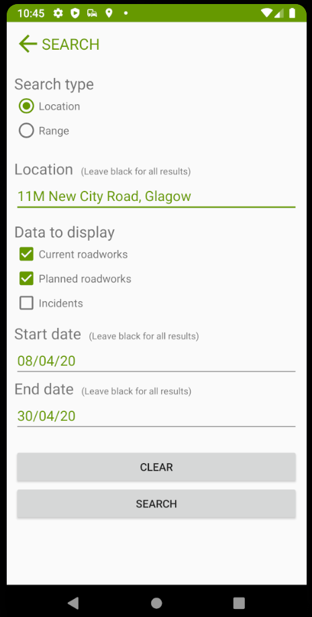

Figure 4: Search screen, parameter input and date selection